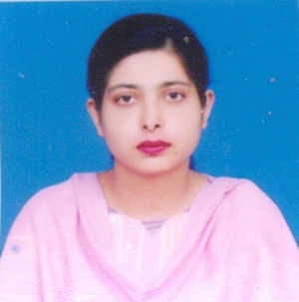
Name: Dr Ayesha Mohyuddin
Designation: Assistant Professor
Department: Chemistry
School/Institute: School of Science and Technology
Educational Qualification: Ph.D. 2010 (GC University Lahore)
Areas of Interest (Research/Teaching): Organic Chemistry, Natural Product Chemistry, Renewable Energy Resources, Analytical Chemistry
Profession Experience: Four and a half years of teaching as assistant professor to MS & BS classes at UMT Lahore, whereas served as lecturer for five months. Serving as external examiner for Lahore College for Women University and GC University Lahore from 3 years. Honorary reviewer of Pharmaceutical Biology from 3 years
Training and Development: Got training for research and teaching in ten different workshops such as on laboratory and analytical instrumentations, High performance Liquid Chromatography (HPLC), Gas Chromatography/Mass Spectrometry (GC/MS), XRD, AAS, Statistical techniques used in Chemistry, Moodle.
Professional Memberships: Life time Member of Chemical Society of Pakistan, Member of Pakistan Institute of Chemists, Affiliate Member of International Union of Pure and Applied Chemistry 2015, Vice President Research Triple Helix Association (South Asia Chapter), Member ORIC UMT.
International Journal & Book Publications: Eight research articles are published in international impact factor journals. Two Books have been published by German publisher.
Conferences and Seminars: Presented research papers in Fourteen international and Five national conferences/seminars.
Key Achievements: HEC Scholarship for Indiginous Ph.D. program, First Position in M.Phil in session 2002-04, Participated and Represented Pakistan as Young Scientist in 56th Meeting of Nobel Laureates, Lindau, Germany 2006.

