Dr. Khurram Shahzad Munawar
PhD Inorganic/Analytical Chemistry
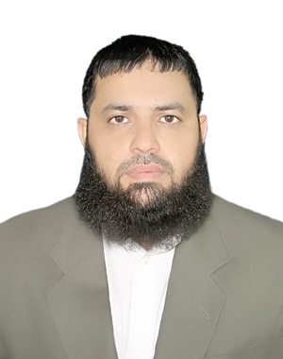

Passport Size
Photograph
Laboratory of Organometallic synthesis
Department of Chemistry
Quaid-i-Azam University
Islamabad (Pakistan)
Cell: +923135399525
Email: khurramchemist@gmail.com

Seeking a challenging work environment to apply my knowledge, skill and abilities to achieve organizational goals and objectives with a willingness to form long-term relations with the organization.

Objective
PhD Research Entitled
- Synthesis and structural elucidation of bioactive oxovanadium(IV) complexes
M.Phil. Research Entitled
- Synthesis and characterization of various donor ligands and their Oxovanadium complexes
Personal Information

Father name | Munawar Hussain
Permanent Address | House No “13-B”, Street No. “Q” Block “X” New Satellite Town Sargodha
Date of Birth | 26, January 1983
NIC No. | 38403-2164549-5
Marital status | Married
Nationality | Pakistani
Domicile | Sargodha

Education

PhD Inorganic/Analytical Chemistry | 2015 | - | Quaid-i-Azam University Islamabad
M.Phil. Inorganic/Analytical Chemistry | 2009 | 3.7 GPA | Quaid-i-Azam University Islamabad
M.Sc. Chemistry | 2005 | 72% | University of The Punjab Lahore
B.Sc. Chemistry, Zoology, Botany | 2003 | 67% | University of Sargodha
F.Sc. (Pre-medical) | 2001 | 65% | Govt. College Sargodha
SSC | 1999 | 75% | M.C. Boys High School Sargodha

International Publications: Twelve

