Name: IMTIAZ AHMAD
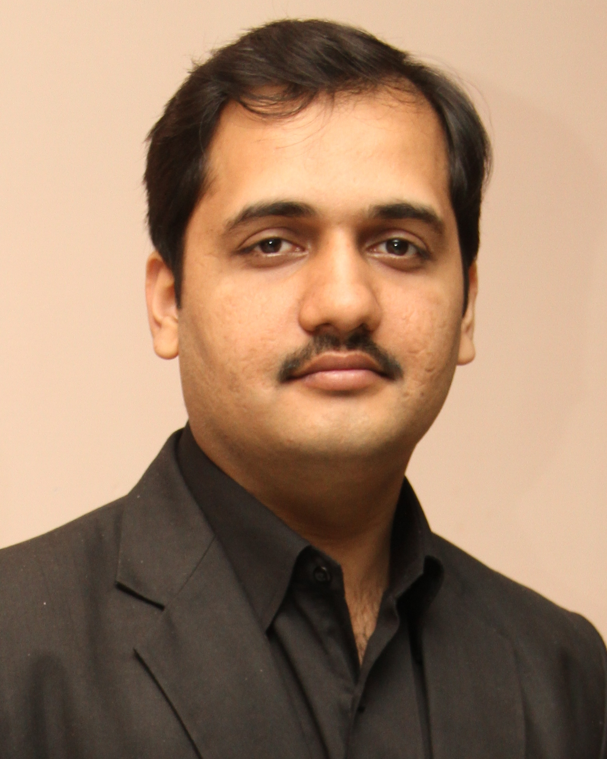hotograph
Academic Designation: LECTURER
UMT Email id: Imtiaz.ahmad@umt.edu.pk

I received my MS degree in Physics (Nanotechnology) from Centre of Excellence in Solid State Physics, University of the Punjab, Lahore (2011-2013). I earned my Master degree M.Sc. in Applied Physics from University of Engineering & Technology, Lahore with special paper of Advanced Electronics (2004-2006).
I joined University of Management and Technology (UMT) faculty as a Research Associate in December 15, 2008. Recently, I am working as a Lecturer in the Department of Physics, School of Science (SSC). I am teaching various Physics courses and conducted Physics Labs. Moreover, I am actively engaged in research related activities and published TWO Research paper in an international journal. Prior to joining at UMT, I have worked as an O-Level, Physics teacher in one of the prestigious School in Lahore, where I served for Two years.
Academic Degrees:
Degree Title | Institution | Passing Year
MS Physics (Nanotechnology) | COE in Solid State Physics  University of the Punjab,  Pakistan | 2011-2013
M.sc.  Applied Physics | University of the Engineering & Technology, Pakistan | 2004-2006
B.sc. | University of the Punjab,  Pakistan | 2002-2004
F.sc. | Board of Intermediate & Secondary Education, Lahore | 2000-2002
Matric | Board of Intermediate & Secondary Education, Lahore | 1998-2000

Interest Areas:
a) Nanomaterials
b) Nano devices
c) Medical Physics

Research Work:
- Publications:
- Z. H. SHAH, I. AHMAD, Q. A. TAHIR, E. E. KHAWAJA
“On the determination of refractive index and thickness of thin dielectric films from measurement of transmittance” Surface Review & Letters, Vol. 19, No. 6 (2012) 1250059-5
- Imtiaz Ahmad, Sidra Khalid and E.E. khawaja
“Filament temperature of Low Power incandescent Lamps: Stefan-Boltzmann Law”
Lat.Am.J.Phys.Educ. Vol. 4,No.1(2010) page 74-78.
- Conferences:
i . Mahwish Bashir, A Ashraf, Imtiaz Ahmad, Saira Riaz and Shahzad Naseem,
“Synthesis and Characterization of ZrO2-ZnO Nanoparticles”, Proc. 2013 World Congress on Advances in Nano, Biomechanics, Robotics and Energy Research (ANBRE), August 25-28, 2013, COEX, Seoul, Korea
ii . Mahwish Bashir, Imtiaz Ahmad, Saira Riaz and Shahzad Naseem, “Structural and
Morphological properties of Zirconia NP’s”, Presented at the International Conference on Solid State Physics – 2013, University of the Punjab, Lahore, Pakistan, December 1-6, 2013
iii. Mahwish Bashir, Imtiaz Ahmad, Saira Riaz and Shahzad Naseem, “Structural,
Optical and Mechanical Properties of Zirconia Thin Films”, Presented at the International Conference on Solid State Physics – 2013, University of the Punjab, Lahore, Pakistan, December 1-6, 2013

