Name: Zaheer Hussain Shah
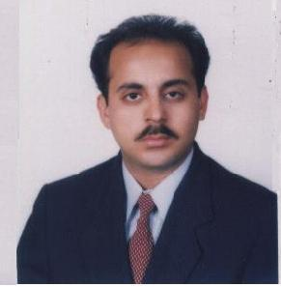
Academic Designation: Assistant Professor
Administrative Designation (if any): Not Applicable
UMT Email id: zaheer.hussain@umt.edu.pk
Affiliated with UMT since: June 18, 2007
Golden Paragraph:

PhD in Solid State Physics/Nanotechnology is in progress (Course Work Completed and Research is going on) and is expected to be completed in 2016. I served as Chairman Basic Sciences Department from Jan 2011 to Jan 2014. I have Sixteen years of professional and teaching experience starting since 1999 (from Physics Department, Punjab University Lahore to UMT). It also includes Five Years (2001-2006) of teaching at an International Level in Abu Dhabi, UAE. My teaching interest areas are Nanotechnolgy, Solid State Physics, Nuclear Physics, Mechanics, Electricity and Magnetism, and Thin Films Technology. I have Three International Impact Factor Publications. Three Research Papers are submitted in Impact Factor International Journals. Some more research papers in the field of Nanotechnology are under preparation.

Academic Degrees (Starting with the latest):
Degree Title | Institution | Passing Year
PhD  (Solid State Physics/Nanotechnology) | COE in Solid State Physics, University of the Punjab,  Lahore, Pakistan | Course Work Completed  (Research in Progress)
M. Phil.  (Solid State Physics) | COE in Solid State Physics, University of the Punjab,  Lahore, Pakistan | 2001
M.Sc.  (Physics) | Department of Physics, University of the Punjab,  Lahore, Pakistan | 1999
B.Sc. | University of the Punjab, Lahore, Pakistan | 1996
F.Sc. | BISE Sargodha, Pakistan | 1993
Matriculation | BISE Sargodha, Pakistan | 1991
Interest Areas:
a) Nanotechnolgy
b) Solid State Physics
c) Nuclear Physics

Research Work (in numerical form only):
- Publications: 03 (International and Impact Factor)
1. S. Siddique, Z. H. Shah, S. Shahid, and F. Yasmin; “Preparation, Characterization and Antibacterial Activity of ZnO Nanoparticles on Broad Spectrum of Microorganisms” Acta Chimica Slovenica, 60 (2013) 660–665.

2. Z. H. Shah, I. Ahmad, Q. A. Tahir and E. E. Khawaja; “On the Determination of Refractive Index and Thickness of Thin Dielectric Films from Measurement of Transmittance” Surface Review and Letters, 19 (2012) 12500591-5.

3. Z. H. Shah and Q. A. Tahir; “Dielectric Properties of Vegetable Oils” Journal of Scientific Research, 3 (2011) 481-492.

- Conferences: 03

