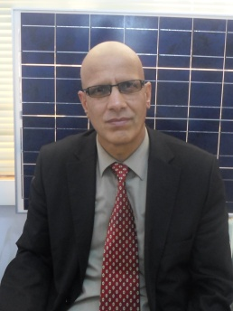

Professor Ali CHEKNANE
Laboratoire des Semiconducteurs et Matériaux Fonctionnels
Université Amar Telidji de Laghouat. ALGERIE

Biography:
Professor Ali CHEKNANE was born in Laghouat, Algeria. He is a full-Professor at the Amar Telidji University of Laghouat-Algeria. He has completed his PhD in physics. Ali is having 20 years teaching graduate and post-graduate teaching experience at the university as temporary, associated and permanent position. He has published many papers in various journals and conference proceedings on renewable energy subjects. He published more than 50 journal papers, did more than 40 conference presentations and served as an editorial board member for several technical and organizing committees for international conferences. He has many years’ experience of supervising several postgraduate and graduate students. He got an incentive award from “Centre de Development des Energies Renouvelables- CDER”. He was awarded for the best publication in physics in Algeria from the ANDRU agency in 2008. He is the Head of the research team: “Photovoltaic Systems & Devices” at the Laboratory of Semiconductors and Functional Materials. He is a reviewer in many Journals as: Solar Energy, Conversion Energy and Management Journal; Electronics Journal, International Journal of Engineering Innovations and Research, Measurement and International Journal of Electronics…etc. Ali CHEKNANE is the Dean of the Faculty of Technology at Amar Telidji University of Laghouat- Algeria.

