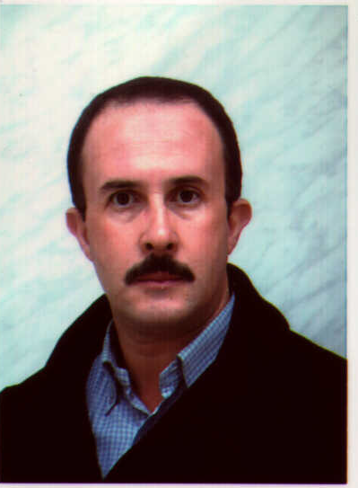

Biography

Cherif Bougriou is a Professor of heat transfer at the University of Batna 2, Algeria. He received his Ph.D. in 1991 from the Institut National des Sciences Appliquées of Lyon and the Groupement pour la Recherche sur les Echangeurs Thermiques (Greth-CEA, Grenoble, France). His main research interests are heat exchangers, heat and mass transfer, solar energy, distillation, new refrigerants, energy in buildings, etc. He has published more than 69 articles in well-recognised journals, books and proceedings. He filed a patent in 2007 on a new type of heat exchangers.

