**Tiltle** [14, Arial, Bold, Centre]

**Ali J.1, M.Saeed1, N. A. Chaudhry2, M. Luqman1, M. F.Tabassum1\*** [10, TNR, Bold, Centre]

1Department of Mathematics, University of Management and Technology, Lahore, Pakistan.

2Department of Mathematics, UCEST, Lahore Leads University, Lahore, Pakistan.[9, TNR, Centre]

* Corresponding Author: Muhammad Farhan Tabassum, [farhanuet12@gmail.com](mailto:farhanuet12@gmail.com), +92-321-4280420

***Abstract:****A novel meta-heuristic known as Artificial Showering Algorithm (ASHA) is presented in this paper. The proposed method is based on flow and accumulation phenomena of water units distributed by human controlled equipment in an ideal field representing the search space. The developed method is applied to benchmarking test functions and quality solutions are obtained. Comparisons witness that the method even at its evolvement phase performs better than pioneering algorithms like Genetic Algorithm,Differential Evolution and Simulated Annealing method.*[10, TNR, Italic, Centre]

***Key Words:*** *Optimization, Meta-heuristics, Flow dynamics of water, Human Driven Systems*[10, TNR, Italic, Centre]

**INTRODUCTION**[10, Arial, Bold, Left, Upper case]

Since the evolvement of GeneticAlgorithm(GA) [1] and Simulated Annealing(SA) [2] type algorithmsthe idea of adaptation of natural phenomena has become an effective source of developing efficient and potential optimization techniques.The concept of using swarms behaviors of achieving excellence was pioneering by Eberhart etal;by proposing Particle Swarms Optimization (PSO) [3] algorithm. This led to evolvement of a number of PSO-type algorithms based on characteristics of swarms of specified species. Artificial Bee Colony (ABC) [4],Bats Algorithm (BA) [5], Firefly Algorithm (FA) [6]and Krill Herds (KH) [7] method are few examples of these algorithms. Differential Evolution (DE) [8] is based on social differences of other individuals to improve the quality of a member of the population.Grenade Explosion Method (GEM) [9] and Mine Blast Algorithm (MBA) [10] are the algorithms based on explosions of grenades and mines respectively.Both of these methods involve shrapnel’spopulations which are static in nature and cannot move ahead or back after they strike their landing positions. This drawback is covered by adjusting the radii of explosions heuristically. In last two decades some meta-heuristics basedon flow dynamics of water have been proposed. These methods involveWater Cycle Algorithm WCA [11], Water Wave Optimization (WWO) algorithm [12], Intelligent Water Drop Optimization (IWDO) algorithm [13] andCircular Water Wave (CWW) [14]. Thesemeta-heuristics are quite recent and require more adaptations and terminologies to evolve much better algorithms.

In this paper, we present a new optimization method based on the idea of flow of water dropped by showers of water via sprinklers surmounted over the whole search space. The main objective of the proposed method is to evolve an approach which can be driven modified/hybridized/enhanced more easily and heuristically. It is expected the designed algorithm will be applicable to engineering design optimization problems [15] and multi-objective discrete optimization problems [16].

Rest of the paper organizes as: In the subsequent section we describe the terminologies and working principles of ASHA. In next section method is applied to well-known benchmark test problems and the obtained solutions are compared with other optimization techniques. In the last section conclusions and some future directions are also given.

**ARTIFICIAL SHOWERING ALGORITHM (ASHA)**

The method is based on following idealizations:

1. The search space is an ideal field in which water flows without resistance and the infiltration takes place only at the lowest location.
2. No evaporation, raining and interflow of water takes place.
3. Every bit of the search space is in the range of the sprinklers surmounted over the field.
4. Water is in abundance and remains constant throughout the iterations.
5. Each unit of the water has the probabilistic sense of moving downhill.

For minimizing a function $f : R^{n}→R$ which is bounded below,consider we are allowed to perform *K* trials and *m* units of water are available for each trial. Each unit of the water showered in the search space is identified by its position vector $x=(x_{1}, x_{2}, { x}_{3}, …, { x}_{n}) ϵ{ R}^{n}$. For starting the algorithm the overhead sprinklers are operated torelease prescribed quantity *m* of water at random positions $x^{(j)}ϵ{ R}^{n}:1≤j≤m$ and positions are evaluated for their heights. The algorithm works by monitoring the flow of water units with speed *F* from higher to lower altitudes based on the probability $ρ_{o}$ of the possible path selection. As the trials are made the water tends to accumulate at the lowest position and the landscape surface resists until its resistance level $(δ)$ is surpassed. Then water is infiltrated to join the underground water which is again lifted and dispatched to showers at new locations in the field by some of overhead sprinklers. The formal description of the algorithm is given below.

**ALGORITHM**

1. Initialize with $m, K,F,δ, ρ_{o}andset ρ=ρ_{o}$.
2. Drive the overhead sprinklers to shower *m* units of water.
3. Evaluate the landscape levels of water units.
4. Until all the trials have been made repeat (a) – (d)

For each unit $i : 1≤i≤m$

1. Choose a random number $r_{i} ϵ \left(0, 1\right)$.
2. ***If $r_{i}<ρ$***, choose a lower location randomly and find the new position as

$x^{(i)}new=x^{\left(i\right)}old+F ×(s)∎( x^{\left(j\right)}lower-x^{\left(i\right)}old)$.

$$if{ x}^{\left(i\right)}new is at lower level$$

$$set x^{\left(i\right)}old←x^{(i)}new endif$$

$$else$$

$x^{(i)}new=x^{\left(i\right)}old+F ×r×( lowest-x^{\left(i\right)}old)$.

$$endif.$$

1. If unit $i$ has infiltrated by surpassing the resistance level $δ$ then lift a new unit of water and shower it in the field.
2. Compare the location of the current unit of water with the lowest one and interchange if it gets lower than the lowest.

In the step 4 (b) of the algorithm $s$ is an n-dimensional vector of random numbers in (0, 1), the mark $∎$ represents the element-wise product and in (b) *r* represents a single random number in (0, 1). Moreover, the flow of water units at initial observations is mostly directed towards the lower positions and towards the lowest as number of observations grows. To imply this phenomenon we use aniteratively dynamic value $ρ$ calculated as:

$$ρ=\max\left(\frac{M-current iteration number}{βM}, ρ_{o}\right)$$

The parameter $β$ is a positive real number which controls the speed of change in $ρ$.

**BENCHMARK FUNCTIONS**

Three well-known benchmarking test functions are considered for comparisons. All the considered functions are highly multi-modal and are challenging for any optimization algorithm. All the functions are experimented over the domain $-100≤x_{1} , x_{2} ≤100$.

1. **Rastrigin function**[10, TNR, Bold, Left]

$$f\left(x\right)=20+ \sum_{i=1}^{n}{x_{i}^{2}}-10\left(\sum_{i=1}^{n}{\cos{2πx_{i}}}\right)$$

The function has global minimum value $f^{*}=0$ at $x^{*}=\left(0, 0\right)$ for $n=2$. A surface plot in the range $\left[-10, 10\right]$ for each variable is given below.

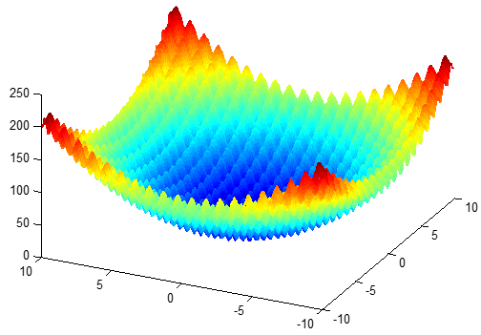

1. **Ackley’s function**

$$f\left(x\right)=-a\exp\left(-b\sqrt{\frac{1}{n}\sum_{i=1}^{n}{x_{i}^{2}}}\right)-\exp\left(\frac{1}{n}\sum_{i=1}^{n}{\cos\left( 2 π{ x}_{i}\right)}\right)+a+exp⁡(1)$$

where $n=2 , a=20, b=0.2$. The function has global minimum value $f^{*}=0$ at $x^{*}=(0, 0)$. A surface plot in the range $\left[-10, 10\right]$ for each variable is given below.

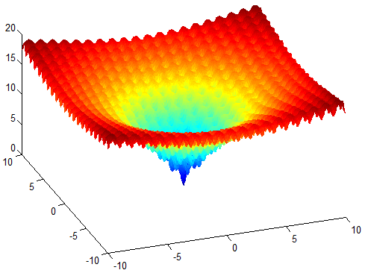

1. **Griewank function**

$$f\left(x\right)=\frac{1}{4000}\sum_{i=1}^{n}{x_{i}^{2}}-\prod_{i=1}^{n}{\cos\left(\frac{x_{i}}{\sqrt{i}}\right)}+1$$

The function in two dimensions has global minimum value $f^{*}=0$ at $x^{*}=(0, 0)$. A surface plot in the range $\left[-100, 100\right]$ for each variable is given below.

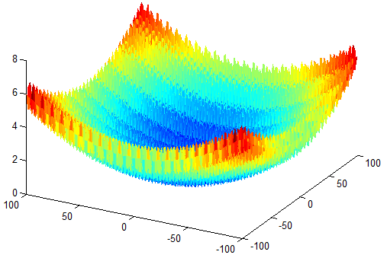

**RESULTS AND DISCUSSION**

For comparisons of results we have selected well known GA andSA. GA is used via MATLAB toolbox with default setting; the source code for WCA is obtained from author’s webpage whereas standard DE with crossover constant 0.5 and differential constant 0.9 is used. The parameters for ASHA are set as $F=2, δ={10}^{-16}$ and $ρ_{o}=0.2$. All the algorithms have been provided $K=1000$ allowed trials with population of $m=50$ members. The results provided in the table are based on 50 independent runs. Parameters for SA areFunction tolerance =1e-16, annealing function as fast annealing, 50000 function evaluations and acceptance probability function: Simulated Annealing acceptance. GA parameters are population type: double vector, Fitness scaling function: Rank, Selection function: Stochastic uniform, Elite Count:4, Crossover fraction: 0.95, Mutation function: constraint dependent, Crossover function: Scattered, Migration: both.



**Figure 1:** Iterative convergence on Rastrigin function

**Table-1:** Comparison of results for Rastrigin function

|  |  |  |  |
| --- | --- | --- | --- |
| Solution Type | **Rastrigin function** | | |
| GA | SA | ASHA |
| Best | 0.121× ${10}^{-11}$ | 0.121× ${10}^{-9}$ | **0** |
| Mean | 5.121× ${10}^{-8}$ | 1.474× ${10}^{-8}$ | **0** |
| Worst | 9.098× ${10}^{-2}$ | 0.352 | **0** |



**Figure 2:** Iterative convergence on Ackley function[9, TNR, Centre]

**Table-2:**Comparison of results for Ackley function

|  |  |  |  |
| --- | --- | --- | --- |
| Solution Type | Ackley | | |
| GA | SA | ASHA |
| Best | 8.882 $×{10}^{-16}$ | 8.882 $×{10}^{-16}$ | **8.882 $×{10}^{-16}$** |
| Mean | 2.96357 $×{10}^{-6}$ | 3.1023 | **8.882 $×{10}^{-16}$** |
| Worst | 5.7387 $×{10}^{-4}$ Scientific  Inquiry  Review | 19.954587 | **8.882 $×{10}^{-16}$** |



**Figure 3:** Iterative convergence on Griewank function

**Table-3:**Comparison of results for Griewank function[9, TNR, Centre]

|  |  |  |  |
| --- | --- | --- | --- |
| Solution Type | Griewank | | |
| GA | SA | ASHA |
| Best | 3.428 $×{10}^{-13}$ | 0.007396 | **0** |
| Mean | 2.4674E-11 | 0.2835 | **0.112 $×{10}^{-15}$** |
| Worst | **0.007396** | 0.35967 | **0.007396** |

**CONCLUSION**

In this work, we have successfully designed a meta-heuristic utilizing downhill water flow and the infiltration at the lowest location only. The developed method is less dependent on nature’s circumstances but uses the human driven water system. The method has produced impressively competitive results when applied to highly multimodal functions. The positive aspect of the method is its simplicity and ease of implementation. As a future direction more human driven phenomena in water system can also be used to increase the potential of the method.

**REFERENCES**

[6] Yang, X. S. “Firefly algorithm, stochastic test functions and design optimization”, *Int. J. Bio-Inspired Computation*, **2**:78–84 (2010).

[7] Gandomi A. H, Alavi A. H, “Krill herd: A new bio-inspired optimization algorithm”, *Commun. Nonlinear Sci. Numer. Simulat.***17**:4831–4845 (2012).

[8] Storn R. and Price K., “Differential evolution-a simple and efficient heuristic for global optimization over continuous spaces”, *Journal of Global Optimization*, **11**:341-359 (1997).

[9] Ahrari A., Atai A. A, “Grenade Explosion Method - A novel tool for optimization of multimodal functions”, *Appl. Soft Comput*. **10**:1132-1140(2010).

[10] Sadollah A., Bahreininejad A., Eskandar H. and Hamdi M., “Mine Blast Algorithm: A new population based algorithm for solving constrained engineering optimization problems”, *Applied Soft Computing***13**, 2592–2612 (2013).

