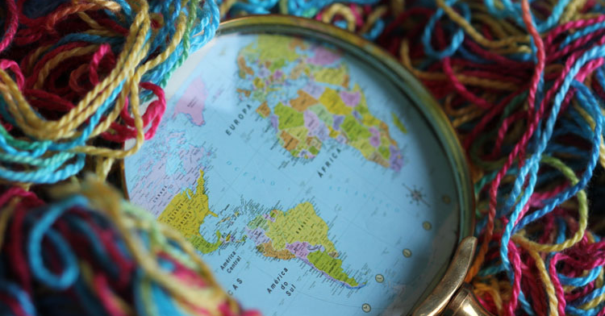
Ana Maier is perhaps best known for investigating territories, maps, horizons, and skylines in her work. She focuses on using paper and other mediums to create art that pushes boundaries and tests limits.
Originally pursuing an education in biology, it wasn’t until experiencing the magic of a pop-up book at age 20 that Ana began to explore the world of textile artistry.
In this interview, Ana Maier reveals her first experience with pop-up books, the influence botany had on her work, as well as her fascination with bustling city skylines around the world.
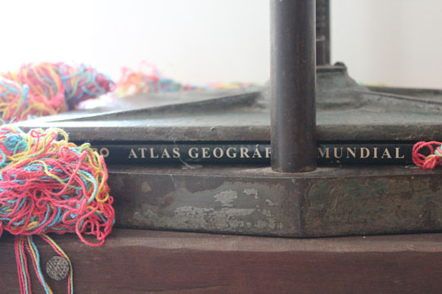
Ana Maier – Prensa para expandir territórios (2014) – detail

Creating paper folds
TextileArtist.org: What initially captured your imagination about textile art?
Ana Maier: I always associated the sewing machine with a magical object, something like the Aladdin lamp. But the genius in my story was my mother. She sewed almost everything I wore in my childhood. She passed to me the passion for embroidery and taught me to sew from quite early.
At 15, I did a basic modeling course to design more elaborate clothes. Since then, I paid more attention to the different types of fabrics and linens. I had no intention to be a professional in the fashion industry, but I was interested in the construction of clothing itself, and the relationships between forms and volumes. I didn’t even care about prints, for example. I preferred monochromatic fabrics or with textures. It was thinking about sculptures, although at the time I was not fully aware of it.
What or who were your early influences and how has your life/upbringing influenced your work?
My father was a bookseller and taught me in origami when I was about five years old. Several times he took me with him to the International Book Fairs in Rio de Janeiro and São Paulo. On one of these trips into the publishing universe, I discovered the technique of making pop-up books. I was fascinated by the possibility of creating paper folds that let the images spring out of the book. I even thought to become illustrator using only paper engineering. At that time I was about 20 years old and studying biology at university, majoring in botany.
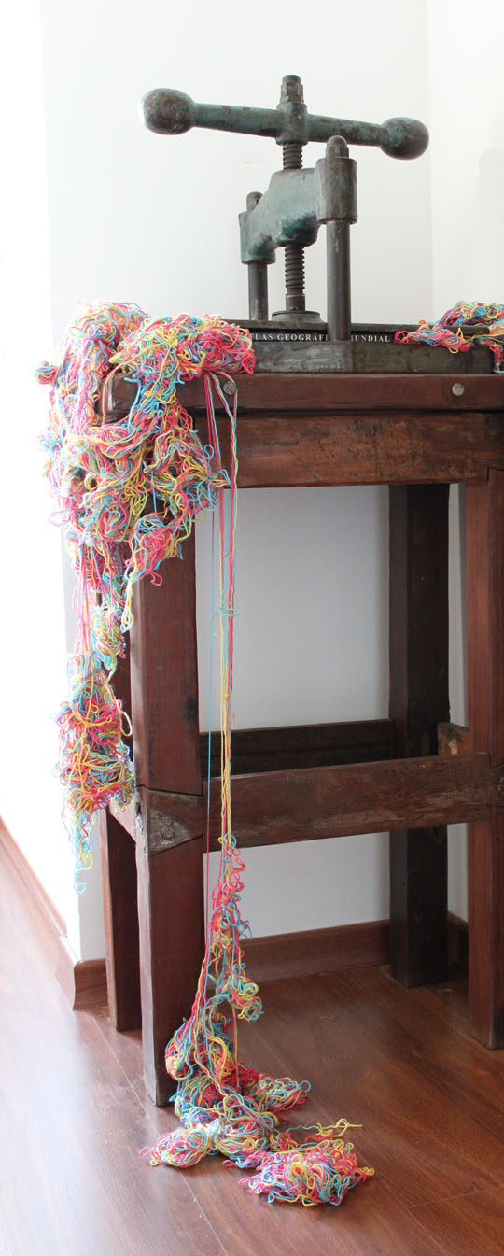
Ana Maier – Prensa para expandir territórios (2014)
I was researching a country flower known as Evergreen, because its essential appearance remains the same, years and years after being taken from its natural environment. My work in the anatomy laboratory of the Institute of Biological Sciences was to analyze the internal architecture of this flower under the microscope. I had to draw life size parts of Evergreens ind detail, make cuts of plant tissues, put color on it, and photograph the images I saw in a larger scale under the microscope lens. My curiosity for the invisible composition of the fibers, with which I already was familiar through textiles, added to my interest in graphic art. I developed an investigative gaze, sort of an attention to detail. This combination of experiences was the reason for changing to the School of Fine Arts.
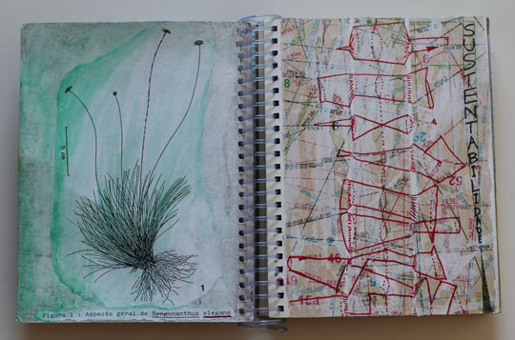
Ana Maier – sketchbook

Express ideas visually
What was your route to becoming an artist?
I left biology, graduated in sculpture in 1998, and gained a teaching qualification in 2003 from the School of Fine Arts at the Federal University of Minas Gerais (UFMG). I then crossed the Atlantic Ocean and moved to Germany, where I lived for five years, from 2003 to 2008. Traveling through Europe increased my interest in cultural diversity around the world. It may sound strange, but the distance made me able to evaluate more clearly my own reality of origins and my perception about the concept of landscape. The expansion of my particular horizon to a territory in constant transformation is what enables me today to reinvent cartographies and express ideas visually.
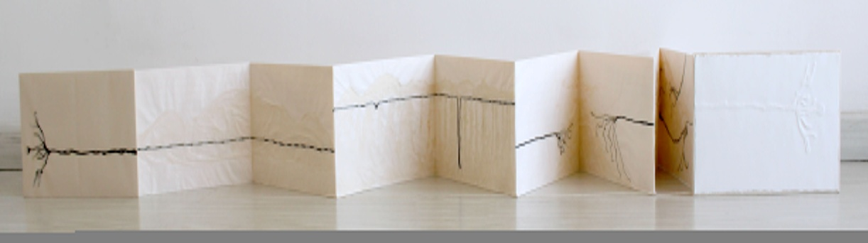
Ana Maier – Epiderme da paisagem (2011)
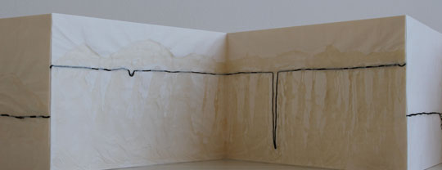
Ana Maier – Epiderme da paisagem (2011) – detail
For a few years I stayed away from the studio to work as a teacher in Brazilian schools. I also taught workshops on art in Brazil and Germany. Only after returning to my country, I resumed the relationship between art and biology by changing the meaning of my images. The mix of urban landscape with nature in the city of Rio de Janeiro caused me to reflect about the symbolic relationship of the fluidity of the sea that restricts the territories inhabited by man.
In 2010, through free courses at the School of Visual Arts of Parque Lage, I explored the aspect of immortality of the Evergreens, to express dialectics like detail and whole, micro and macro, inner and outer spaces, still life and rebirth. This theoretical and practical deepening resulted in a master’s degree at the State University of Rio de Janeiro (UERJ) in 2013. My thesis discusses my poetic operations by deconstructing territories and their borders, so that they always can be reinvented, even on an imaginary level only.
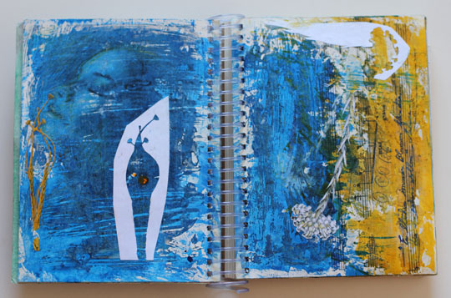
Ana Maier – sketchbook
What is your chosen medium and what are your techniques?
Regardless of the medium I choose to express a particular idea, there is always a three-dimensional context or concept of a book, even in the videos. It’s not something planned, it just happens at a certain moment in the creative process. I think the traditional sculpture category applies only to my early work, still produced during the graduation. I prefer to classify the latest series by themes, e.g. cartographies, or as objects. Some pieces approach the concept of installation by having flexible dimensions or by being thought of as site-specific.
In my working process, the expression of an original idea is enhanced through the manual work, even if third parties perform some steps and some elements are bought at antique shops. However, I realize that there is some resistance in the academic world against the usage of craft techniques and textile fibers for the construction of artworks. I always need to research and invent my own methodologies, because I want to work with unconventional materials, e.g. reusing industrial waste. I believe that this dialogue with the past serves to question the contemporary, to reflect upon changes. So I can communicate concepts related to virtual technologies and their networks, e.g. exploring the symbolic and historical meaning associated with weaving.

Replaced by new technologies
How would you describe your work and where do you think it fits within the sphere of contemporary art?
My motivation is essentially autobiographical, but under the impact of contemporary issues related to mobility and to a redefinition of space and time caused by new communication technologies and the dynamics of globalization. When using manual techniques, I question the increasing mechanization of production processes and seek to express concepts that go beyond the individual sphere.
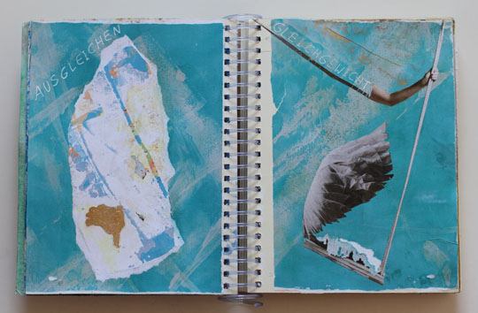
Ana Maier – Sketchbook
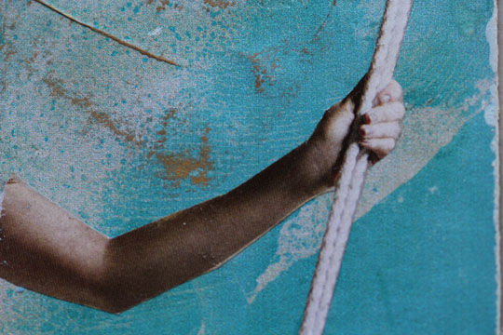
Ana Maier – Sketchbook (detail)
The first step was to realize that paper and fabric have a lot in common because of the fibers. And most importantly, they don’t need to be organized according to a specific standard, as in the industry. But they can be arranged randomly, as in the manual process of making paper crafts. I researched these handicrafts and learned that a free ordering of fiber generates structures and surfaces without defined limits, allowing me to interconnect papers, fabrics and lines continuously over a three-dimensional construction. And that’s what enabled me also to integrate old objects in my latest work, which have lost their original function because they were replaced by new technologies. To retrieve identities and emotional memories, I take iron tools used in the past to prepare food at home, e.g. a meat grinder moved by a crank.
This led me to the next step: the ability to access symbolic meanings associated with weaving and real contact networks between people, just poetically changing the meaning of the objects. That is what I mean to refer to when passing a map through a meat grinder. It is not only to the change what happens to territories, but mainly to explore the consequences for the people who occupy them.
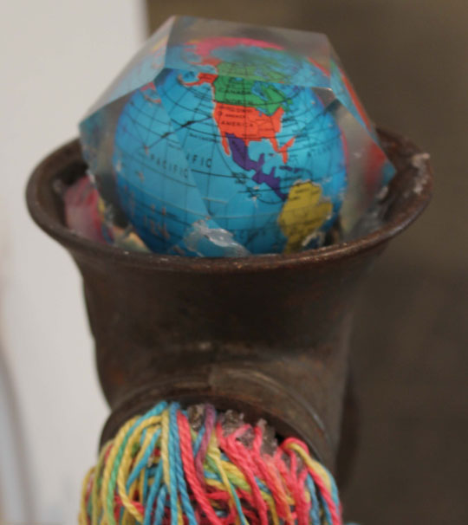
Ana Maier – Roca de fiar distâncias II (2012) – detail
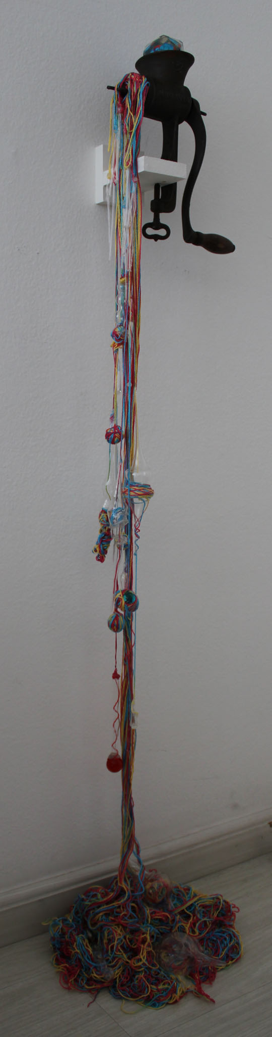
Ana Maier – Roca de fiar distâncias II (2012)
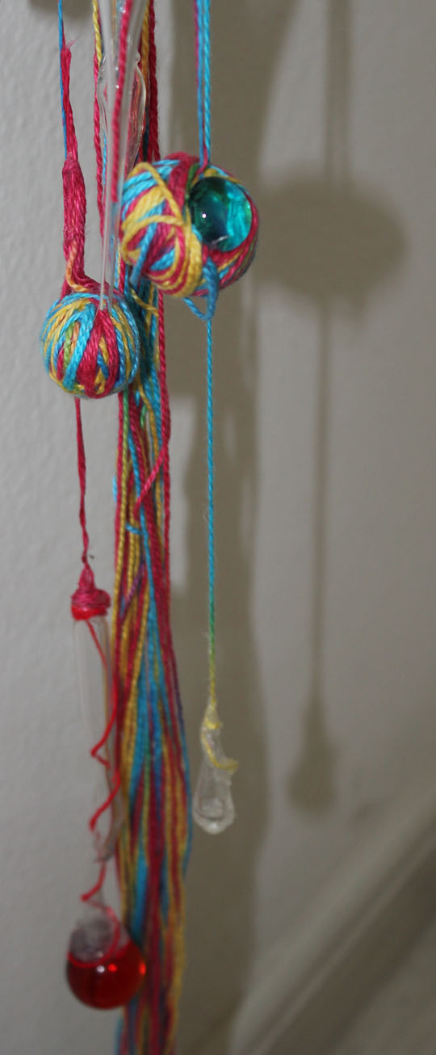
Ana Maier – Roca de fiar distâncias II (2012) – detail
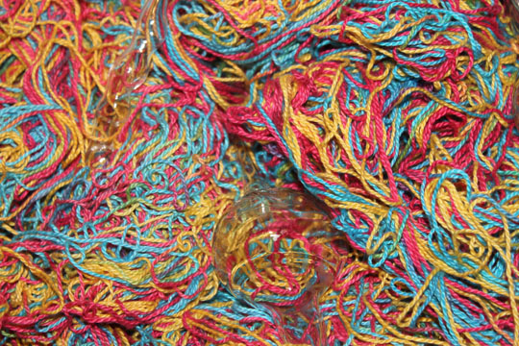
Ana Maier – Roca de fiar distâncias II (2012) – detail
Tell us a bit about your process and what environment you like to work in.
I understand the line as an essential element of fable. Especially the skyline, which is a human invention and does not exist in nature. This fictive line has a symbolic power to activate the desire for what is beyond our visual field, as it moves us in the search of new horizons and unknown territories. So I try to live in high places, where I can have a wide view from the window. I like the contrast of a quiet studio environment, with white walls, situated in the middle of an urban landscape, visually chaotic and in constant reconstruction. When I go out and realize the noise of the streets, the incessant movement of people and vehicles, I feel that life is pulsing out there with an intensity, that I try to take into my work. I need to recharge myself with that energy to deal with the isolation that is necessary for immersive moments in artistic practice. These realities are different but only to some extent, because they move in parallel. I seek keeping my balance in an imaginary line connecting these individual and collective experiences. Whenever I finish a piece, I feel that it is a synthesis of all the previous ones. This causes a reinterpretation of the entire process due to new discoveries.

Ana Maier – Work in progress, Rio de Janeiro 2012
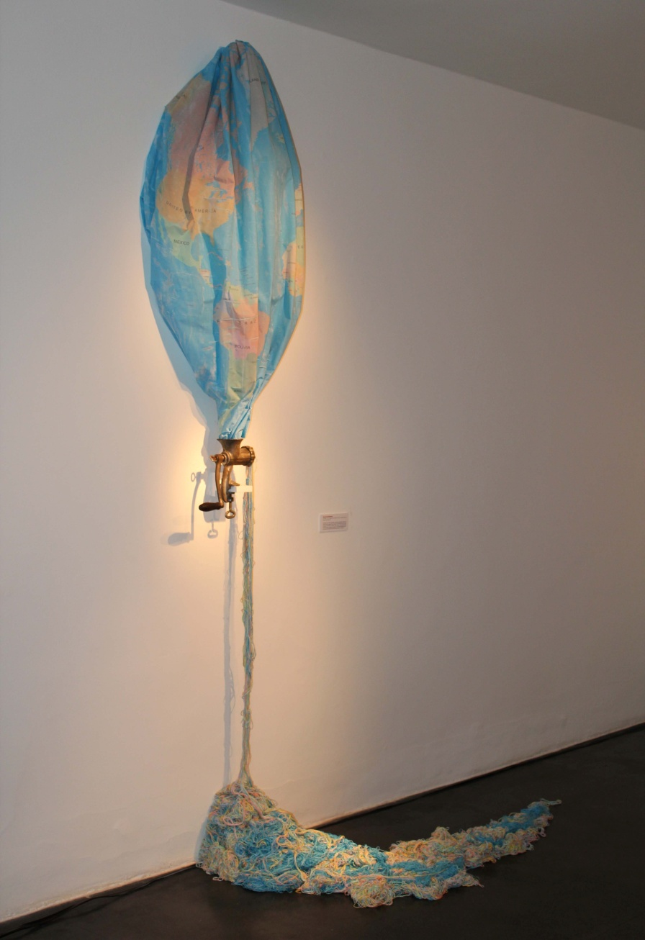
Ana Maier – Roca de fiar distâncias (2012)
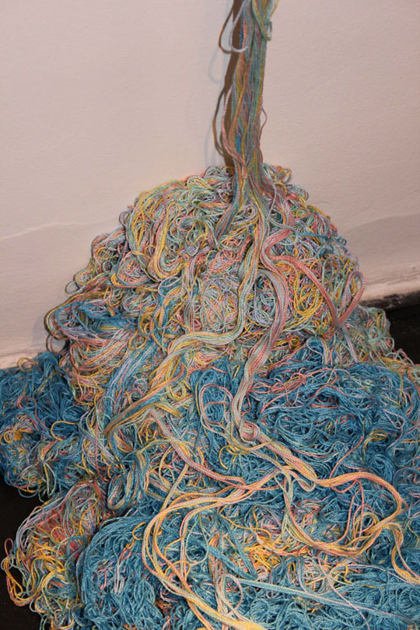
Ana Maier – Roca de fiar distâncias (2012) – detail
Do you use a sketchbook?
I have the habit of sketching or writing down my ideas on single sheets of paper, which I keep in a drawer attach them to walls and reorganize at every new idea. Only recently I started to use sketchbooks as notebooks with spirals, so that I constantly can change the sequence of the pages and insert new drawings among the old ones, which generates permanent re-interpretations. This reflects better my natural rhythm of working.

Intriguing dialogues
What currently inspires you and which other artists do you admire and why?
Currently, I live in São Paulo, one of the largest metropolises in the world. I was born in Belo Horizonte and lived in Rio de Janeiro, two of the top three most populated cities of Brazil. I also lived near Stuttgart, in Germany, and traveled to some big cities in Europe. Despite the similarities between all these major cities, I am always surprised when being confronted with the solutions that human being develops to live with the differences and how to adapt to the environment. This makes each single city unique. The unpredictability of the landscape is the main reference for my current artistic process.
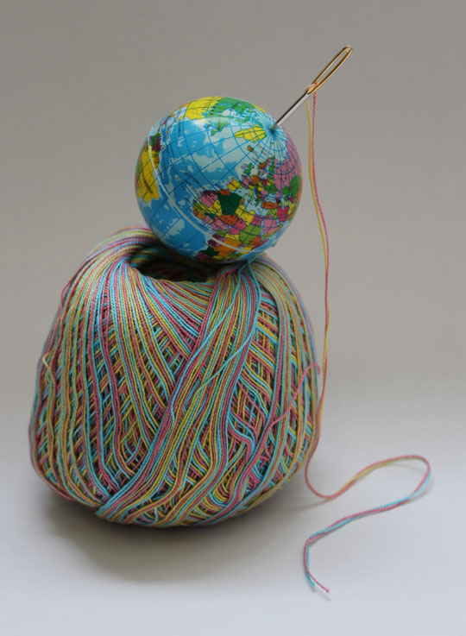
Ana Maier – Ovo de cerzir histórias (2013)
My artistic references are so many that I find it hard to name some.
I admire the sculptors of earth art like Robert Smithson, Richard Long, Andy Goldsworthy, and also Christo & Jeanne Claude, Richard Serra and Anish Kapoor. The ability to reframe objects as in the work of El Anatsui and Faig Ahmed also fascinates me.
From Brazil, I find myself inspired by those artists who have researched the line, as Lygia Clark, Edith Derdik, Georgia Kyriakakis, Iole de Freitas, Elisa Bracher, Adrianna Eu; artists who have a poetic eye on everyday life, like Wilma Martins and Nino Cais; artists that work with crossing territories, like Alberto Martins and Henrique Oliveira. And artists who establish intriguing dialogues about the human situation like the brilliant Arthur Bispo do Rosário, or Znort, from the new generation of artists.
How has your work developed since you began and how do you see it evolving in the future?
My initial theme was strongly influenced by issues relating to life cycles, the theory of evolution and the metamorphosis process on a human scale. I even did two solo exhibitions at the end of my graduation. But the maturation of the concepts was enhanced during the period abroad and was consolidated with the master’s degree. The impact of other cultures on my perception of the world made me recognize and incorporate symbolic concepts into my artwork associated with my laboratory experiences with Evergreen flowers.
In late 2014 I moved to São Paulo and decided to dedicate myself full-time to studio work. The neighborhood where I live is a cultural concentration, close to major museums and galleries. I am currently with several projects in progress, including objects and two installations with lines and Evergreens.

Read, study, travel, and pay attention
What advice would you give to an aspiring textile artist?
Respect your natural rhythm and poetic maturation, without letting the art system overrun and direct your artistic process. See art, read a lot, study, travel, pay attention to small everyday events. And always draw.
Can you recommend 3 or 4 books for textile artists?
All the books by Keith A. Smith about binding alternative techniques for creating book-objects. Also,
- Six memos for the next millennium, Italo Calvino
- The practice of everyday life, Michel de Certeau
What piece of equipment or tool could you not live without?
I could not live without being surrounded by books and plants and could not work without a sewing machine, a photographic macro lens, and my laptop.
Do you give talks or run workshops or classes?
I am updating my workshops to teach soon in Sao Paulo.
Where can readers see your work this year?
Right now I have an exhibition project with another Brazilian artist, Eglair Quicolli, who also investigates the line and its possibilities. The exhibition is scheduled for the second half of 2015 in Sao Paulo. The place and date will be announced on my website.

