McDonald's drinks concept given eye-popping packaging

This concept design sees fantasy hot drink flavors given their own packaging designs.
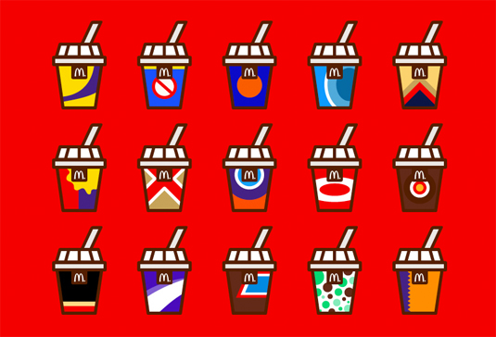
The packaging designs take their inspiration from chocolate bars
There's no denying that McDonald's is one of the most influential brands in the retail world; creating one of the most iconic brand mascots, the company are also a forerunner when it comes to an outstanding use of color in branding. So, it's no surprise that their designs inspire many-a-concept, with this latest venture an example in eye-popping color.
Discover the biggest logo designs of 2015 so far
"I thought it would be cool to develop some of my very own McDonald's hot drink designs but in a more abstract and simplistic style, developing flavors I would love to drink." explains graphic designer Jonathan Quintin.

Featuring UK chocolate bar favorites, Quintin has taken aspects of the bar's packaging, incorporating the coolers and sometimes shapes into the hot beverage designs. We love the minimal inspiration throughout the concepts, with the cup designs very much in line with McDonald's usual executions. A few of our favorites are showcase below; you can see the whole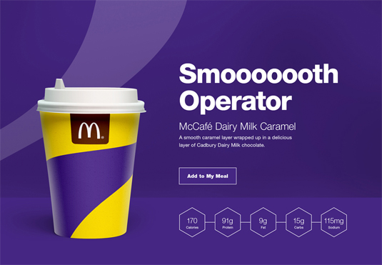 series over on Behance.
