**Meeting Report**

**Strengthening Commercialization Offices of Universities (ORICs) in KP Province of Pakistan**

By SATHA, IRP and ORIC, UET Peshawar

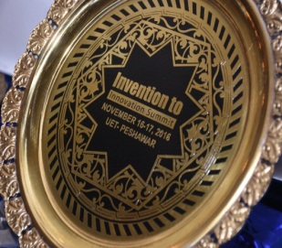**South Asia Triple Helix Association (SATHA)**

South Asia THA (SATHA) Chapter has been established at University of Management and Technology (UMT) to promote regional S&T and economic development through enhanced coordination and networking among University-Industry-Governments (UIG). **SATHA**-South Asia Triple Helix Association is a chapter of **THA**-International Triples Helix Association for the promotion and policy advocacy of science, technology and innovation.

**Institute of Research Promotion (IRP)**

Institute of Research Promotion (IRP) has been established to provide services in research related activities to promote quality research culture in the universities and corporate sector of Pakistan. IRP is a non- profit organization working under the guidance and cooperation of researchers of academia and industry. IRP, on one hand, is bridging the gap between the universities, research institutes, public and corporate sector and developing the culture of creating and sharing knowledge on the other.

**Innovation Summit**

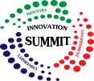The impactful venture of Innovation Summit is an annual two-day event held in all provincial capitals of Pakistan to exhibit industry driven ideas, products and technologies. It provides free of cost opportunity to network with innovation leaders, potential investors and commercial partners. Event is cordially attended by academia, industry, government and non-government officials and profoundly appreciated by intellectuals. In order to promote, encourage and revitalize the culture of innovation, sash awards and souvenirs are presented to viable technologies and innovative ideas.

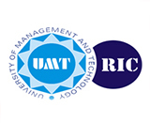**ORICs of KP**

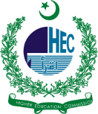ORIC (Office of Research, Innovation and Commercialization) are set up in universities under the guidelines and accreditation by Higher Education Commission (HEC), Pakistan, to link research with industry. The job of ORICs is to supply technology to industry from universities and develop enabling environment for it.

***Report Developer:*** *Aafia Khalid, Coordinator SATHA*

***Editor:*** *Rahmat Ullah, Secretary General SATHA*

***Co-Editor:*** *Dr. Rashida R. Zohra, In-charge Annual Innovation Summit- IRP*

Meeting was held as part of

**2nd Invention to Innovation Summit, KP**

University of Engineering and Technology, Peshawar

November 16-17, 2016

**Date:** November 16, 2016 – **Time:** 03pm-05pm

**Participants:** Directors and representatives from ORICs of KP

**Program**:

* Welcome address by Dr. Awais Adnan, Director ORIC, IM Sciences
* Presentation on “THA Entrepreneurial University Framework to Strengthen ORICs” by Rahmat Ullah General Secretary SATHA – South Asia Triple Helix Association
* Presentation on “Role of IPR to Strengthen ORICs for Technology Transfer” by Saad Nasrullah, Director Hamayuns IP Consulting
* Presentation on “Strengthening ORICs International Linkages”, by Ghulam Abbas, ECO Science Foundation (ECOSF)
* Industrial presentation by Mr. Sami Yazdani, Manger, Pakistan Chemical Manufacturers Association (PCMA)
* Highlights of ORICs progress and discussion
* Address by session chair, Dr. Abid Latif, Advisor R&D, Higher Education Commission of Pakistan(HEC)
* Vote of Thanks by Dr. Saeed Gul, Director ORIC, UET Peshawar.

**Minutes of the Meeting**

A session regarding Challenges and Opportunities for ORICs was conducted in the Invention to Innovation Summit 2016 at UET Peshawar on 16.11.2016 at 3 pm to 5.30 pm. The Session was chaired by Dr. Muhammad Latif, Advisor R&D HEC Islamabad in the presence of director ORICs from KPK institutions.

Mr. Rahmat Ullah, Chief Coordinator, IRP Lahore, presented in detail as how to create the required awareness in academic sector and motivate the researcher to win the confidence of the industries. He further explained the dynamics of an “Entrepreneurial University Framework” and how an entrepreneurial environment can set the foundation stone of a culture to pave the path for the promotion of technology transfer. He constantly stressed upon the strengthening of linkages between three representatives of Triple Helix Model which are Academia, Industry and Government respectively.

Mr. Saad Nasrullah, Director Hamayun’s IP Consulting, emphasized the role of Intellectual Property Rights (IPR) to strengthen the ORICs for technology transfer. He explored and analyzed various important aspects of patenting and commercialization. The presentation was succeeded by Mr. Ghulam Abbas, ECO Science Foundation (ECOSF) who emphasized upon international linkage development of ORICs and its long term benefits.

Mr. Sami Yazdani, presented the roles and objectives of Pakistan Chemicals Manufacturer Association in the light of research and development. He stressed the academic sector to opt for societal need based projects for research and briefed about their commercial value.

**Discussion and Recommendations**

During the group discussions session, Prof. Rashid Ahmad, Director ORIC, University of Malakand raised the point that the research environment will be enhanced only if the industries, throughout the country, are bound to reserve a minimal portion of their earnings for research and development activities.

Endorsing the above mentioned suggestion, Dr. Saeed Gul, Director ORIC, UET Peshawar urged that the industry must play its due role in establishing research institutions relevant to their production lines.

Dr. Muhammad Latif, Advisor R&D, HEC Islamabad highlighted the relevant issues to bridge the gap between research and development activities. He pointed out that in the past, HEC had been focusing on activities for raising academic research standards; which it accomplished successfully. Now acknowledging the importance of applied research and its dimensions, HEC has started certain programs and is planning to do more to engage industry with academia. Policies for such developmental programs have been devised and will surely welcome the input of ORICs in this regard.

Dr. M. Latif added that HEC has formulated an Innovation Steering Committee wherein experts from all the industries will be framing strategies for ORIC setups and in the light of their recommendations; the performance of universities will be evaluated. He suggested that all these points will be compiled and submitted to HEC for their future planning considerations.

The ICT R&D representative (Mr. Ali Iqbal) said that we have to remove the ambiguities from the alliance of industry and academia by ensuring that our researchers are more responsible and committed towards resolving their day to day problems in a better and cost effective manner.

Mr. Azhar Afridi, Manager Research Operations, University of Peshawar emphasized the need of proper marketing of the research and innovative accomplishments of universities to relevant stake holders in order to grab maximum investments. He also highlighted that information of academic discoveries and innovations must be spread in society effectively.

Dr. Jehangir, Director ORIC, University of Haripur, emphasized the need of developing cost effective solutions for the local industries by ORICs.

Dr. Shafiq ur Rehman, Director ORIC, KUST, Kohat, appreciated UET Peshawar, IRP and other collaborative partners and hoped that such events will pave the way for research oriented environment in the academia resulting a better economic growth.

Dr. Saeed Gul, while appreciating all the points raised by the session informed that ORIC in UET is working on the same lines and has developed a new slogan for ORIC i.e. from Concept to Market which will involve academia to find out the legitimate answers to the challenges of the day.

Dr. Awais Adnan, Director ORIC, IM Sciences, informed that a unified forum for ORICs working has been formed in KP under the umbrella of IM Sciences and it is encouraging all the participants to regularly join the meetings and contribute to the cause of building a nation through innovation.

It was unanimously approved that all the ORIC heads of the province should hold meetings on regular basis so that a joint working relationship is adopted to settle the contemporary problems of industry.

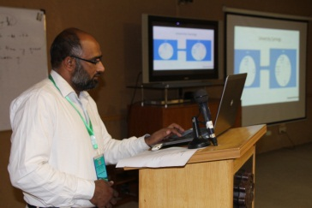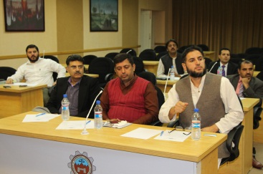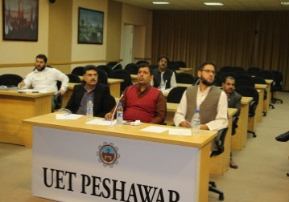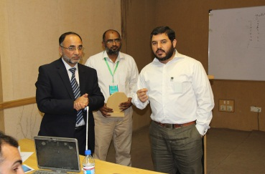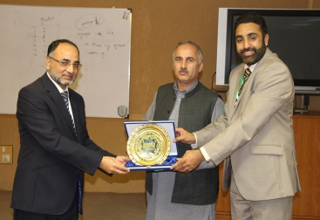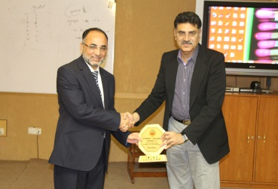

**Souvenirs Distribution to Guests and Participants of Session**