**Meeting Report**

**Strengthening ORICs for**

**Trust Building between Industry and Institutions**

By SATHA, IRP and ORIC, University of the Punjab Lahore

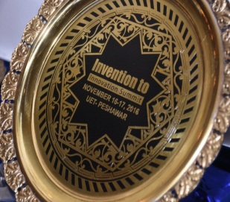**South Asia Triple Helix Association (SATHA)**

South Asia THA (SATHA) Chapter has been established at University of Management and Technology (UMT) to promote regional S&T and economic development through enhanced coordination and networking among University-Industry-Governments (UIG). **SATHA**-South Asia Triple Helix Association is a chapter of **THA**-International Triples Helix Association for the promotion and policy advocacy of science, technology and innovation.

**Institute of Research Promotion (IRP)**

Institute of Research Promotion (IRP) has been established to provide services in research related activities to promote quality research culture in the universities and corporate sector of Pakistan. IRP is a non-profit organization working under the guidance and cooperation of researchers from academia and industry. IRP, on one hand, is bridging the gap between the universities, research institutes, public and corporate sector and developing the culture of creating and sharing knowledge on the other.

**Innovation Summit**

****The impactful venture of Innovation Summit is an annual two-day event held in all provincial capitals of Pakistan to exhibit industry driven ideas, products and technologies. It provides free of cost opportunity to network with innovation leaders, potential investors and commercial partners. The event is cordially attended by academia, industry, government and non-government officials and profoundly appreciated by intellectuals. In order to promote, encourage and revitalize the culture of innovation, cash awards and souvenirs are presented to viable technologies and innovative ideas.

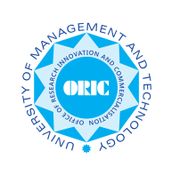**ORICs**

****ORIC (Office of Research, Innovation and Commercialization) are set up in universities under the guidelines and accreditation by Higher Education Commission (HEC), Pakistan, to link research with industry. The job of ORICs is to supply technology to industry from universities and develop enabling environment for it.

***Report Developer:*** *Aafia Khalid, Coordinator SATHA*

***Editor:*** *Muqaddas Tariq, Institute of Research Promotion*

Meeting on

**Strengthening ORICs for**

**Trust Building between Industry and Institutions**

**Date: March 9, 2017 – Venue: Committee Room, Al-Razi Hall - University of the Punjab, Lahore -- Time: 11am-03pm**

​As a part of

**6th Invention to Innovation Summit**

**Buy and Sell Technology**

University of the Punjab – March 8-9, 2017

**Program**

|  |  |
| --- | --- |
| **Time** | **Addresses/Presentations** |
| **11:00 – 11:10** | Welcome by **Prof. Dr. Tahir Jameel**, Director ORIC-PU |
| **11:10-11:30** | Presentation on “SATHA Entrepreneurial University Framework and Trust Building Measures” by **Rahmat Ullah**, Secretary General SATHA |
| **11:30-11:50** | Presentation on “ECOSF for S&T Support and Regional Integration” by **Ghulam Abbas**, Program Manager ECOSF (ECO Countries Science Foundation) |
| **11:50-12:10** | Industrial Case Study on "Industrial Growth of SRC and Opportunities for Academia to be Growth Partners" by **Mr. Abrar Ahmad** CEO, SRC Pvt Ltd. |
| **12:10-12:40** | Presentation on “Role of IPR to Strengthen ORICs for Technology Transfer” by **Mr.** **Saad Nasrullah**, Director Hamayuns IP Consulting and **Mr.** **Ghulam Mujtaba**, IPO Pakistan |
| **12:40-01:10** | Industrial Case Study on "Industrial Growth of Diamond Jumbolon and Opportunities for Academia to be Growth Partners" by **Eng. Nisar Mohyuddin** GD, Diamond Jumbolon Industries |
| **01:10-2:00** | Highlights of ORICs by Directors of ORICs – Open Discussion |
| **2:00-2:10** | Final Recommendations |
| **2:10-2:20** | Address by Guest of Honor |
| **2:20-2:30** | Address by Session Chair |
| **2:30-3:00** | **Lunch** |

**Highlights of Open Discussion by the participants and speakers**

Session chair: Prof Dr. Tahir Jameel, Director ORIC University of the Punjab.

Opening note Session chair: Everyone should resolve our weaknesses and negative points by making common grounds and consensus

**Suggestions from the participants** (These are the random points and proposals by the meeting participants on, how to make ORICs more trustable, organized and strengthened)

1. While planning the research or any invention, future needs must be kept in view.
2. Emphasis should be more on practical work rather than theory only.
3. Frequent industry visits and frequent internships to industry should be planned.
4. Teachers PER and Industry ranking must be based on mutual linkage and projects.
5. Industry academia and Govt. should team up for cutting edge initiatives to bring the substantial impact on economy.
6. We should think out of the box, and must work in associations with academic institutions as well as with industry and R&D organizations by:
7. Developing industry university partnership
8. Encouragement to need based research
9. Provision of Enabling research environment
10. Consistency required for success
11. There should be a review and analysis of the outcomes of previously done work/efforts/investments.
12. Causes of failure should be found out and rectified by follow up meetings.
13. Selection criteria of ORIC directors should be based on his /her extensive research experience, communication skills, grooming, industrial linkages, innovation management etc.
14. ORIC directors should not be appointed to an additional charge.
15. ORIC directors/focal persons/facilitators should be recognized and disseminated to all stakeholders (universities, funding agencies, industries and chambers).
16. ORIC directors must have such communication skills to be known well by their working, even in their own faculty and University doesn’t know well about the ORIC and they don’t trust.
17. ROI (return on investment) concept should be propagated.
18. There must be arranged some trainings /preferably foreign trainings for ORIC directors.
19. ORIC must know the capability of its entire faculty i.e. who can coordinate with industry and to which specific industry (expertise of faculty must be in knowledge).
20. There could be faculty sharing with industry, Industry persons may take visiting lectures in Universities. Similarly, industry experts should also be involved in curriculum design of academic degrees (particularly applied sciences, engineering etc.).
21. This type of sessions (Like ORIC session and other expert discussion sessions) should also be held in Chambers and industries along with universities.
22. An accessible data base of need based projects should be there for researchers. Similarly, the international research reciprocity should also be made available by ORICs.
23. Academia when communicated about industry projects/problems, they should own them.
24. Relevant problems should be shared with relevant people/organizations
25. We should emphasis on the use of satellite based information and should move along with the speed of IT based technologies in our routine.
26. The culture of sharing should be promoted, if one University or ORIC have low capability or not having much facilities to execute some projects, they must share/refer projects with other universities and developed ORIC/Universities must help them. Also, faculty should be guided by the IP rights and IP policies so that they may not be reluctant in sharing the research activities and ideas with each other.
27. Model ORICs should be followed and model ORICs should share resources with low capability Universities.
28. The process of providing research and outreaching facilities by ORIC to the Univ. faculty and researchers should be without delays and long processes.
29. Universities and ORICs must focus on the improvement of faculty profile to overcome communication gap between all researchers as well as between researchers and industry (No proper and complete profiles of Professors’, researchers and even industry people are available to know their expertise and area of interest to contact them back).
30. Alumni network should be strengthened for more linkages and outreaching (either alumni are working inside country or abroad)
31. Should convince Public sector/Govt. organizations to amend their policies to make strong linkages between ORICs and industry. The faculty or employees who are contributing more towards applied research should be acknowledged and must be given extra weight for their efforts during their evaluation.
32. Sci-Tech and education budgets should be enhanced on a priority basis.

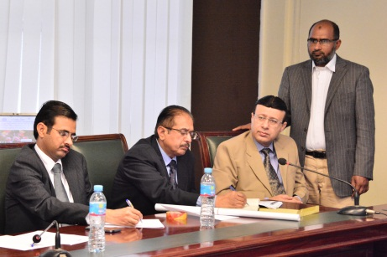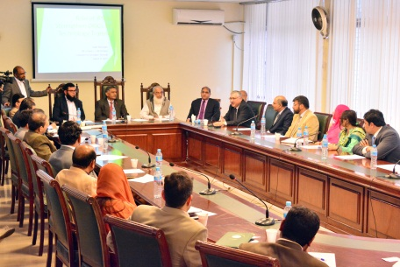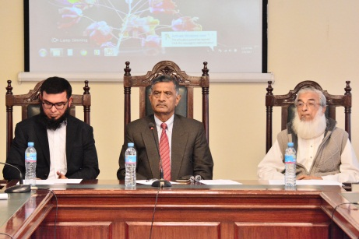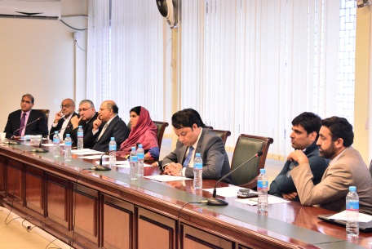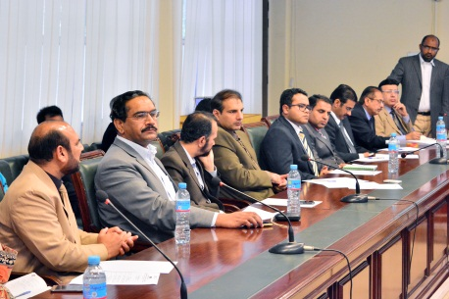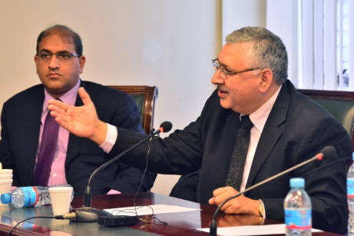

**Participants of the ORIC Session**