SATHA Report
As a part of
6th Invention to Innovation Summit
University of the Punjab, Lahore
March 8-9, 2017

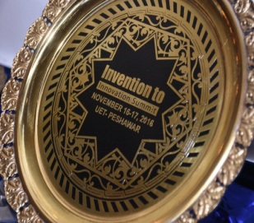
South Asia Triple Helix Association (SATHA)
South Asia THA (SATHA) Chapter has been established to elicit regional growth and economic development through enhanced coordination and networking among University-Industry-Governments (UIG). SATHA-South Asia Triple Helix Association is a chapter of THA-International Triples Helix Association for the promotion and policy advocacy of science, technology and innovation.

SATHA Innovation Award
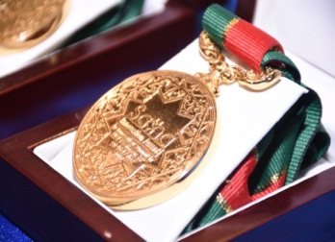
SATHA as part of international innovation network offers "SATHA Innovation Awards" to the people who contribute substantially to science, technology, social and public sector. Such innovative case studies of people are nominated which positively impacted the organization or human life. SATHA Innovation Award is an international award by South Asia Triple Helix Association as a Part of International Triple Helix Association.

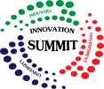
Invention to Innovation Summit
Invention to Innovation Summit is an annual event to exhibit industry driven ideas, products and technologies in Pakistan. The summit provides a great opportunity to network with innovation gurus, find commercial partners, promote technology and link your idea with stakeholders.

Report Developer: Aafia Khalid, Coordinator SATHA
Editor: Rahmat Ullah, Secretary General SATHA

Networking Dinner and SATHA Innovation Award

Date: March 8, 2017 – Venue: University of Management and Technology (UMT), Lahore – Time: 07pm-09pm
As a part of 6th Invention to Innovation Summit, Punjab
March 8-9, 2017 in University of the Punjab, Lahore.
Program
- Arrival of Guests and Seating
- Recitation of Verses from the Holy Quran
- Welcome Address by Abid H K Shirwani, President SATHA / DG UMT
- Address by Prof. Dr. Tahir Jameel, Director ORIC University of Punjab

- Industrial Case Study on "Industrial Growth of Kay & Emms Textile and Opportunities for Academia to be Growth Partners" by Dr. Khurram Tariq, CEO, Kay & Emms (Pvt) Ltd.
- SATHA Innovation Awards Distribution
- Presentation by Antti Johannes Kaskinen, Founder and CEO of KOULU Group, Area Director (MEA), Benecol Division, Business Controller, Food Division, Northern Europe on “Finnish Education System Promoting Innovation”

- Address by Dr. Akram Shaikh, DG PASTIC

- Address by Mr. Awais Raoof Chairman, University of Lahore
- Address by Guest of Honor Prof. Dr. Talat Naseer Pasha Vice Chancellor, UVAS Lahore
- Vote of Thanks
- Dinner

SATHA Networking Dinner, Lahore
SATHA innovation Awards were given on the occasion of networking dinner of 6th Invention to Innovation Summit in University of the Punjab, Lahore. This networking dinner brings all the innovators together in a close network that establishes linkage between them and promotes the thriving idea of a progressive society.
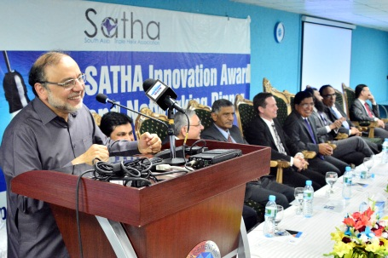
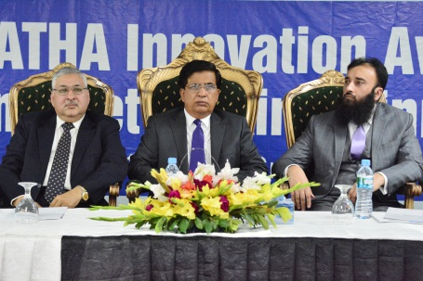
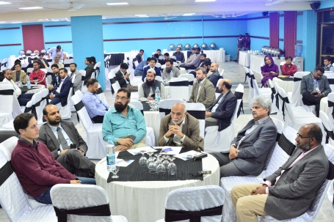
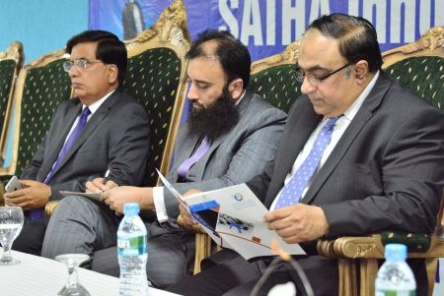
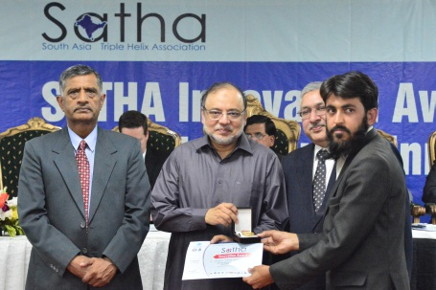
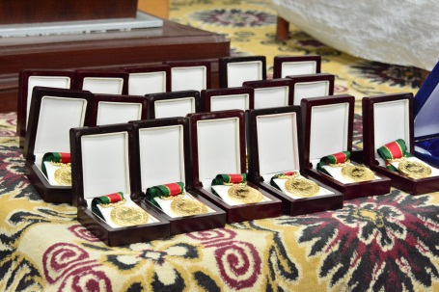

Summary Highlights of Speakers
- All the distinguished guests appreciated SATHA Award initiative especially its transparent conduct of award assessment. The elevated and decisive value of award was generously applauded on account of zero registration fees and zero cost from the winners. This guaranteed the merit of awards.
- The speakers endorsed their commitment for next year initiatives of SATHA for science, technology and innovation. SATHA platform can be used in future to network the society and promote triple helix in Pakistan.
- Academic speakers appreciated that scientists working to solve community and industry problems are acknowledged and rewarded. In academia, there is a lot of recognition for academic publishing and patent. SATHA has rightly taken the initiatives to reward those who do innovative venture and solve problems of the country.
- Government speakers acknowledged SATHA and offered their support for triple helix program in Pakistan. Govt. is keen to participate in this growing concept of university-industry linkages. Govt. has been trying to flourish such work.
- Industrialists presented their growth case studies and suggested ways of how academia can avail opportunities to become their growth partners. Industry people eagerly expressed their keen interest to participate in triple helix program and promised to actively get engaged in future SATHA program. Industry acknowledged that through SATHA award, industry innovators are also recognized and rewarded. Industry speakers encouraged academia to focus on problem solving research and relevant innovation. The industry is ready to cooperate for economically viable projects.
- UMT management thanked the participants, offered same commitment of hosting SATHA innovation award for upcoming progressive years.

The Winners of SATHA Innovation Award in 6th Invention to Innovation Summit Lahore
- Dr. Muhammad Asif Zahoor for Introducing an Indigenous ELISA to detect Humoral Immunity against Measles
- Dr. Muhammad Imran for Introducing Waste Heat and Low Grade Heat Recovery from Energy Intense Industries
- Diamond – Jumbolon Symbol Industries ( Pvt) Ltd for Producing Thermal Insulation Material for Buildings
- Dr. Waqas A. Qazi for Using Satellite Imagery for Crop Acreage and Health Assessment.
- Hussan Bin Iqbal for Developing Disaster Management Information System
- Muhammad Azeem Ashraf for Developing a Bio Mass Gasifier
- Usman Ali for Developing Smart Power Management System
- Muhammad Naveed Ashraf for Developing Synthesis and Plant Designing of CPC Pigment
- Shahid Lone for Establishing Allah Waley Trust
- Ammar Tarin for Establishing Kawish Welfare Trust
- Mr. Nisar Ahmad for Establishing Human Appeal International
- Syed Farooq Ali for Developing Optical Mark Recognition
- Emmen Farooq for Developing Management Information System for Local Hospital
- Dr. Ikram-ul-Haq for Production of Bioenergy from Plant Biomass
- Prof Dr. Saeed Akhtar for Mango Industrial Waste Management for the Production of Value-Added Food Products
- Amri, Multan for production of Soilage Bailer
- Dr. Abdurrahman for developing multifunctional Drill machine
- Dr. Adeel for fabricating air dried bricks
- Rana Usman for developing virtual dressing room
- Waseem Ahmad for developing Di-Nero, a diagnostic sensor device for the diabetic patients
- Kiran Zafar for Producing Wall Papers And by Recycling of Waste Paper
- Dr. Tayeb for Manufacturing Biolostic Gun as Gene Transformer in Plants
- Rafae Engineering for Developing Caustic Recovery System
- M.Usman for Developing Automatic Remote Sensing Weather Station

