SATHA Report
As part of
2ndInvention to Innovation Summit, KP
University of Engineering and Technology, Peshawar
November 16-17, 2016

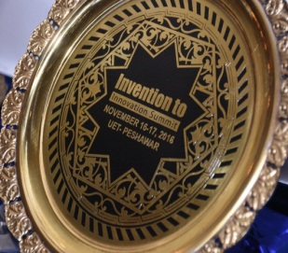
South Asia Triple Helix Association (SATHA)
South Asia THA (SATHA) Chapter has been established to elicit regional growth and economic development through enhanced coordination and networking among University-Industry-Governments (UIG). SATHA-South Asia Triple Helix Association is a chapter of THA-International Triples Helix Association for the promotion and policy advocacy of science, technology and innovation.

SATHA Innovation Award
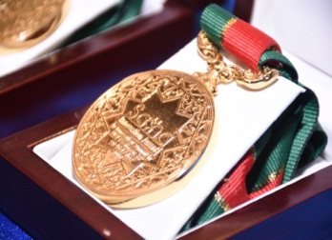
SATHA as part of international innovation network offers “SATHA Innovation Awards” to the people who contribute substantially in science, technology, social and public sector. Such innovative case studies of people are nominated which positively impacted the organization or human life. SATHA Innovation Award is an international award by South Asia Triple Helix Association as Part of International Triple Helix Association.

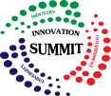
Invention to Innovation Summit
Invention to Innovation Summit is an annual event to exhibit industry driven ideas, products and technologies in Pakistan. The summit provides great opportunity to network with innovation gurus, find commercial partners, promote technology and link your idea with stakeholders.

Report Developer: Aafia Khalid, Coordinator SATHA
Editor: Rahmat Ullah, Secretary General SATHA
Co-Editor: Dr. Rashida R. Zohra, In-charge Annual Innovation Summit- IRP

Networking Dinner and SATHA Innovation Award
by
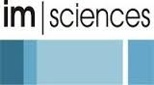
Date: 16th Nov. 2016 – Venue: IM Sciences – Time: 06pm-09pm
As part of 2ndInvention to Innovation Summit
November 16-17, 2016 in UET Peshawar
Program
- Arrival of Guests and Seating
- Recitation of Versus of the Holly Quran
- Welcome Address by Prof. Dr. Muhammad Mohsin Khan, Director IM Sciences
- Address by Abid H K Shirwani, President SATHA
- Keynote Address by Khalid Saleem Malik, Ex Chairman, Pakistan Poultry Association
“Poultry Industry Challenges and Academic Response”
- Innovation Award Distribution
- Address by Dr. Iftikhar Hussain, Vice Chancellor, UET
- Address by Ms. Nasira Taskeen, Director STEDEC
- Address by Dr. Khalid Khan Additional Secretary, Higher Education Department, KP
- Vote of Thanks by Dr. Muhammad Usman, Deputy Director IM Sciences
- Dinner

Contact: Adnan Ameen Khan -adnan.khan@imsciences.edu.pk - 0346-9429249

SATHA Networking Dinner, Peshawar
SATHA innovation Awards were given on the occasion of networking dinner of 2ndInvention to Innovation Summit, KP. This networking dinner brings all the innovators together in a close network that establishes linkage between them and promotes the thriving idea of a progressive society.
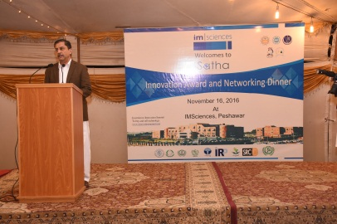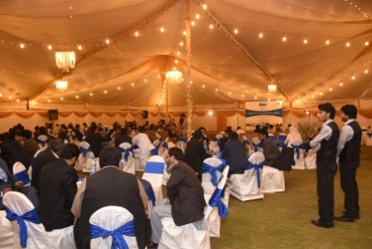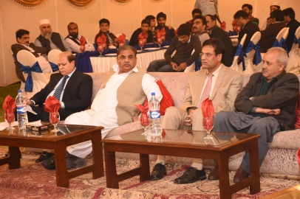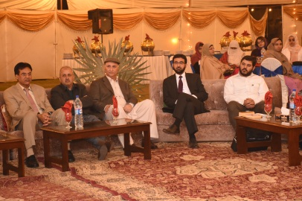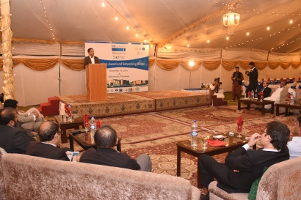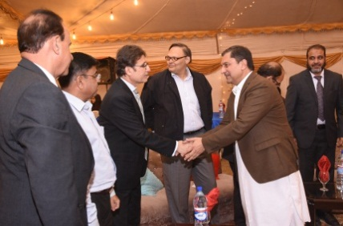

Summary Highlights of Speakers
- There was a warm welcome and appreciation of SATHA Award initiative by all the dignitaries and specially the transparent conduct of award assessment. The elevated and decisive value of award was generously applauded on account of zero registration fees and zero cost from the winners. This guaranteed the merit of awards.
- The speakers endorsed their commitment for next year initiatives of SATHA for science, technology and innovation. SATHA platform can be used in future to network the society and promote triple helix in Pakistan.
- Academic speakers appreciated that scientists working to solve community and industry problems are acknowledged and rewarded. In academia, there is a lot of recognition for academic publishing and patent. SATHA has rightly taken the initiatives to reward those who do innovative venture and solve problems of the country.
- Government speakers acknowledged SATHA and offered their support for triple helix program in Pakistan. Govt. is keen to participate in this growing concept of university industry linkages. Govt. has been trying to flourish such work.. Especially KP government has taken many similar initiatives in KP like setting up of DOST- directorate of science and technology, KP.
- Industry people eagerly expressed their keen interest to participate in triple helix program and promised to actively get engaged in future SATHA program. Industry acknowledged that through SATHA award, industry innovators are also recognized and rewarded. Industry speakers encouraged academia to focus on problem solving research and relevant innovation. Industry is ready to cooperate for economically viable projects.
- IM Sciences management thanked the participants, offered same commitment of hosting SAHA innovation award and proposed a dinner each year to recognize the innovators of KP Province, Pakistan.

The Winners of SATHA Innovation Awards in 2nd Invention to Innovation Summit, KP

- Soheeb Kiyani for Development of Shaving Blade for Leather Industry
- Hasnanin Qasim for Nano Filter Membrane
- Dr. Muhammad Shahid for Development of Choloroprene Rubber Adhesive
- Abdul Waseem for Real Time Wireless Power Transmission
- Dr. Jamil Ahmad for Conversion of solid waste into biofertilizer by EM technology
- Dr. Naveed Umer for Synthesis of Anti Tuberclulosis Activity of Lipophilic isonized derivatives
- Dr. Mumtaz Khan, Director ORIC Gomal for Turning Press Mud into Bioachar
- Mr. Naseer A. Khan for Improving performance of the Nitric acid plant
- Dr. Gul Muhammad for Electrical Power Technology
- Dr. Faisal Khan for Securing 3rd Position for Pakistan in an International Competition of Bio-Technology held in Boston, USA in 2016.
- Mr. Saboor Sethi for Peshawar Model Schools, Colleges and City University
- Fazal Hussain for Development Model Coal Mining
- Khalid Saleem Malik for development of good practices at Pakistan Poultry Association
- Dr. Saeed Ahmed for Poultry Association
- Mr. Athar Chaudhary for Micro-Hydro Turbines
- Sahib Zada Anees for Contribution to Social Sector

