SATHA Report
As part of
1st Invention to Innovation Summit, Sindh
University of Karachi
December 06-07, 2016

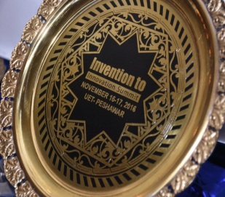
South Asia Triple Helix Association (SATHA)
South Asia THA (SATHA) Chapter has been established to elicit regional growth and economic development through enhanced coordination and networking among University-Industry-Governments (UIG). SATHA-South Asia Triple Helix Association is a chapter of THA-International Triples Helix Association for the promotion and policy advocacy of science, technology and innovation.

SATHA Innovation Award
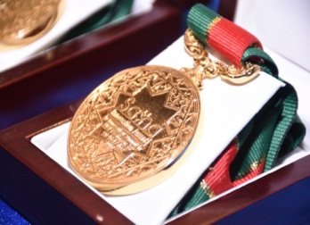
SATHA as part of international innovation network offers “SATHA Innovation Awards” to the people who contribute substantially in science, technology, social and public sector. Such innovative case studies of people are nominated which positively impacted the organization or human life. SATHA Innovation Award is an international award by South Asia Triple Helix Association as Part of International Triple Helix Association.

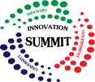
Invention to Innovation Summit
Invention to Innovation Summit is an annual event to exhibit industry driven ideas, products and technologies in Pakistan. The summit provides a great opportunity to network with innovation gurus, find commercial partners, promote technology and link your idea with stakeholders.

Report Developer: Aafia Khalid, Coordinator SATHA
Editor: Rahmat Ullah, Secretary General SATHA

 | Biotechnology Department | 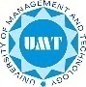

Department of Biotechnology, University of Karachi cordially invites you to
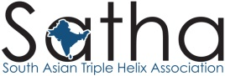
Innovation Award and Networking Dinner
Date: 6th December, 2016 – Venue: Karachi University – Time: 06pm-09pm
As part of 1st Invention to Innovation Summit, Sindh
Tentative Program
- Welcome by Dr. Raheela R Zohra, Head Biotechnology Department, University of Karachi
- Address by Dr. Aliya Rehman, Director ORIC, University of Karachi
- Introduction to SATHA by Rahmat Ullah General SATHA
- SATHA Innovation Award Distribution
- Keynote address on Technology from Lab to Market – Success Case Study of Date Palm Research Institute by Prof. Dr. G.S Markhand, Director DRI, SAL University, Khairpur
- Address by Lt. Col. Abdu Latif Dar, Secretary General, SITE Industrial Area
- Address by Mr. Shakil Hashmi, President Pakistan Business Forum (Karachi)
- Address by Muhammad Khalil Raja, Senior Vice Chairman Travel Agents Association of Pakistan
- Address by Prof. Dr. Khalid Iraqi, Dean Faculty of Management Sciences, University of Karachi
- Vote of Thanks by Dr. Saifullah, Assistant Professor, Department of Biotechnology., University of Karachi
Please confirm your registration with Muzammil – 0335-2906031 – muzammil52@hotmail.com

SATHA Networking Dinner, Karachi
SATHA innovation Awards were given in the networking dinner of 1st Invention to Innovation Summit, Sindh. This networking dinner brings all the innovators together in a close network that establishes linkages between them and promotes betterment of the society.
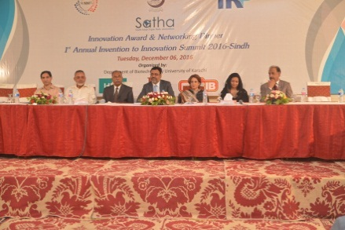
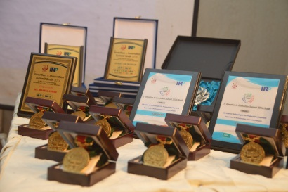
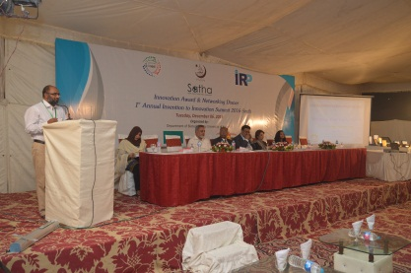
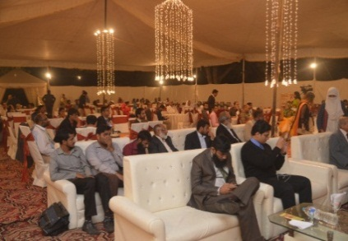
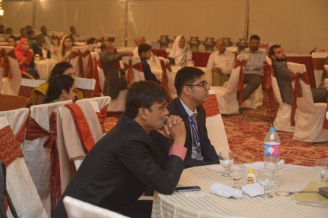
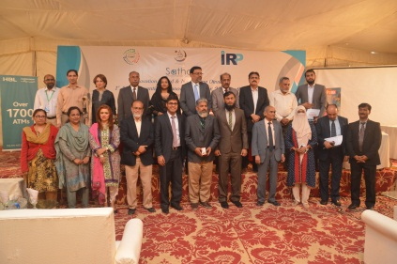

Summary Highlights of Speakers
- All the speakers gave a warm welcome and appreciation for SATHA Award Initiative. Especially the process of award seemed very transparent. The high value of the award is applauded due to zero registration fees and zero cost from the winners. This guarantees the merit of award.
- The speakers endorsed their commitment for such next year initiatives of SATHA for science, technology and innovation. SATHA platform can be used in future to network the society and promote triple helix in Pakistan.
- Academic speakers appreciated that scientists working to solve community and industry problems are acknowledged and rewarded. In academia, there is a lot of recognition for academic publishing and patent. SATHA has rightly taken the initiatives to reward those who do innovations and solve problems of the country.
- Industry speakers also showed their great concern in the SATHA Award. They appreciated the initiative and promised to become a part of this event each year. They also encouraged academia to focus on applied research that may serve the need and problem thus leading to innovation. Industry showed acceptance to cooperate for economically viable projects.
- Government speakers acknowledged SATHA and offered their support for triple helix program in Pakistan. Govt. is keen to participate in this growing concept of university-industry linkages. Govt. is keep trying for such working.
- Management of Karachi University extended thanks to the participants of SATHA Innovation award for their dedication in the initiative taken in the Sindh province. Also, they showed their commitment to hosting SATHA innovation Award and networking dinner in the upcoming years to recognize the innovators of Sindh Province, Pakistan.

The Winners of SATHA Innovation Awards in 1st Invention to Innovation Summit, Karachi
- DR. SEHAR AFSHAN NAZ
For Hepatitis B Free FUUAST and Extended Vaccination Services
- MR. ATEEQ UR RAHMAN
For Setting up Health Care for thalassemia Kids
- MR. MUNAWAR ALI SYED
For Rung de Karachi- Reimagining the Walls of Karachi
- DR. ADEEB HASAN RIZVI
For Establishment of SIUT for kidney related diseases
- M.FARAZ AHMAD
For Development of Video Conference Network across the Sindh Province
- SARDAR YASIN MALIK
For Philanthropic Services to Academia
- PROF. DR. GS MARKAND
For Biotechnology Tissue Culture Lab for Date Palm Trees
- SHAFIQ AHMED SHAIKH
For Energy Solution in Village Area - PannoAqal
- NAEEM QURASHI
For Tree Plantation in Karachi City
- PROF.DR. ALLAH BUX GHANGHRO
For Impact of Blue Light for the Reduction of Aflatoxin Level
- DR. FEROZ ALAM
For Biodegradable / Edible Film
- RAZIA BEGUM, DR. TOOBA NAVEED, NIAZ AHMAD
For Portable Biogas Plant
- RAZIA BEGUM, DR. TOOBA NAVEED, NIAZ AHMAD
For Activated Sludge based waste water treatment plant at meet NEQs limit.
- ZAHID SAEED
For Water Tube Wells in Tharparkar
- ATIF BIN ARIF
For Promoting Tourism in Karachi
- RASHID HUSSAIN ANSARI
For Educating street children
- PROF. DR JAWAID QUAMAR
For founding Institute of Space and Planetary Astrophysics (ISPA), University of Karachi.
- MR. WAKEEL AHMED

