Instructions

Thesis binding Colors

Ph.D.Thesis: Maroon with golden writing
MS/M.Phil. Thesis: black with golden writing

Thesis Words Limits:

- For MS/M.Phil.; Agriculture, biological & medical sciences: 15 to 25 thousand words
- For PhD thesis; Agriculture, biological & medical sciences: 4o to 60 thousand words
- These word limits include tables, equations, and figures but exclude the abstract, table of contents, list of figures, acknowledgments, and declaration of originality at the beginning and exclude the references, bibliography, and appendices at the end of the document. Tables should be counted as 150 words per table. Maps, illustrations, and other pictorial images count as o words. Figures must be counted as 150 words if only representing the presented data. However, if figures/graphs illustrate data presented elsewhere within the thesis (as a table, for instance), it will count as 0 words.
- The number of tables and figures shall not exceed 35% of the total thesis word count.
- Thesis Submission relies on the supervisor’s final approval.
- Submit the thesis in the hard form with color prints/ photocopies.
- Use 80 gram paper for hard binding submission.

Page setup must from Left 1.5’’ Top, Bottom and Right 1.0”

Title (capitalized, 16-bold-TNR, centralized)

stUDENT Name (capitalized, 12-bold-TNR, centralized)
Student id (capitalized, 12-bold-TNR, centralized)

DOCTOR OF PHILOSOPHY/Master of Science
[ enter degree name] (capitalized, 12-bold-TNR, centralized)

[Department name]
School of food and agricultural sciences
(capitalized, 12-bold-TNR, centralized)
UNIVERSITY OF MANAGEMENT AND TECHNOLOGY, LAHORE
PAKISTAN
2023
Title (capitalized, 16-bold, centralized)

by

[Student Name]
[STUDENT ID]

A thesis submitted in partial fulfillment of
The requirement for degree of

Doctor of Philosophy/ Master of Science
in
[Degree Name] (Sentence case, 12-Bold, centralized)

[Department Name]
School of food and Agricultural sciences
UNIVERSITY OF MANAGEMENT AND TECHNOLOGY, LAHORE
PAKISTAN
2023

Student Declaration
I hereby undertake that my MS thesis titled “Title” is entirely my research work with no contributions from any other person and no part of this thesis falls under plagiarism. Small contributions taken from peers, mentors, teachers, and other researchers, on the other hand, have been formally acknowledged.
I understand the zero-tolerance policy of HEC and the University of Management and Technology regarding plagiarism. I, therefore, declare that any material used in my thesis as a reference has been properly cited/referred to and that no part of my thesis is plagiarized. If found otherwise at any stage, I will be responsible for the consequences and the actions taken by the University.

Name: Date:

Registration no: Signature: _______________

CERTIFICATE OF APPROVAL
The supervisory committee certifies that the thesis entitled “Title (Sentence case, 12-bold)” submitted by Student Name, Registration No. Student ID has been found satisfactory and fulfills the requirement for the degree in MS in Degree Program recommends that it may be processed for further formalities.

Date of Viva Voice: ___________

Supervisor _____________

External Examiner _____________

Chairperson _____________

Dean _____________

Research Completion Certificate

It is certified that the work contained in this thesis titled, Title has been carried out and completed by Student Name, Student ID Student ID under my supervision for MS in Human Nutrition and Dietetics

Research Supervisor

______________________
Dr. Muhammad Nadeem

(To be signed after viva voice exam)

Approved/Rejected

_______________
Supervisor
Dr. Muhammad Nadeem

_______________
External Examiner
Dr. Muneeb Khan

_______________
Dean
Dr. Nauman Khalid

DEDICATION
(Capitalized, 12-Bold, Centralized)

Write dedication here. (Sentence case, 12-TNR, Justified)

ACKNOWLEDGEMENT
(Capitalized, 12-Bold, Centralized)

I express my deepest gratitude to Allah Almighty, the Most Merciful and the Most Compassionate, for granting me the strength, perseverance, and blessings to complete this thesis.
Write your acknowledgement here. (Sentence case, 12-TNR, justified)

Table of Contents
CHAPTER 1 1
INTRODUCTION 1
CHAPTER II 8
REVIEW OF LITERATURE 8
CHAPTER III 14
MATERIALS AND METHODS 14
3.1 Chemicals and samples 14
3.2. Selected proximate analysis 14
3.2.1 Moisture content 14
3.2.2 Ash content 15
3.2.3 Fat content 15
3.2.4 Protein content 15
3.3 Shelf stability of liver samples 16
3.4.Color analysis 16
3.5 Free fatty acid analysis 16
3.6 Peroxide value 17
3.7 Antioxidant activity 17
3.8 Total phenolic content 18
3.9 ABTS [2,2′-azino-bis (3-ethylbenzothiazoline-6-sulfonic acid)] 18
3.10 FRAP 19
3.11 Value addition in chicken nuggets with liver 19
3.12 Proteins estimation in value addition in chicken nuggets 22
3.13 Textural profiling of value-added nuggets 22
3.14 Sensory evaluation 22
3.15 Experimental designs 23
3.16 Statistical analysis 23
CHAPTER IV 24
RESULT AND DISCUSSION 24
4.1. Characterization of liver 24
4.1.1 Moisture content 24
4.1.2 Ash content 25
4.1.3 Fat content 26
4.1.4 Protein degradation kinetics 27
4.1.5 Estimation of protein half-life 29
4.1.6 Evaluation of FFA and POV 35
4.1.7 Evaluation of antioxidant activity of livers 36
4.1.8 ABTS and FRAP assays 38
4.1.9 Color analysis 40
4.2 Formulation and characterization of value-added nuggets 42
4.2.1 Moisture content 42
4.2.2 Ash content 43
4.2.3 Fat content 44
4.2.4 Protein content 45
4.2.5 Evaluation of FFA and POV 46
4.2.6 Evaluation of antioxidant activity of nuggets 48
4.2.7 Textural analysis of nuggets 50
4.2.8 Sensory Evaluation 54
CHAPTER V 57
SUMMARY 57
5.1 Future Prospects 58
5.2 Limitations 59
LITERATURE CITED 60
ANNEXURES 73

LIST OF TABLES
(Capitalized, 12-Bold, Centralized)
(Added automatically by inserting proper captions for tables)
(Sentence case, 12-TNR, Justified)
Table 3.1: Experimental design for nuggets formulation with different recipe 20
Table 3.2: Standard recipe for chicken nuggets and value-added chicken nuggets 21
Table 4.3: Degradation rate constants and half-life of the protein (day-wise) degradation in chicken and beef liver. 33
Table 4.4: Degradation rate constants and half-life of the protein (hour-wise) degradation in chicken and beef liver. 34
Table 4.5: Color analysis of chicken and beef liver with respect to storage time 41
Table 4.6: Texture profiling of chicken nuggets supplemented with beef liver 52
Table 4.7: Texture profiling of chicken nuggets supplemented with chicken 53

LIST OF FIGURES
(Capitalized, 12-Bold, Centralized)
(Added automatically by inserting proper captions for tables)
(Sentence case, 12-TNR, Justified)

LIST OF Abbreviations
(Capitalized, 12-Bold, Centralized)

Bold: Abbreviation (12-TNR, Justified)

ABSTRACT
(Capitalized, 12-Bold, Centralized)

Keywords: arranged in alphabetical order (Sentence case, 12-TNR, Justified)

CHAPTER I
Introduction

Insert additional chapters with the “New Chapter” command on the menu bar or under “ARID Thesis Tools”.

(Main heading, 12 font size, bold)
Welcome to University of Management and Technology Lahore. The approved reference style is American Psychological Association (APA) 7th edition. APA requires that information be cited in 2 different ways citation in the text and in a reference list at the end of the paper. Citation of one reference with one author within or at the end of sentence is like this (Ramsin, 2010). Start of Sentence is like this. Ramsin (2010) has presented this study. One reference by two authors: Within or End of Sentence: In this study the authors (Pereira & Fontoura, 2012) has reported. Start of Sentence is like this. Pereira & Fontoura (2012) has presented this study. One reference by three to five authors is like this (Healy, Matthews, Dunstan, Winkler, & Owen, 2011). Start of the Sentence: Healy et al. (2011) has presented this study. One reference by six or more authors is like this (Ashburner et al., 2000). Start of the Sentence: Ashburner et al. (2000) has presented this study. Multiple references is like this. All citation: In these studies the authors (Ashburner et al., 2000; Pereira & Fontoura, 2012; Ramsin, 2010) have presented. All Citation: In this study the author All Citation: In this study the author Being an Agricultural Institution, our main objective is to produce high quality Agricultural Food Scientists. Therefore, we are committed with the philosophy that we advance our farmer community by sharing positive and proven ideas and experiences. Along with Agricultural Sciences, the university offers degree programs at all levels in basic and Natural Sciences, Social Sciences, Humanities, Management Sciences, Computer Sciences and Information Technology.
With a dynamic and stimulating educational environment, our tradition is to accept challenges and to receive wisdom today, in order to achieve new things and new approaches for tomorrow. Embracing education in its widest context, we continually strive to remain at the forefront of knowledge.

(Sub-Heading, 12 font size, Bold)
With a dynamic and stimulating educational environment, our tradition is to accept challenges and to receive wisdom today, in order to achieve new things and new approaches for tomorrow. Embracing education in its widest context, we continually strive to remain at the forefront of knowledge. Embracing education in its widest context, we continually strive to remain at the forefront of knowledge. Embracing education in its widest context, we continually strive to remain at the forefront of knowledge.

(Sub-Heading, 12 font size, Bold)
Insert section using “Start New sub-subsection” command form “ARID Thesis Tools”.
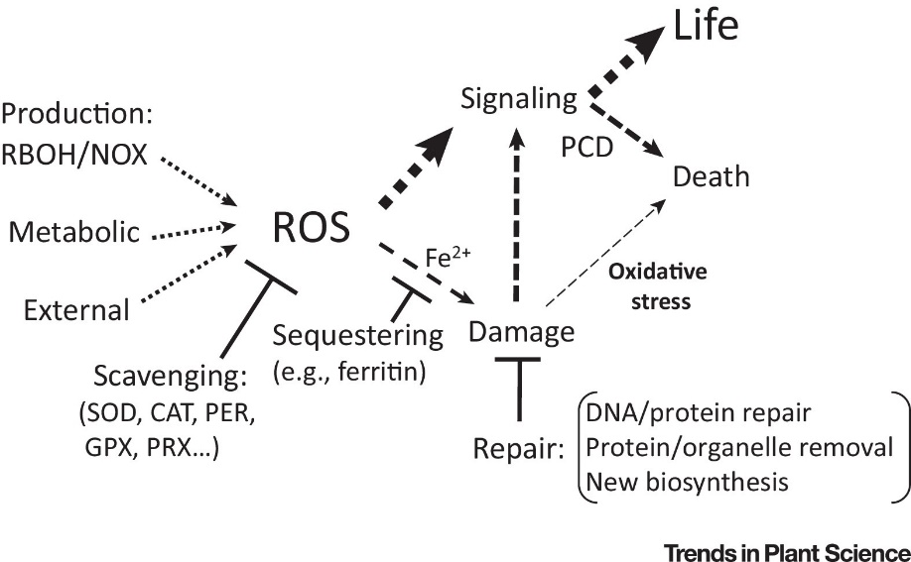
Figure 1.1: Insert figure caption using “Figure Caption” command in ARID Thesis Toolbar
Figure 1.1 shows a representation of our proposed model. All Capitalized Letters. Welcome to PMAS-Arid Agriculture University, Rawalpindi. Being an Agricultural Institution, our main objective is to produce high quality Agricultural Scientists. Therefore, we are committed with the philosophy that we advance our farmer community by sharing positive and proven ideas and experiences. Along with Agricultural Sciences, the university offers degree programs at all levels in basic and Natural Sciences, Social Sciences, Humanities, Management Sciences, Computer Sciences and Information Technology.
With a dynamic and stimulating educational environment, our tradition is to accept challenges and to receive wisdom today, in order to achieve new things and new approaches for tomorrow. Embracing education in its widest context, we continually strive to remain at the forefront of knowledge.

Table 1.1: Insert Table Caption using “Table Caption” Command in ARID Thesis Toolbar

Parameter 1 | Parameter 2 | Parameter 3 | Parameter 4
1 | Aaa | Bbb | Ccc
2 | Ddd | Eee | Fff
3 | Ggg | Hhh | eee
As shown in Table 1.1, with a dynamic and stimulating educational environment, our tradition is to accept challenges and to receive wisdom today, in order to achieve new things and new approaches for tomorrow.

CHAPTER II
REVIEW OF LITREATURE

2.1 (Main Heading, 12 font size, Bold)
2.1.1 (Sub-Heading, 12 font size, Bold)

CHAPTER III
MATERIALS AND METHODS
3.1 (Main Heading, 12 font size, Bold)
3.1.1 (Sub-Heading, 12 font size, Bold)

CHAPTER IV
RESULT AND DISCUSSIONS

4.1 (Main Heading, 12 font size, Bold)
4.1.1 (Sub-Heading, 12 font size, Bold)

CHAPTER V
SUMMARY

Literature cited
(fOLLOW apa 7 GUIDELINES)
Healy, G. N., Matthews, C. E., Dunstan, D. W., Winkler, E. A. H., & Owen, N. (2011). Sedentary time and cardio-metabolic biomarkers in US adults: NHANES 2003-06. European Heart Journal, 32(5), 590–597. https://doi.org/10.1093/eurheartj/ehq451
Ramsin, R. (2010). Towards tool support for situational engineering of agile methodologies. In Software Engineering Conference (APSEC), 2010 17th Asia Pacific (pp. 326–335).

APPENDICES/ANNEXURES/ADDENDUM

