Green Synthesis of Copper Oxide Nanoparticles using Plant Extract of Abutilon indicum and Its Biological Activities



By
NAME
ID: F201700000

SUPERVISOR(s)
NAME

DEPARTMENT OF ……………..
SCHOOL OF SCIENCE
UNIVERSITY OF MANAGEMENT AND TECHNOLOGY, LAHORE, PAKISTAN
202?

Green Synthesis of Copper Oxide Nanoparticles using Plant Extract of Abutilon indicum and Its Biological Activities

Submitted to the University of Management and Technology Lahore
In partial fulfillment of the requirements
For the award of the degree of

BS/MS/PhD
IN
--------------

BY
NAME

ID
F | 2 | 0 | 2 | 2 | 0 | 0 | 0 | 0 | 0 | 0

SESSION: 202?-202?

DEPARTMENT OF ………….
SCHOOL OF SCIENCE
UNIVERSITY OF MANAGEMENT AND TECHNOLOGY, LAHORE, PAKISTAN



Start with the name of Allah who is the most beneficent and the merciful.

THESIS SIMILARITY REPORT

DECLARATION

I, Name D/o Name ID: F201700000 Session 2017-2021 hereby declare that the matter printed in the thesis titled “Title” is my work and has not been printed, published, and submitted as research work, thesis, or published in any form in any university, research institution, etc. in Pakistan or abroad.

I confirm that I will not publish the research work presented in this thesis without affiliation to UMT. If I do so, UMT reserves the right to take necessary action.

_______________

Name

Dated: _______________

RESEARCH COMPLETION CERTIFICATE
Certified that the research work contained in this thesis titled, “[Title]” has been carried out and completed by [Name], ID: XXXXXXXXXXX. The quantum and the quality of the work contained in this thesis are adequate for the award of the degree of BS/MS/PhD.

_____________________
External Examiner
Name
Designation
Affiliation

Supervisor

Name

Designation Affiliation

___________________________
Dean
Name
Designation Affiliation

Chairperson

Name

Designation
Affiliation

DEDICATION
I want to dedicate my work to Allah Subhan-wa-Tala who is my creator and my master. My Lord allowed me to get scientific knowledge in chemistry. In this world, God blessed me with a most cooperative brother “Name” who always supports me and encouraged me to stand high. All the sacrifices and compromises of my beloved brother during this whole period of my study deserve to get credit for my success the most.

ACKNOWLEDGEMENT
I am grateful to Allah, Lord of Glory and the supreme authority of the universe who enabled me to achieve all this.
I want to commend the efforts of my teachers. They delivered to me all the possible concepts related to my course. I want to appreciate the efforts of Dr.___________, Chairperson Department of Chemistry, and faculty members of the chemistry department who allowed me to enhance my knowledge in chemistry. I want to admire the support and guidance of my supervisor Name who was very cooperative with all the students. He/She helped me a lot to solve every single problem related to my study.
I want to admire the participation of my family who supported and guided me throughout my education career. I also want to mention the sincere consideration of my friends in my studies.

Name

Note: It is an expression of thanks for the assistance given by the supervisor of research and by others. You can follow your design for acknowledgments and dedication.

TABLE OF CONTENT
THESIS SIMILARITY REPORT |  | I
DECLARATION |  | II
RESEARCH COMPLETION CERTIFICATE |  | III
DEDICATION |  | IV
ACKNOWLEDGEMENT |  | V
TABLE OF CONTENT |  | VI
LIST OF TABLES |  | VIII
LIST OF FIGURES |  | IX
LIST OF ABBREVIATIONS |  | X
NATIONAL SIGNIFICANCE/ LINKED SDGS |  | XI
ABSTRACT |  | XII
CHAPTER 1 | INTRODUCTION | 1-14
1.1. | Background | 1
1.2. | Nanotechnology | 2
1.3. | Semiconductor Photocatalysis | 2
1.4. | Zinc Oxide | 4
1.5. | Transition metal-doped ZnO | 5
1.6. | Graphitic Carbon Nitride | 6
1.7. | ZnO Based Heterojunction Composites | 7
1.8. | Principles of Photocatalysis | 8
1.9. | Antibacterial Activity | 10
1.10. | Nanomaterial synthesis methods | 10
1.10.1. | Physical Methods | 11
1.10.2. | Chemical Techniques | 11
1.10.2.1. | Sol-gel Synthesis Technique | 11
1.10.2.2. | Hydrothermal method | 12
1.10.2.3. | Chemical co-precipitation method | 12
1.11. | Statement of the problem | 13
1.12. | Objectives of the study | 13
CHAPTER 2 | LITERATURE REVIEW | 15-27
CHAPTER 3 | EXPERIMENTAL WORK | 28-37
3. | Experimental Work | 28
3.1 | Chemicals | 28
3.1.1. | Chemicals Used for Green Synthesis of Nanoparticles | 28
3.2. | Apparatus | 29
3.3. | Instruments | 29
3.4. | Preparation of Plant Extract | 30
3.5. | Green Synthesis of CuO Nanoparticles | 31
3.6. | Anti-Inflammatory Activity | 33
3.6.1. | Sample Preparation | 34
3.6.2. | Standard Preparation | 35
3.7. | Standard Preparation | 37
CHAPTER 4 | RESULTS AND DISCUSSION | 38-55
4. | Results and Discussion | 38
4.1. | Scanning Electron Microscopy (SEM) Analysis | 39
4.2. | X-ray diffraction XRD Analysis | 40
4.3. | Energy Dispersive X-Ray Analysis | 42
4.4. | Optical rotation test result | 44
4.5. | UV-Visible Spectroscopy | 45
4.6. | FT-IR Analysis | 46
4.7. | Anti-Inflammatory Activity | 48
4.8. | Anti-Bacterial Activity | 50
4.9. | Conclusion | 54
4.10. | National Relevance | 56
4.11. | Sustainable Development Goals of UNO | 57
 | REFERENCES | 58-66

LIST OF TABLES
Table No. | Title | Page No.
Table 1.1 | Properties of CuO Nanoparticles | 16
Table 4.1 | % Inhibition and IC₅₀ of standard (Diclofenac Sodium) | 48
Table 4.2 | % Inhibition and IC₅₀ of CuO Nanoparticles | 49
Table 4.3 | % Scavenging and IC₅₀ of standard (Ascorbic Acid) | 53
Table 4.4 | % Scavenging and IC₅₀ of CuO Nanoparticles | 54
Table 4.5 | Scavengers used for capturing reactive species | 56
Table 4.6 | Antibacterial Performance of CuO | 58

LIST OF FIGURES
Figure No. | Title | Page No.
Figure 1.1 | Comparison of Nanomaterial Sizes | 2
Figure 1.2. | Biological Usage of Nanoparticles | 3
Figure 1.3. | Flow Sheet of Types of Nanoparticles | 4
Figure 1.4. | Classifications of Nanoparticles on the Bases of Dimensions | 7
Figure 1.5. | Schematic Diagram of Green Synthesis of Nanoparticles | 8
Figure 1.6. | CuO Nanoparticles Synthesis | 10
Figure 1.7. | Applications of CuO Nanoparticles | 12
Figure 1.8. | Scanning Electron Microscope | 13
Figure 1.9. | Transmission Electron Microscope | 14
Figure 1.10. | UV-Vis Spectrophotometer | 15
Figure 3.1. | Plant of Abutilon indicum | 29
Figure 3.2. | Filtration of Plant Extract | 30
Figure 4.1. | SEM Image of CuO Nanoparticles | 39
Figure 4.2. | XRD Spectra of CuO Nanoparticles | 42
Figure 4.3. | EDX Spectra of CuO Nanoparticles | 43

Note: All the headings in Chapters 1-4 and the List of Tables and Figures are flexible and can be changed according to the work and organization

All the figures and Tables must be cited in the text as well
LIST OF ABBREVIATIONS
Abbreviations | Stands for
CuO | Copper Oxide
NPs | Nanoparticles
UV | Ultraviolet
FTIR | Fourier transform infrared
SEM | Scanning Electron Microscope
XRD | X-ray diffraction
EDX | Energy Dispersive X-Ray
MB | Methylene Blue
IC₅₀ | Half Maximal Inhibitory Concentration
DPPH | 2,2-diphenyl-1-picrylhydrazyl

ABSTRACT

CHAPTER 1:

INTRODUCTION
- Introduction
This comprises primary knowledge of nanotechnology, nanocomposites, nanoparticles, and their applications in various fields. Brief information about graphene oxide is also provided. This contains information about the aim of the work as well as characterization techniques involved in this research work.
1.1. Nanotechnology
“Nanotechnology deals with matter, manipulating on the atomic, molecular, and supramolecular level in the range of 1-100nm”.
It concerns an important part of science that involves the growth and formation of nanomaterial. Nanotechnology's definition in the United States is “It includes substances which show unique biological, physical and chemical characteristics and mechanism because of nano-size”. Nanotechnology is a multidisciplinary term that has a wide variety of applications in the field of physics, biology, material science, etc. (Cao et al., 2004).
1.2. Importance of Nanoscale
The word nano means dwarf. A nanometer is defined as one billion meters. Nanotechnology concerns substances that are small in size. The properties of nanotechnology defined by the National Science Foundation of the US are as follows.
- Dimension: Ranges from 1-100nm in diameter.
- Process: It showed the overall charge on physical and chemical characteristics of the structure.
- Building block properties: Used to form the structure on a macro-scale.
Nanoscience deals with biological structures (including DNA, protein, and enzyme) with a range of 1-100nm.
Nanoscale is important because of four reasons which are following
- The quantum mechanical characteristics of negatively charged particles that are wave-like and present in the matter are affected by variations on the nano-scale. The micro and macroscopic properties are changed without altering their chemical composition like temperature, charge capacity, and magnetization by designing the materials on the nano-scale.
- The macroscopic system consists of nanostructures and microstructures. The nanostructures have a density lower than the microstructures that are also good conductors of electricity.
- On the nano-scale, there is an important feature which is the systematic organization of biological molecules inside the matter. Developments in nanoscience and nanotechnology have allowed us to place man-made nanoscale things inside living cells. It has become feasible through the use of self-assembly of molecules by the study of microstructures and macrostructures of materials and surely in material science a strong tool. Figure 1.1. shows the comparison of nanomaterial sizes.
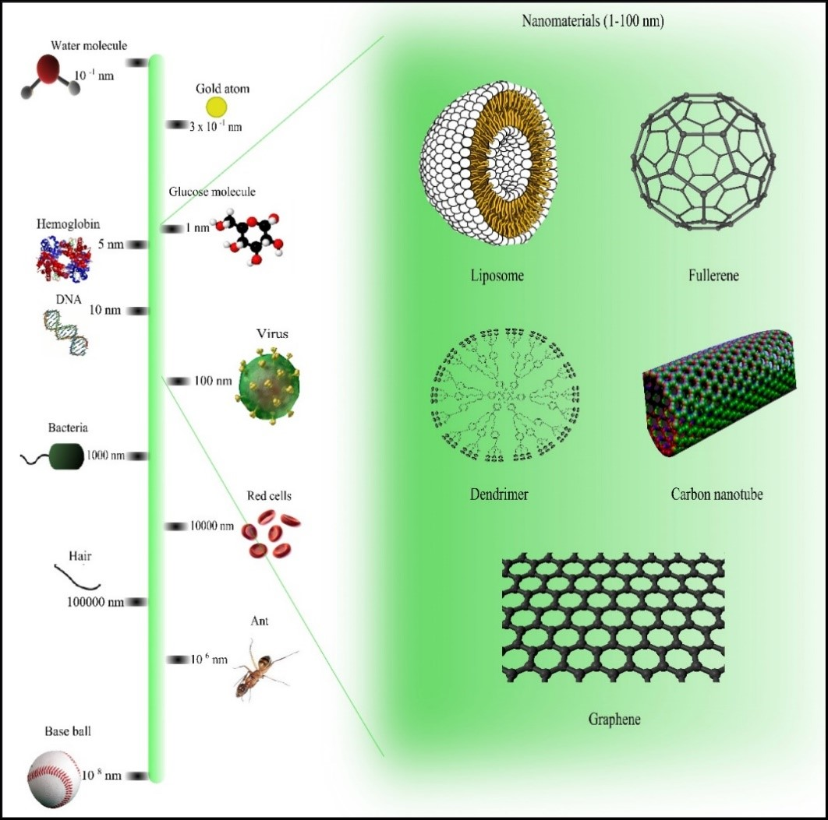
Figure 1.1. Comparison of nanomaterial sizes with other common objects.
1.3. Nanoparticles
Nanoparticles have a size range from 1-100nm. These particles can be manufactured by green synthesis or chemical synthesis. Green synthesis is rapid, safe, non-toxic, sustainable, and eco-friendly. Green synthesis use plant extract to synthesize nanoparticles. It is used in medicine, cosmetics, and cloth (Hassan et al., 2015).
1.4. Types of Nanoparticles
1.4.1. Metallic Nanoparticles
In 1857, Faraday discovered metallic nanoparticles while in 1908, Mie described nanoparticles color changing phenomenon in solution. Characteristics of metal nanoparticles are mentioned below:
- Large Surface energies
- Quantum Confinement
- Large surface area
- Plasmon excitation
- Specific Electronic Structure (Pal, 2019)
Silver nanoparticles because of their unique antimicrobial activity against prokaryotic organisms such as bacteria and viruses and some other eukaryotic microorganisms showed more efficacy. They have a wide range of applications in textile industries, in water treatment, as a sunblock, and as antimicrobial agents. The plants that are efficiently used for the formation of Ag NPs are Azadirachta indica, Coriandrum sativum, Mintha pipperita, Carica papaya, etc.
Gold nanoparticles have a wide range of applications such as in immunochemical studies, as a lab tracer, in the detection of antibiotics, etc. The nanorods made of gold are utilized in stem cells detection, for cancerous diagnosis along with the detection of the different bacterial classes. gold nanoparticles exhibit excellent catalysis activity in many organic reactions at room temperatures. Owing to undesirable Chemical compounds and toxic chemical effects by chemical synthesis hinders the catalysis activity in various industrial applications.
1.4.2 Alloy
These nanoparticles show some unique structural properties. Silver exhibits the highest electroconductivity among the metal that are used as fillers. Other metals as well as their metal oxides also exhibit good electrical conductivity. These nanoparticles show more benefits than commonly used metallic nanoparticles. Bimetallic or trimetallic nanoparticles are considered more effective than monometallic nanoparticles because of their synergistic characteristics.
1.4.3 Magnetic
There is a type of nanoparticles known as magnetic nanoparticles such as magnetite and maghemite that are biocompatible. Magnetic nanoparticles have two components. One is magnetic components like Zn, Cu, and Fe. The second is a chemical component with specific functionality (Pal et al., 2019). They are utilized in the treatment of cancer as magnetic hyperthermia, in gene therapy, medical diagnosis, drug delivery, DNA analysis, stem cell sorting as well as in its manipulation and magnetic resonance imaging.

.

CHAPTER 2:
LITERATURE REVIEW

- Literature Review
Nguyen et al., (2018) explained the synthesis of metallic nanoparticles using the green synthesis method. The use of biological methods for the fabrication of metal nanoparticles has attracted wide attention due to its low cost, feasible and eco-friendly approach. The approach was applied to synthesize a variety of metal nanoparticles including Au, Pt, Pd, Ag, and CuO NPs. Natural polymer gum karaya acts as a reducing and stabilizing agent. The characterization techniques used in this work were Zetasizer Nano, UV-Visible spectroscopy, and electron microscopy. The biological effect of synthesized nanoparticles was investigated on a unicellular alga. By measuring photosynthetic efficiency, algal growth, oxidative activity, and membrane integrity the biological effect can be elaborated. Algal growth was slightly reduced by Au and Pt nanoparticles at the concentration of 5mgL⁻¹ while Pd, Ag, and CuO nanoparticles showed complete inhibition of algal growth.
Mohsen et al., (2017) reported the catalytic potential of green synthesized CuO nanoparticles using aqueous medium. The method reported in this work was the microwave-assisted technique. By using this technique copper salt was chemically reduced in the presence of hydrazine hydrate which act as a strong reducing agent. The formation of well-dispersed CuO nanoparticles was confirmed by various characterization techniques. Copper oxide catalyst fabricated from biological method showed many advantages that include the use of eco-friendly solvent, green synthesis method, and mild reduction conditions for the synthesis of nanoparticles.
Ghidan et al., (2016) studied CuO nanoparticles fabricated by green synthesis using Punica granatum peel extract. Green synthesized nanoparticles were characterized by spectroscopy techniques like FTIR, SEM, UV-Vis, and XRD. The nature of the particles was crystalline with a 40nm size. The formation of CuO nanoparticles was accomplished by the concentration of Punica granatum peel extract. It also included Cu⁺² ions.

CHAPTER 3:
EXPERIMENTAL WORK

- Experimental Work
The experimental section was performed at chemistry laboratory, Department of Chemistry, School of Science, University of Management and Technology, Lahore. During experimental work, chemicals, apparatus, solvent, and instrument used are given below:
  - Chemicals
    - Chemicals Used for Green Synthesis of CuO Nanoparticles
- CuSO₄.5H₂O Solution
- Plant Extract
- Double Distilled Water
3.2. Apparatus
- Beaker (100ml, 250ml, 500ml)
- Conical flasks (500ml, 250ml)
- Volumetric flasks (100ml)
- Sample vials
- Stirrer
- Cotton
- Aluminum Foil
- Measuring Cylinder
- Pipette
- Thermometer
- Petri dishes
- Burette

CHAPTER 4:
RESULTS AND DISCUSSION
4. Results and Discussion
4.1. Scanning Electron Microscope (SEM) Analysis
All the results obtained must be properly explained with the help of figures, graphs, and tables.
All the figures and graphs along with the caption must be centralized. The caption of tables must be left aligned. The Figures and Tables must be of an appropriate size not too large and not too small. Figure Table or Text must be Aligned and within the defined scale. All the tables and figures numbers must be cited in the text.
Table 4.1. Percentage scavenging and IC₅₀ of standard (Ascorbic acid)

Concentration mg/mL | Absorbance of Control | Absorbance of standard | % Scavenging | IC₅₀
0.05 mg/mL | 0.940 | 0.820 | 12.77 | 0.20
0.125 mg/mL | 0.940 | 0.668 | 28.94 | 0.24
0.25 mg/mL | 0.940 | 0.597 | 36.49 | 0.37
0.5 mg/mL | 0.940 | 0.501 | 46.70 | 0.51

4.9. CONCLUSION
In the conclusion provide your findings in your own words. The Conclusion must be written in systematic and understandable writing.

4.10. National Relevance
Please provide a brief description of the importance or benefits of your research work for your country.
4.11. Stainable Development Goals (SDGs) of UNO
Please indicate the Sustainable Development Goal(s) (SDG) to which your research work relates.
References
Arshad, H. M., Gauhar, S., Bano, R., & Muhammad, I. N. (2009). Development of HPLC-UV method for analysis of cefixime in raw materials and in capsule. Jordan Journal of Pharmaceutical Sciences, 2(1), 53-65.
Aldalbahi. A, Aldawish. B, Awad, M.A.G., Aldosari, N.S., Alshathri, R.H. and Shoqiran, K.I.B. (2021).JUSTIA Patents 1095010. King Saud University
Brown, J. Q., Vishwanath, K., Palmer, G. M., & Ramanujam, N. (2009). Advances in quantitative UV–visible spectroscopy for clinical and pre-clinical application in cancer. Current Opinion in Biotechnology, 20(1), 119-131.
(2013, May-9). Copper Oxide (CuO) Nanoparticles - Properties, Applications. Retrieved from https://www.azonano.com/article.aspx?ArticleID=3395
Mali, A., Jadhav, S., Gorad, R., Quazi, A., Bathe, R., Patil, M., & Tamboli, A. (2016). Simultaneous UV Spectrophotometric Methods for Estimation of Cefixime Trihydrate and Ofloxacin in Bulk and Tablet Dosage Form. Asian Journal of Pharmaceutical Research, 6(2), 100-106.
Mathew, C., Swathi, B., Ajitha, M., & Babu, P. S. (2016). Development and validation of a new and economical stability indicating RP-HPLC method for cefixime trihydrate. Brazilian Journal of Pharmaceutical Sciences, 52, 87-94.
The citations must be according to the format provided in these guidelines. All the cited references at the end of the report must be cited in the report as well and must be cross-checked. References should be arranged in alphabetical order.

