SCHOOL OF SCIENCE
Guidelines and Format of the Thesis
for BS/MS/PhD Degree Program

Thesis Writing Guidelines

Title
The title of your thesis should be clear, concise, and accurately reflect the content and focus of your research. Avoid overly complex or ambiguous titles that may confuse or mislead readers. Use precise language that captures the essence of your work succinctly.
Abstract
- Start with a concise statement of the research problem or objective: Begin the abstract by clearly stating the purpose of your study. Summarize the main research question or objective in a single sentence.
- Provide background information: Briefly describe the relevant background information and context for your research. Highlight the key concepts, theories, or previous studies that are essential for understanding your work.
- Describe the methods used: Provide a concise overview of the experimental methods, data collection techniques, or theoretical approaches employed in your study. Mention any specialized equipment or software used.
- Summarize the results: Present a summary of your main findings or results. Highlight the most significant outcomes or discoveries that address your research question or objective. Use quantitative data or specific examples where possible.
- Emphasize the implications and significance: Discuss the broader implications and significance of your research. Explain how your findings contribute to the field and why they are important. Address any potential applications or future research directions.
- Keep it concise and focused: The abstract should be brief and to the point. It should be between 150 to 300 words for BS, 500 to 1000 words for MS, and 1500 to 4000 words for Ph.D. thesis, depending on the specific requirements of your department.
- Use clear and concise language: Write in a clear, concise, and straightforward manner. Use simple and accessible language, avoiding jargon or highly technical terms. Aim to make your abstract understandable to readers outside your specific subfield.
- Follow a logical structure: Organize your abstract in a logical sequence that reflects the flow of your thesis. Typically, this includes introducing the problem, summarizing the methods, presenting the results, and discussing the implications.
- Reflect on the content of the thesis: The abstract should provide an accurate representation of your thesis. Avoid making claims or including information that is not supported by your research. Ensure that the abstract aligns with the main body of your thesis.
- It is also mandatory to mention the sustainable development goals (SGDs) that are linked with your presented research.
Introduction

- Provide context
Begin by providing background information and context for your research topic. Explain the broader field or discipline in which your study is situated. Describe the significance and relevance of the topic, highlighting any existing knowledge gaps or unresolved issues.
- State the research problem
Clearly state the specific research problem or objective that your thesis addresses. Formulate a concise and focused research question or set of objectives that will guide your study.
- Present the rationale
Provide a rationale for your research by explaining why it is important and necessary. Discuss how your study builds upon and extends the existing knowledge in the field. Clearly articulate the value and potential impact of your research.
- Outline the scope and methodology
Describe the scope of your study and the specific approach or methodology you have employed. Explain the key techniques, methods, or experimental designs used in your research. Justify your chosen approach and provide a brief overview of the data collection and analysis methods.
- Highlight the expected contributions
Clearly state the potential contributions of your research. Explain how your study will advance the field, fill the identified knowledge gaps, or provide novel insights. Outline the specific outcomes or results you expect to achieve.
- References for support of your research
Provide relevant references which support your research/information provided in your thesis.
- Review and revise
After drafting the introduction, review it for coherence, clarity, and logical flow. Ensure that the information presented is accurate and relevant.
- Consider the length
The length of the introduction may vary depending on the specific requirements of your department. Generally, it should be long enough to provide sufficient context and rationale but concise enough to maintain reader engagement.

Literature Review

Review relevant literature: Conduct a comprehensive literature review to familiarize a reader with the existing research and theories related to your topic. Summarize the key findings and debates in the field. Identify the strengths and weaknesses of previous studies and highlight any gaps or limitations that your research aims to address.

Experimental/Methodology

- Provide a clear overview: Begin the experimental section by providing a clear and concise overview of the overall experimental design. Describe the purpose of the experiments and how they contribute to addressing the research question or objective.
- Include detailed methods: Present detailed descriptions of the experimental procedures, techniques, or measurements, calculations, equations, and mathematical procedures (according to your specific subject/research area) used in your study. Include information such as sample preparation, equipment used, measurement parameters, calculations, computational work, and any specific protocols followed. Be specific and provide enough detail for the experiments/procedure/calculations/equations to be reproducible.
- Use subsections: Organize the section into subsections (if required) based on the different experiments or methods used.
- Include controls and variables: Clearly describe any controls, variables, or conditions that were included in the experiments.
- Include data collection and analysis: Explain how data were collected during the experiments. Describe the instruments, calculations, equations, or software used for data acquisition and the specific measurements taken. Outline the analytical techniques or statistical methods used for data analysis and provide references to any established protocols.
- Consider reproducibility: Provide sufficient detail and information to ensure the reproducibility of your experiments. Include any specific protocols, parameters, or conditions that are crucial for replicating your work.

Results and discussion

- Presentation of the data: Start the chapter by presenting your data in a clear and organized manner. Use tables, graphs, figures, or charts to effectively display your results. Include appropriate labels, units, and error bars, if applicable.
- Interpretation and analysis: Immediately following the presentation of the data, interpret and analyze the results. Explain the meaning and implications of your findings about your research question or objective. Consider both expected and unexpected results.
- Address each research objective: Structure your discussion around each specific research objective or hypothesis. Address how your findings relate to each objective and whether they support or contradict previous research or theories.
- Provide context: Situate your results within the broader context of the field. Discuss how your findings align with or deviate from existing literature. Highlight any similarities or differences between your results and those reported by other researchers.
- Identify patterns or trends: Look for patterns, trends, or relationships within your data. Discuss the significance of these patterns and their implications for the understanding of the research problem. Use supporting evidence, such as statistical analyses or comparisons with literature, to strengthen your arguments.
- Discuss limitations and uncertainties: If applicable, acknowledge any limitations or uncertainties in your study. Discuss potential sources of error or bias and their impact on the results. Address any constraints or limitations of the experimental design or data collection methods and how they may have affected the outcomes.
- Depending upon the specific area of research, results and discussion chapters can be divided into two chapters.
Conclusions

- Summarize key findings: Begin the conclusion by summarizing the key findings of your research. Provide a brief overview of the main results and discoveries that address your research question or objective. Focus on the most significant and impactful findings.
- Address research objectives: Revisit each research objective or hypothesis stated at the beginning of your thesis. Discuss how your findings have contributed to achieving these objectives and whether they support or refute your initial hypotheses.
- Discuss implications and significance: Discuss the broader implications and significance of your research. Explain how your findings advance the field, fill knowledge gaps, or challenge existing theories. Highlight the practical applications, if applicable, and discuss the potential impact of your work on the relevant scientific community or society.
- Avoid introducing new information: The conclusion is not the place to introduce new data, arguments, or references. Ensure that all the information presented in the conclusion has been discussed earlier in the thesis. Focus on summarizing and synthesizing the existing information to provide a coherent and cohesive conclusion.
- Keep it concise: The conclusion should be concise and focused. Aim to provide a succinct summary of the main points without unnecessary repetition. Avoid going into excessive detail or delving into tangential discussions.
Ethical Considerations: consent/access/and participants’ protection
- List down issues like informed consent, anonymity, the confidentiality of data, data storage, and the use of the results, etc.
- Other can be study specific like intervention and advocacy etc.

General Instructions on Formatting Details
Font Details

The thesis should be printed on A4 size paper. The thesis/report must be typed in 12-point font Times New Roman. There should be a spacing of 6 points before and after the headings and each paragraph. Do not try to make your thesis unnecessarily large, try to keep its volume in a reasonable range. Maintain consistency in font style throughout the thesis.
The page margins should have Left, right, top, and bottom margins equal to 1.5″, 1″, 1″ and 1″ respectively.
- The font size of the main text should be 12 Times New Roman and the line spacing should be 1.5.
- The font sizes for the level headings are given as follows:
  - Level Heading 1 Font Size=18 With TNR Font in Bold Face,
  - Level Heading 2 Font Size=16 With TNR Font in Bold Face,
  - Level Heading 3 Font Size=14 With TNR Font in Bold Face,
  - Level Heading 4 Font Size=12 With TNR Font in Bold Face,
- All equations should be center-justified, and their captions/numbers right justified.
- The first page of the main text will start with page number 1 where the introduction of the Thesis starts.
It should have references from journals/magazines/books. The format of the references at the end of the Thesis should be given according to the APA referencing format.
(https://www.mendeley.com/guides/apa-citation-guide)or(https://apastyle.apa.org/).
This document describes the guidelines for MS Thesis. All students are required to follow the guidelines mentioned below.
        - Hard binding
The color of the hard binding should be dark maroon with golden writing for the Ph.D., pure black with golden writing for the MS, and navy blue with silver writing for the BS thesis.
Please take color print of the pages where some diagrams/Figures/structures are given which cannot be understood completely if printed in black and white.
b) Language: Must be written in English.
c) Spellings: American or British spelling is acceptable, but one form must be used consistently throughout the thesis.
d) Paper: Page size should be A4. The thesis must be printed on good-quality white paper on one side of the paper only. Photographs and other special figures or tables may be printed on photographic quality paper.
e) Font: For the main body of the text, 12-point font is preferred in Times New Roman. Condensed type is not acceptable. Chapter titles should be bold in size 24. Section (sub) headings should be bold in the order of 18, 16, 14, and 12. The first letter of each word in the headings should be a capital letter.
f) Indentations: There should be no indentation at the start of the paragraph. Don’t add Tab spacing at the start of each paragraph.

Margins
TOP 1'', Bottom 1'', Left 1.5'', and Right 1''. These margins also apply to all illustrative material, diagrams, maps, photographs, charts, tables, and computer printouts.

Header
You can add a header to the thesis showing the name of the chapter or the article being discussed. e.g.
Introduction
font size should be 10 fonts in Times New Roman

Pagination
All pages should be numbered starting from 1, at the right bottom of the page, EXCEPT the preliminary pages up to the title. The remaining pages of the preliminaries should be numbered with lower-case Roman numerals (ii, iii, iv, etc.) placed at the bottom right of the page. This includes pages with tables, figures, references, and appendices.
Figures and Tables
Number and label figures and tables sequentially according to the chapter (e.g., Figure 1.1, 1.2, 1.3 for Chapter 1 Figure, 2.1, 2.2, 2.3, for Chapter 2 Figure 3.1, 3.2 for Chapter 3 and 4.1, 4.2 for Chapter 4. Similarly for Table e.g., Table 1.1, 2.1, 3.1, 4.1).
Provide clear and concise captions for figures and tables, explaining their content.
Place figures and tables close to the relevant text and refer to them within the main body of the thesis.
Ensure that figures and tables are of sufficient resolution and clarity.

Illustrative Material

Maps, diagrams, and tables need not be placed on separate pages. However, if the diagram or table is big enough then it should be placed on a separate page. All the diagrams should be the same size provided their resolution is not suffering. Try not to copy the diagrams. The diagrams and tables should be properly captioned. For figure captions use font size 12 and use a smaller font size (10 points), for header and footnotes. The Figure and Table number should be given in bold letters (like Figure 1.1. Table 1.1.), while the caption of figures and tables should not be given in bold letters E.g.,
Table 1.1. Importance of Thesis
If you have diagrams or charts etc. which are Oversized, then these should be carefully folded into the thesis.

Abbreviations
One of the most important things in thesis writing is that people often use such abbreviations which can only be understood by them. You should always keep in mind one thing you are writing a thesis/report to tell others about your work who didn’t know it previously. Therefore, use only those abbreviations which are used commonly, and you must elaborate on the abbreviation on first use in your article and then you can use it repeatedly. Or you can also elaborate on the abbreviation in the footnotes.

Sequence of Thesis
Although this document is written in the prescribed format, here is the sequence of the preliminaries and chapters of your thesis. After writing the thesis completely you must tally it with the sequence given below.
- Title Page
- Title Page with the statement “Thesis submitted in partial fulfillment of …….”
- Thesis Similarity Report
- Declaration (of originality)
- Research completion certificate
- Dedication
- Acknowledgement
- Table of contents
- List of Tables
- List of Figures
- List of Abbreviations
- Glossary (if applicable)
- Abstract
- Chapter 1 and then the subsequent chapters of your report will follow (your report should consist of at least four chapters, namely, Introduction, Literature Review, Experimental Work, Results, and Discussion).
- References
- Vita (your simplified bio-data along with your picture)
- Appendices
The purpose of the “1st title page” is that it provides the binder of the thesis with a pattern, which is printed on the binding.

Acknowledgments
It is an expression of thanks for the assistance given by the supervisor of research and by others. You can follow your design for acknowledgments, and dedication.
Suggested Words limit
- Word limits for a BS thesis are 8000-15000; an MS thesis is 16000-20000 (Minimum-Maximum), while for the Ph.D. it is 50000-60000 (Minimum-Maximum).
- The word limit for each chapter/section is given below.

Prog | Abstract | Intro | Lit. Review | Methodology | Results & Discussion | Conclusions | Minimum References
BS | 150-300 | 2000- 4000 | 2000-4000 | *As given in the table note | 2000-4500 | #As given in the table note | 35
MS | 500-1000 | 4000- 6000 | 4000-6000 | *As given in the table note | 4000-5000 | #As given in the table note | 70
PhD | 1500-4000 | 13000-16000 | 15000-18000 | *As given in the table note | 12000-16000 | #As given in the table note | 200
*. Experimental/Methodology: Words limit for the experimental/ methodology chapter of the thesis can be flexible depending on the specific requirements of your research area/subject. # Conclusions: Word limits for “conclusions” can be flexible, however, it should not be less than one page.
- Note: Each table/figure/graph is considered equal to 150 words.
National Significance
Please briefly discuss how the presented research work deals with National interests, such as technological advancements, economic development, social welfare, public health, environmental sustainability, growth and development of industry, or national security.

References
The written material in your document should not be copied. If you want to quote some of the findings from a book or a published paper, then you must rephrase it and give the reference of the author or book. The pattern of the references must be in APA style and listed alphabetically. The spacing should be 1.5 while before and after spacing between all the references must be 12 points.
Examples:
Journal Citation
Chivulescu, A.I., Doni, M.B., Cheregi, M.-C., and Danet, A.F. (2011). Determination of amoxicillin, ampicillin, and penicillin G using a flow injection analysis method with chemiluminescence detection. Revue Roumaine de Chimie, 56(3), 247-254
Mitchell, J.A. (2017). Citation: Why is it so important? Mendeley Journal, 67(2), 81-95.
Sen A., and Batra A. (2012). Chemical composition of methanol extract of the leaves of Melia azedarach L., Asian Journal of Pharmaceutical and Clinical Research, 5(3), 42-45
Book Citation
Hubschmann, H.J. (2009). Handbook of GC-MS: Fundamentals and applications, (2nd ed.). Weinheim: Wiley-VCH.
Jones, A.F and Wang, L. (2011). Spectacular creatures: The Amazon rainforest (2nd ed.). San Jose, Costa Rica: My Publisher
Mitchell, J.A., Thomson, M., and Coyne, R.P. (2017). A citation guide. London, England: My Publisher
Website Citation
Mitchell, J.A. (2017, May 21). How and when to reference. Retrieved from https://www.howandwhentoreference.com.
Following website show how electronic references can be cited and quoted. APA Style Guide: http://www.apastyle.org/elecsource.html
http://www.apastyle.org/electext.html
https://www.mendeley.com/guides/apa-citation-guide

Core Components of an APA Reference:
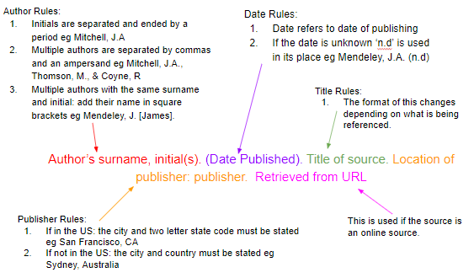
How to Cite a Journal Article in Print or Online in APA Format?
Articles differ from book citations in that the publisher and publisher location are not included. For journal articles, these are replaced with the journal title, volume number, issue number, and page number. The basic structure is:


How to Cite a Book (Title, not Chapter) in APA Format?

Book referencing is the most basic style; it matches the template above, minus the URL section. So the basic format of a book reference is as follows:
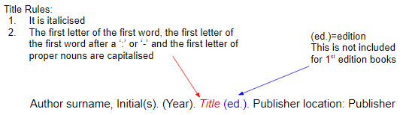

CD submission
The Library UMT requires a CD containing
Your thesis is both in DOC text format and PDF format. Each student should submit a soft copy of his/her thesis at the time of submitting the hard-bound thesis.

For the title pages, please follow the format as given on the next pages.
Green Synthesis of Copper Oxide Nanoparticles using Plant Extract of Abutilon indicum and Its Biological Activities



By
NAME
ID: F201700000

SUPERVISOR(s)
NAME

DEPARTMENT OF ……………..
SCHOOL OF SCIENCE
UNIVERSITY OF MANAGEMENT AND TECHNOLOGY, LAHORE, PAKISTAN
202?
Green Synthesis of Copper Oxide Nanoparticles using Plant Extract of Abutilon indicum and Its Biological Activities

Submitted to the University of Management and Technology Lahore
In partial fulfillment of the requirements
For the award of the degree of

BS/MS/PhD
IN
--------------

BY
NAME

ID
F | 2 | 0 | 2 | 2 | 0 | 0 | 0 | 0 | 0 | 0

SESSION: 202?-202?

DEPARTMENT OF ………….
SCHOOL OF SCIENCE
UNIVERSITY OF MANAGEMENT AND TECHNOLOGY, LAHORE, PAKISTAN



Start with the name of Allah who is the most beneficent and the merciful.

THESIS SIMILARITY REPORT

DECLARATION

I, Name D/o Name ID: F201700000 Session 2017-2021 hereby declare that the matter printed in the thesis titled “Title” is my work and has not been printed, published, and submitted as research work, thesis, or published in any form in any university, research institution, etc. in Pakistan or abroad.

_______________

Name

Dated: _______________

RESEARCH COMPLETION CERTIFICATE
Certified that the research work contained in this thesis titled, “[Title]” has been carried out and completed by [Name], ID: XXXXXXXXXXX. The quantum and the quality of the work contained in this thesis are adequate for the award of the degree of BS/MS/PhD.

_____________________
External Examiner
Name
Designation
Affiliation

Supervisor

Name

Designation Affiliation

___________________________
Dean
Name
Designation Affiliation

Chairperson

Name

Designation
Affiliation

DEDICATION
I want to dedicate my work to Allah Subhan-wa-Tala who is my creator and my master. My Lord allowed me to get scientific knowledge in chemistry. In this world, God blessed me with a most cooperative brother “Name” who always supports me and encouraged me to stand high. All the sacrifices and compromises of my beloved brother during this whole period of my study deserve to get credit for my success the most.

ACKNOWLEDGEMENT
I am grateful to Allah, Lord of Glory and the supreme authority of the universe who enabled me to achieve all this.
I want to commend the efforts of my teachers. They delivered to me all the possible concepts related to my course. I want to appreciate the efforts of Dr.___________, Chairperson Department of Chemistry, and faculty members of the chemistry department who allowed me to enhance my knowledge in chemistry. I want to admire the support and guidance of my supervisor Name who was very cooperative with all the students. He/She helped me a lot to solve every single problem related to my study.
I want to admire the participation of my family who supported and guided me throughout my education career. I also want to mention the sincere consideration of my friends in my studies.

Name

Note: It is an expression of thanks for the assistance given by the supervisor of research and by others. You can follow your design for acknowledgments and dedication.

TABLE OF CONTENT
THESIS SIMILARITY REPORT |  | I
DECLARATION |  | II
RESEARCH COMPLETION CERTIFICATE |  | III
DEDICATION |  | IV
ACKNOWLEDGEMENT |  | V
TABLE OF CONTENT |  | VI
LIST OF TABLES |  | VIII
LIST OF FIGURES |  | IX
LIST OF ABBREVIATIONS |  | X
NATIONAL SIGNIFICANCE/ LINKED SDGS |  | XI
ABSTRACT |  | XII
CHAPTER 1 | INTRODUCTION | 1-14
1.1 | Background | 1
1.2 | Nanotechnology | 2
1.3 | Semiconductor Photocatalysis | 2
1.4 | Zinc Oxide | 4
1.5 | Transition metal-doped ZnO | 5
1.6 | Graphitic Carbon Nitride | 6
1.7 | ZnO Based Heterojunction Composites | 7
1.8 | Principles of Photocatalysis | 8
1.9 | Antibacterial Activity | 10
1.10 | Nanomaterial synthesis methods | 10
1.10.1 | Physical Methods | 11
1.10.2 | Chemical Techniques | 11
1.10.2.1 | Sol-gel Synthesis Technique | 11
1.10.2.2 | Hydrothermal method | 12
1.10.2.3 | Chemical co-precipitation method | 12
1.11 | Statement of the problem | 13
1.12 | Objectives of the study | 13
CHAPTER 2 | LITERATURE REVIEW | 15-27
CHAPTER 3 | EXPERIMENTAL WORK | 28-37
3. | Experimental Work | 28
3.1 | Chemicals | 28
3.1.1. | Chemicals Used for Green Synthesis of Nanoparticles | 28
3.2. | Apparatus | 29
3.3. | Instruments | 29
3.4. | Preparation of Plant Extract | 30
3.5 | Green Synthesis of CuO Nanoparticles | 31
3.6. | Anti-Inflammatory Activity | 33
3.6.1 | Sample Preparation | 34
3.6.2 | Standard Preparation | 35
3.7. | Standard Preparation | 37
CHAPTER 4 | RESULTS AND DISCUSSION | 38-55
4. | Results and Discussion | 38
4.1. | Scanning Electron Microscopy (SEM) Analysis | 39
4.2. | X-ray diffraction XRD Analysis | 40
4.3. | Energy Dispersive X-Ray Analysis | 42
4.4. | Optical rotation test result | 44
4.5. | UV-Visible Spectroscopy | 45
4.6. | FT-IR Analysis | 46
4.7 | Anti-Inflammatory Activity | 48
4.8 | Anti-Bacterial Activity | 50
4.9. | Conclusion | 54
 | REFERENCES | 56-66

LIST OF TABLES
Table No. | Title | Page No.
Table 1.1 | Properties of CuO Nanoparticles | 16
Table 4.1 | % Inhibition and IC₅₀ of standard (Diclofenac Sodium) | 48
Table 4.2 | % Inhibition and IC₅₀ of CuO Nanoparticles | 49
Table 4.3 | % Scavenging and IC₅₀ of standard (Ascorbic Acid) | 53
Table 4.4 | % Scavenging and IC₅₀ of CuO Nanoparticles | 54
Table 4.5 | Scavengers used for capturing reactive species | 56
Table 4.6 | Antibacterial Performance of CuO | 58

LIST OF FIGURES
Figure No. | Title | Page No.
Figure 1.1 | Comparison of Nanomaterial Sizes | 2
Figure 1.2. | Biological Usage of Nanoparticles | 3
Figure 1.3. | Flow Sheet of Types of Nanoparticles | 4
Figure 1.4. | Classifications of Nanoparticles on the Bases of Dimensions | 7
Figure 1.5. | Schematic Diagram of Green Synthesis of Nanoparticles | 8
Figure 1.6. | CuO Nanoparticles Synthesis | 10
Figure 1.7. | Applications of CuO Nanoparticles | 12
Figure 1.8. | Scanning Electron Microscope | 13
Figure 1.9. | Transmission Electron Microscope | 14
Figure 1.10. | UV-Vis Spectrophotometer | 15
Figure 3.1. | Plant of Abutilon indicum | 29
Figure 3.2. | Filtration of Plant Extract | 30
Figure 4.1. | SEM Image of CuO Nanoparticles | 39
Figure 4.2. | XRD Spectra of CuO Nanoparticles | 42
Figure 4.3. | EDX Spectra of CuO Nanoparticles | 43

Note: All the headings in Chapters 1-4 and the List of Tables and Figures are flexible and can be changed according to the work and organization

All the figures and Tables must be cited in the text as well
LIST OF ABBREVIATIONS
Abbreviations | Stands for
CuO | Copper Oxide
NPs | Nanoparticles
UV | Ultraviolet
FTIR | Fourier transform infrared
SEM | Scanning Electron Microscope
XRD | X-ray diffraction
EDX | Energy Dispersive X-Ray
MB | Methylene Blue
IC₅₀ | Half Maximal Inhibitory Concentration
DPPH | 2,2-diphenyl-1-picrylhydrazyl

ABSTRACT

CHAPTER 1:

INTRODUCTION
- Introduction
This comprises primary knowledge of nanotechnology, nanocomposites, nanoparticles, and their applications in various fields. Brief information about graphene oxide is also provided. This contains information about the aim of the work as well as characterization techniques involved in this research work.
1.1. Nanotechnology
“Nanotechnology deals with matter, manipulating on the atomic, molecular, and supramolecular level in the range of 1-100nm”.
It concerns an important part of science that involves the growth and formation of nanomaterial. Nanotechnology's definition in the United States is “It includes substances which show unique biological, physical and chemical characteristics and mechanism because of nano-size”. Nanotechnology is a multidisciplinary term that has a wide variety of applications in the field of physics, biology, material science, etc. (Cao et al., 2004).
1.2. Importance of Nanoscale
The word nano means dwarf. A nanometer is defined as one billion meters. Nanotechnology concerns substances that are small in size. The properties of nanotechnology defined by the National Science Foundation of the US are as follows.
- Dimension: Ranges from 1-100nm in diameter.
- Process: It showed the overall charge on physical and chemical characteristics of the structure.
- Building block properties: Used to form the structure on a macro-scale.
Nanoscience deals with biological structures (including DNA, protein, and enzyme) with a range of 1-100nm.
Nanoscale is important because of four reasons which are following
- The quantum mechanical characteristics of negatively charged particles that are wave-like and present in the matter are affected by variations on the nano-scale. The micro and macroscopic properties are changed without altering their chemical composition like temperature, charge capacity, and magnetization by designing the materials on the nano-scale.
- The macroscopic system consists of nanostructures and microstructures. The nanostructures have a density lower than the microstructures that are also good conductors of electricity.
- On the nano-scale, there is an important feature which is the systematic organization of biological molecules inside the matter. Developments in nanoscience and nanotechnology have allowed us to place man-made nanoscale things inside living cells. It has become feasible through the use of self-assembly of molecules by the study of microstructures and macrostructures of materials and surely in material science a strong tool. Figure 1.1. shows the comparison of nanomaterial sizes.
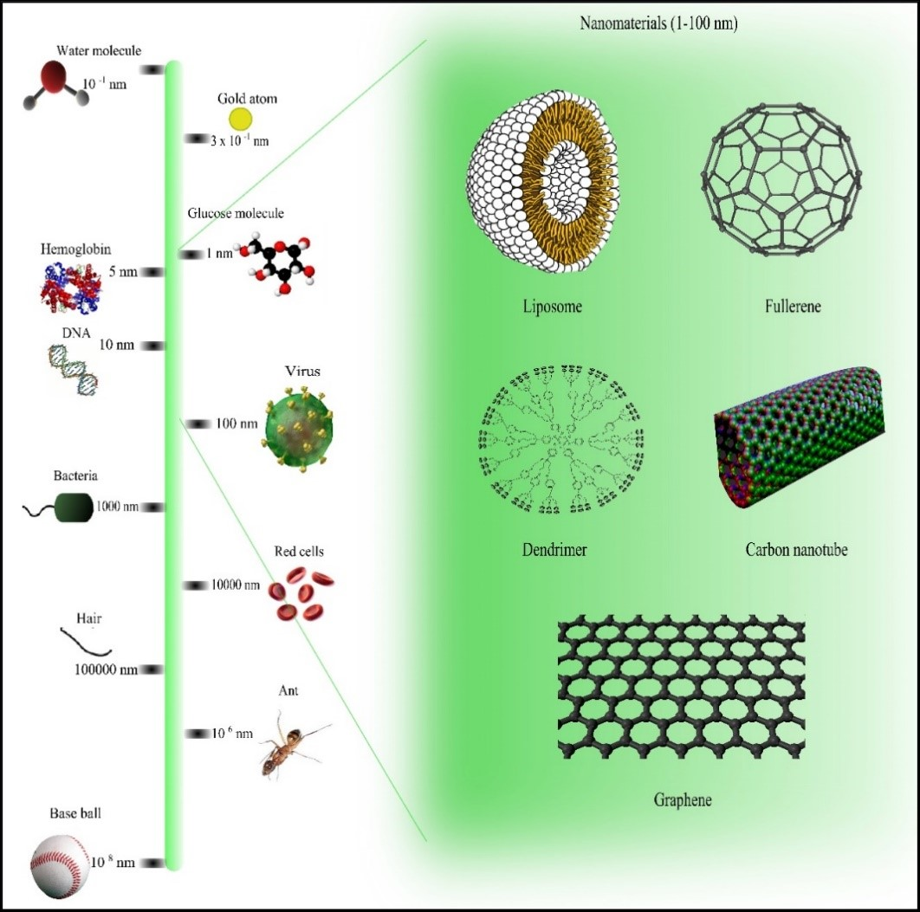
Figure 1.1. Comparison of nanomaterial sizes with other common objects.
1.3. Nanoparticles
Nanoparticles have a size range from 1-100nm. These particles can be manufactured by green synthesis or chemical synthesis. Green synthesis is rapid, safe, non-toxic, sustainable, and eco-friendly. Green synthesis use plant extract to synthesize nanoparticles. It is used in medicine, cosmetics, and cloth (Hassan et al., 2015).
1.4. Types of Nanoparticles
1.4.1. Metallic Nanoparticles
In 1857, Faraday discovered metallic nanoparticles while in 1908, Mie described nanoparticles color changing phenomenon in solution. Characteristics of metal nanoparticles are mentioned below:
- Large Surface energies
- Quantum Confinement
- Large surface area
- Plasmon excitation
- Specific Electronic Structure (Pal, 2019)
Silver nanoparticles because of their unique antimicrobial activity against prokaryotic organisms such as bacteria and viruses and some other eukaryotic microorganisms showed more efficacy. They have a wide range of applications in textile industries, in water treatment, as a sunblock, and as antimicrobial agents. The plants that are efficiently used for the formation of Ag NPs are Azadirachta indica, Coriandrum sativum, Mintha pipperita, Carica papaya, etc.
Gold nanoparticles have a wide range of applications such as in immunochemical studies, as a lab tracer, in the detection of antibiotics, etc. The nanorods made of gold are utilized in stem cells detection, for cancerous diagnosis along with the detection of the different bacterial classes. gold nanoparticles exhibit excellent catalysis activity in many organic reactions at room temperatures. Owing to undesirable Chemical compounds and toxic chemical effects by chemical synthesis hinders the catalysis activity in various industrial applications.
1.4.2 Alloy
These nanoparticles show some unique structural properties. Silver exhibits the highest electroconductivity among the metal that are used as fillers. Other metals as well as their metal oxides also exhibit good electrical conductivity. These nanoparticles show more benefits than commonly used metallic nanoparticles. Bimetallic or trimetallic nanoparticles are considered more effective than monometallic nanoparticles because of their synergistic characteristics.
1.4.3 Magnetic
There is a type of nanoparticles known as magnetic nanoparticles such as magnetite and maghemite that are biocompatible. Magnetic nanoparticles have two components. One is magnetic components like Zn, Cu, and Fe. The second is a chemical component with specific functionality (Pal et al., 2019). They are utilized in the treatment of cancer as magnetic hyperthermia, in gene therapy, medical diagnosis, drug delivery, DNA analysis, stem cell sorting as well as in its manipulation and magnetic resonance imaging.

.

CHAPTER 2:
LITERATURE REVIEW

- Literature Review
Nguyen et al., (2018) explained the synthesis of metallic nanoparticles using the green synthesis method. The use of biological methods for the fabrication of metal nanoparticles has attracted wide attention due to its low cost, feasible and eco-friendly approach. The approach was applied to synthesize a variety of metal nanoparticles including Au, Pt, Pd, Ag, and CuO NPs. Natural polymer gum karaya acts as a reducing and stabilizing agent. The characterization techniques used in this work were Zetasizer Nano, UV-Visible spectroscopy, and electron microscopy. The biological effect of synthesized nanoparticles was investigated on a unicellular alga. By measuring photosynthetic efficiency, algal growth, oxidative activity, and membrane integrity the biological effect can be elaborated. Algal growth was slightly reduced by Au and Pt nanoparticles at the concentration of 5mgL⁻¹ while Pd, Ag, and CuO nanoparticles showed complete inhibition of algal growth.
Mohsen et al., (2017) reported the catalytic potential of green synthesized CuO nanoparticles using aqueous medium. The method reported in this work was the microwave-assisted technique. By using this technique copper salt was chemically reduced in the presence of hydrazine hydrate which act as a strong reducing agent. The formation of well-dispersed CuO nanoparticles was confirmed by various characterization techniques. Copper oxide catalyst fabricated from biological method showed many advantages that include the use of eco-friendly solvent, green synthesis method, and mild reduction conditions for the synthesis of nanoparticles.
Ghidan et al., (2016) studied CuO nanoparticles fabricated by green synthesis using Punica granatum peel extract. Green synthesized nanoparticles were characterized by spectroscopy techniques like FTIR, SEM, UV-Vis, and XRD. The nature of the particles was crystalline with a 40nm size. The formation of CuO nanoparticles was accomplished by the concentration of Punica granatum peel extract. It also included Cu⁺² ions.

CHAPTER 3:
EXPERIMENTAL WORK

- Experimental Work
The experimental section was performed at chemistry laboratory, Department of Chemistry, School of Science, University of Management and Technology, Lahore. During experimental work, chemicals, apparatus, solvent, and instrument used are given below:
  - Chemicals
    - Chemicals Used for Green Synthesis of CuO Nanoparticles
- CuSO₄.5H₂O Solution
- Plant Extract
- Double Distilled Water
3.2. Apparatus
- Beaker (100ml, 250ml, 500ml)
- Conical flasks (500ml, 250ml)
- Volumetric flasks (100ml)
- Sample vials
- Stirrer
- Cotton
- Aluminum Foil
- Measuring Cylinder
- Pipette
- Thermometer
- Petri dishes
- Burette

CHAPTER 4:
RESULTS AND DISCUSSION
4. Results and Discussion
4.1. Scanning Electron Microscope (SEM) Analysis
All the results obtained must be properly explained with the help of figures, graphs, and tables.
All the figures and graphs along with the caption must be centralized. The caption of tables must be left aligned. The Figures and Tables must be of an appropriate size not too large and not too small. Figure Table or Text must be Aligned and within the defined scale. All the tables and figures numbers must be cited in the text.
Table 4.1. Percentage scavenging and IC₅₀ of standard (Ascorbic acid)

Concentration mg/mL | Absorbance of Control | Absorbance of standard | % Scavenging | IC₅₀
0.05 mg/mL | 0.940 | 0.820 | 12.77 | 0.20
0.125 mg/mL | 0.940 | 0.668 | 28.94 | 0.24
0.25 mg/mL | 0.940 | 0.597 | 36.49 | 0.37
0.5 mg/mL | 0.940 | 0.501 | 46.70 | 0.51

4.2. CONCLUSION
In the conclusion provide your findings in your own words. The Conclusion must be written in systematic and understandable writing.
References
Arshad, H. M., Gauhar, S., Bano, R., & Muhammad, I. N. (2009). Development of HPLC-UV method for analysis of cefixime in raw materials and in capsule. Jordan Journal of Pharmaceutical Sciences, 2(1), 53-65.
Aldalbahi. A, Aldawish. B, Awad, M.A.G., Aldosari, N.S., Alshathri, R.H. and Shoqiran, K.I.B. (2021).JUSTIA Patents 1095010. King Saud University
Brown, J. Q., Vishwanath, K., Palmer, G. M., & Ramanujam, N. (2009). Advances in quantitative UV–visible spectroscopy for clinical and pre-clinical application in cancer. Current Opinion in Biotechnology, 20(1), 119-131.
(2013, May-9). Copper Oxide (CuO) Nanoparticles - Properties, Applications. Retrieved from https://www.azonano.com/article.aspx?ArticleID=3395
Mali, A., Jadhav, S., Gorad, R., Quazi, A., Bathe, R., Patil, M., & Tamboli, A. (2016). Simultaneous UV Spectrophotometric Methods for Estimation of Cefixime Trihydrate and Ofloxacin in Bulk and Tablet Dosage Form. Asian Journal of Pharmaceutical Research, 6(2), 100-106.
Mathew, C., Swathi, B., Ajitha, M., & Babu, P. S. (2016). Development and validation of a new and economical stability indicating RP-HPLC method for cefixime trihydrate. Brazilian Journal of Pharmaceutical Sciences, 52, 87-94.
The citations must be according to the format provided in these guidelines. All the cited references at the end of the report must be cited in the report as well and must be cross-checked. References should be arranged in alphabetical order.

