English Emersion

Jul 11, 2024, 11:14 AM (23 hours ago)
Dear Dr. Irfan,

English Immersion is an online course and it has no specific course outline as the lectures are based on different, random online videos and audios, chosen for students' communication skills. It's mainly based on improving their listening and speaking skills. The lectures are solely based on the discussion of those videos/audios and students' speaking practice during the class in order to encourage them to speak confidently and effectively.

Ramish Nazir
Hope your query got addressed.

Thanks!
--
Regards,
Ms Ramish Nazir
Digital Course Facilitator (Assistant Manager)
UMT-CONNECTED
University of Management and Technology
C-II, Johar Town, Lahore, Pakistan.

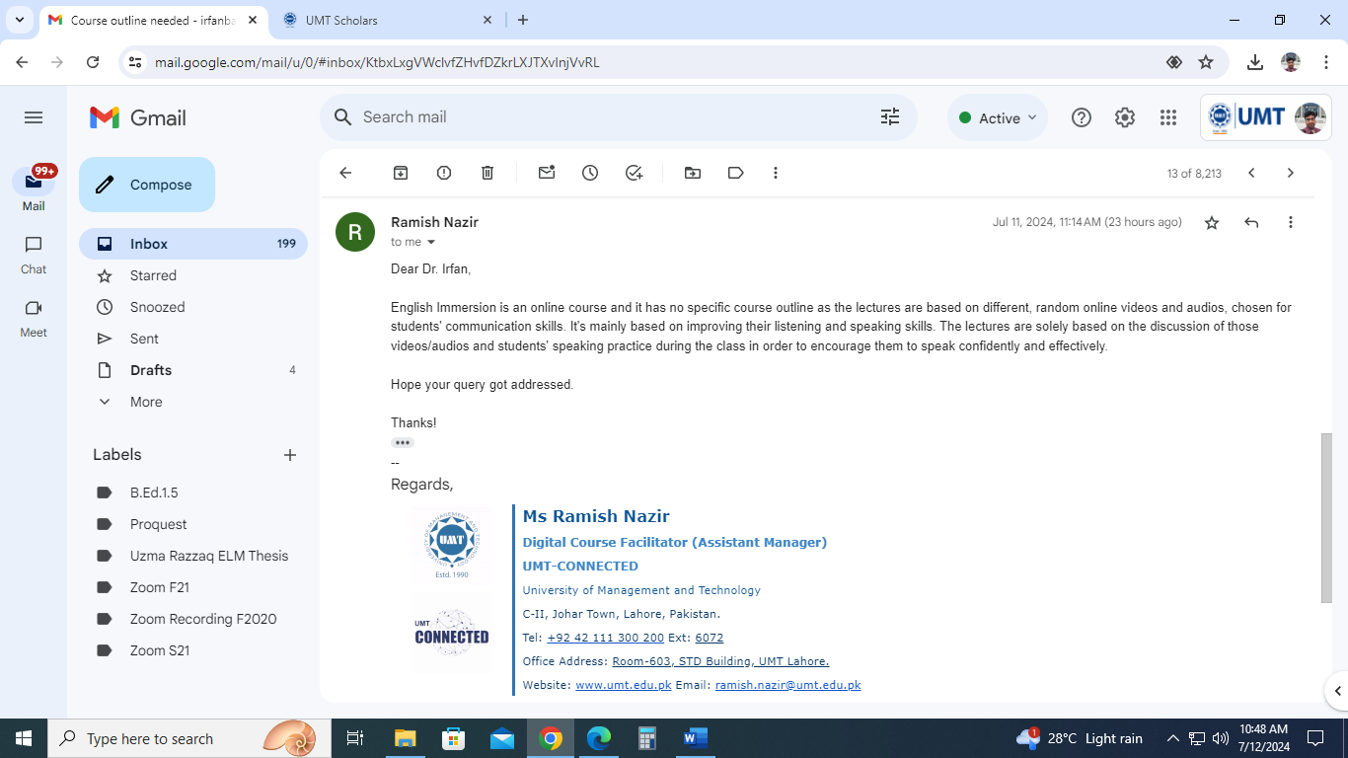
to me

