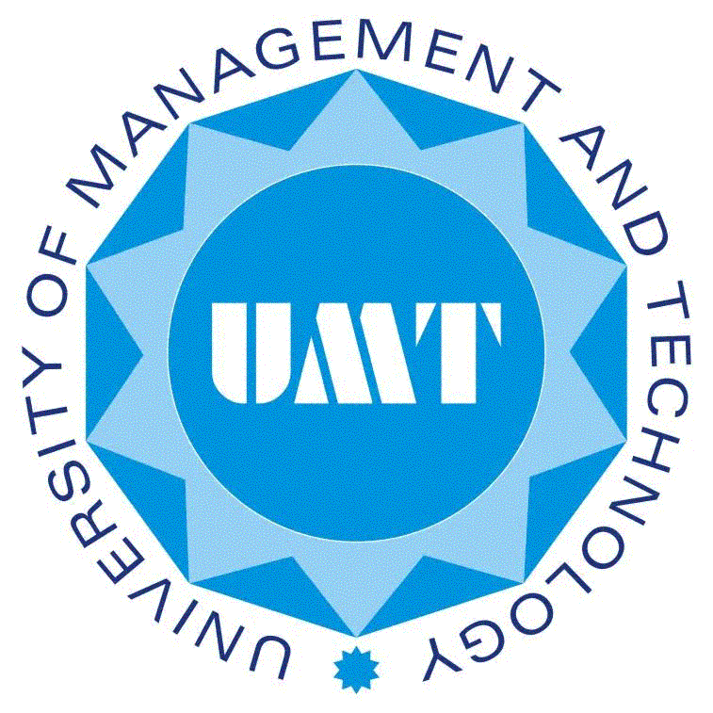**UNIVERSITY OF MANAGEMENT & TECHNOLOGY**

**SCHOOL OF SOCIAL SCIENCES & HUMANITIES**

**Department of Education**

|  |  |
| --- | --- |
| Program | PhD |
| Course Title | Advanced Research Methods |
| Course Code | ED 710 |
| Credit hours | 3 |
| Semester | Fall 2023 |
| Duration | 16 Weeks |
| Course Coordinator | Prof. Dr. Rizwan Akram Rana |
| Contact Detail | Cell: 0300-4202966 |
| E-mail | rizwan,akram@umt.edu.pk |

1. **COURSE DESCRIPTION**

The course Advanced Research Methods is intended to provide participants with the Knowledge and skills to do primary research in both the academic setting and in the practical world of education including theories of education. This course is designed to prepare participants to comprehend, analyzed and evaluate materials and issues associated with the logic of the scientific method, research design, and quantitative and statistical analysis of data. Connecting to take students through each step involved in conceiving a research idea to writing research report primarily in researches involving empirical data but the course will also accommodate students intending to do qualitative studies. Thus, course involves a lot of hands on activities on the part of the students. The ideal output of the course will be a research proposal/article produced by each students or least having some work which can be continued to produce a publication at some stage.