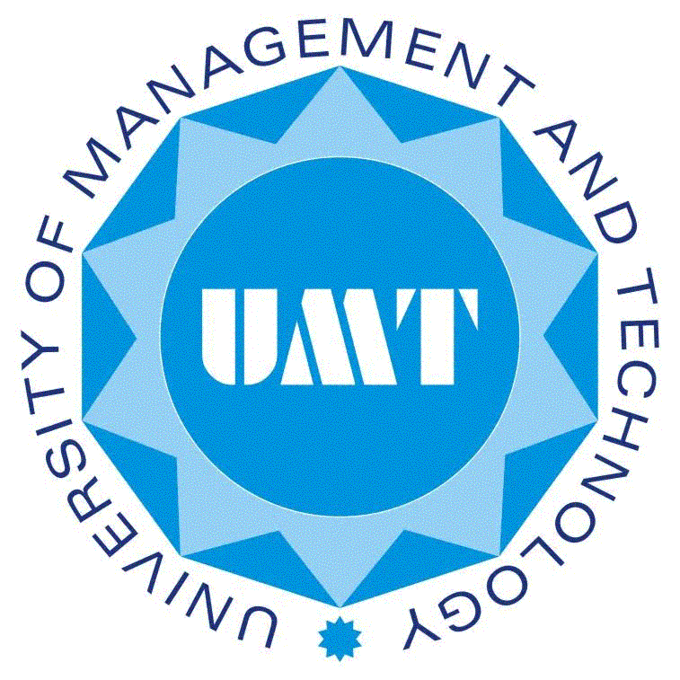
UNIVERSITY OF MANAGEMENT & TECHNOLOGY
DEPARTMENT OF GENDER STUDIES

GS-635 GENDER, HUMAN RIGHTS AND LAW

Capsule Statement:

This course examines the development of women’s human rights in International, National and Religious perspectives from legal, political, social and cultural dimensions. Topics covered in the course include history of UN human rights mechanism, International system for protection of women’s rights, Muslim family laws and recent amendments in Constitution of Pakistan.

Objectives:
After the completion of this course, students will be able to

- Familiarize with the knowledge of the relationship between gender and human rights
- Explore origins, development and challenges of integrating gender into human rights law discourse and practice
- Introduce relevant international bodies and instruments and critical analysis of law within the context of women’s rights protection

Contents:
- Introduction
  - International Women’s Human Rights and Categories of Difference: Understanding the boundaries of human and human rights
  - Universal Declaration of Human Rights (UDHR)
  - International Covenant, Civil and Political Rights, thru 28
  - International Covenant, Economic, Social, Cultural, thru 13
  - Highlights from relevant HR Documents
    - International Convention on the Elimination of All Forms of Racial Discrimination, Pt. I
    - Convention against Torture, Pt I, gist of Pt. II
    - Supplemental Convention on Abolition of Slavery, 1-4
    - Declaration on the Elimination of Intolerance Based on Religion, all
    - Declaration on the Right to Development, 5, 6, 8
- International system for protection of women’s rights
  - Historical development
  - Declaration on the Elimination of All Forms of Discrimination Against Women
  - Convention on the Elimination of All Forms of Discrimination Against Women and its Protocol
    - Overview
    - Work of Committee
    - CEDAW and Cultural consideration
    - A Reservation to the Women's Convention and Objections to that Reservation
  - World Conference on Human Rights: Vienna Declaration, I, 1-23, 28-30; II, 22, 36-53
  - Beijing Declaration and Platform for Action: Beijing+5 Political Declaration and Outcome
  - Declaration on the elimination of violence against women
- Islam and Human rights
  - Islamic Human rights and the Last Sermon of the Holy Prophet (SAW)
  - Cairo Declaration on Human Rights in Islam (CDHRI)
- Constitution of Pakistan – Safeguards for women
  - Muslim Family Law in the subcontinent
  - Muslim Family law Ordinance 1961
    - Marriage, polygamy, divorce, dissolution of marriage otherwise by divorce, maintenance, dower, and gifts, parents and child guardianship, will and inheritance.
  - Changes introduced in the criminal laws: Law of Evidence, Shariyat Act, Rajam, Qisas and Diyat, Hudood and Punishments.
  - The Protection against Harassment of Women at Workplace Act, 2010
  - The Acid Control and Acid Crime Prevention Act, 2010
  - Child Marriage Restraint Act 1929/ 2016
  - The Punjab Protection of Women Against Violence Act 2016

Recommended Readings:
Basic Documents:

UDHR. (1948). http://www.ohchr.org/EN/UDHR/Documents/UDHR_Translations/eng.pdf
International Covenant, Civil and Political Rights. (1966). http://www.ohchr.org/Documents/ProfessionalInterest/ccpr.pdf
International Covenant, Civil and Political Rights (1966). http://www.ohchr.org/Documents/ProfessionalInterest/ccpr.pdf
International Covenant, Economic, Social, Cultural. (1966). http://www.ohchr.org/Documents/ProfessionalInterest/cescr.pdf
International Convention on the Elimination of All Forms of Racial Discrimination (1966). http://www.supremecourt.ge/files/upload-file/pdf/act6.pdf
Convention against Torture. (1984). http://www.ohchr.org/Documents/ProfessionalInterest/cat.pdf
Supplemental Convention on Abolition of Slavery (1956). http://www.ohchr.org/EN/ProfessionalInterest/Pages/SupplementaryConventionAbolitionOfSlavery.aspx
Declaration on the Elimination of Intolerance Based on Religion (1981). http://www.ohchr.org/Documents/ProfessionalInterest/religion.pdf
CEDAW. (1981). http://www.ohchr.org/Documents/ProfessionalInterest/cedaw.pdf
Vienna Declaration. (1993). http://www.ohchr.org/Documents/ProfessionalInterest/vienna.pdf
Declaration on the elimination of violence against women (1993) http://www.ohchr.org/Documents/ProfessionalInterest/eliminationvaw.pdf
Cairo Declaration. (1990). http://www.bahaistudies.net/neurelitism/library/Cairo_Declaration_on_Human_Rights_in_Islam.pdf
Muslim Family Law Ordinance (1961). http://lgkp.gov.pk/wp-content/uploads/2014/03/Muslim-Family-Laws-Ordinance-1961.pdf
The Protection against Harassment of Women at Workplace Act. (2010). https://www.iba.edu.pk/News/protection-of-women-act2010-03082016.pdf
Government of Pakistan Labour Policy. (2010). http://www.ilo.org/dyn/travail/docs/995/Government%20of%20Pakistan%20Labour%20Policy%202010.pdf
Changes introduced in the criminal laws. (2011). http://www.na.gov.pk/uploads/documents/1393931809_140.pdf
The Punjab Protection of Women Against Violence Act (2016). http://punjablaws.gov.pk/laws/2634.html
Child Marriage Restraint Act. (1929). http://punjablaws.gov.pk/laws/147a.html
Child Marriage Restraint Act. (2016). http://www.na.gov.pk/uploads/documents/1458813688_951.pdf
The Acid Control and Acid Crime Prevention Act. (2010). http://bolobhi.org/wp-content/uploads/2012/02/Acid-Control-and-Acid-Crime-Prevention-Act-2010.pdf

Other Readings:

Agarwal, B. R. (ed.). (1986). Plight of a Muslim Woman: The Shah Bano Case. New Delhi: Arnold-Heinemann.
Ahmad, Anis. (1991). Women and Social Justice: Some Legal and Social Issues in Contemporary Muslim Society. Islamabad: Institute of Policy Studies.
Ahmed, K. (1972). The Muslim Law of Divorce. Islamabad: Islamic Research Institute.
Ali, Shaheen Sardar. (2000). Gender and Human Rights in Islam and International Law: Equal Before Allah, Unequal before Man. The Hague: Kulwer Law Institute.
Ali, Shaheen Sardar (2002) Gender and Human Rights in Islam and International Law: Equal Before Allah, Unequal Before Man? UK: Kluwer Law International, London.
Ali, Shaheen Sardar. (1994). Are Women also Human? Women’s Rights and Human Rights in Tribal Areas: A Case Study of the Provincially Administered Tribal Areas of Pakistan. Pakistan Journal of Women’s Studies: Alam-e-Niswan 1, no., 21–26.
Asghar Ali Engineer (ed.) (2001). Islam, Women and Gender Justice. New Delhi: Gyan Publishing House.
Ashraf, Mohammad. (1969). Family Laws in Pakistan: as amended up-to-date with exhaustive commentary. Lahore: Premier Book House.
Askin, Kelly (1999). Women and International Humanitarian Law, Women's Human Rights: A Reference Guide, (Kelly Askin & Dorean Koenig eds.) pp. 41-87. New York: Transnational Publishers.
Balchin, Cassandra. (1994). A Handbook of Family Law in Pakistan. Lahore: Shirkat Gah.
Charlesworth, Hilary. (1999). Feminist Methods in International Law. American J. of Int'l Law 93: 379-394. pp. 379-385
Cook, R, B., Dickens and M. Fathalla, (2003). Reproductive health and human rights, Oxford: Clarendon Press. Rights relating to Reproductive and Sexual Health pp154-179
Cook, Rebecca. State Responsibility for Violations of Women's Rights, 147-152 (issues). pp 172-174 (limitations)
Denise Brennen. (2003). Selling Sex for Visa: Sex Tourism as Stepping Stone to International Migration. In Global Woman: Nannies, Maids, and Sex Workers in the New Economy. pp. 154--‐168.
Firdous, Rehana. (2000). “Woman’s Right of Separation (Khula) Can She Claim it as a Matter of Law?” Pakistan Journal of Women’s Studies: Alam-e-Niswan 7, no. 1, 1–20.
Firdous, Rehana. (2003). A Permissible Step for Restraining Man’s Unilateral Right of Divorce: Talaq-i Tafwid (Delegation Power of Divorce). Pakistan Journal of Women’s Studies: Alam-e-Niswan 10, no. 1, 73–79.
Fraser, Arvonne. (1999). Becoming Human: The Origins and Development of Women's Human Rights. Human Rights Quarterly 21: 853-906. pp. 885-904
Gruskin, Sofia et al. (2008). Using human rights to improve mental and neonatal health: history, connections and a proposed practical approach. Bulletin of the World Health Organization 86.8. pp 589-592.
Huang, Margaret. (2007). Going global: Appeals to International and regional human rights bodies. Bringing human rights home, Vol. 2. Westport, CT: Praeger Perspectives. pp. 105-122.
Jahangir, Asma and Hina Jilani. (1990). The Hudood Ordinances: A divine sanction? A research study of the Hudood ordinances and their effect on the disadvantaged sections of Pakistani society. Lahore: Rhotas Books.
Khan, Shahnaz. (2006). Zina, transnational feminism, and the moral regulation of Pakistani women. Vancouver: UBC Press.
Mansuri, Ghazal. (2008). Family law and custom in Pakistan. Pakistan Journal of Women’s Studies: Alam-e-Niswan, vol. 15, no. 1, 1-27.
Mehdi, Rubya . (1997).Women’s Law in Legal Education and Practice in Pakistan: North South Co-operation. Copenhagen: New Social Science Monograph. Patel, Rashida. 2003. Woman versus man: socio legal gender inequality in Pakistan. Karachi: Oxford University Press.
Mehdi, Rubya. (1994). The Islamization of the Law in Pakistan. Richmond, Surrey: Curzon Press
Mehdi, Rubya. (2002). Gender and property law in Pakistan: resources and discourses. Lahore: Vanguard.
Okin, Susan Moller. (1998). Feminism, Women's Human Rights, and Cultural Difference. Hypatia. Vol. 13, No. 2, Border Crossings: Multicultural and Postcolonial Feminist Challenges to Philosophy (Part 1). pp. 32-52
Patel, Rashida. (1986). Islamization of Laws in Pakistan. Karachi: Faiza Publishers.
Rebecca Cook (1990). Reservations to the Convention on the Elimination of All Forms of Discrimination against Women. Virginia J. of Int'l Law 30: 643- 716. pp. 660-663
Roth, Kenneth. (1994). Domestic Violence as an International Human Rights Issue in Human Rights of Women: National and International Perspectives 326-339. Philadelphia: U of Penn Press.
Shah, Niaz A. (2006). Women, the Koran and international human rights law: the experience of Pakistan. Leiden: Martinus Nijhoff Publishers.
Shaheed, Fareeda (1998). The Other Side of the Discourse. Women’s Experiences of Identity, Religion, and Activism in Pakistan, in Patricia Jeffery and Amrita Basu (ed.). Appropriating Gender: Women’s Activism and Politicized Religion in South Asia. New York: Routledge, pp. 143–64.
Shaheed, Fareeda (ed.) (1997). Women’s Law in legal education and practice in Pakistan: north south cooperation. Copenhagen: New Social Science Monograph.
Walters, Rossie. (2013). Are Women’s Rights Human Rights? http://www.e-ir.info/2013/07/20/are-womens-rights-human-rights/
Warraich, Sohail Akbar. (2004). Reading the Constitution: In Search of Rights. Lahore, Shirkat Gah.
Zia, Afiya Shehrbano. (1994). Sex crime in the Islamic context: rape, class and gender in Pakistan. Lahore, Pakistan: ASR.

