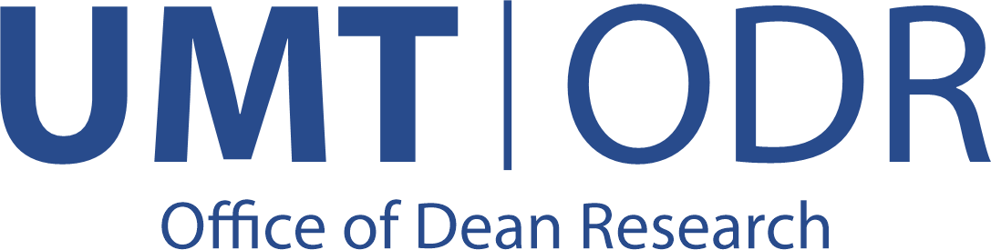
Newspaper Article Reward Claim Form

Date of Reward Claim: __/__/____ Sr. No. (For Official Use Only) -----------------------

Title of the Newspaper Article:

Date of Publication: |  | Total No of Authors: | No. of UMT Authors:
UMT Author no 1: |  | Employee Code: | Dept: |  | Contact No:
Email: | CNIC: | Reward Amount: |  | Signature:
UMT Author no 2: |  | Employee Code: | Dept: |  | Contact No:
Email: | CNIC: | Reward Amount: |  | Signature:
UMT Author no 3: |  | Employee Code: | Dept: |  | Contact No:
Email: | CNIC: | Reward Amount: |  | Signature:
Newspaper: |  | Publication detail:
Total Reward Amount as per UMT Policy:
Checklist:
Copy of published article attached. Yes □ Applicant Signature:
All UMT authors have signed the reward form. Yes □
All UMT authors' university cards (Employee/Student cards) are attached. Yes □
All UMT authors' CNICs are attached. Yes □ ____________________

Please Note: Apply only for the articles published from 1st October 2024 onwards. Non-UMT authors will not be considered, and their reward will be deducted from the total.
Incomplete and late submissions will not be considered. Fill out the form carefully.

____________________________________________ __________________________________
Verification of RGC Committee Member/Secretary Approval of Chairperson RGC

