How to Use Moodle LMS
Step 1:
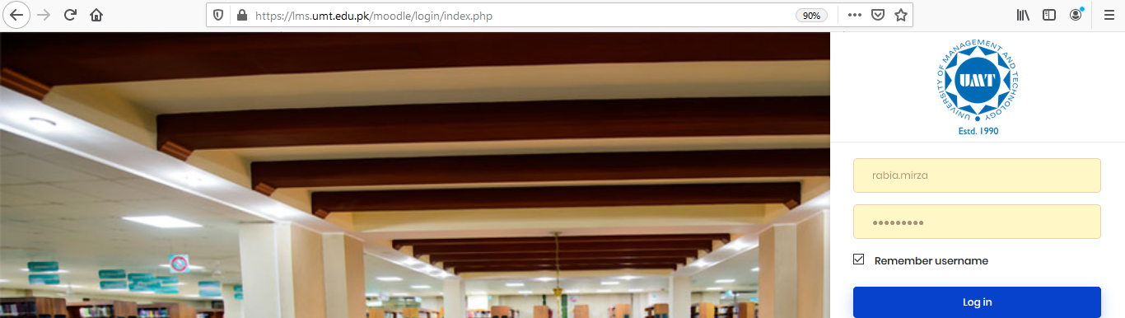
Copy and paste the given link in your browser URL area as highlighted in the image. https://lms.umt.edu.pk/moodle/login/index.php

Step 2:
Write/Enter your LMS ID and password in the red circled area.

Step 3:
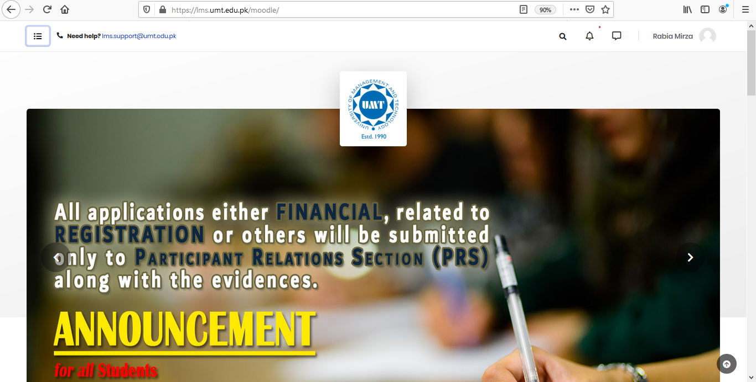
On the top left corner click on the menu button.

Step 4:
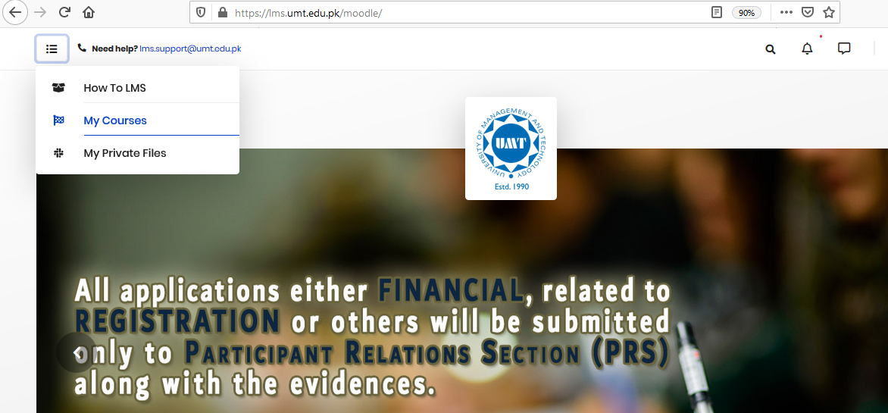
Click on “My Courses” as highlighted in the image.

Step 5:
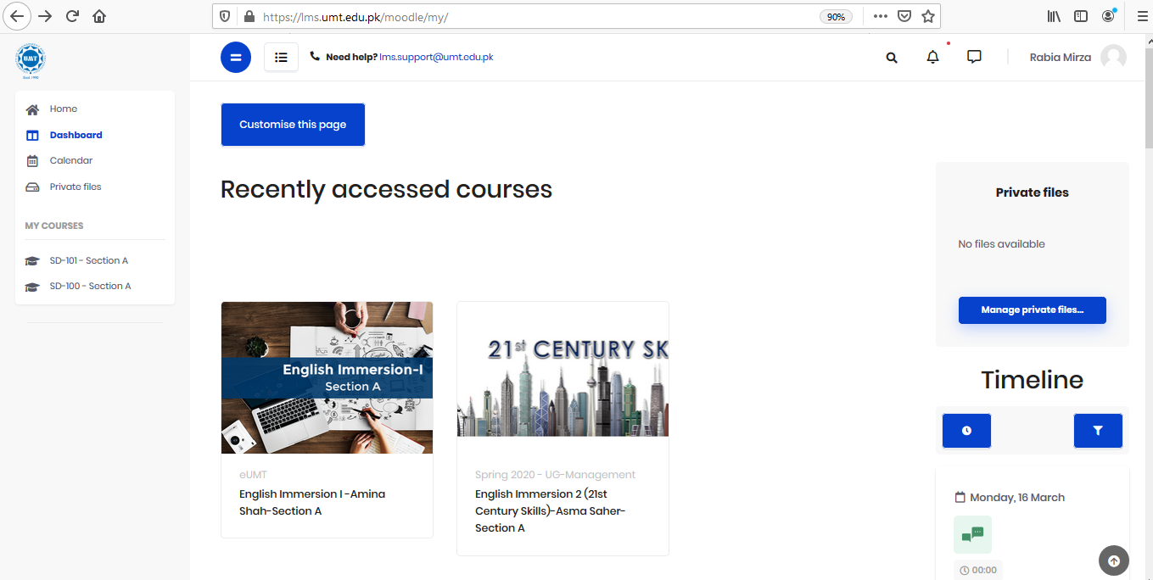
Now you are in the section where you can see all courses. Go to the course that you want to deliver online.

Step 6:
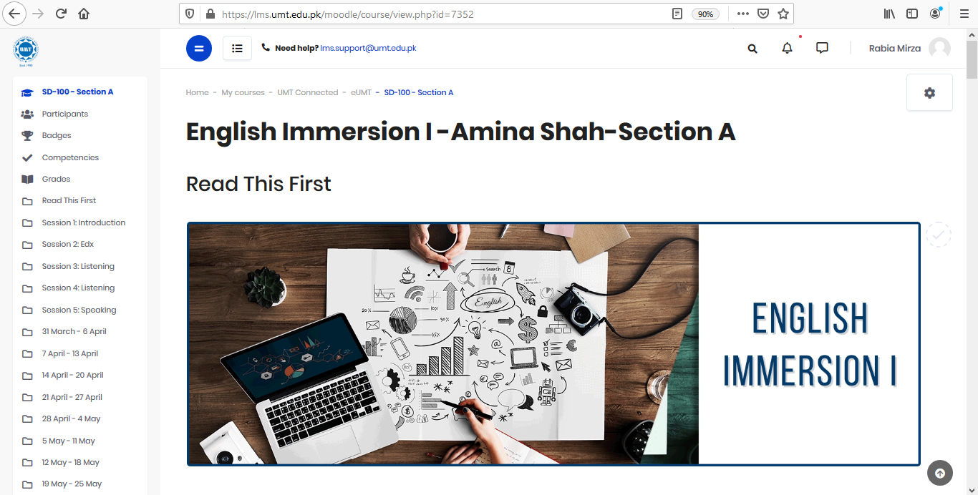
Now, you are in your desired course on the LMS.

S.T.A.I.R.S. office is always
there to help you out!
Feel free to visit the office
3S/32 Main Building
Call Us @ 0307 444 6362
Email Us @ stairs@umt.edu.pk

