Controls for Audio
Step 1
Click on “Manage Participants”
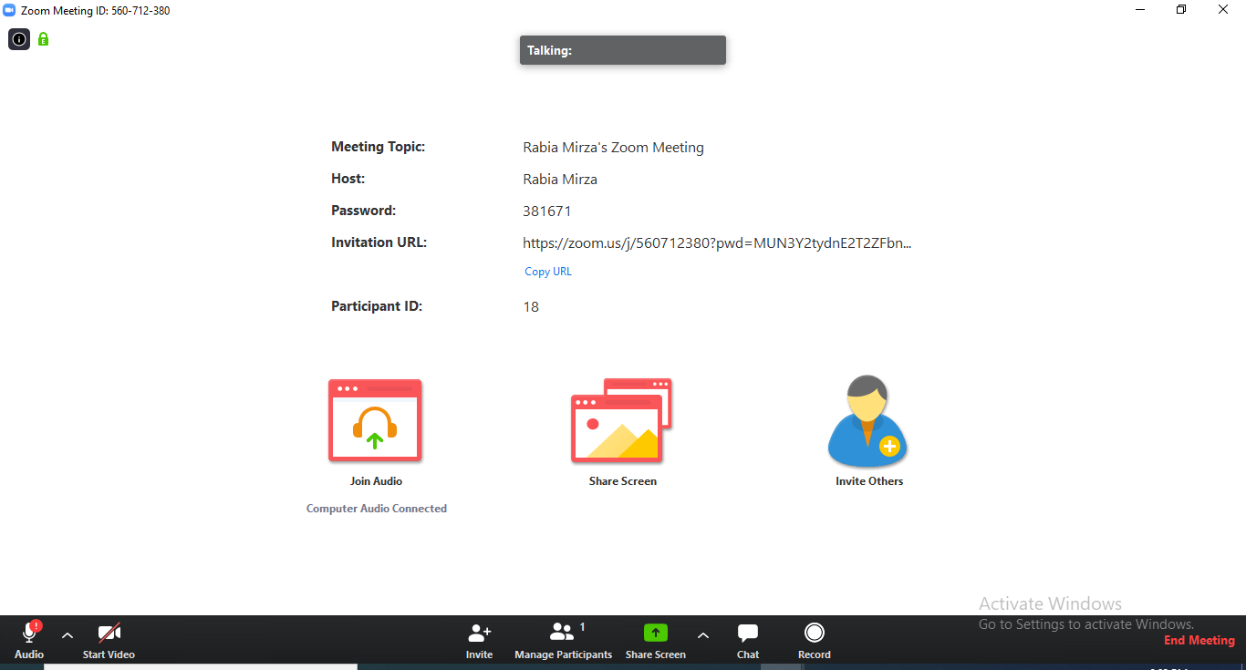

Step 2
Click on “Mute All” to ensure that your students will be muted during the lecture to avoid any interruption. You can unmute them after the delivery of lecture.
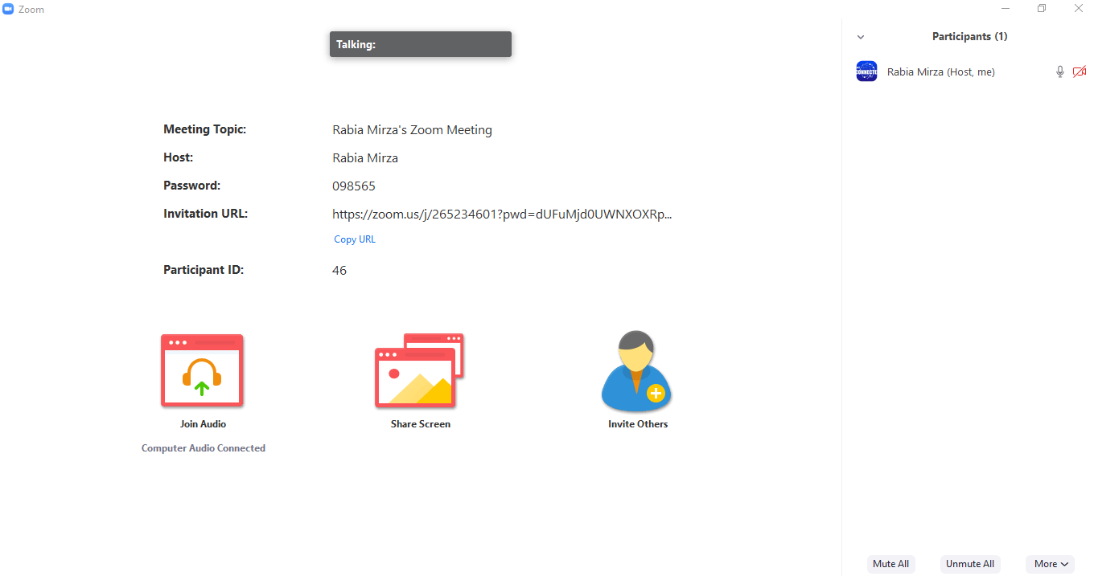

Step 3
Do not click on “allow participants to Unmute Themselves”. After that, click on “Yes”. Now, your students will not be able to Unmute themselves after you mute them.
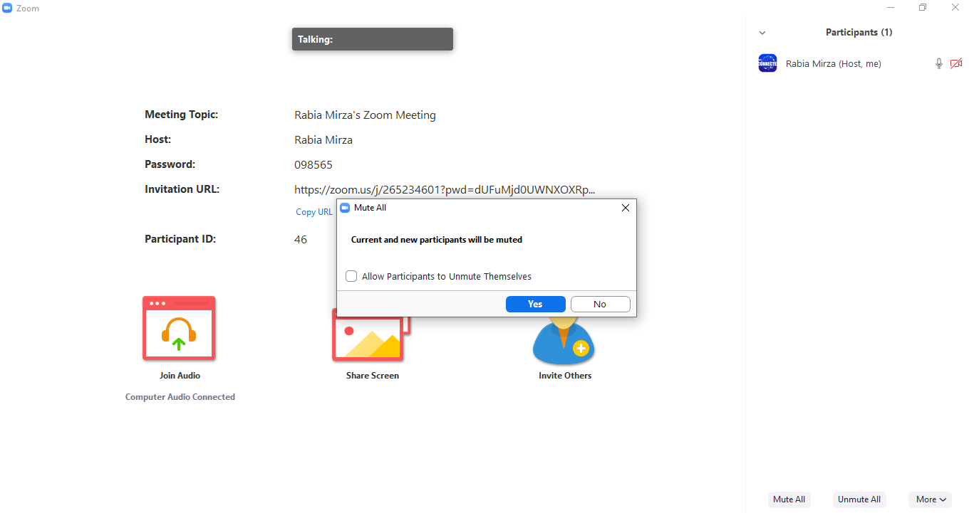

Step 4
Click on “More”

Step 5
Click only on “Mute Participants on Entry”. All other options should be deselected to ensure that your students do not Unmute or Rename themselves or Lock the meeting.
If you want to hear a sound each time your student join or leave the meeting, then Click on “Play Enter/Exit Chime” in the tool bar as highlighted in the figure below.
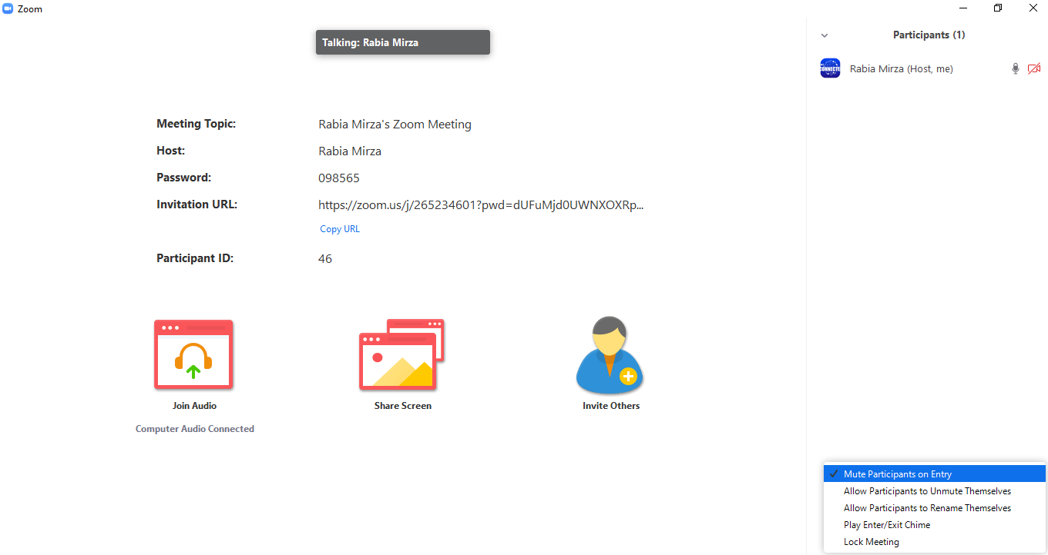
Controls for Chat
Step 1
Click on “Chat”

Step 2
Click on the “dots” as highlighted in the figure below.
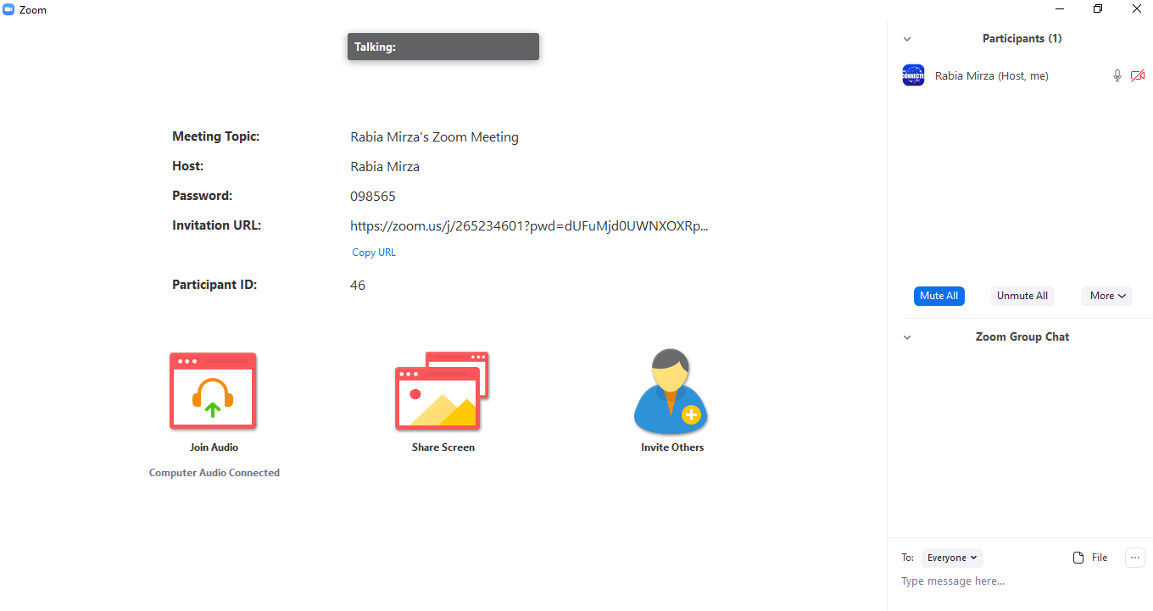

Step 3
Click on “Everyone Publicly” to make sure that your students interact with each other publicly instead of communicating in private.
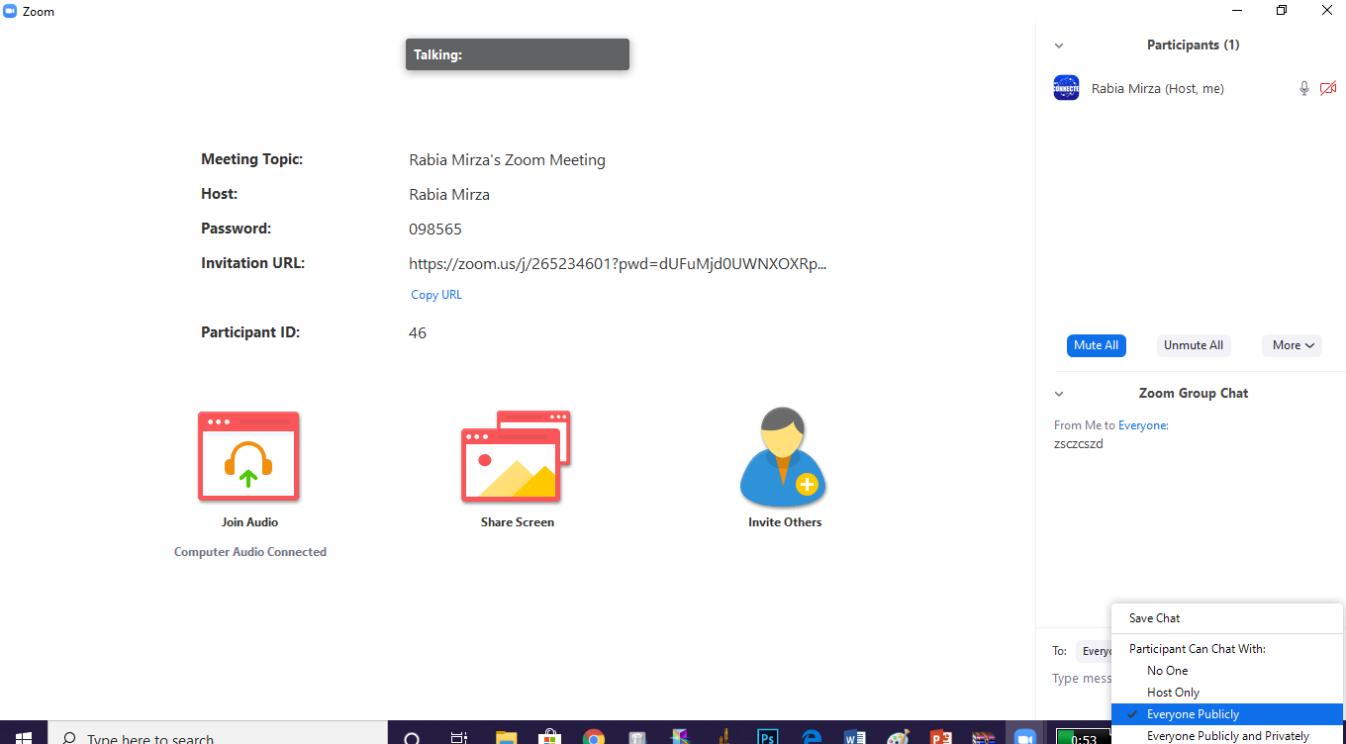

Controls for Screen Share
Step 1
Click on the little arrow present at the right of Share Screen as the arrow depicts.

Step 2
Click on “One participant can share at a time” to ensure that your students do not share their screen during the lecture delivery.
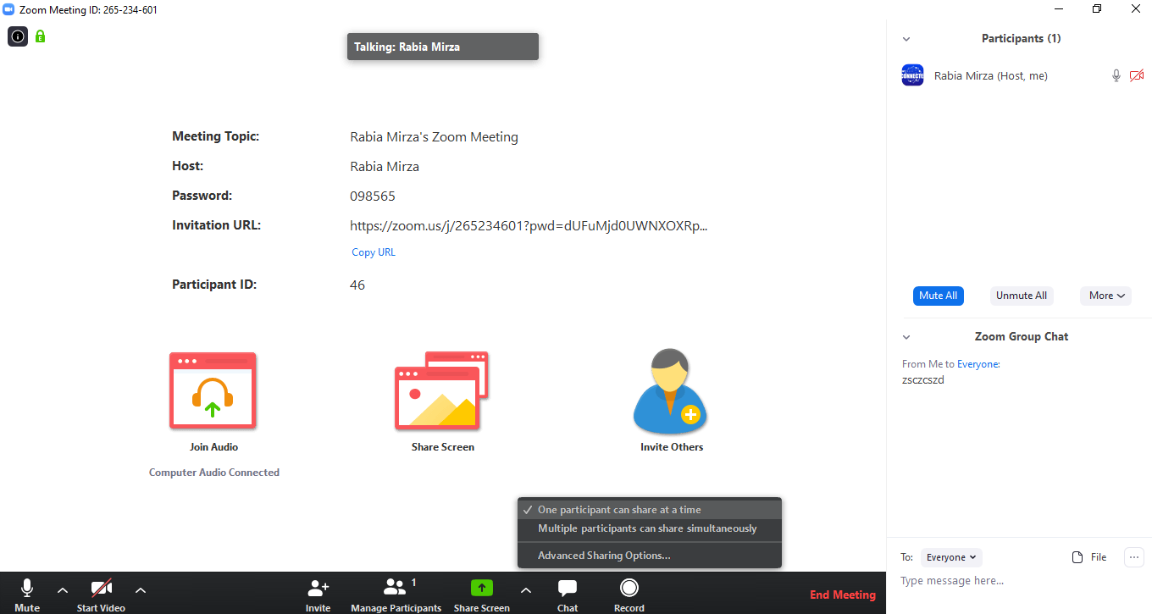

Controls for Whiteboard
Step 1
Click on “Share Screen”

Step 2
Click on “Whiteboard”
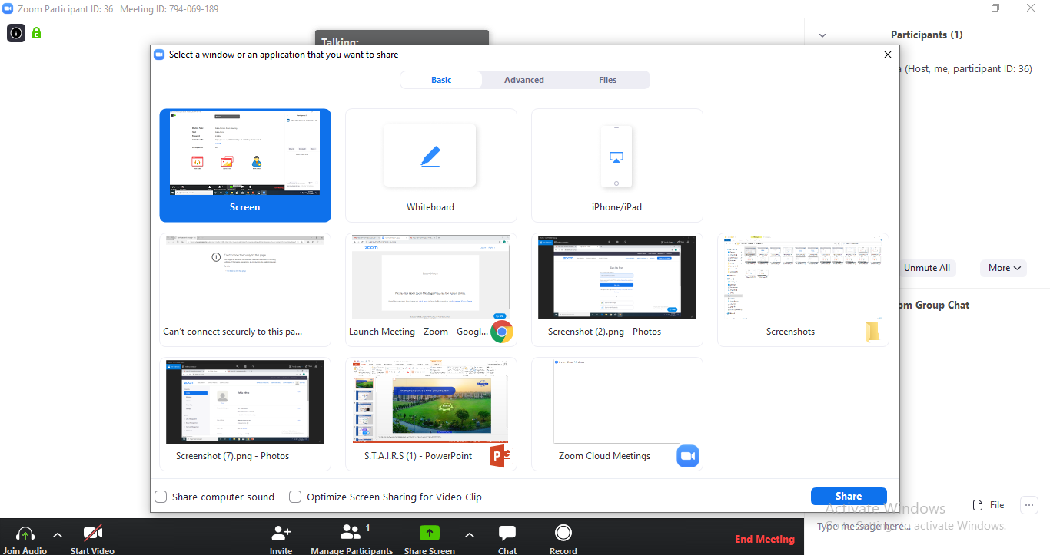

Step 3
Click on the “More” as shown by the arrow.
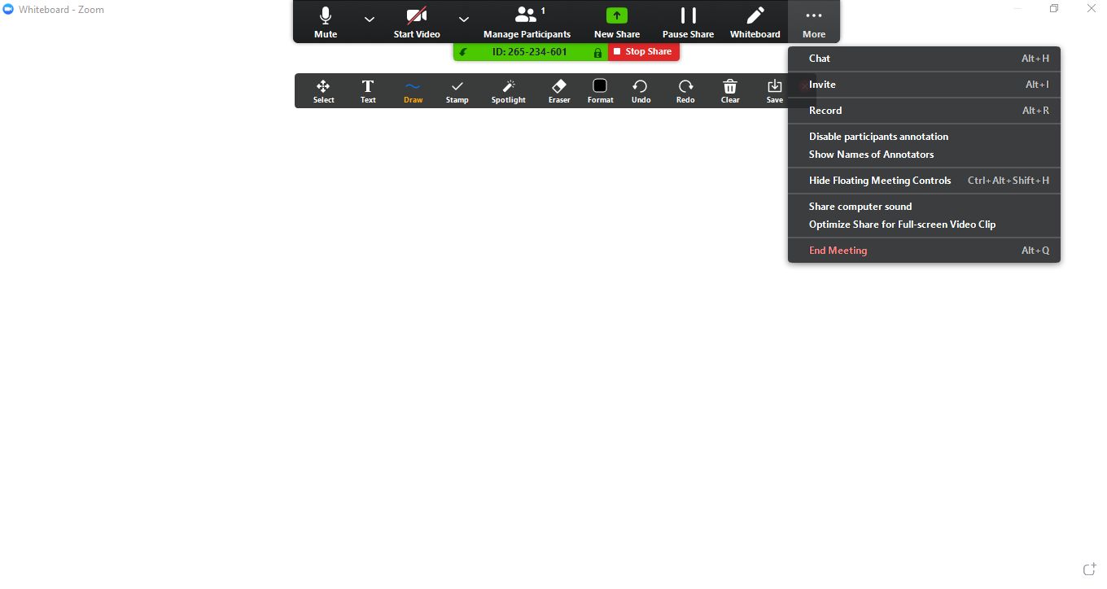

Step 4
Click on “Disable participant’s annotation” to make sure that your students do not write on the whiteboard while you are using it.
Step 4
If you want any student to write on the whiteboard, then click on “Show Names of Annotators”. This will allow you to identify the specific student who have written on the whiteboard.

