

**School of Business & Economics**

**Course Outline**

Course code…… MG644……….. Course title……..Organization Theory………………

|  |  |
| --- | --- |
| Program | MS Management / SHRM |
| Credit Hours | 3 |
| Duration | 15 Weeks |
| Prerequisites | - |
| Resource Person | Dr. Naveed Yazdani |
| Counseling Timing  (Room# ) | - |

**Chairman/Director signature………………………………….**

**Dean’s signature…………………………… Date………………………………………….**

**Capsule Statement**

Organization Theory, is a self explanatory course name. We all have basic understanding about organizations. Whereas, “theory”, in simple words, is logical explanation/description of a phenomenon. Course on Organization Theory, therefore, is an attempt to “logically describe organizations”.

A dedicated course at MS level on “logically explaining what organizations are” holds deep implications. For instance,

1. It implies that in contradiction to normative understanding, organizations are “complex” entities.
2. Since one theory explains a phenomenon through one perspective, an attempt to explain organization through multiple theories (as we will do in this course), implies that organizations are equivocal.
3. It also implies that for organizational scientists (that we all are aiming to be) it is of utmost importance to get into the complex discussion on prevailing and future perspectives about organizations. This very reason, in fact, makes this course worth studying.

In my point of view, these three implications are imperative in providing basis to the premise of Organization Theory and, hence, setting contours of this course. The subsequent section highlights some insights from literature to help us develop a view about the questions that beget from above implications. In coming classes, we will further explore these and other important implications by discussing the work of some leading ‘organizational scientists’.

The objectives of this whole endeavor are;

1. To discuss contemporary theoretical perspectives about ‘organization’
2. To build our capacity to understand organizations as complex and multifaceted realties, about which organizational actors continuously attempt to make sense
3. To be able to develop a comprehensive view about organizational life, to encounter the challenges posed by it
4. To extend our contribution towards Organizational Theory, in the form of conceptual note (research paper)

**Building view** (Based on three implications):

# Organizations as complex entities:

It is interesting to compare how three leading authors on organization theory, describe organizations:

Organizations are social entities that are goal directed, designed as deliberately structured and coordinated activity systems, and are linked to the external environment. (Daft, Organization Theory & Design, 2009)

Organizations are many things at once. They are complex and multifaceted. They are paradoxical. (Morgan, Images of Organizations, 2005)

Organization is collection of people, trying to make sense of what is happening around them. (Karl Weick, Sense Making of the Organizations)

So what are organizations? Consider the metaphoric explanation of organization, given by Karl E. Weick (Educational Organizations as loosely coupled systems, Administrative Science quarterly, 1976, Page 1), which reads as follows

Imagine that you are either the referee, coach, player or spectator at an unconventional soccer match: the filed for the game is round; there are several goals scattered haphazardly around the circular field, people can enter and leave the game whenever they want; they can say “that’s my goal” whenever they want to; as many times as they want to; and for as many goals as they want to; the entire game takes place on the sloped field, as the game is played as if makes sense.

Version 2 of the Soccer game metaphor appears on page 276 of the March and Olsen book titled Ambiguity and Choice in Organizations (1976) as fallows;

Consider a round, sloped, multi goal soccer field on which individuals play soccer. Many different people (but not everyone) can join the game (or leave it) at different times. Some people can throw balls into the game or remove them, Individuals while they are in the game try to kick whatever ball comes near them in direction of the goals they like and away from the goals that they wish to avoid. The slope of the field produces bias in how the balls fall and what goals are reached, but the course of a specific decision and the actual outcomes are not equally anticipated. After the fact, they may look rather obvious; and usually normatively reassuring.

Both these versions invite our attention to the fact that organizations are complex systems, which are not as deliberately structured as we normally see them; rather organizations are loosely coupled systems. But purpose here is not to say that organizations have no order or structure at all. The point is that organizations may be anarchies, but organized anarchies. Organizations may be loosely coupled, but they are loosely coupled systems. Organizations are deliberately structured, goals directed entities; but they are also loosely controlled political systems, instrument of production, living and learning systems, and many other things. In the words of G. Morgan “Organizations are many things at once! They are complex and multifaceted; they are paradoxical.”

If organizations are that complex, why do we generally tend to assume them a simple phenomenon? For Karl Weick, this is because of the sense making patterns. Weick argues that taking organization as rational and orderly systems is an allusion which stems out of flawed sense making of the situation. Though this assertion opens up a foray of interesting critiques and questions, two main points are worth considering here. One, that different people make different sense of the same situations. Weick asserts that this is because of the fact that “our commitmentis reference point of sense making. People have (1) different commitments - that are developed gradually as additive process – and (2) different cognitive structures (thinking style) – which make them interpret situations differently. This brings us to the second important point that why we have different commitments and cognitive structures. As David Hume argued, when a child is born, he or she would have a mind as a blank paper. From his or her interaction of the social environment, the child will start making patterns of frames of thinking and he or she would then make sense of the situations through those reference points or mental frames. To make it simple, imagine how would a child make sense of a cow, if he or she has never seen or heard of a cow? The sense of child would ultimately hinge on the reference point/thinking frames that he would have learned from the social environment. Similarly we, as business students, generally posses a simplistic, and flawed, sense about organizations because our social environment is of such which has given us those frames through which organizations look simple and straight forward situations.

# Describing organizationswith multiple perspectives/theories

In their article “From Borrowing to Blending: Rethinking the Process of Organizational Theory Building, *Academy of Management Review* 2011, Vol. 36, No. 2, 318–337.” Oswick, Fleming, and Hanlon note down the trend of using multidisciplinary approach in Organization Theory, as fallows;

It has been widely acknowledged that organization and management theory (OMT) is a multidisciplinary area of inquiry that extensively draws from other foundational disciplines (Huff, 1999; McKinley, Mone, & Moon, 1999; Reed, 1999; Tsang & Kwan, 1999). Arguably, this is not a problem on the basis that borrowing is an inevitable and integral facet of theory development in all disciplines, inasmuch as there are always foundational antecedents prefiguring and shaping the formulation of a specific theory. In this regard all theory development is, to a greater or lesser extent, derivative and “intertextual” (Bakhtin, 1981). However, we contend that there is an overreliance on borrowing within OMT.

One reason of describing organization with multiple perspectives and theories is therefore because of interdisciplinary approach being used in organization theory.

Another important reason is level of analysis. Consider an example of a glass on table, filled with water. At one level of analysis, the water will look static and calm. Whereas, if you change your level of analysis and look at that water through microscope, you would see a chaotic movement of molecules and atoms within it. The water will look turbulent and chaotic with a micro scope level of analysis; and would look static with an eye level analysis. Same is true about organizations and other phenomena. When you change your level of analysis, a different perspective/view of organization comes into front. In this course, and at MS/PhD level, we invite you to come into ‘organizational scientist role” and start looking at phenomena from multiple levels of analysis.

# Why to get into the complex discussion on prevailing and future perspectives about organizations?

In his critique of management theory, Sumantra Goshal (“Bad Management Theories are destroying good management practices, Academy of Management Learning & Education, 2005, vol, 4, No.1,75-91) furnishes following interesting line of argument;

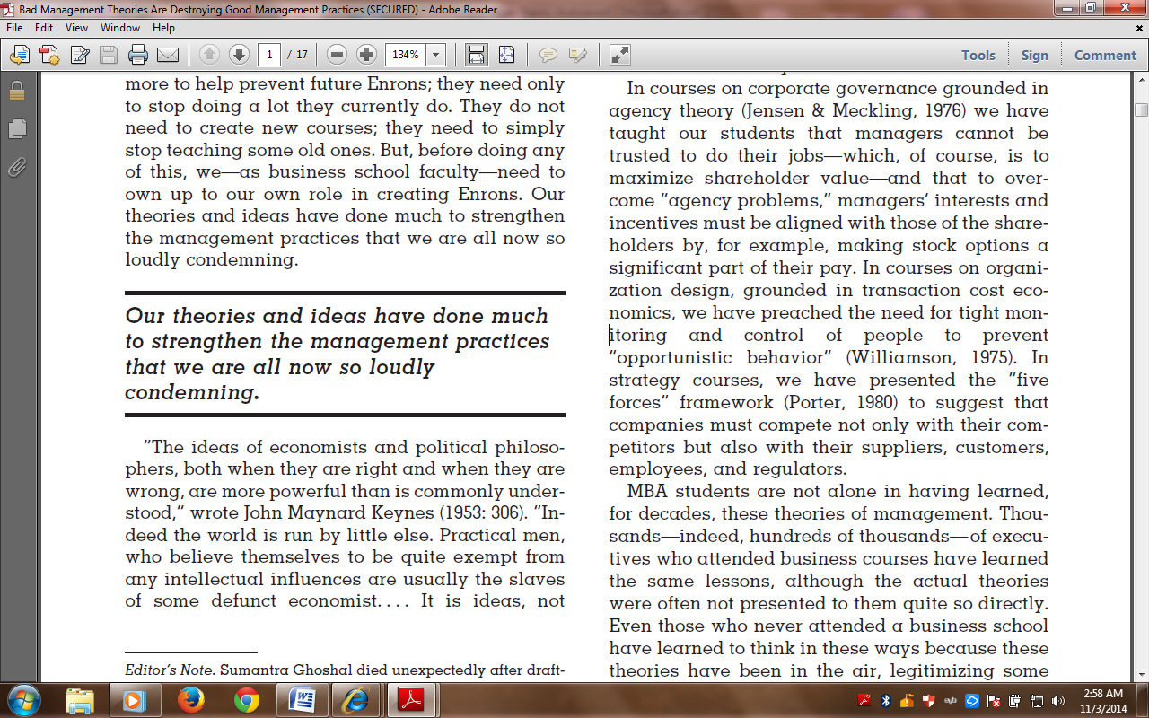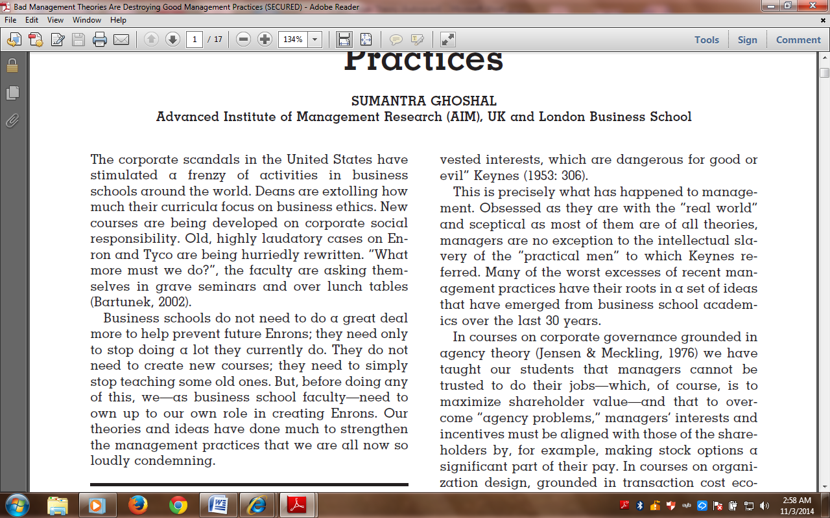

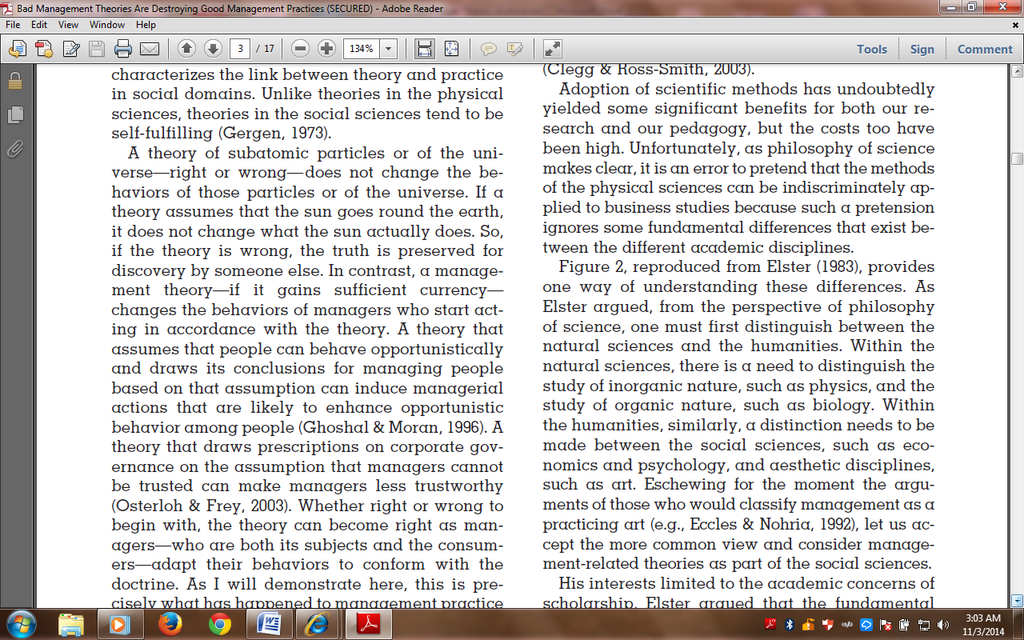

Finally, look at the following assertion by G. Morgan in preface of “Images of Organization”:

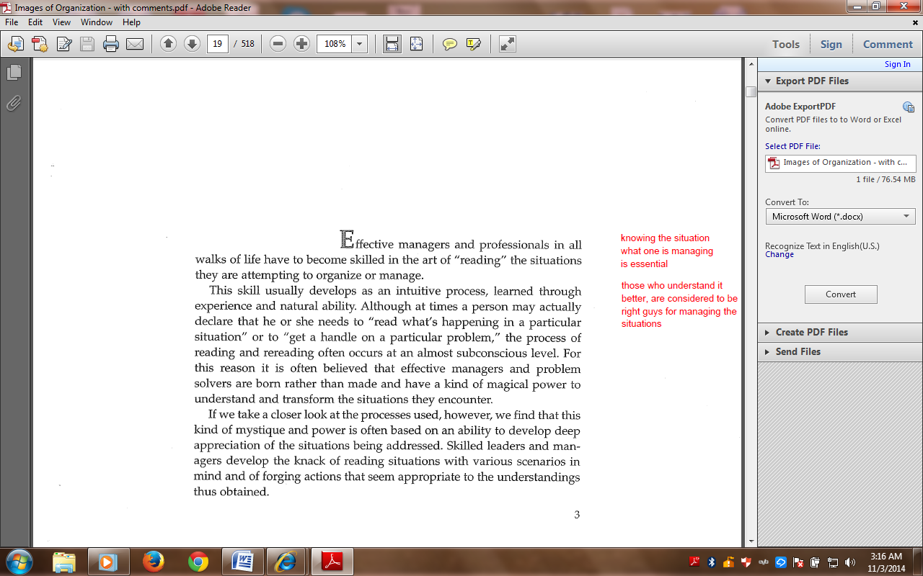



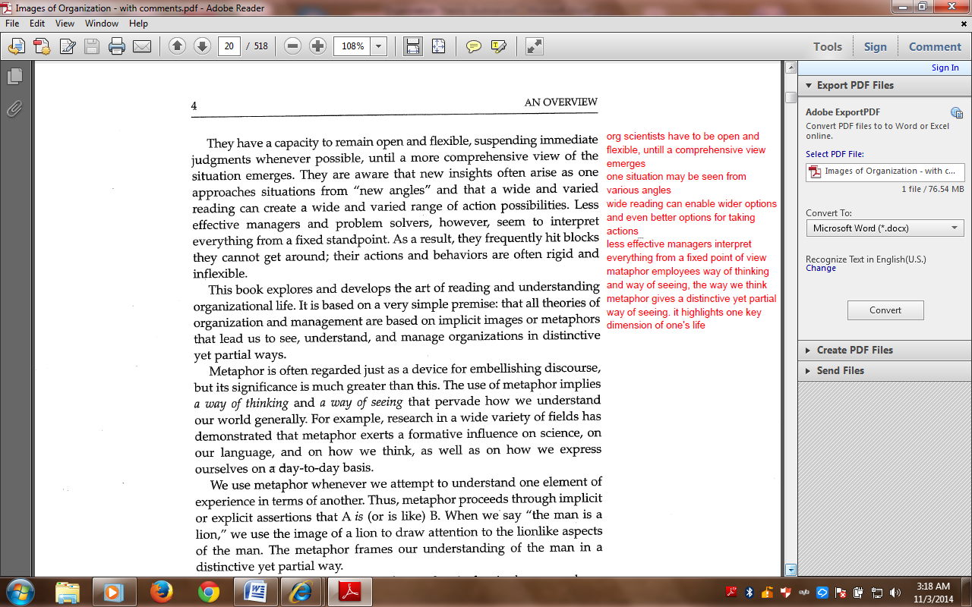

**Grading and Scores**

|  |  |  |
| --- | --- | --- |
| Class Participation | 30 points | Positive and healthy discussion is essence of class at MS/PhD level. All participants would have to come in class after reading the prescribed chapters and contribute towards class discussion. Asking relevant questions will be especially acknowledged. |
| Assignments | 30 points | 2 group based assignments (2 members group) will be given, where each group will submit Review of assigned chapter on prescribed format. |
| Presentation | 10 points | Participants will be given a topic in groups of 2 members each. It will be 20 minutes presentation. |
| Term Paper | 30 points | Each group (2 members) will write a Term paper, till end of the sessions. Details of term paper will be shared in due course. |

**\*\*\* Please note that Zero tolerance policy will strictly be observed regarding Plagiarism.**

**Readings**

Given the wide scope of the course, it is not deemed appropriate to recommend a single book as sole reference. An assortment of different articles and chapters of books has been compiled, in course pack form, for reading reference. The course pack is available with photocopier.

**Calendar of Activities**

|  |  |
| --- | --- |
| Session 1& 2 | Already held |
| Session 3 | Knowing more about each other, Discussion on Course outline  Lecture Focus: Organization Theory: A Primer |
| Session 4 | (1) Organization and Organization Theory – R. Daft  (2) Strategy, Organization Design and Effectiveness – R. Daft |
| Session 5 | Theory of Firms (Organizational Theory – Richard H. Hall) |
| Session 6 | Organization Size, Life cycle and Control – R. Daft  Organizations as Machines – G. Morgan |
| Session 7 | Organizations as Organisms – G. Morgan |
| Session 8 | Organizations as Brains – G. Morgan |
| Session 9 | Organizations as Culture, Organization as Political Systems – G. Morgan |
| Session 10 | Organizations as Psychic Prison – G. Morgan |
| Session 11 | Organization as Flux, Organizations as Instruments of Domination – G. Morgan |
| Session 12 | Origins of system Thinking – Ralph D. Stacey |
| Session 13 | Responsive Process thinking – Ralph D. Stacey |
| Session 14 | Sense making in organizations, Organizational Redesign as Improvisation– Karl E. Weick |
| Session 15 | Postmodernism as a philosophy: the ultimate challenge to organization theory – John McAuley, Jaonne Dubareley and Phil Johnson |
| Assignment one  **Due** in 6th Session | Sensemaking in organizations: small structures with large consequence – Karl E. Weick |
| Assignment Two  **Due** in 9th Session | Organizational Redesign as Improvisation – Karl E. Weick |

**Important Note:**

1. For each class, relevant research paper will be uploaded on moodle.
2. For each reading, discussion questions will be given (on moodle). Class discussion will primarily hinge on these questions.

**STUDENTS ARE REQUIRED TO READ AND UNDERSTAND ALL ITEMS OUTLINED IN THE PARTICIPANT HANDBOOK**

**Class Policy: -**

* Be on Time

You need to be at class at the assigned time. After 10 minutes past the assigned time, you will be marked absent.

* Mobile Policy

**TURN OFF YOUR MOBILE PHONE!** It is unprofessional to be texting or otherwise.

* Email Policy

**READ YOUR EMAILS!** You are responsible if you miss a deadline because you did not read your email.

Participants should regularly check their university emails accounts regularly and respond accordingly.

* Class Attendance Policy

A minimum of 80% attendance is required for a participant to be eligible to sit in the final examination. Being sick and going to weddings are absences and will not be counted as present. You have the opportunity to use 6 absences out of 30 classes. Participants with less than 80% of attendance in a course will be given grade ‘F’ (Fail) and will not be allowed to take end term exams. International students who will be leaving for visa during semester should not use any days off except for visa trip. Otherwise they could reach short attendance.

* Moodle

UMT –LMS (Moodle) is an Open Source Course Management System (CMS), also known as a learning Management System (LMS). Participants should regularly visit the course website on MOODLE Course Management system, and fully benefit from its capabilities. If you are facing any problem using moodle, visit <http://oit.umt.edu.pk/moodle>. For further query send your queries to [moodle@umt.edu.pk](mailto:moodle@umt.edu.pk)

* Harassment Policy

Sexual or any other harassment is prohibited and is constituted as punishable offence. Sexual or any other harassment of any participant will not be tolerated. All actions categorized as sexual or any other harassment when done physically or verbally would also be considered as sexual harassment when done using electronic media such as computers, mobiles, internet, emails etc.

* Use of Unfair Means/Honesty Policy

Any participant found using unfair means or assisting another participant during a class test/quiz, assignments or examination would be liable to disciplinary action.

* Plagiarism Policy  
    
  All students are required to attach a “Turnitin” report on every assignment, big or small. Any student who attempts to bypass “TurnItin” will receive “F” grade which will count towards the CGPA. The participants submit the plagiarism report to the resource person with every assignment, report, project, thesis etc. If student attempts to cheat Turnitin, he/she will receive a second “F” that will count towards the CGPA. There are special rules on plagiarism for final reports etc. all outlined in your handbook.
* Withdraw Policy

Students may withdraw from a course till the end of the 12th week of the semester. Consequently, grade W will be awarded to the student which shall have no impact on the calculation of the GPA of the student.A Student withdrawing after the 12th week shall be automatically awarded “F” grade which shall count in the GPA.

* Communication of Results

The results of quizzes, midterms and assignments are communicated to the participants during the semester and answer books are returned to them. It is the responsibility of the course instructor to keep the participants informed about his/her progress during the semester. The course instructor will inform a participant at least one week before the final examination related to his or her performance in the course.