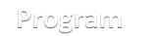


University of Management and Technology

Course Outline
Course code…… QM610………….. Course title…Statistical Analysis for Management Research ………

Program | MS Management
Credit Hours | 3
Duration | 15 Weeks
Prerequisites | -
Resource Person | Umer Ayub
Counseling Timing  (Room# ) | -
Contact | -
Chairman/Director signature………………………………….
Dean’s signature…………………………… Date………………………………………….

A major function of a business manager or an entrepreneur is to make decisions. Success of the organization or business depends heavily on soundness of these decisions. Quantitative methods have always played an important role in enhancing the soundness. However, with recent development in information technology, the role of quantitative techniques in decision making has increased manifold. More and more managers are using such techniques to complement their experience and expertise in business world.

This course is aimed to provide the necessary tools to managers and entrepreneurs for decision making in variety of business situations. Participants will learn to formulate the real life business problems into quantitative models. Teaching of conceptual framework of these tools will be supplemented by hands on application of various software packages that will aide in solving these models. Expertise will be developed in interpretation of these solutions and their use in decision making.

1
Learning Objectives

The purpose of the course is to provide the participants with mathematics, statistical and data analytical tools useful for business managers. Future managers will use these tools in planning, executing and evaluating their business needs. Upon successfully completing this course, the participants will be able to:

- Identify and formulate problems where quantitative techniques can have an impact.
- Use mathematical & statistical tools to solve these problems.

- Assess data with healthy skepticism and seek expert help when needed.
- Recognize when better data and information are needed for decision making.

Learning Methodology

Following instructional tools and methodologies would be used during the course.


Lectures 11 sessions in total including 1 MID TERM Exams.
Each of these lectures is accompanied by detailed description
of the technique, pertinent examples from the research world.
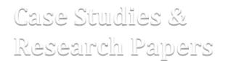

Case Studies & Each session is accompanied by discussions on Ca se Studies, Research Papers Research Publications.
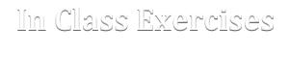

In Class Exercises Data analyses would be conducted to appreciate numerical
aspects of the techniques.
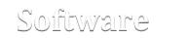

Software IBM SPSS


Mini Projects 9 Week long Mini-Projects to be completed

Recommended Text

There is no single book that covers the whole text for the course with respect to its philosophy and completes requirements. However, there are some books available that covers the course in its minimum requirements. This deficiency may be overcome by using some references besides a recommended book. Following text is recommended for the course;

2

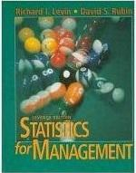

Statistics for Management
7th Edition,

By Richard I. Levin & David S. Rubin (1998) Prentice-Hall Singapore.
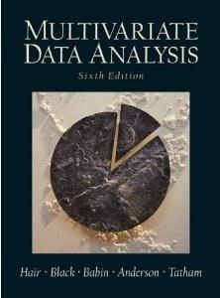

Multivariate Data Analysis
6th Edition

By Joseph F. Hair, Bill Black, Barry Babin, Rolph E. Anderson, Ronald L. Tatham

{2010) Pearson Singapore.

In addition to these, following texts may be used as additional sources and for references;
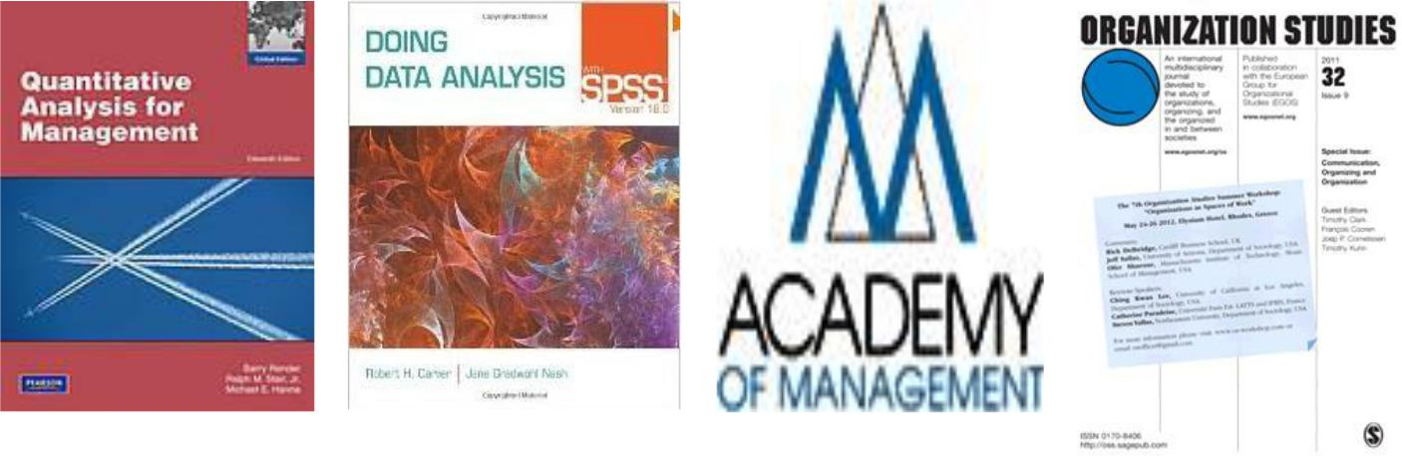

Quantitative Analysis | Doing Data Analysis with | Journal of Academy | Organization Studies
for Management, | SPSS, Version 18 | of Management, | By Sage Publications.
By Barry Render, Ralph | By Robert H. Carver,
M. Stair Jr., & Michael | Jane Gradwohl Nash
Hanna (2000) | Brooke/Cole.
Pearson Singapore.

3
Assessment Scheme
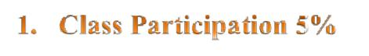

Participants are expected to be present, both physically and mentally, in each and every session and this is contributed towards their final evaluations. Attendance would be called in first 5 minutes of each session and no concession would be given in relaxing these minutes. Discipline should be maintained at all cost and a healthy and conducive participation is always cherished.


There would be 9 assignments in total. Some of these assignments are group assignments where participants are expected to produce the solution in groups. All of these assignments are 7 day’s long duration and are to be submitted at the start of the 8th day for full grading. No concession would be given for this due date. However, you may submit your assignments at any time after this date with a deduction of 1% points/day. All of these assignments would have three parts; Data Analysis using SPSS, Critique on Research Paper, and Doing research from Newspaper. All of these components carry equal marks.
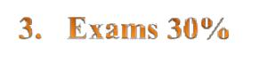

There would be ONE exam; around the middle of the semester.


Participants are expected to produce a term paper at the end of the semester. The themes for current semester are “Performance Measurement”, "Learning Organization", “Leadership in Crises” and "Entrepreneurship" where the students are expected to collect data using a given instrument, analyze the data for the hypotheses, and to present the results. Usually, a time period of THREE weeks is given after the conclusion of 14 classes to submit the paper.

Cheating

Participants are expected to do their own work in their assignments, quizzes and exams. They are always encouraged to discuss with each other but the assignments, quizzes and exams should be their own work reflecting their own effort and intellect. The School of Business & Economics is VERY STRICT against any action of plagiarism, copying and cheating. So don’t put yourself in any embarrassing position that may mar your career. In summary, any or all of these actions may be taken against you in case of cheating.

4

Topics to be Taught

- Shapes & Distributions

- Averages & Dispersion
- Uncertainties and their calculations
- Models & Modeling
- Logistic Models
- Factor Analysis

- Cluster Analysis
- Discriminant Analysis
- Canonical Correlation Analysis

Lecture Plan

Topic | Text to be Covered | Exercises/Assignments
Shapes & |  Statistical & Mathematical Data | .
Distributions |  Data Collection & Scales
 |  Data Presentation Techniques
 |  Frequency Distribution & Histograms
 |  Recognition of Shapes
 |  Skewness & Symmetry of Shapes
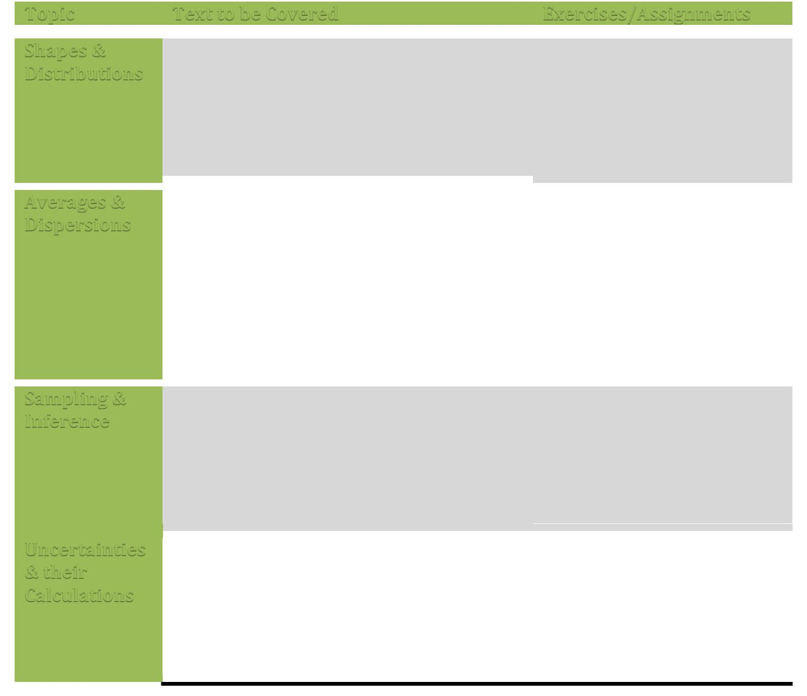
 |  | Arithmetic Mean
Averages & | ☞ | Arithmetic Mean
Dispersions | ☞ | Median
- Mode

- Empirical Relationship between Mean, Median & Mode
- Variance & St. Deviation
- Kurtosis
- Skewness Calculations

Sampling & |  Sampling Techniques
Inference |  Inferential Statistics
 |  Generalization Concept
 |  Statistical Tests

Uncertainties  Probability & Related Calculations

& their  Binomial Probability Distributions Calculations  Normal Probability Distribution
- Role of Probability in Managerial decisions
- Using SPSS for Probability

5

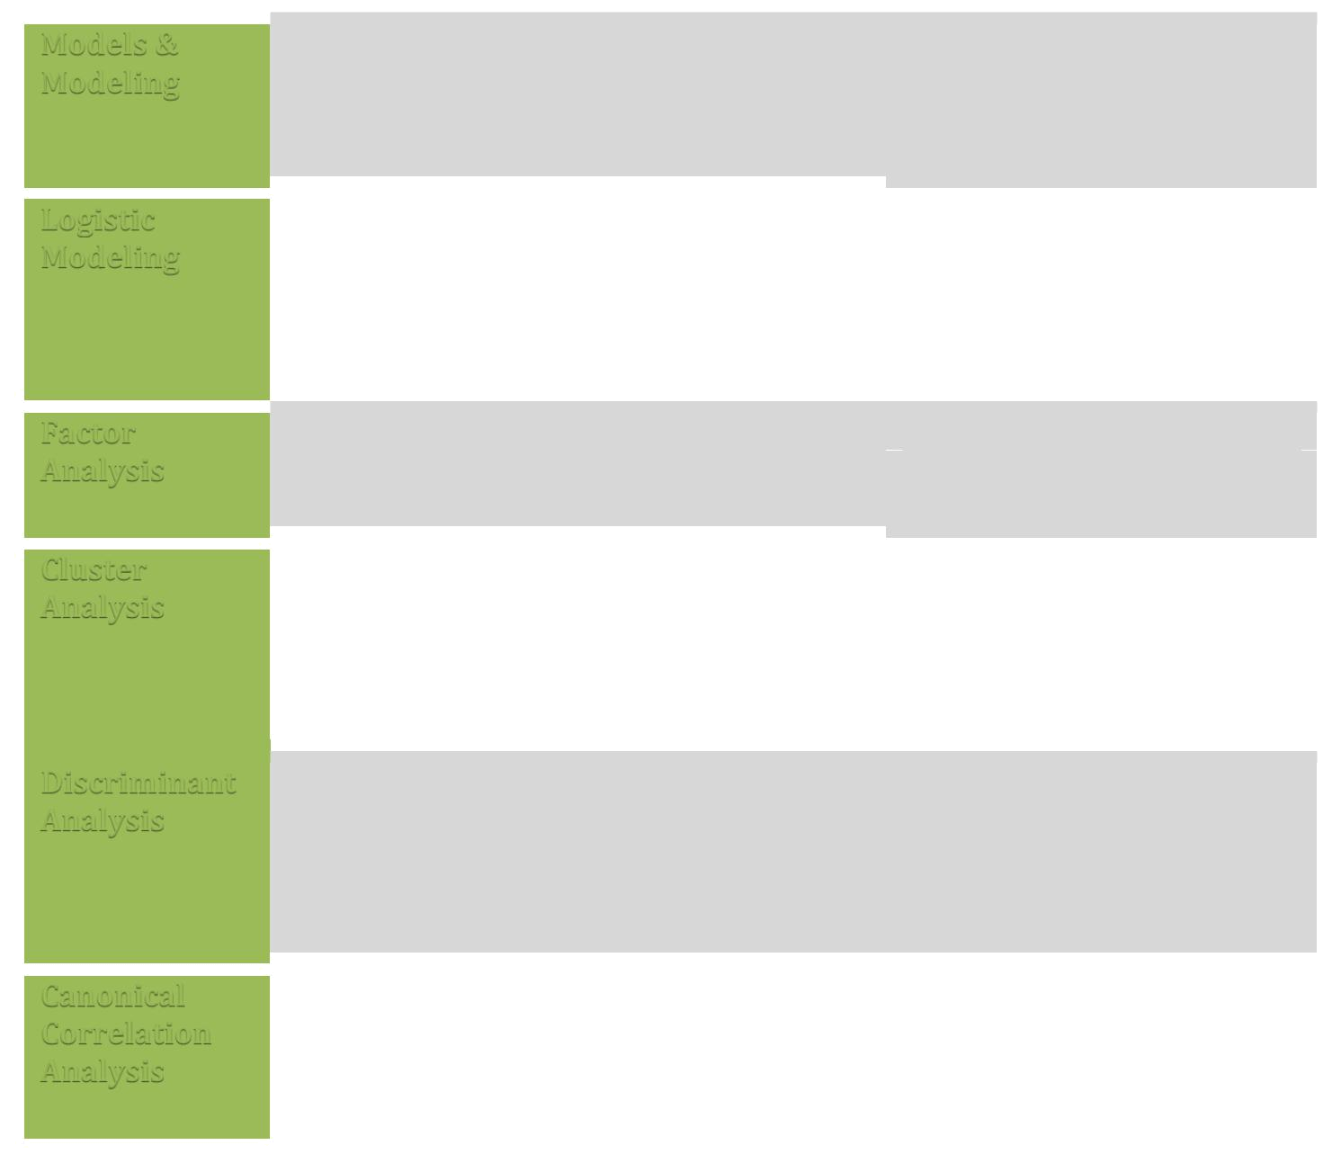 |  |  Relationships & Dependencies
Models &
Models & |  | ☞ | Multiple Regression Analysis
Modeling |  | ☞
Modeling |  | ☞ | Coefficient of Determination
 |  |  Forecasting
 |  |  Binomial Modeling
Logistic
Logistic |  | ☞ | Multinomial Modeling
Modeling |  | ☞
Modeling |  | ☞ | Logit/Probit Modeling
 |  |  Factor Model
Factor
Factor |  | ☞ | Factor Loadings
Analysis |  | ☞
Analysis |  | ☞ | Factor Profiling
 |  |  Grouping & Segments
Cluster
Cluster |  | ☞ | Frequentist Approach
Analysis |  | ☞
Analysis |  | ☞ | Bayesian Approach
 Quick Clustering
 Cluster Memberships

Discriminant Analysis

- Problem of Criterion Based Grouping

- Clustering vs Discriminant
- Logistic Modeling & Discrimination
- Classification Problems
- Group Membership

 |  |  Group Based Correlation Analysis
 | Canonical
 | Canonical | ☞ | Use of Factor Analysis
 | Correlation | ☞ | Use of Factor Analysis
 | Correlation | ☞ | Use of Canonical Correlation in
 | Analysis | ☞ | Use of Canonical Correlation in
 | Analysis |  | Managerial decisions & policy Making

6

STUDENTS ARE REQUIRED TO READ AND UNDERSTAND ALL ITEMS OUTLINED IN THE PARTICIPANT HANDBOOK

Class Policy: -

Be on Time

You need to be at class at the assigned time. After 15 minutes past the assigned time, you will be marked absent.

Mobile Policy

TURN OFF YOUR MOBILE PHONE! It is unprofessional to be texting or otherwise. In case you caught using mobile phone in the class plenty will be imposed

Email/Portal Announcement Policy

READ YOUR EMAILS! You are responsible if you miss a deadline because you did not read your email or portal announcement. Participants should regularly check their university emails accounts/portal announcement regularly and respond accordingly

Class Attendance Policy

A minimum of 80% attendance is required for a participant to be eligible to sit in the final examination. Being sick and going to weddings are absences and will not be counted as present. You have the opportunity to use 6 absences out of 30 classes. Participants with less than 80% of attendance in a course will be given grade ‘SA’ (Short Attendance) and will not be allowed to take end term exams. International students who will be leaving for visa during semester should not use any days off except for visa trip. Otherwise they could reach short attendance.

Moodle

UMT –LMS (Moodle) is an Open Source Course Management System (CMS), also known as a learning Management System (LMS). Participants should regularly visit the course website on MOODLE Course Management system, and fully benefit from its capabilities. If you are facing any problem using moodle, visit http://oit.umt.edu.pk/moodle. For further query send your queries to moodle@umt.edu.pk

Harassment Policy

Sexual or any other harassment is prohibited and is constituted as punishable offence. Sexual or any other harassment of any participant will not be tolerated. All actions categorized as sexual or any other harassment when done physically or verbally would also be considered as sexual harassment when done using electronic media such as computers, mobiles, internet, emails etc.

Use of Unfair Means/Honesty Policy

Any participant found using unfair means or assisting another participant during a class test/quiz, assignments or examination would be liable to disciplinary action.

Plagiarism Policy All students are required to attach a “Turnitin” report on every assignment, big or small. Any student who attempts to bypass “TurnItin” will receive “F” grade which will count towards the CGPA. The participants submit the plagiarism report to the resource person with every assignment, report, project, thesis etc. If student attempts to cheat Turnitin, he/she will receive a second “F” that will count towards the CGPA. There are special rules on plagiarism for final reports etc. all outlined in your handbook.

Withdraw Policy

Students may withdraw from a course till the end of the 12th week of the semester. Consequently, grade W will be awarded to the student which shall have no impact on the calculation of the GPA of the student.A Student withdrawing after the 12th week shall be automatically awarded “F” grade which shall count in the GPA.

Communication of Results

The results of quizzes, midterms and assignments are communicated to the participants during the semester and answer books are returned to them. It is the responsibility of the course instructor to keep the participants informed about his/her progress during the semester. The course instructor will inform a participant at least one week before the final examination related to his or her performance in the course.

7

