University of Management and Technology

Online Portal
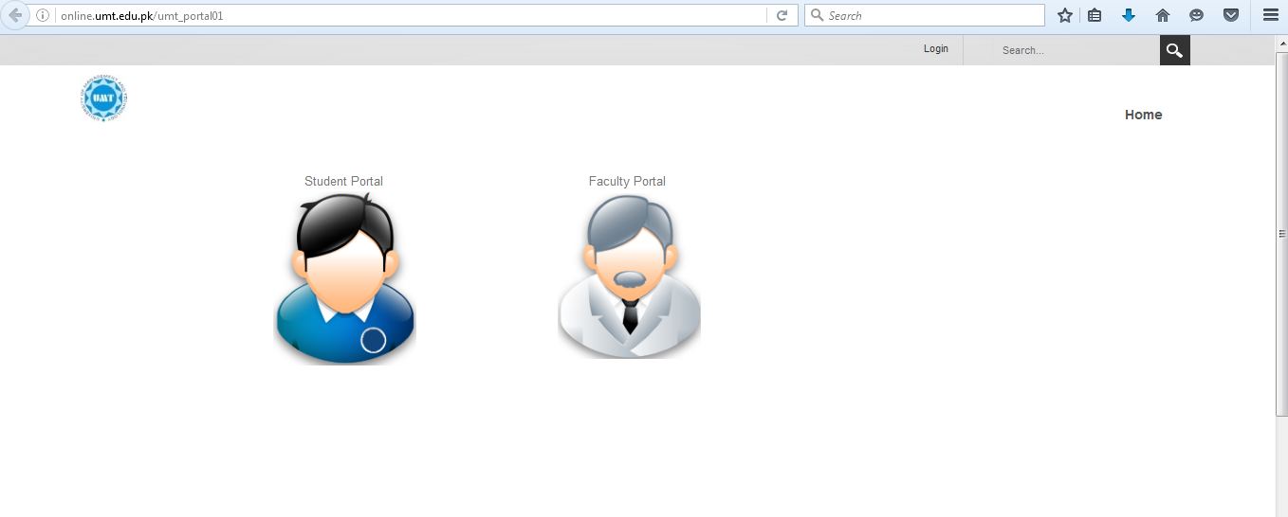
Student Training Guide

Contents
Introduction 3
Access to Online Portal 3
My Courses 4
Course Registration 5
Drop a Course inquiry 5
Add a Course Inquiry 7
Roadmap 10
Course Catalog 10
Reset Password 11

Introduction
Online Portal is designed for the participants and this portal includes Registration of Courses, Current Courses, Road map, Transcript of Participant moreover participant can change their password of portal.

Access to Online Portal
To access online Portal follow the following steps

- Open browser and enter link http://online.umt.edu.pkFollowing window will appears

- Click on Student Portal
- Enter your User id
- Enter Password
- Click on Login
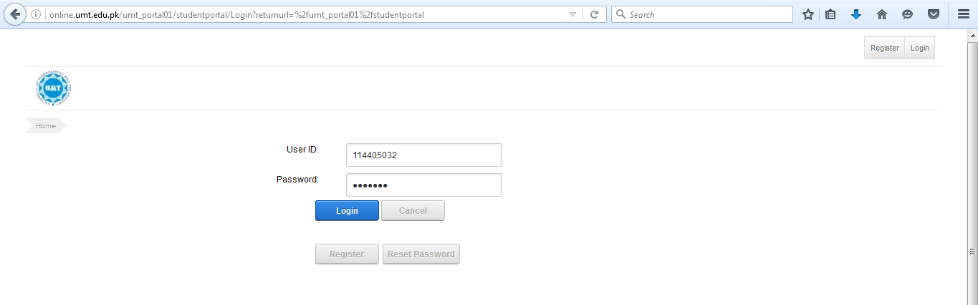
- The following window appears
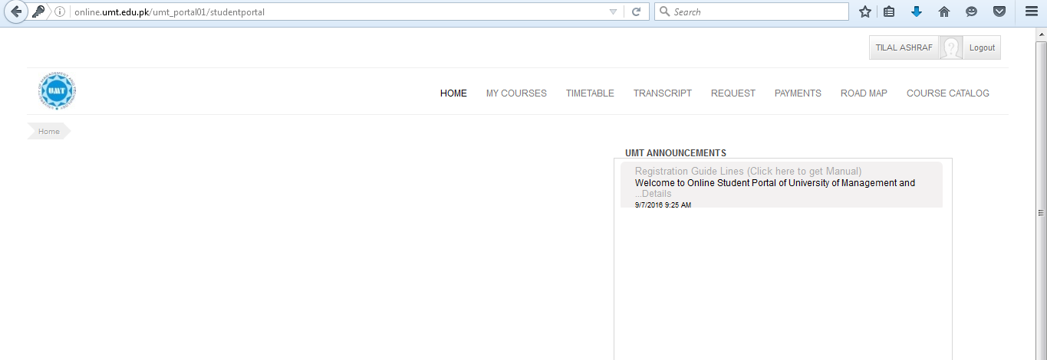
- Participant Portal is Open now and participant is logged in
- Look at top user will find all the required field

My Courses
When participant log in to online portal
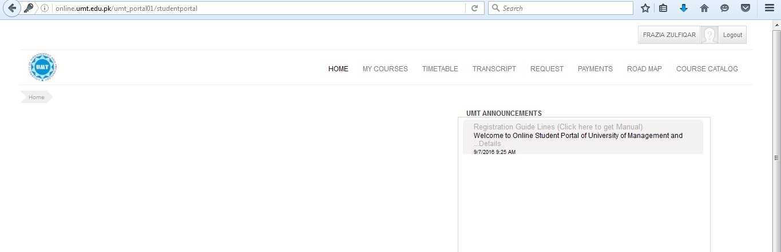
- My Courses tab is next to Home tab
- Participant clicks on My Courses
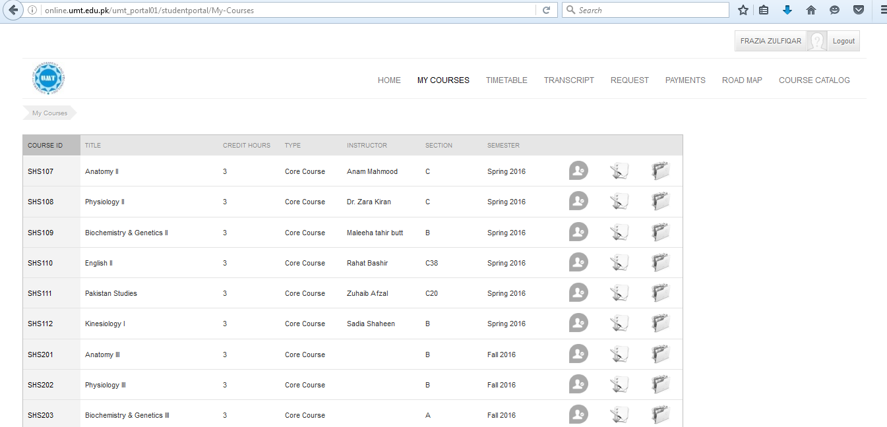
- Screen appears includes all the semester wise registered courses of participant as shown in the screen shot below

Course Registration
In online portal participant register his/her courses by clicking on Request Tab shown below
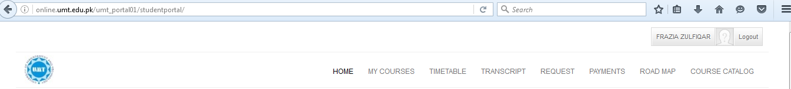
In course registration participant
- Drop a course inquiry
- Add a course inquiry

Drop a Course inquiry
To drop a course participant can follow the following steps
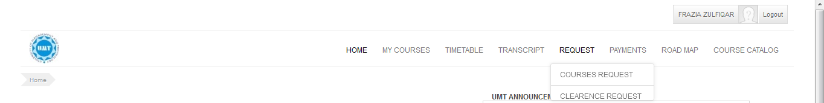
- Participant click on Request Tab and select Course Request shown below

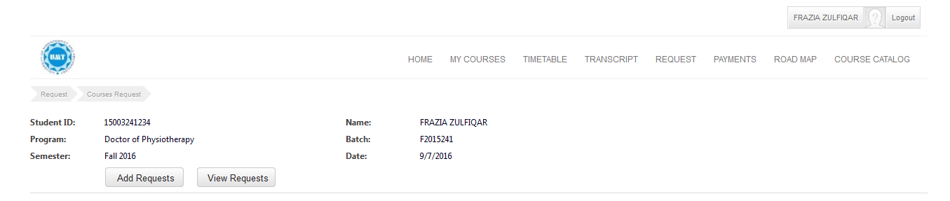
- When participant click on course request following screen will appear
- Participant click on Add Request Tab and click on “Please Select Request Type” dropdown select Add/Drop
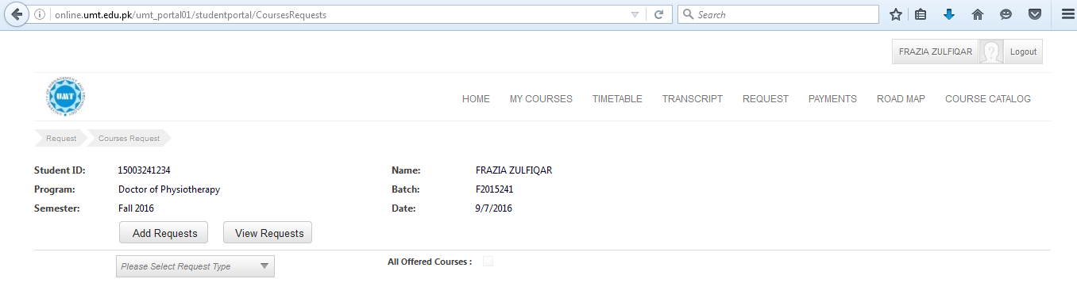
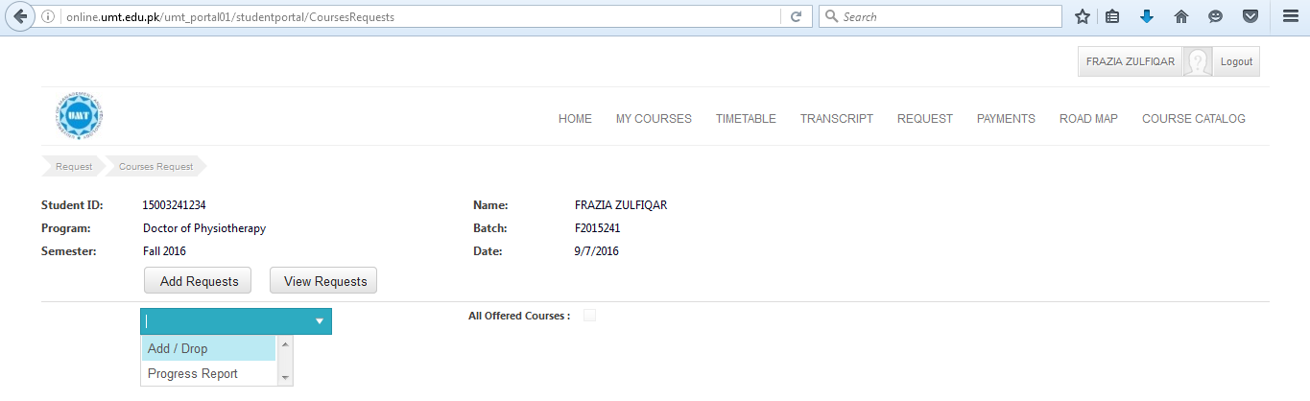

- When participant click on Add/Drop following Screen will appears
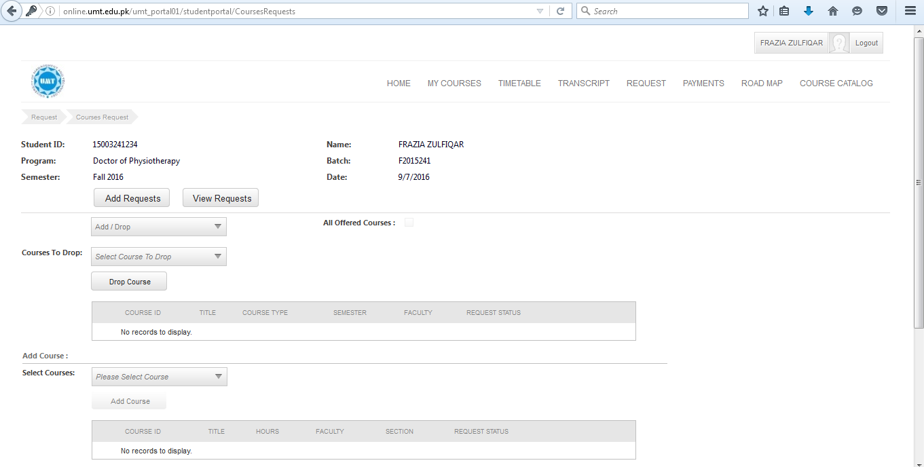

- To drop a course participant click on select courses to drop course list appear. participant select course and click on drop course as shown below
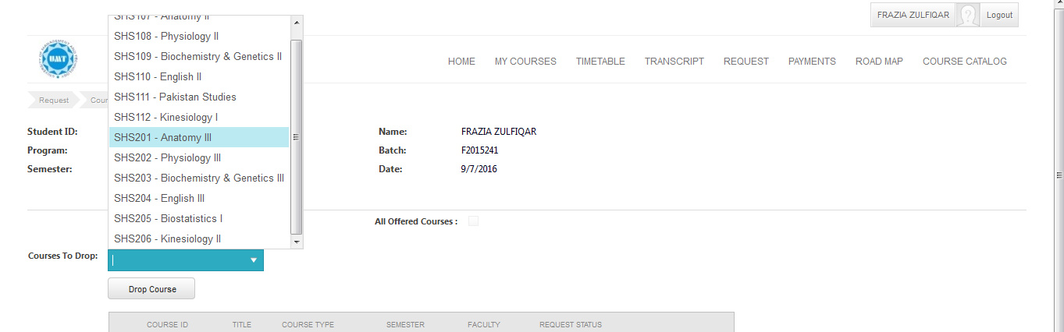
- Requested course of participant is dropped
Note: Participant can send Add of course request and Drop of course request at a same time

Add a Course Inquiry
To add a course participant can follow the following steps
- Participant click on Request Tab and select Course Request shown below

- When participant click on course request following screen will appear

- Participant click on Add Request Tab and click on “Please Select Request Type” dropdown select Add/Drop
- When participant click on Add/Drop following Screen will appears

- To add a course participant move to Add Course area in the same screen shown above
- Clicks on please select course button
- The list of offered courses to participant open shown below
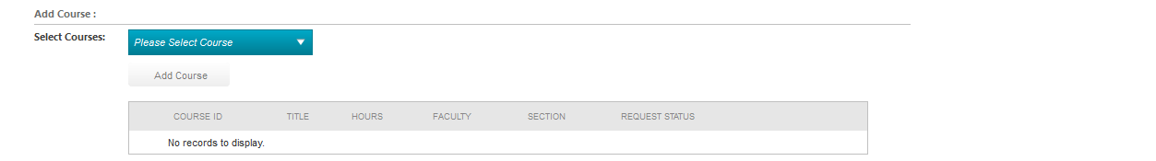
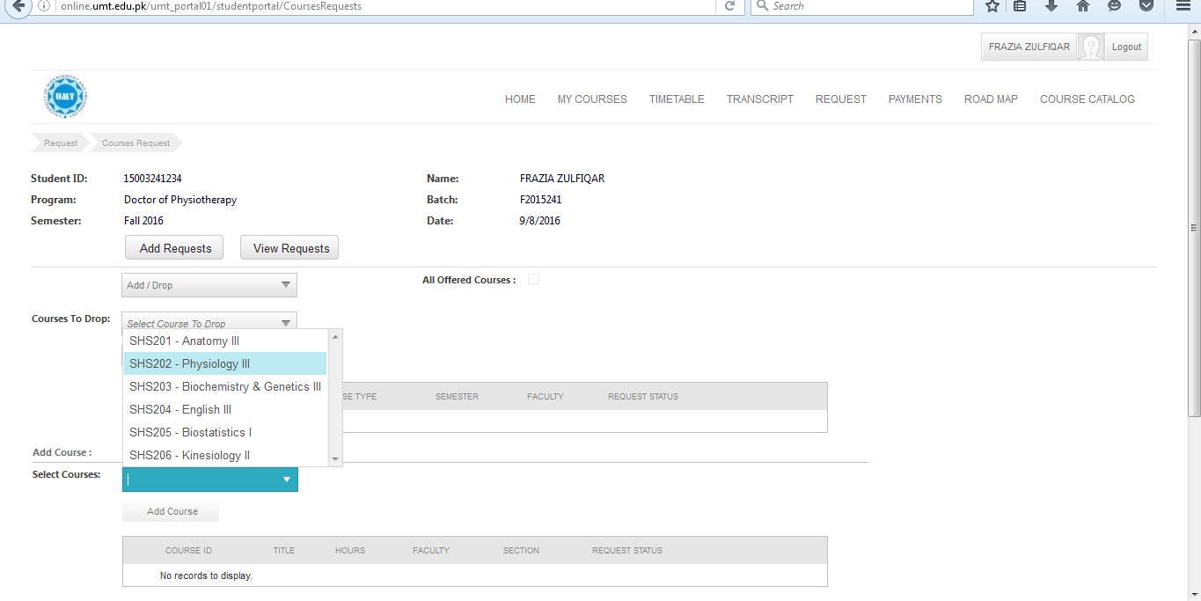
- When participant select his course from list course section dropdown appears
- Participant select section from section drop down shown below
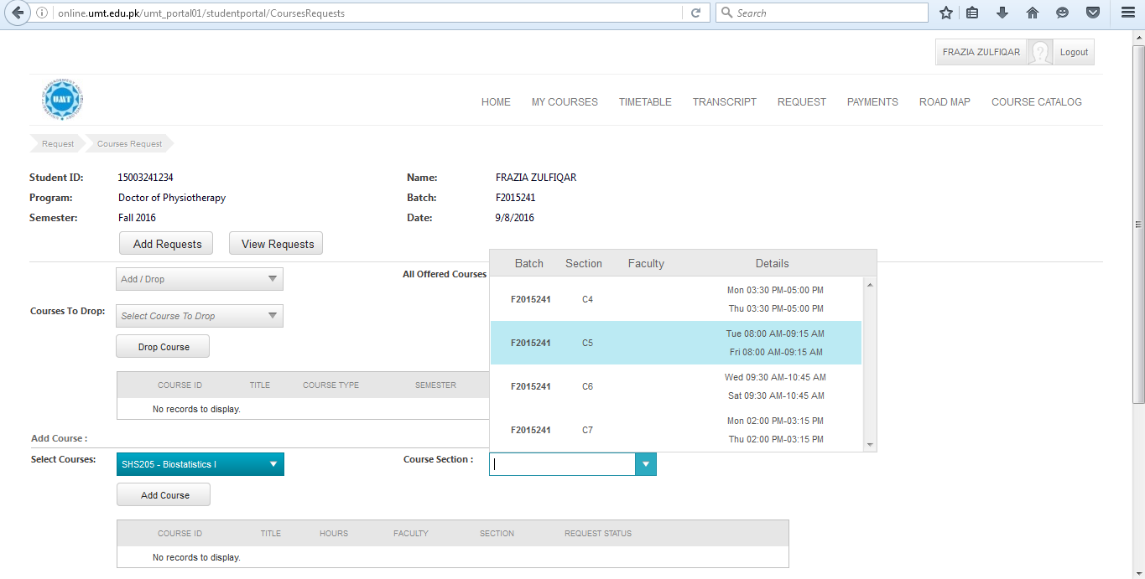
- Participant click on Add Course button
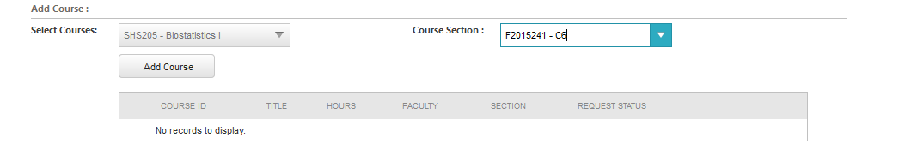
- Course appears in the table shown above
- Request status of course is in progress
- The requested course of participant is added

Roadmap
Roadmap helps the participant to know his semester wise courses as shown below
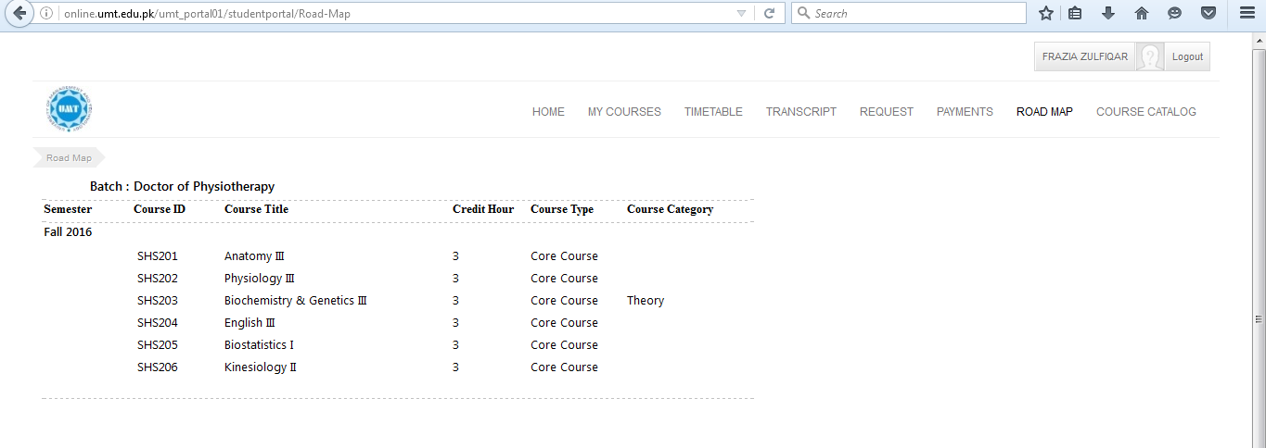

Course Catalog
In course catalog participant finds list of courses according to his/her degree program
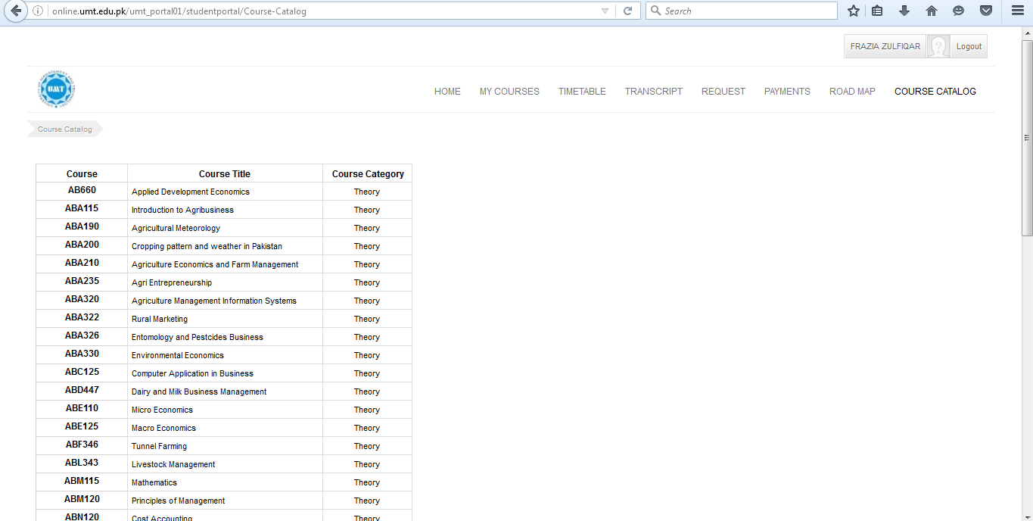

Reset Password
In case participant forgotten his/her online portal password portal allows participant to reset password by following three step procedure
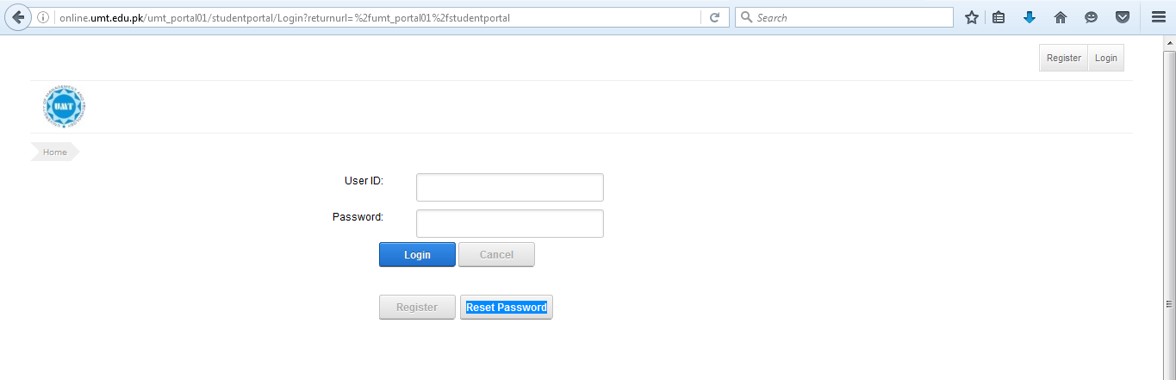
- Go to online student portal and click on reset password tab

- Participant click on reset password tab selected on the above screen shot the following pop up appears
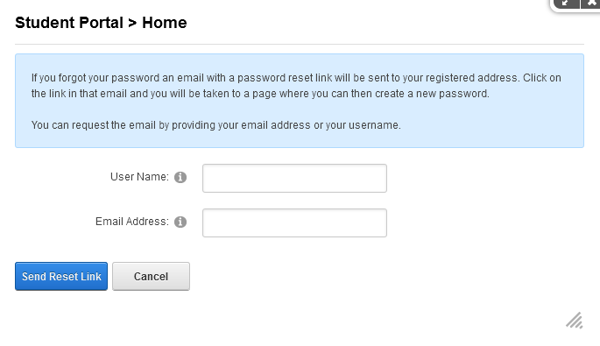
- Participant enter his/her student id (e.g. S201600021) in User Name
- Participant enter his/her UMT mail address i.e. S201600021@umt.edu.pk in Email Address field
- Click on Send Reset Link highlighted in screen shot below
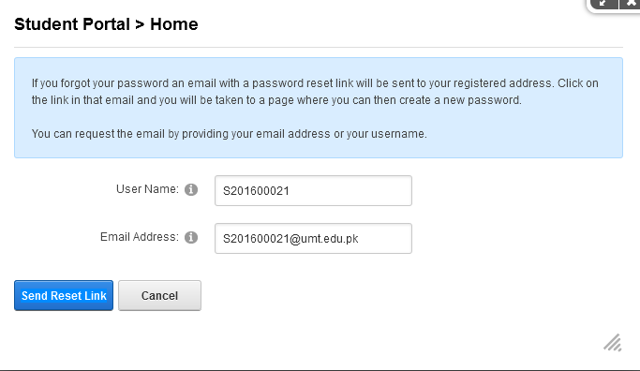
- After click on Send Reset Link button the following pop up apear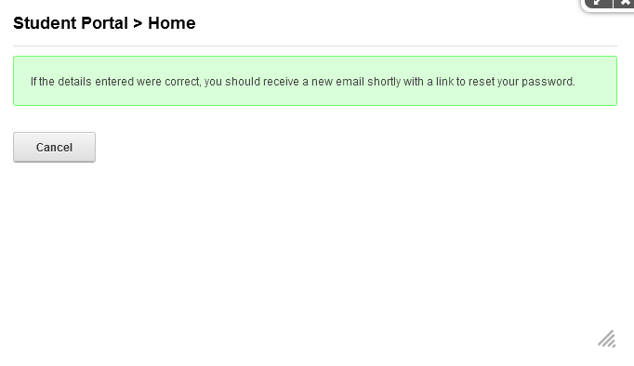
- Participant open his/her UMT mail in Gmail and find mail sent by CMS
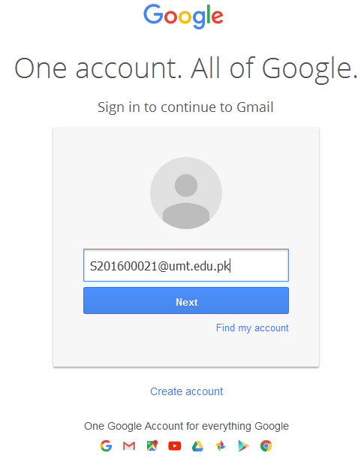
- Participant open his mail sent by CMS this mail includes a link
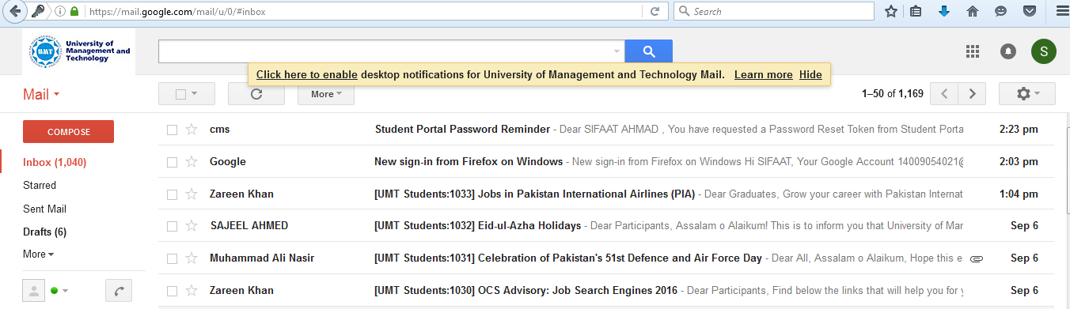

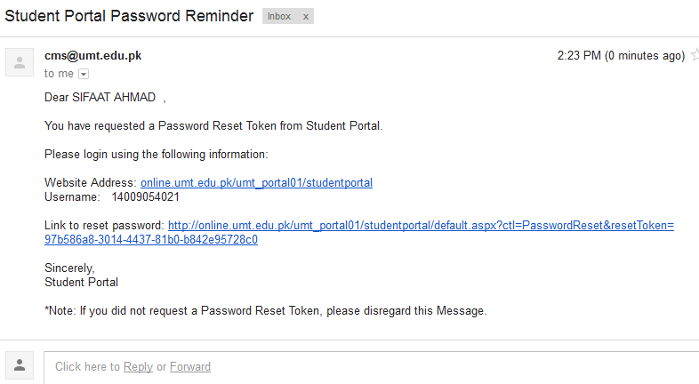

- Click on link receive in mail the following screen appears
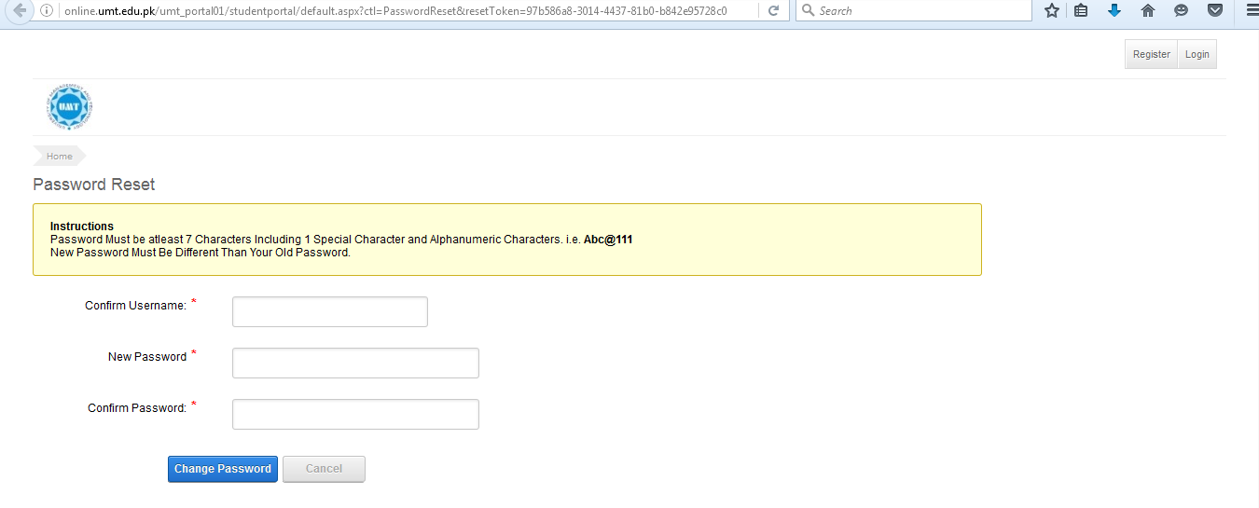
- Participant is supposed to enter his UMT id S201600021 in confirm username field on the above screen
- Participant enter his/her new password set new password according to following guidelines
- Password Must be at least seven characters
- Must include one special character like @,_ and etc
- Try to use alpha numeric characters i.e. AbC@123
- New password must be different then your old password
- Participant reenter his/her password in confirm password field
- Participant password is successfully changed

