TITLE OF DISSERTATION: CENTERED, DOUBLE SPACED

by
Full Name of the Scholar
Registration Number

Submitted in the partial fulfillment of the requirements for the Degree of
Doctor of Philosophy
in
ARCHITECTURE

University of Management and Technology, Lahore.

Name of Research Supervisor

2023
Department Name
University of Management & Technology, Lahore

CERTIFICATE OF APPROVAL
Accepted by the Faculty of School of Architecture and Planning, University of Management and Technology, Lahore in partial fulfillment of the requirements for the degree of PhD in Architecture.

Supervisor
Research Supervisor Name
School of Architecture & Planning, UMT

Co-Supervisor
Research Supervisor Name
School of Architecture & Planning, UMT

External Examine#1 External Examiner#2

Chairperson Department of Architecture Dean School of Architecture & Planning

2023
University of Management & Technology, Lahore

© 2023
Scholar’s Full Name
All Rights Reserved
Any part of this thesis cannot be copied, reproduced or published without the written approval of the Scholar.

DECLARATION
I __________________ hereby declare that the matter printed in the thesis titled “________________________________________________________________________” is my own work and has not been printed, published and submitted as research work, thesis or publication in any form in any University, Research institution etc. in Pakistan or Abroad.

Dated: December 00, 2023 Signature of Student

PLAGIARISM UNDERTAKING
I solemnly declare that research work presented in the dissertation titled “___________________________________________________________________________________________________________________” is solely my research work with no significant contribution from any other person. Small contribution or help wherever taken has been duly acknowledged and the complete dissertation has been written by me.
I understand the zero tolerance policy of the HEC and University of Management & Technology towards plagiarism. Therefore, I as an author of the above titled dissertation declare that no portion of my dissertation has been plagiarized and any material used as references properly referred or cited.
I undertake that if I am found guilty of any formal plagiarism in the above titled dissertation even after award of Ph.D. degree, the University reserves the rights to withdraw or revoke my Ph.D. degree and that HEC and the University has the right to publish my name on the HEC/University Website on which names of students are placed who submitted plagiarized dissertation.

Student Name
Dated: December, 00, 2023

SIMILARITY REPORT

CERTIFICATE BY SUPERVISOR
I certify that I have read “________________________________________________________________________” by _____________________________________, and that in my opinion this work meets the criteria for approving a dissertation submitted in partial fulfillment of the requirements for the Doctor of Philosophy degree at the University of Management and Technology.

Research Supervisor Name

ABSTRACT

This section contains the dissertation abstract, designed as a standalone document for a broad audience. The abstract provides a comprehensive summary of the work, emphasizing the problem statement, theoretical background, methodology, experimentation, and key results. Adhering to the text format of the entire dissertation, this one-page document is structured with paragraphs. References are typically excluded from the abstract.

DEDICATION
First and foremost, my lost backbone who initiated me with the idea of doing a Ph.D. My father _________________________ who dreamt it and my Mother ___________________________, who pushed me throughout and prayed for me countlessly.

ACKNOWLEDGMENT
Thanks and gratitude are due to Allah for whom this work would not take place except with His will and His support, wishing that it will show among my good deeds in the latter-day.

Scholar Name
PhD (Scholar)
Department of Architecture
University of Management and Technology, Lahore.

TABLE OF CONTENTS

Page
ABSTRACT iv
ACKNOWLEDGMENTS v
STATEMENT OF ORIGINALITY vi
TABLE OF CONTENTS vii
LIST OF FIGURES ix
LIST OF TABLES x
NOMENCLATURE xi
- INTRODUCTION 1
  - FIRST LEVEL HEADINGS 1
    - Second Level Headings 1
    - Second Level Headings that are Longer, Single- Spaced Lines 2
  - TABLE OF CONTENTS, LIST OF TABLES, LIST OF FIGURES 2
    - Table of Contents 2
    - Formatting Figures 2
    - Formatting Equations 3
    - Formatting Tables 4
- MISCELLANEOUS INFORMATION ON FOMATTING 5
  - MISCELLANOUS INFORMATION 5
  - DISSERTATION FINAL BINDING 6
BIBLIOGRAPHY 9
APPENDICES 10

LIST OF TABLES
Tables & Charts
1.1 | Terminologies for Climatically Designed Buildings | 6
2.1 | Electricity Consumption GWH Pakistan | 22
2.1 | Electricity Consumption GWH Pakistan (Chart) | 29
2.2 | Sale (GWh) of Electricity (Chart) | 29
2.3 | Electricity Consumers (Chart) | 30
2.4 | Sale (GWh) of Electricity (Chart) | 30

LIST OF FIGURES
Figures
1.1 | Graphical Illustration of the Research Strategy | 15
1.2 | Methodology of the Thesis Study Based on Theoretical and Simulation Analysis | 16
2.1 | Three Tier Design Approach | 25
2.2 | Architects vs. Engineers Approach | 25
2.3 | Electricity Consumers -Sale (Gwh) of Electricity | 28
2.4 | Comparison Between Karachi And Lahore Solar and Wind Turbines | 31

Thesis Chapter Headings | Font Size 14, Centered, Capitalized, Numbered | Heading 0
First Level Headings | Font Size 12, Centered, Capitalized, Numbered | Heading 1
Second Level Headings | Same as above and just first letter capitalized | Heading 2
Figures Formatting | As followed the chapter and section details  Captions feature in the MS word should be used for figures | For example figures in chapter 1 should be numbered 1.1 and then continue in the same format
Table Formatting | Tables should be formatted similar to figures  Captions feature in the MS word should be used for tables | For example tables in chapter 1 should be numbered 1.1 and then continue in the same format

FOR EXAMPLE:
The focus of the research is on the residential buildings in Lahore, Pakistan, with various house forms and geometrical shapes in different proportions and orientations of the plot in diverse urban settings investigated dynamically (Williamson, 1997). The cooling and heating loads were premeditated for each model house unit designed. The results were evaluated to optimize the thermal behavior of the models. The quantitative method adopted has been extended to test the model house as a valid resolution to address the issue explored in the thesis as in Fig 1.1.

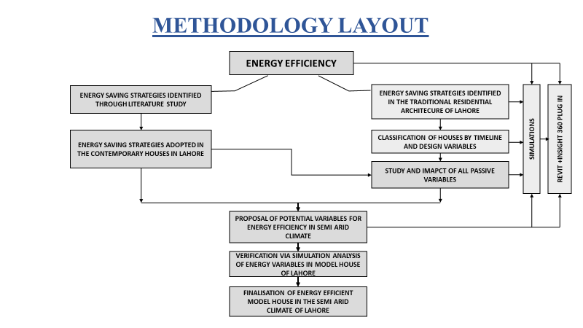
Figure 1.1 Graphical Illustration of the Research Strategy. Source: Author
- Devising a problem statement based on observations and literature archives. Previous research is carefully studied and analyzed. Relevant approaches are formulated based on the building design process, performance assessment methodologies, building simulation and optimization and theories.
- Both Current and previous research pieces, concepts and philosophies aided in collecting information on the problem area.
- Investigations based on the collected strata and explanation of the problem statement. A model house proposed after detailed studies and a testable model house was planned as the problem solution. A prototype computer tool Autodesk Revit with 360 plug-in that implements the proposed model house design, was adopted (Del et al., 2019). The simulation software gives the cooling and heating loads of the house's performance in a simplistic form (Reddy, et al., 2016). Therefore, the model house is viewed as a scientific object and the thematic models describing the scientific item are studied during experiments applying the suggested solution to answer the problem. The majority of the research was conducted utilizing both theory and simulation, as in Fig 1.2.

Figure 1.2 Methodology of the Thesis Study based on Simulation Analysis. Source: Author

Table 1.1 A Sample Table

Activity | Start Date | Duration | End Data
Literature Review | Sep 1, 2020 | 8 Months | April 30, 2021
Model Development | January 1, 2020 | 3 Months | March 30, 2021
Experimentation | April 1, 2021 | 6 Months | September 30, 2021
Dissertation Writing | June 2022 | 3 Months | August 2022

GENERAL RECOMMENDATIONS:

ITEM | SPECIFICATIONS
External Cover | Hard Cover and Binding  Color = Maroon with Golden Writing
Writing on Cover Page | The first page is the template for cover page with inscription in golden  Recommended font is Times New Roman with 22  UMT logo should also be in gold
Writing on Spine | Inscription on Gold Color (sample is provided below)
Paper Size | A4 (8.2’’ x 11.6’’)-80g
Margins | Left = 1.5 inch Right = 1.0 inch; Top = 1.1 inch; Bottom =1.0 inch
Thesis Word Limit | 50 to 70 thousand words (excluding the references, appendices etc.)

TITLE OF THE DISSERTATION. TIMES NEW ROMAN WITH 22 SIZE
SCHOLAR NAME REGISTRATION #

2023

Sample Formatting for the Spine

BIBLIOGRAPHY

It is recommended that a reference management software such as EndNote, Mende-ley is used for bibliography. The references should be downloaded directly from the authentic sources to ensure accuracy of information.
Double spacing should be used between each reference. References that are more than one line long should be single-spaced within.
Separate sections for references and bibliography may be added as well if required.

FOR EXAMPLE:

References
Abdel-Aziz, D. M., Shboul, A. A., & Al-Kurdi, N. Y. (2015). Effects of tree shading on building's energy consumption-the case of residential buildings in a mediterranean climate. American Journal of Environmental Engineering, 5(5), 131-140.

APPENDICES

Appendices are generally used to provide useful information about your work for more details but are not essential part of your research. Some of the items that become part of your appendices include detailed explanations and elaborations, additional or large diagrams, additional or long tables, detailed mathematical derivations, experimental standards and protocols etc.
Use letters to label the appendices e.g. Appendix A, Appendix B, etc. Each appendix should have a suitable title and should contain a specific type of information. Each appendix should start on a new page. Every appendix must be referred in your body text.

