Spatial Adversities of Commercialization of Main Roads:
A Case Study of Main Road, Samanabad, Lahore
Ar. Umair Zia Malik, Dr. Saima Gulzar, Plnr. Mutahir Awan

Abstract
The negative impacts of land-use commercialization on built environment are studied in this research. Data was collected from the target population on Main Road Samanabad, Lahore. Data was collected through stratified sampling technique and analyzed in SPSS. The variables were correlated to draw conclusions. It was discovered that it is not only the tangible infrastructure that is responsible for degradation of built environment but also intangible factors such as the existing policy on acquiring No-Objection Certificate. Furthermore, site-specific regulatory procedures need to be implemented. These loopholes were identified and organized in terms of their urgency of action and the recommendations were prepared according to the research findings.

Keywords
Land-Use Commercialization, Samanabad, Spatial Adversities of Commercialization

Introduction
Main Road, Samanabad, Lahore is one of the emerging commercial corridors of Lahore. Its peculiar nature of commercial activity, the history of the town, its linkages with rest of the city, memory of the people along with their aspirations for future, all of it is intertwined with the process of commercialization. An attempt to slow down or diminish this process entirely, for it brings with it a lot of planning liabilities and challenges, would only be half-effective. This restless drive to convert residential land-use to commercial one needs to be understood in order to identify all its adversities on built environment.
The research conducted within limited scope of variables, aims at drawing out the reasons which cause this phenomenon to take place and a study of inter-relationship between these variables is made with the help of SPSS. Target population is divided into three sub-groups namely residential, car-related commercial and general commercial sub-group in order to apprehend all three angles to the problem. They are further split into those who want land-use commercialization to increase and those who are against it through questionnaire survey.
The commercial space is defined in terms of its five essential components- the showcase space, storage space, circulation space, open space and parking space. The damages made to the infrastructure are the twelve variables which are directly affected by commercialization. They are electric poles and cables, water and sewerage, air quality, noise, heat, access to natural light, trees and vegetation, condition of roads and pavements, pedestrian accessibility, vehicular accessibility, existing built environment on account of its structure and existing built environment on account of its aesthetics.
Historical Background of Samanabad
Saman Khuda was an 8th Century Persian noble whose descendants later ruled Persia during the Samanid Period (819-999). One of their descendent tribes was Kambojas, a tribe of irano-indian origin (their second root in Shem) and frequently mentioned in Sanskrit and Pali literature (Bosworth 2004). Kambojas lived in Ichra which was the oldest and largest settlement outside Walled City. Ichra was Lahore in the ancient times (Rehman 2013) as the Lahori Gate of Walled City of Lahore was named after it (Thronton 1873). Thus Saman refers to Saman Khuda whereas Abad means populated, hence the word Samanabad.
Lahore has engulfed and flourished some of the most exuberant cultures of region (Thornton 1873). The city is presently Pakistan’s second largest city with over 7 million population. Its internal zones continue to face several planning related challenges whereas the center continues to drift slowly to the south-west of the city. With the increasing trend of absolute population as well as urbanization, there is an ever increasing demand to meet the supplies (Khan 1994). Hence commercialization finds its way through legal and illegal means alike.
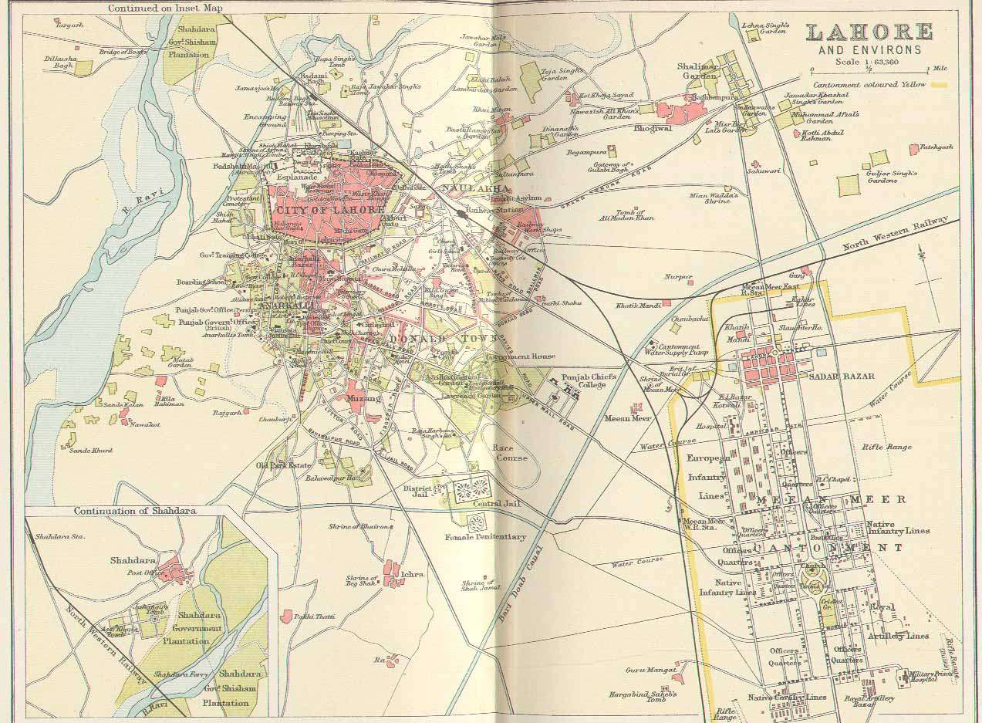
Map 1: Lahore and Environs (Source: Mapping Lahore: Tracing Historical Geography of a City through Maps)
Table 1: Internal Zones of Lahore (Source: JICA Study, LUTMP 2010)
Main Road of Samanabad, Lahore manifests a multitude of diverse, commercial functions. It has one of the first planned markets (Main Market, Samanabad) of Lahore and has the largest used-car sale market. Sunday Bazar of used cars along the Road is a commercial spectacle in its own right. However, commercial activity has sprawled deep into residential area since conception of this planned society. Many illegal developments have not only created problems for the residents but has effected desired traffic patterns as well (Nadeem 1997). Spatial quality of Samanabad has been largely effected with land-use commercialization. It is important to collect data from the site and analyze it to understand the impact of commercialization on built environment instead of relying on utopian model for residential-commercial function. Empirical research in this regard should harmoniously synchronize future developments with existing spatial functions.
Development of Samanabad
The next important phase was the construction of residential quarters for middle-class income group. Presently converted into N-block housing the quarters were uniformly spread out in Samanabad. All of these quarters have now been converted to private residential and commercial property.
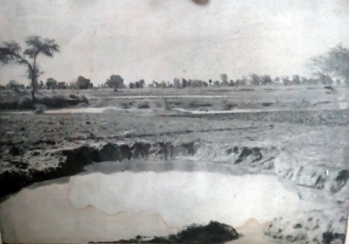
Fig 1: A View of the Site before Development (Source: LIT)
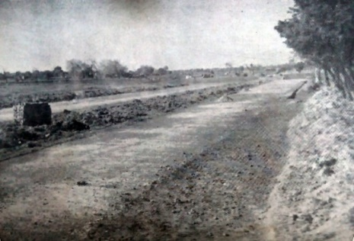
Fig 2: Preparations for Construction (Source: LIT)
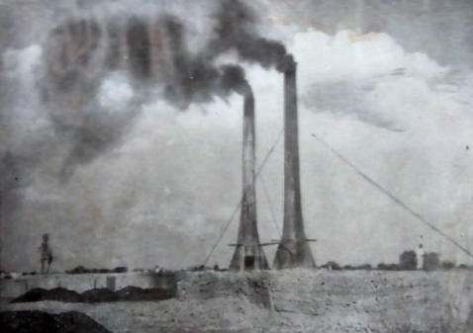
Fig 3: Preparations for Construction (Source: LIT)
Housing infrastructure was laid out for the quarters. It is noticeable that change in requirement of services from quarters to private housing is difference from the change in requirement of services when quarters/private housing is converted to commercial use. Residential areas near increased commercial activity therefore suffered more in terms of services and constant need of up gradation.
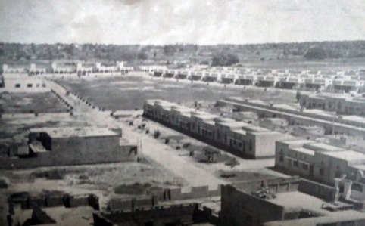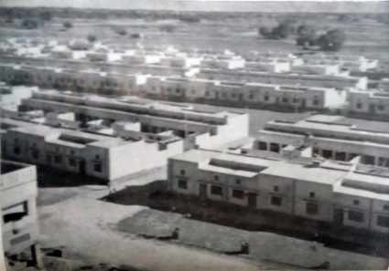
Fig 4: Samanabad Quarters Under-Construction (Source: LIT)
Fig 5: Quarters View from Above (Source: LIT)
Several private housing units on Main Road, Samanabad are still standing. It is not only their architectural value but often their event-based historic value which increase architectural value of these houses. For example, several film celebrities’ actors and producers resided in Samanabad in early 50’s, a study area which needs thorough documentation and empirical study in its own right.
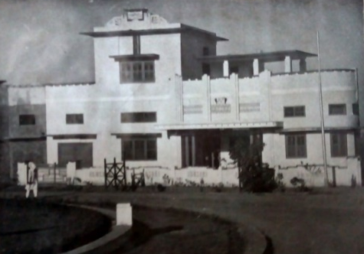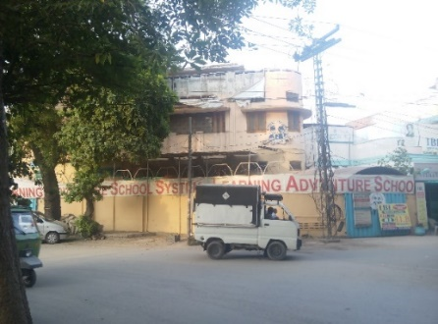
Fig 6 (Left): A Private House at First Roundabout during Post-partition Development
Fig 7 (Right): The same house in 2015 (Source: LIT)
An Overview of Commercialization Policies in Lahore
It was in this plan that the aforementioned south-west direction of sprawl was suggested to disperse the population in least damaging fashion to existing load on infrastructure. Structural Plan 1980 also highlighted areas of interest which had good potential for healthy commercial activity. Subdivision of residential plots was made possible in 1982 policy. In 1988, it was acknowledged that commercial activity not only affected the urban concerns at close proximity to the site but it also effected the environment and ecology of the area at large, hence a more holistic approached was advocated in 1988 commercial policy. It was until 1993 that precise location and site was given due consideration in devising a policy. In was decided in 2001 policy that commercial activity on the declared ribbons through the city would be more structured and follow the given regulations. Illegal commercial activity in legitimate cases (determined by the committee) could be made legal after paying annual fee at fixed rate (elaborated in detail).
Challenges of Commercialization in Samanabad
Samanabad is one of the identified zones in 2010 report of Lahore Urban Transportation Master Plan, which are under immense pressure of commercialization. Planning-wise it is not commercialization itself as much as the issues which are firmly tied with it which cause gigantic problems such traffic and parking issues among a list of others. Being densely populated, as stated in the report, Samanabad projects a series of advantages and prospects with respect to commercialization. LDA along with its sister departments like TEPA recognizes this scenario. Traffic plan for Samanabad was assigned ‘Urgent’ value in the 2010 report.
Table 2: Proposed Action Plan for Traffic Management Project (Source: LUTMP 2010)
In a very recent study conducted by Dr. Hameed R. and Nadeem O. (2014) it has been observed with special reference to Samanabad that haphazard commercialization is directly linked with traffic-related, parking-related and environment-related problems. The researchers have pointed out unplanned commercialization as one of the cardinal forces of degradation of quality of life, especially in residential areas.
Hence it is very important to identify the factors involved in transformation of historic town of an historic city. For they continuously influence and get influenced by larger forces at play. Without having a clear understanding of these changes it would be impossible to evaluate and hence improve quality of life in Lahore (Naz & Anjum 2007).
Research Methodology
The following three types of variables were deployed in the research:
Independent variables or predictors or inputs of research were the five spatial aspects of commercial land-use discussed above. They represented not only the scale of deficit but also a scale of opportunity once cross-tabulated with the dependent variables. The independent variables were: Showcase Space, Storage Space, Circulation Space, Parking Space and Open Space.
Dependent variables were used to identify the links between several aspects of built environment. The level of adverse impact of commercialization on built environment was also drawn through co-relation matrix. Twelve dependent variables were:
- Water and Sewerage System
- Electric Poles and Cables
- Roads and Pavements
- Accessibility: Pedestrian Movement
- Accessibility: Vehicular Movement
- Environment: Air Pollution
- Environment: Noise Pollution
- Environment: Heat
- Environment: Natural Light
- Environment: Green and Vegetation
- Existing Building Structures
- Existing Building Aesthetics
Since this research focuses on spatial aspects of built environment only, some of the critical aspects of commercialization were restricted off bounds. They constitute a list of Extraneous Variables mentioned below. They were Real Estate Prices, Climatic Anomalies, Crime, Land Politics and Season.
Sampling Technique
Stratified Random Sampling Technique was used in the research. Target population was divided into three strata (Commercial: Car Showrooms, Commercial: Other and Residential Subgroup). The resultant sample size, n was calculated for the target population using sample-size formula (for small populations when target population N is known).
n = [z2 * (1-p)] / e2 / 1 + [z2 * p (1-p)] / e2 * N]
Where,
z = z-score
e = margin of error
p = standard of deviation
n = 281 (calculated)
With stratified proportionate samples of:
n1= 28 (Commercial: Car Showrooms)
n2= 112 (Commercial: Other)
n3= 141 (Residential)
Kth interval turned to be 2.2 therefore alternate samples were focused in survey.
Data Collection and Documentation
A detailed Land-use map was needed for the research therefore primary data was collected through field surveys and documentation of built environment. Following are a list of detailed maps of the Main Road, Samanabad which were documented in the research.

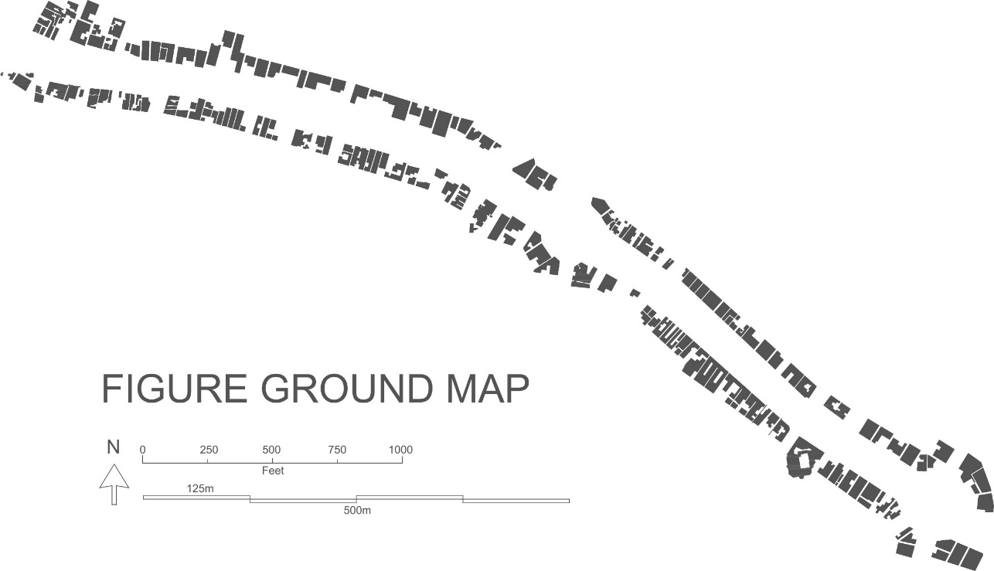
Map 2: Figure Ground Map of Main Road, Samanabad

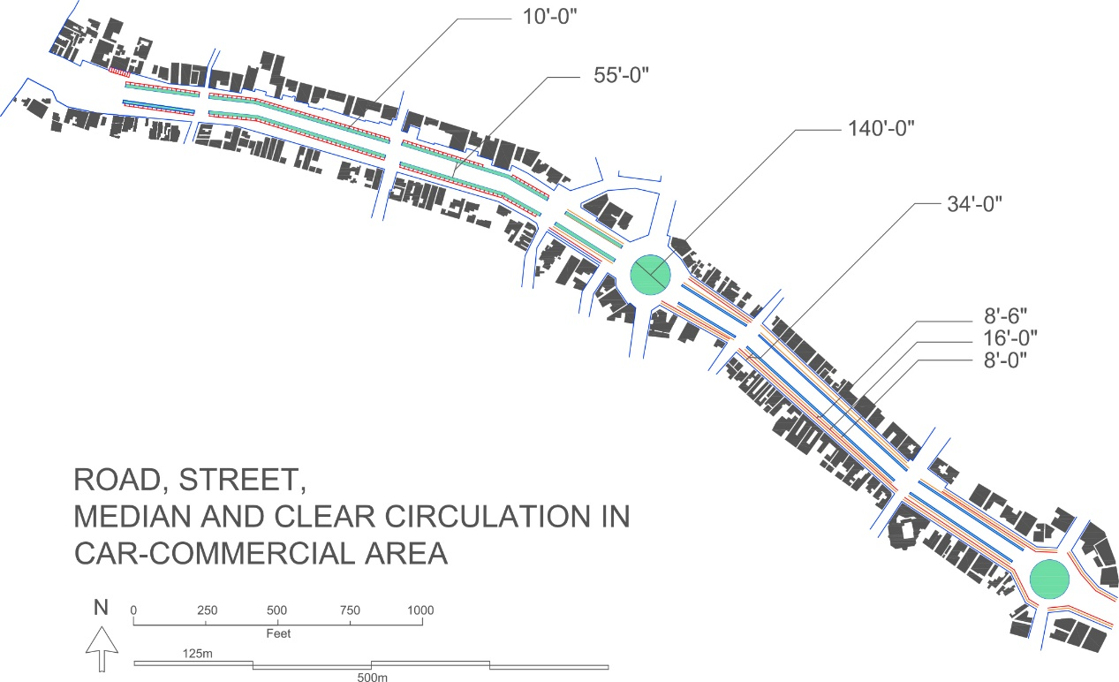
Map 3: Map Showing Main Road, Adjacent Streets, Medians and Circulation Area

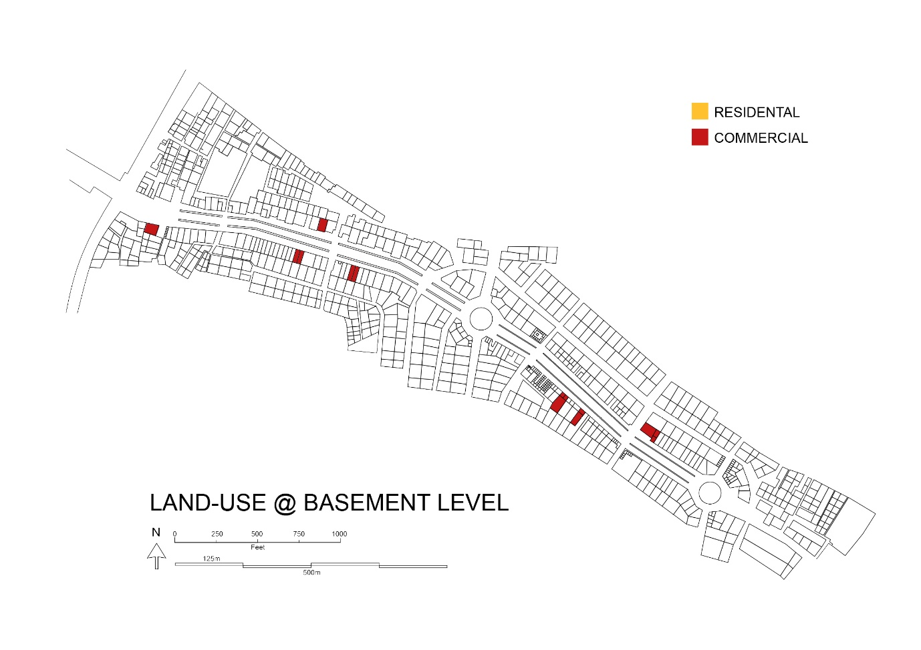
Map 4: Land-Use at Basement Level of Main Road, Samanabad
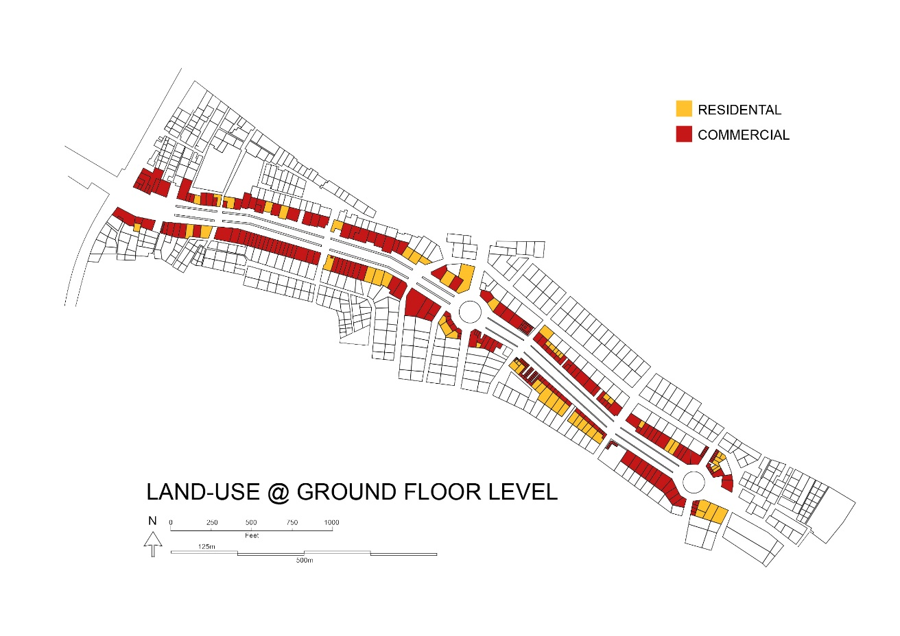
Map 5: Land-Use at Ground Level of Main Road, Samanabad
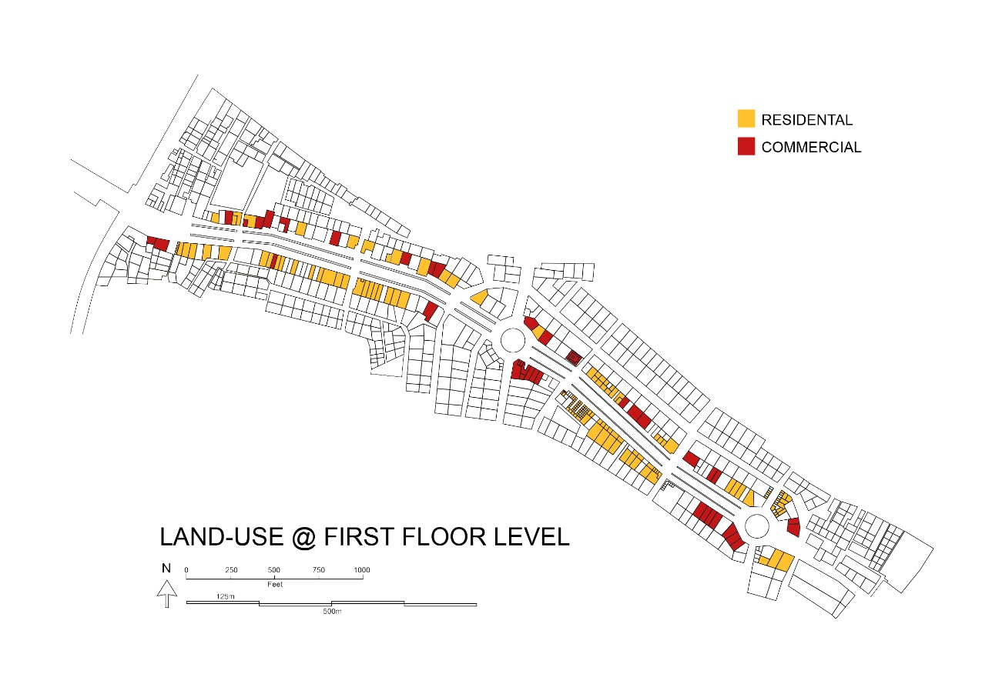
Map 6: Land-Use at First Floor Level of Main Road, Samanabad
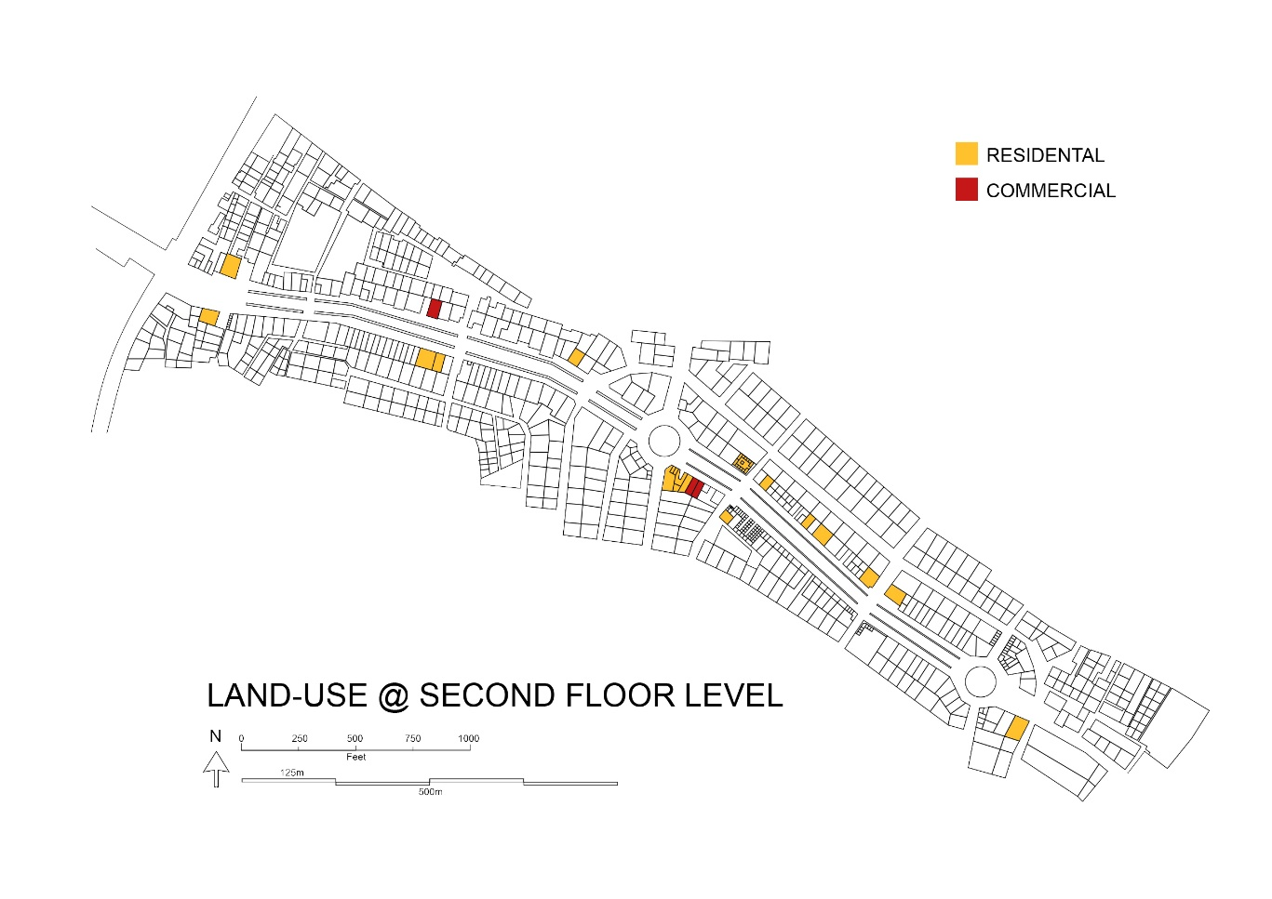
Map 7: Land-Use at Second Floor Level of Main Road, Samanabad
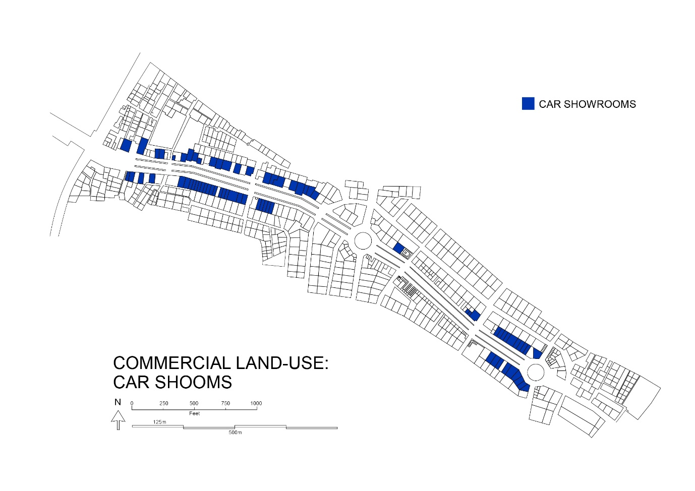
Map 8: Commercial Land-Use at Main Road, Samanabad Related to Car-Showrooms Only
Problems in Acquiring No Objection Certificate
One of the important findings of this research was respondents take on the difficulty level of acquiring NOC. Contrary to a naturally presumed outcome of criticizing a ‘higher fee’ and/or ‘lengthy administrative procedure’ as a cause of not acquiring outcome, only a handful of respondents blamed it on those two accounts. The largest chunk of population pointed out ‘No Problem’ instead of identifying one. However an important remark was made by one of the respondents where he suggested that, ‘the way to getting neighbor’s approval is simple. You sign their NOC, they sign yours.’ This kind of approach in researcher’s understanding can have far-fetched and dire consequences on the site in general and context as whole. The ‘You sign my NOC, I sign yours’ approach could be one of the cardinal forces of unwanted but authorized proliferation of commercial activity in the city.

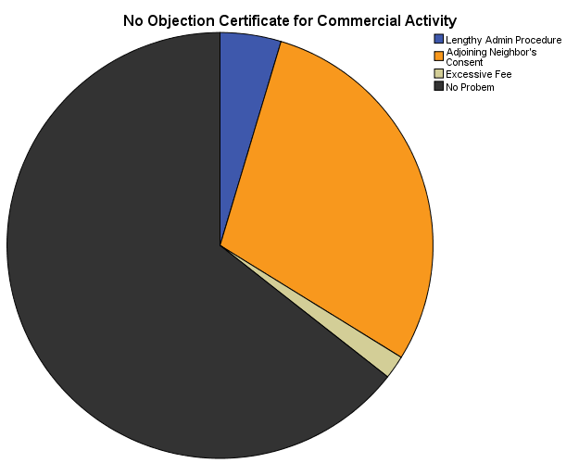

Chart 1: Problems in Acquiring No Objection Certificate
Research Findings
Following bar charts give an insight into respondents’ feedback on the Bad Effects which commercialization has on existing infrastructure.
Electric Poles and Cables
Both residents and businessmen on Main Road, Samanabad identified an impact of commercialization on the electrical systems, cables and poles. Their placement and condition not only ruin the architectural aesthetics of built environment but pose great danger to people residing/working nearby. Future commercialization is expected to make the situation worse.
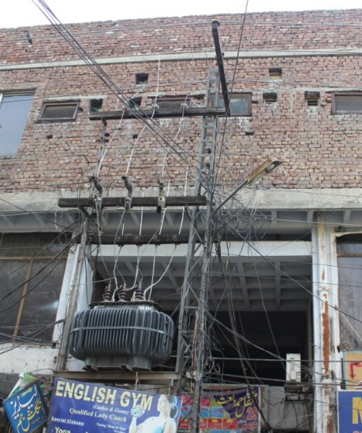
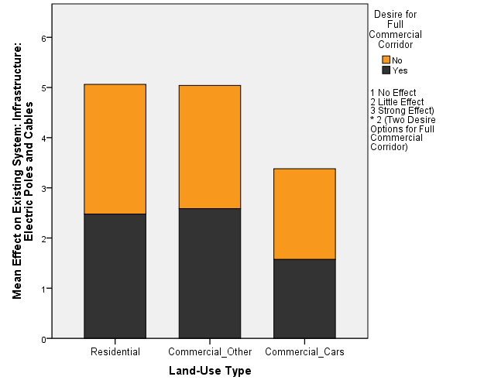
Chart 2 (Left): Effect of Commercialization on Electric Poles and Cables
Figure 8 (Right): Effect of Commercialization on Electric Poles and Cables
Water and Sewerage
Increased commercialization has also put extra load on water and sewerage systems. However its peculiar nature in the form of car showrooms has specific implications besides constant up gradation of infrastructure to meet the needs. Water from public outlet is used for car wash in the picture mentioned above.
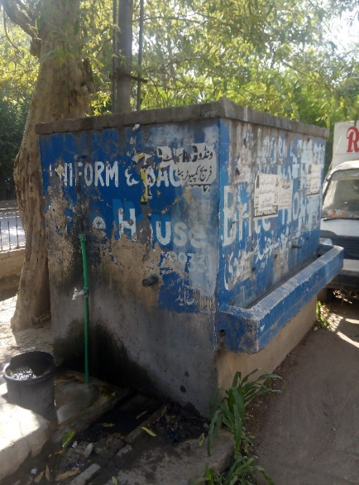
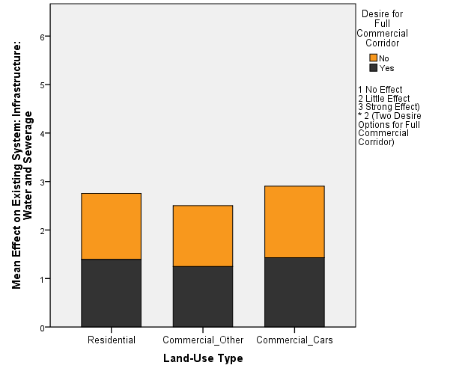
Chart 3 (Left): Effect of Commercialization on Water and Sewerage System
Figure 9 (Right): Effect of Commercialization on Water and Sewerage System
Roads and Pavements
Non-car dealer respondents strongly proclaimed that one of the areas affected badly by commercialization is the condition of roads and pavements. It is because the cars are frequently washed on the roads and water (often carrying detergents in it) seeps into the ground slowly but surely damages the roads.

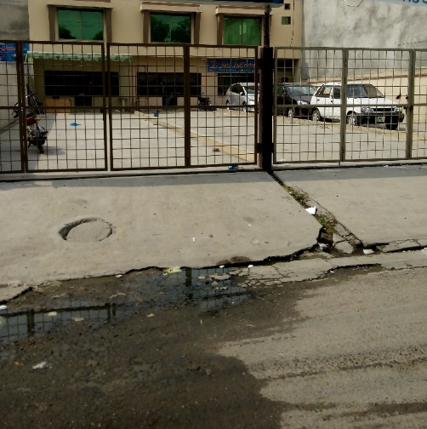
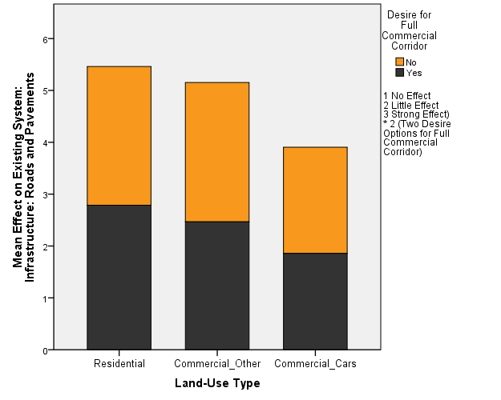
Chart 4 (Left): Effect of Commercialization on Roads and Pavements
Figure 10 (Right): Effect of Commercialization on Roads and Pavements
Pedestrian Accessibility
Car market has largely created hindrance in the mobility of pedestrians. Unfortunately it is not only limited to roads. Dealers often nail in the cars through the circulation space of Main Market where the shops have been shut down. This pattern is contagious and has bad consequences on pedestrian mobility. Similarly the cars parked along medians inside the service lane, also blocks out pedestrian entrances into and across the medians, hence enforcing alternate routes.
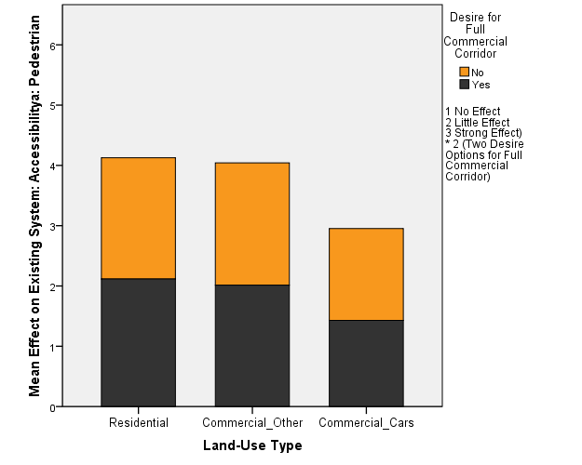
Bar Chart 5: Effect of Commercialization on Pedestrian Accessibility
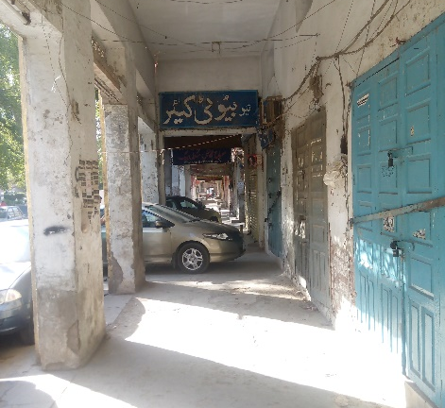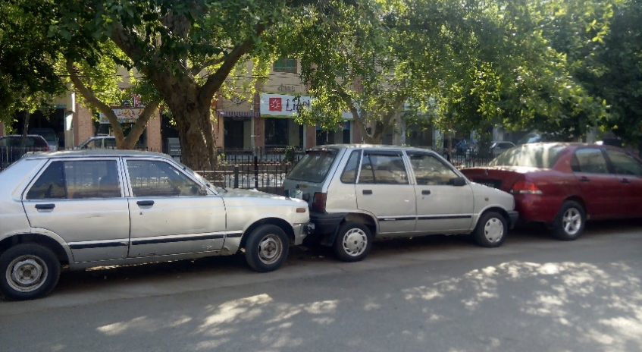
Figure 11 (Right) and 12 (Left): Pedestrian Accessibility Blocked by Cars
Vehicular Accessibility
Residents also face most trouble with driving through their vehicles from areas of highly commercialized car dealerships. One of the biggest reasons stated by them in this hindrance and observed by the researcher was the orientation of these cars. When parked perpendicular to the road they consume the space also twice as much leaving even a lesser room for other vehicles.
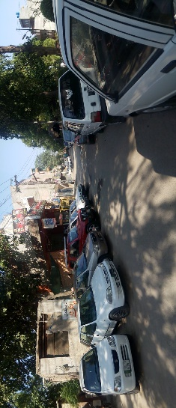
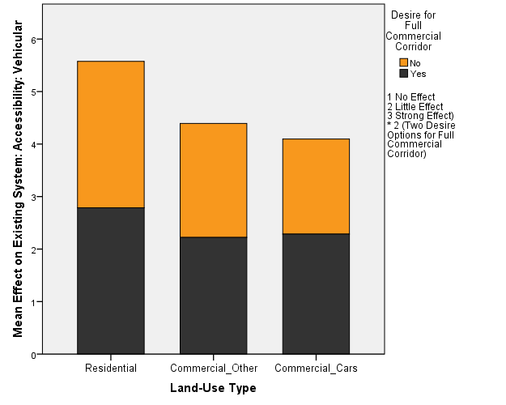
Chart 6: Effect of Commercialization on Vehicular Accessibility
Figure 13: Vehicular Accessibility Reduced by Cars

Environment: Air
Highest proportion of respondents to point out bad air quality was residents of the area. The bar chart also gives an insight on the activity pattern. Local residents happen to be the group which spends most time in the area, particularly at night. Furthermore highest one of the highest level of CO emissions has been recorded at Samanabad Mor in the following studies done by faculty of Environment and Public Health, Institute of Public Health, Lahore.
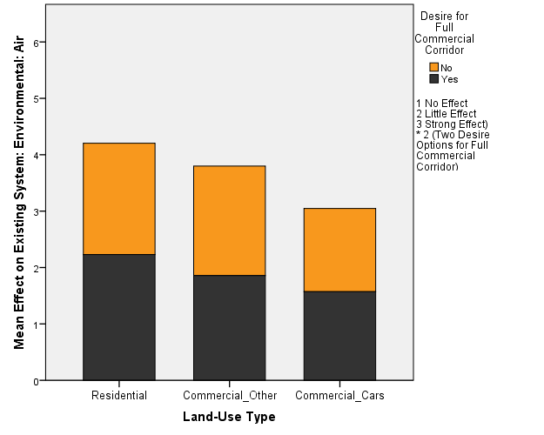
Chart 7: Effect of Commercialization on Air Quality
Environment: Natural Light
Access to natural sunlight is everybody’s equal right just like being able to breathe the same air (Cartwright 1980). Multistoried buildings rise at the expense of depriving immediate neighborhood from receiving direct natural light. No such problem is recorded in Samanabad but this trend might change soon. Suzuki motors has already erected a franchise which dominates the skyline and other commercial plazas are already under construction.

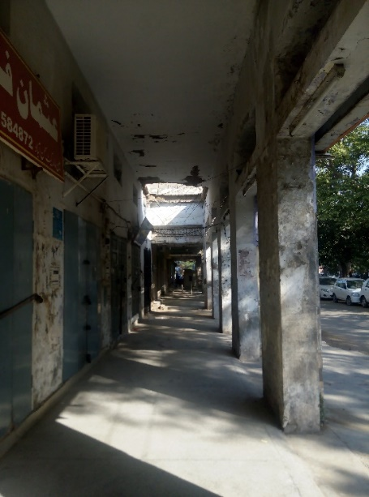
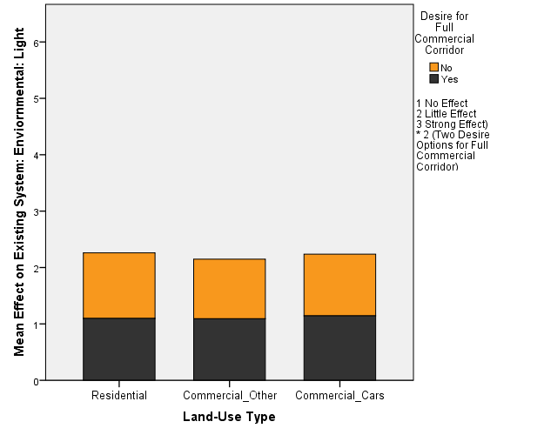
Chart 8 (Left): Effect of Commercialization on Access to Natural Light
Figure 14 (Right): Effect of Commercialization on Access to Natural Light
Environment: Heat
Higher levels of air temperature often recorded in heavily commercialized areas is also not a major problem in Samanabad. Trees and medians largely help in dissipating the heat generated by cars. Furthermore since the cars are mostly parked and dispersed all over in a horizontal fashion, it reduces the thermal impact of commercialization.
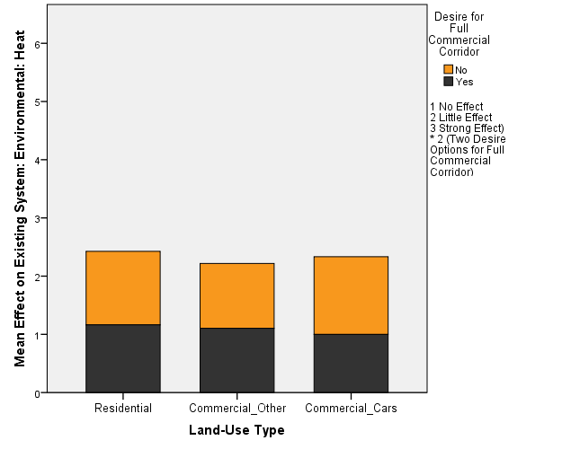
Chart 9: Effect of Commercialization on Heat
Environment: Noise
Unlike natural light and heat, noise is a major environmental concern. Residents have been bothered by the increase in noise levels most. It is not only the clattering sound of automobiles but oblivious honking which adds to the noise pollution.
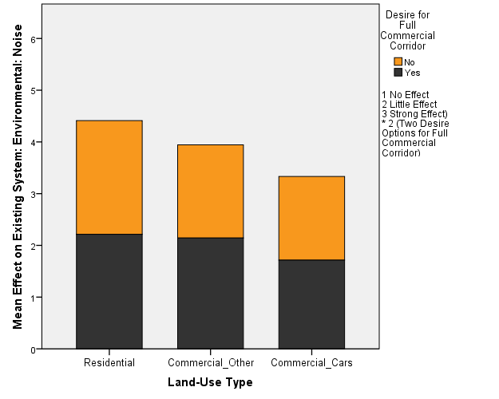
Chart 10: Effect of Commercialization on Noise
Environment: Green and Vegetation
Most damaging effect of commercialization has been recorded on the plants, trees and greenery, long affiliated with Samanabad. This is one affect even car dealers pointed out with a larger proportion. A number of causes and effects of degradation of built environment such as increased noise pollution and reduced quality of air, are directly linked to the loss of green nature.
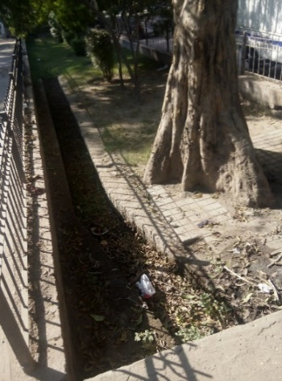
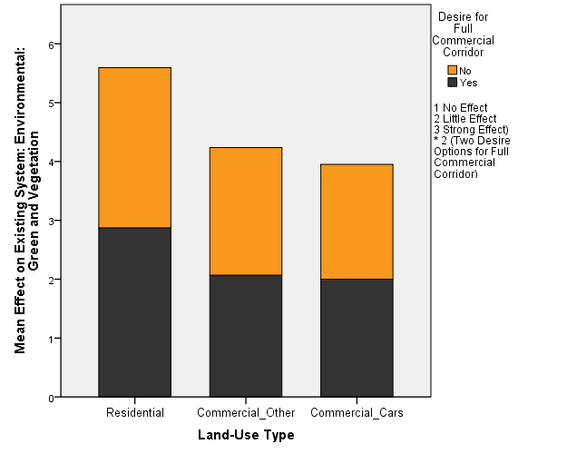
Chart 11 (Right): Effect of Commercialization on Plants and Trees
Figure 15 (Right): Effect of Commercialization on Plants and Trees
Environment: Buildings Structure
Structure of the residential area has been immensely effected by commercialization of car dealership. Walls of the property at the back of commercial face are blithely brought down- sometimes up to three plots in order to provide covered parking for the cars. The severity of this structural intervention and its sheer contrast with the neighbor’s pot can be seen in the following photograph.
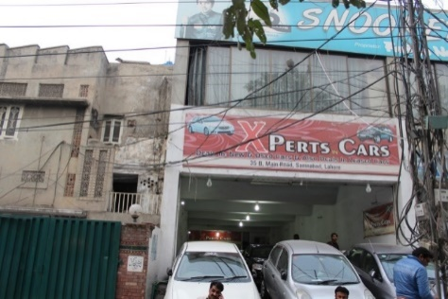
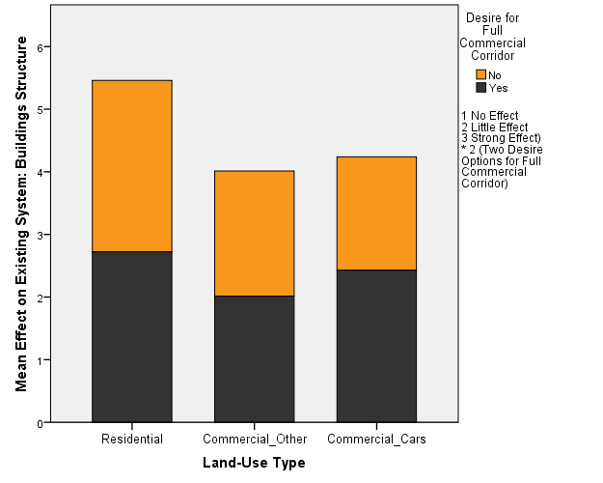
Chart 12: Effect of Commercialization on Building Structures
Figure 16: Effect of Commercialization on Building Structures
Environment: Building Aesthetics
One of the most intriguing results related to the architectural characteristic- building aesthetics. To the utmost delight of researcher, the responds had a fairly good sense of appreciation for good architectural aesthetics. The shops in Main Market had been divided out of a larger plot, there still exists a residential area at the back of the market. Both shopkeepers and residential respondents consequently associated with the built environment and in most cases witnessed a change. Major population in sample set identified the damage made to building aesthetics as a strong effect of commercialization.

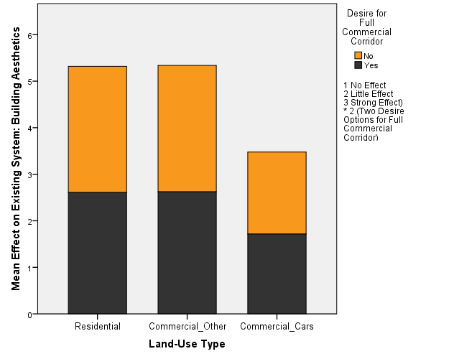
Chart 13: Effect of Commercialization on Building Aesthetics
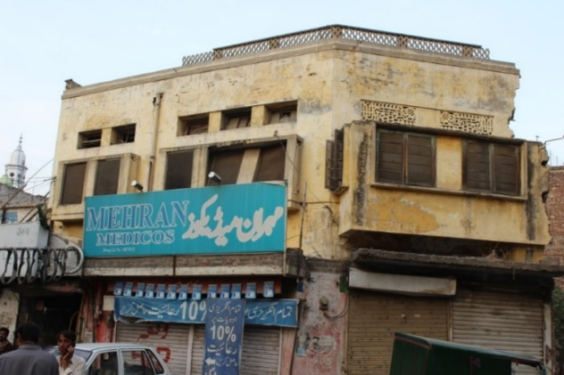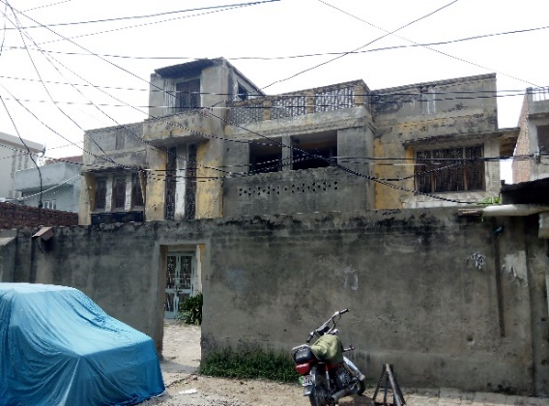
Figure 17 (Left) and Figure 18 (Right): Private Houses on Main Road, Samanabad
Conclusions and recommendations made in the next section are driven from following co-relation matrix.

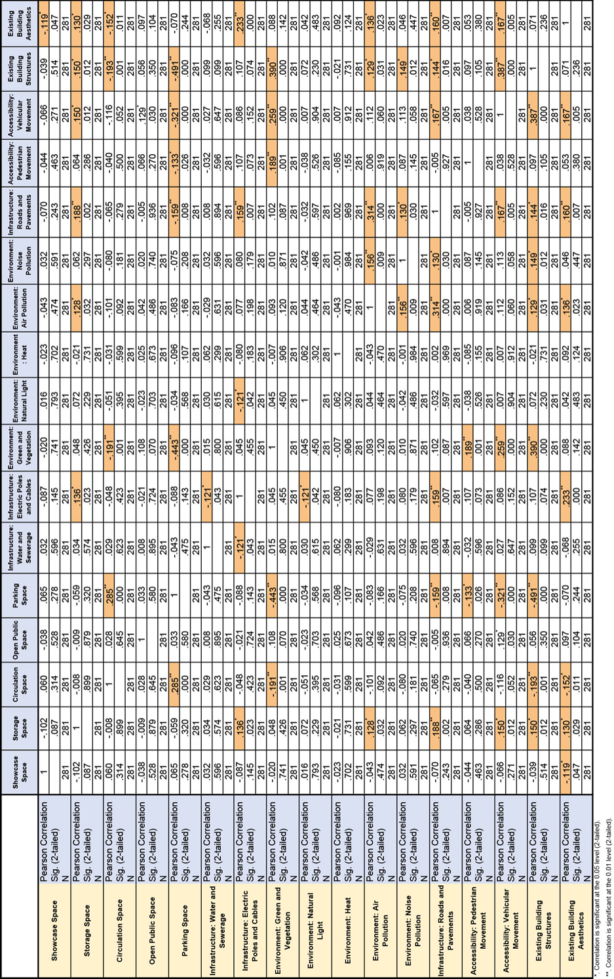
Conclusions and Recommendations
Following spatial adversities need urgent regulatory action (double steric).
Between “Bad Effect on Trees and Greenery” and “Bad Effect on Structure of Existing Buildings” (0.390**)
Samanabad population pointed out strong relationship between damage made to the trees and vegetation and the changes made in building structures. This relationship, seemingly obscure at first, implied a strong mental map and memory of the place of local population. It was stated through consistent accounts to the researcher that houses along Main Road, Samanabad used to have set back as far as 16 feet from the road. This land (in some cases inside of property wall and in others outside of it) was all green with a good number of trees in it. With the increasing trend of commercialization, built environment drifted itself gradually closer and closer to the road. Furthermore, the new commercial storefronts tend to cut out the trees and other visual barriers to their façade which generates money through advertisements and hoardings.
Site specific byelaws need to be defined and strictly implemented for Samanabad Main Road (for the offsets are not consistent throughout) on urgent basis in order to block out further encroachment of the structures towards road. Trees may be planted not only inside the medians but also along the property lines as physical barrier and in order to revive character of the place.
Between “Bad Effect on Trees and Greenery” and “Bad Effect on Vehicular Accessibility” (.259**)
Another important relationship of environmental degradation was pointed out to be the vehicular accessibility. Later is inherently linked to structural change of built environment. Closer the walls squeeze in, narrower the path in between them becomes, hence more pressure in favor of removing trees and other ‘obstructions’ in the path. Newer, heavier, faster modes of transportation along with increased number of trips demand clear view and obstruction-less mobility.
Mixed mode of traffic should be strongly discouraged, for it slows down the overall flow and puts more pressure on widening up the roads.
Between “Bad Effect on Electric Poles and Cables” and “Bad Effect on Existing Building Aesthetics” (.233**)
One of the highest stated problems was the damage caused to aesthetic value of the built environment by a chaos of electric wires jumbled up in front of the plots and haphazardly planted electric poles (sometimes encroaching the road so deep as to pose danger to the vehicles).
Underground wiring in Samanabad is not a good solution because the town is already sunken compared to the neighborhood towns, water in most areas remain standing for days after heavy rain fall. However electric cables should deploy standard number of separators between wires and poles should be rooted off the roads. Furthermore wires should have a safe distance from built structures. It will not only mitigate danger but also provide an aesthetic relief to built environment.
Between “Bad Effect on Vehicular Accessibility” and “Bad Effect on Existing Structure of Buildings” (.387**)
Commercial buildings which do not provide adequate parking space put pressure on vehicular mobility.
It is a mutual relationship, the more space is provided to vehicles, more damage is done on the peripheral structure. In order to assign balanced intervention plan, building byelaws should be cross-examined with the traffic byelaws before implementation if the either.
Between “Opportunity for Providing Circulation Space” and “Bad Effect on Parking” (.285**)
There is a strong tradeoff between opportunities for providing circulation space to new commercial activity under the existing circumstances of parking. Cars nailed into the circulation space of Main Market Samanabad has been documented in Chapter 4. Car showrooms are majorly responsible for this.
Before implementing circulation space byelaws on present and future commercial activity, regulations need to be laid out for existing car showrooms. Otherwise circulation space may be overtaken by cars on sale.

Between “Bad Effect on Trees and Greenery” and “Bad Effect on Pedestrian Accessibility” (.189**)
People are inherently intelligent and they relate with and appreciate nature even if they are not specialized in the given field. Good pedestrian accessibility is also a good pedestrian walk. And trees play important role in it for they not only provide shade but also better air quality and refreshment to the eyes. Having eradicated trees and replaced it with walls and encroachments has effected good pedestrian accessibility as well.
Pedestrian accessibility needs not only to be re-allocated but also redesign with good landscape measures considered beforehand. And existing greenery could be utilized on that account.
Between “Opportunity for Providing Storage Space” and “Bad Effect on Roads and Pavements” (.188**)
Car-sale commercial activity has already been seeping towards Main Market, Samanabad, from both ends. One of the problems associated with car storage in public domain is that the cars are constantly washed. The water tainted with all kinds of detergents runs down the roads and pavements and accumulates where there is no drain. Consequently it seeps into ground and result in destruction of the roads and pavements.
Car parking policy for showrooms should not only be restricted to space regulations but should also be tied to proper water drainage and associated systems.
Between “Bad Effect on Vehicular Accessibility” and “Bad Effect on “Building Aesthetics” (.167**)
When vehicular accessibility is restricted through encroachments or effected through degradation of roads or through other reasons, they directly affect building aesthetics.
Temporary, informal commercial on main road with vehicular traffic should be strongly discouraged. Existing context of built environment, or buildings of half-a-century old or more need to be taken into consideration while planning ahead for vehicular accessibility.

Between “Bad Effect on Roads and Pavements” and “Bad Effect on Vehicular Accessibility” (.167**)
This relatively evident relationship calls for high priority planning and regulation. Roads which are being frequently used by vehicles get badly affected by them.
Providing road accessibility is not going to solve the problem for long. A constant check and maintenance is required on the Main Road, Samanabad.
Between “Bad Effect on Roads and Pavements” and “Bad Effect on “Building Aesthetics” (.160**)
Roads and pavements in particular are connected to built environment, are an extension of building in that sense. When the roads and pavements are damaged, they directly affect the building aesthetics nearby.
Both planning and conservation are continuous processes and they should be integrated as such. Not only the buildings and structures of value need maintenance and preservation but the whole context including roads and pavements outside the property line.
Between “Bad Effect on Electric Poles and Cables” and “Bad Effect on “Roads and Pavements” (.159**)
One of the most significant causes of destruction of roads and pavements was insertion of electric poles in them without proper, adequate protocol. They not only damage the roads and pavements and limit the flow of circulation but also pose a constant threat to people.
LESCO should also be brought on board while planning regulations for building and traffic related problems.
Between “Bad Effect on Air Quality” and “Bad Effect on “Sound/Noise” (.156**)
One of the most insightful relationships are found between air quality and noise. With more cars, and more CO₂ emissions, the air temperature begins to rise. Hot air molecules, already oscillating at higher rate amplifies the sound, hence increasing the noise.
One of the ideal barriers under given circumstances is plantation of more trees for they help in climate control and dampers down noise level through providing barrier, and their importance have already been concluded in aforementioned relationships.
Between “Opportunity for Providing Storage Space” and “Bad Effect on Vehicular Accessibility” (.150*)
Cars parked along medians and property lines by showrooms in Samanabad represent both their storage and showcase space. Cars which need fixing are more than often parked indistinguishably among the cars on display. It is because of difficulty of re-arranging all of units when a single unit moves in or out. In any case when they become obstacle in vehicular flow. Hence the opportunity with excessive storage space is directly tied to the damage it is going to cause on vehicular accessibility.
The number of cars being parked, their location and the orientation in which they are parked needs to be monitored in favor of unobstructed traffic flow.
Between “Opportunity for Providing Storage Space” and “Bad Effect on Existing Structure of Buildings” (.150*)
It has been observed and documented for number of cases in Samanabad, where car showrooms have pierced through up to two and in some cases three buildings perpendicular to the road, in order to provide storage space to the cars. This is one of the strongest impact car-related commercialization has had on built environment of Samanabad.
The permit to subdivide a given plot for different land-use type may be revised in order to slow down this trend of continuous internal destruction of built environment on Main Road, Samanabad. A couple of the properties have been divided into strips of up to four different car dealers, each of which run down separately all the way back to up to three properties lengthwise. This trend has radically changed the built environment of Samanabad from within. There needs to be a check and ideally a cap on such voracious spatial transformation.
Following spatial adversities should be addressed in the following stage. They represent a lesser rate of urgency for action (single steric):
Between “Bad Effect through Noise” and “Bad Effect on Existing Buildings Structure” (.149*)
Sound vibrations and noise strongly affect building structures.
Sound can be reduced or blocked out entirely through several design techniques e.g., increasing the distance between source and the structure and placing barriers like trees in between.
Between “Bad Effect on Roads and Pavements” and “Bad Effect on Structure of Existing Buildings” (.144*)
Commercialization, particularly in case of car sales, contributes to the deterioration of roads and pavements. Similarly buildings which go through deterioration damage the roads as well. And the regulations relating construction process are not followed. Construction material is dumped on side of road without much consideration.
New construction process needs to be inspected and car-related commercial activity should be administered.
Between “Bad Effect on Quality of Air” and “Bad Effect on Existing Building Aesthetics” (.136**)
Now that the Samanabad, Nala has been covered to make room for dual-carriage way, nala smell has been reduced. But the toxics in air negatively impact on architectural aesthetics for architecture is a full-body experience.
Air quality needs to monitored and kept under control in order to revive and maintain an overall ambiance of the place.
Between “Opportunity for Providing Storage Space” and “Bad Effect on Electric Poles and Cables” (.136*)
Building loads increase with increase in commercialization, resulting in heavier electrical infrastructure in place, therefore an opportunity for providing more storage space is tied to further degradation of built environment through electrical systems; if not considered beforehand.
There should be a limit to commercialization process in order to ensure adequate electrical supply to everyone, free of visual noise.
Between “Opportunity for Providing Storage Space” and “Bad Effect on Existing Building Aesthetics” (.130*)
More than often, one comes across in Main Market, Samanabad a set of tables jammed into each other. It is a common practice to wrap up the goods at night and create movable storage spaces inside the circulation space. It affects the visual characteristic of the market. Advertisement boards of all colors and sizes have hid and majorly ruined aesthetic quality of several houses.
Storage space should be very well defined and under no circumstances should it break into circulation space.
Between “Bad Effect of Noise” and “Bad Effect on Roads and Pavements” (.130*)
Sound vibrations travel through ground as well. Constant vibrations tend to cause damage to floors and pavements and even roads.
Roads should be properly laid out end to end within assigned dimensions with no rough and brittle edges; noise levels should be reduced through design and policy as stated before.
Between “Bad Effect on Quality of Air” and “Bad Effect on Existing Buildings Structure” (.129*)
Some level of C0₂ in air is inevitable for it is produced by breathing but huge amount of other toxics caused primarily through traffic pollution have damaging effect on built environment.
New trees should be planted, and existing open spaces should be populated with grass, plants and trees and maintained consistently.
Between “Opportunity for Providing Storage Space” and “Bad Effect on “Quality of Air” (.128*)
Even the most attractive storage space may not pull in customers if it smells bad or is affected by air pollution. In case of car showrooms, customers tend to spend a longer period of time at each dealer’s shop, inspecting the cars, but they do not put up with air pollution if it is not bearable and quickly skip ahead.
More trees need to be planted near Mor-Samanabad in particular, where this trend is worse.
Between “Bad Effect on Electric Poles and Cables” and “Bad Effect on “Natural Light” (.121*)
This relatively weaker relationship indicates dire consequences for there a good number of apartments occupying upper floors. Transformers, jumbled up cables and the advertisement boards affixed to the poles partially blocked out sun light from entering the apartments at upper floors. Road side windows would literally open up into transformers and electric wires in more than one cases.
Under no circumstances an electric pole should be erected closer than a safe standard distance from the shops and apartment windows.
General Conclusions and Recommendations
A number of general conclusions are stated below:
NOC, A License to Object
One of the most important general conclusions of the research concerns No Objection Certificate. The highest percentage of people (Please see Pie Chart 3) claimed there was no problem in acquiring the NOC. On further investigation they stated (in different fashion but along the same line) that acquiring a neighbor’s consent is not that big a problem. All you need to do is sign an NOC for them. This trend has horrible consequences. If allowed un-checked, every residential property owner, especially in an area which is already losing residential proportion would want his/her property to become commercial so that it could be sold at higher price. This is where planners need to intervene and stop this trend in order to keep a balance which individuals oversee in their limited scope of self-interest. The weightage of acquiring NOC from adjacent neighbor in administrative procedure for commercialization should be reduced.
Distinction between Showcase and Storage Space
In case of used car-sale markets, almost all cars happen to be simultaneously both stored and showcased at the same time. Building byelaws therefore need to cater
to this difference between ordinary and car-sale commercial activity.
Clear, Defined Circulation Space
It has been deduced that a clear defined circulation space, ideally enhanced by good architectural aesthetics, not only facilitates consumers, but planning-wise creates more potential visits for each seller in the market; It is good in everyone’s interest, particularly in case of ribbon commercialization.
Parking Space is a Moderator
Buildings with inadequate parking space should not be approved in the first place. And a flexible and shared parking space may be adjusted for existing scenarios where there is inadequate space for car parking. It may be done through third party administrator like Lahore Parking Company. In the case of car showrooms, each parking space occupied on public property like streets and roads, needs to be listed and documented, and therefore charged by a fee. It would discourage broad dispersal of cars all over the area and keep a constraint on commercial activity. The fee generated as such may be invested back in protection of the cars against theft or other damages.
Specified Commercialization
Biggest threat to the area is a vicious trend of a specific kind of commercialization i.e. car-dealership market. It is approaching in fast from both ends of Main Market where cars have already started nailing into the customers’ circulation space. A good number of old shops have already been evacuated and if the trend continues on, it wouldn’t be too long before Main Road, Samanabad loses its original character entirely.
It has been concluded that two areas are strongly linked with the degradation caused by commercialization which need to be immediately addressed. The first one is accessibility in terms of traffic, parking and road condition-related issues. Both pedestrian and vehicular accessibilities have been largely compromised. And the second problem, directly linked with several other aspects is the loss of trees and damage made to the environment. This aspect is also frequently related with variables applied to the study.

References
Bosworth, C. E., 2004, The New Islamic Dynasties: The Chronological and Genealogical Manual. Edinburgh University Press.
Burns, W., 1959, British Shopping Centres: New Trends in Layout and Distribution, Leonard Hill Books Ltd. Eden Street, London.
Cartwright, R. M., 1980, The Urban Design of Urban Space, The Architectural Press Ltd. London.
Ezdi, R., 2007, The Dynamics of Land Use in the Lahore Inner City: A Case for Mochi Gate. Lund University Pub.
H & PP Department. Govt. of Punjab, 1993, Housing and Physical Planning Development.: Policy Regarding Commercialization of Residential Plots, Lahore.
Hameed, R. and Nadeem O., 2014, Haphazard Commercialization: A Potential Threat to Sustainable Commercial Development in Metropolitan Cities? The Case of Lahore
HUD & PHED. The Punjab Commercialization of Properties Rules-2001. Housing, Urban Development and Public Health Engineering Department, Government of the Punjab, Lahore, 2001.
Khan, A. A., 1994, Commercialization in the City if of Lahore, M.Sc. Term Paper, Guided Individual Study, CRP Department, UET, Lahore.
Kilbridge, M. D.,Block, P. O. & Teplitz, P. V., 1970, Urban Analysis. Graduate School of Business Administration.
Lahore Development Authority, 1984, Building Regulations. Lahore, LDA. Govt. of Punjab.
Lahore Development Authority, 1997, Building Regulations. Lahore, LDA. Govt. of Punjab.
Lahore Development Authority, 2002, Building Regulations. Lahore, LDA. Govt. of Punjab.
Lahore Development Authority, 2007, Building Regulations. Lahore, LDA. Govt. of Punjab.
Lahore Improvement Trust, 1936, Lahore: Today and Tomorrow, LIT Publication.
LG & RD. The Punjab Local Government (Commercialization) Rules-2004. Local Government and Rural Development Department, Government of the Punjab, Lahore, 2004.
Nadeem, O., 1997, Impact of Linear Commercialization on Traffic Flow, MSc. Dissertation, Department of City and Regional Planning, UET, Lahore.
Naz, N & Anjum, G, A, 2007, Transformation of Main Road, Gulberg, Lahore: From Residential to Commercial. NED University of Engineering and Technology.
NESPAK; LDA. Integrated Master Plan for Lahore-2021. Lahore Development Authority, Lahore, 2004.
Qadeer, M. A., 1983, Lahore: Urban Development in the Third World. Vanguard Books Ltd., Lahore.
Rehman, A., 2013, Mapping Lahore: Tracing Historical Geography of a City through Maps. Al-Mezan Publishers, Lahore.
Shahzad, K., 2008, Commercialization and its Impact on the Built Environment: The Case of Study is Main Boulevard Gulberg, Lahore, M.Arch Dissertation, Department of Architecture, UET Lahore.
Talbot, I., 2006, Divided Cities: Partition and its Aftermath in Lahore and Amritsar. Oxford University Press.
Thornton, T. H., 1873, A Brief Account of the Histories and Antiquities of Lahore Part 1, Government Civil Secretariat Press, Lahore.

Ar. Umair Zia Malik is Assistant Professor at the Department of Architecture, National College of Arts, Lahore
Dr. Saima Gulzar is the Chair Person of School of Architecture and Planning, University of Management and Technology, Lahore
Plnr. Mutahir Awan is Assistant Professor at University of Management and Technology, Lahore

