Thermal Analysis of an Educational Building with Different Construction Materials
Kashif rasheed¹,Shimza Jamil², Muhammad Ramzan³, Muhammad Zulqarnain⁴

- Project Engineer at Tricon Engineers, BSc Building and Architectural Engineering
- Lecturer at Depart of Building and Architectural Engineering Bahuddin Zakriya University Multan, MS in Integrated Building Design
- Designer at Design Edge, BSc Building and Architectural Engineering
- MS in Civil Engineering, BSc Building and Architectural Engineering
Email:kashif245245@gmail.com

ABSTRACT
The rapidly growing world energy use has already raised concerns over supply difficulties, exhaustion of energy resources and an enormous environmental impact (ozone layer depletion, global warming, climate change, etc.). This study was about an educational building located in the climatic zone of Multan. The objective of this study was to minimize energy consumption by using different construction materials. Different aspects of the building were studied including passive and active techniques, planning and design. These aspects were analyzed and the results were evaluated. Different construction materials were identified, surveyed and analyzed used in the making of effective building envelope. The Autodesk Ecotect 2011 was used to determine indoor comfort condition and heating, ventilation, air conditioning and cooling loads (HVAC). The total reduction in energy consumption was 11.86% including 11.76% reduction in cooling loads and 46.59% in heating loads with locally available materials and glazing. This study will help us in reducing the heating and cooling loads of the buildings and in cutting costs.
Keywords: educational building, Multan, cooling and heating load, thermal performances.
- INTRODUCTION
The global contribution of buildings, both residential and commercial, in energy consumption has steadily increased, reaching figures between 20% and 40% in developed countries. It has also exceeded two other major sectors, that is the industrial and transportation sectors. Population growth and an increasing demand for building services and comfort levels, together with the rise in time spent inside buildings has made certain that the upward trend in energy demand will continue in future. [1]
For this reason, energy efficiency in buildings remains a prime objective for energy policy at regional, national and international levels. Among building services, growth in HVAC systems energy use is particularly significant (50% of building consumption and 20% of total consumption in USA) [1]. In Pakistan, 50% of total energy is consumed only in the building sector [02].
Pakistan is suffering from an energy crises, so saving energy is our need. This study deals with buildings and aims to reduce energy consumption and (HVAC) loads with different construction materials.
Fig.1 Multan has a mild winter season and high relative humidity. The main seasons are summer and winter interspersed with brief spring and autumn seasons. Summer season persists for the longest period during the year. The level of precipitation is low for most of the year. Multan receives the monsoon rains from July to September.
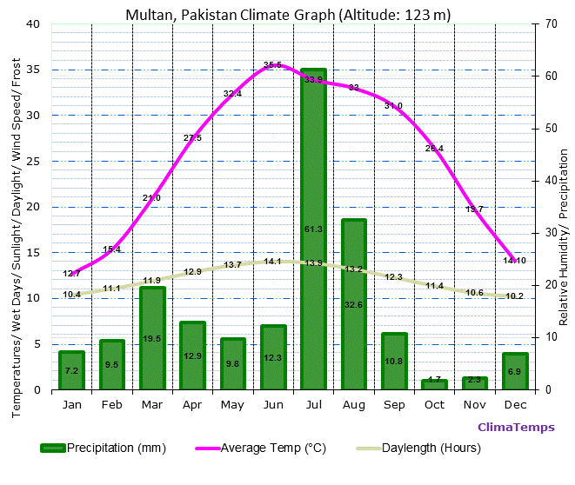
Fig 1. Multan, Pakistan climate Graph (Altitude: 123 m) [source: climatemps.com]
- BUILDING ENVOLPE
The building envelope, also known as the building shell, fabric or enclosure, is the boundary between the conditioned interior of a building and the outdoors. The energy performance of building envelope components, including external walls, floors, roofs, ceilings, windows and doors, is critical in determining the amount of energy required for heating and cooling. The building envelope’s impact on energy consumption should not be underestimated. Globally, space heating and cooling accounts for over one-third of all energy consumed in buildings, rising to as much as 50% in cold climates and over 60% in the residential sub-sector in countries with a cold climate. [3]
Local building designers have largely ignored passive design strategies which can moderate internal temperatures and hence reduce building energy consumption by adjusting the building to match the local climatic conditions. Most previous passive design studies have focused on houses and commercial buildings in moderate, cold or hot arid climates. [3]
2.1 ROOF
Roof design and material can reduce the amount of air conditioning required in hot climates by increasing the amount of solar heat that is reflected rather than absorbed by the roof. For example, roofs that qualify for energy star are estimated to reduce the demand for peak cooling by 10 to 15 percent. Proper insulation is also important in attics and building cavities adjacent to the roof. In addition, roofs also offer several opportunities for installing on-site generation systems. Solar photovoltaic (PV) systems can either be installed as a roof top array on the top of the building or a building-integrated photovoltaic system can be integrated into the building as roofing tiles or shingles. In single and double story buildings, 50-70% heat transferred through the roof in which hollow clay blocks were used as insulation and were 38-63% more effective than the conventional systems of insulation [4]. Roofs absorb maximum solar radiation in terms of area through which heating and cooling loss occurs [5].
2.2 WALLS
Heat flow through wall can be reduced by wall insulation. Wall insulation will reduce both cooling and heating demands of the buildings [6]. Massive construction on the eastern and western external walls can reduce solar heat gain. By doubling wall thickness on east and west sides cooling loads can be reduced up to 7-10% [7]. Understanding and optimizing heat transfer through walls is important in high performance building design. Using thermal mass and insulation to our advantage with passive design strategies can help reduce the amount of energy that active systems need to use. Therefore, it is critically important to determine properly the thermal transmittance of walls when assessing the energy performance of buildings. It is worth mentioning that many previous studies have confirmed the benefits of improving the envelope thermal properties of the consumed energy of buildings [8].
  - WINDOWS
Double glazed low-energy windows with coating and gas filling of low U-value are very useful. Energy can be saved by minimizing thermal bridges in constructions and joints to make an airtight building envelop with low infiltration rate [9]. Window panels are a major component of the building fabric with considerable influence on energy performance and are accountable for up to 60% of a building’s overall energy loss. Therefore, the thermal performance of glazing materials is an important issue within the built environment [10].

2.4 FLOORS
Thermal mass is very important with reference to the high heat capacity materials that can absorb heat, store it and release it later. In his research, he concluded that the floors of a building can store thermal energy and help in the regulation of indoor temperatures by absorbing and progressively releasing the heat gained through both external and internal means. The research work conducted in the University of Florida recommended an increased airflow by designing raised floors. Raising the floor slab actually reduces the computed energy savings and insulation is beneficial for the floor slab. A maximum of 1m stripe of the perimeter below the floor slab should be insulated to facilitate the heat transfer to the soil in summertime [11].
- METHODOLOGY
In this research, first of all we selected an educational building and then different aspects of the building were studied including passive and active techniques, planning and design. These aspects were analyzed and the results were evaluated. Different construction materials used in making of the effective building envelope were identified, surveyed and analyzed. After studying the building, Autodesk Ecotect 2011 was used to gauge the thermal performance of the building. We made different cases for building with different materials, analyzed it using Autodesk Ecotect 2011 and concluded the results.
- CASE STUDY OF BUILDING
The building in this case study was computer engineering department located in Bahuddin Zakriya University Multan, Punjab, Pakistan.
The total area of building is 11300 sq-ft. It is a double story building with 6 class rooms, 3 labs, 1 kitchen, store, combined bathroom, and central courtyard at each story. Sunshades are not provided on windows and their material is shown in table 1.
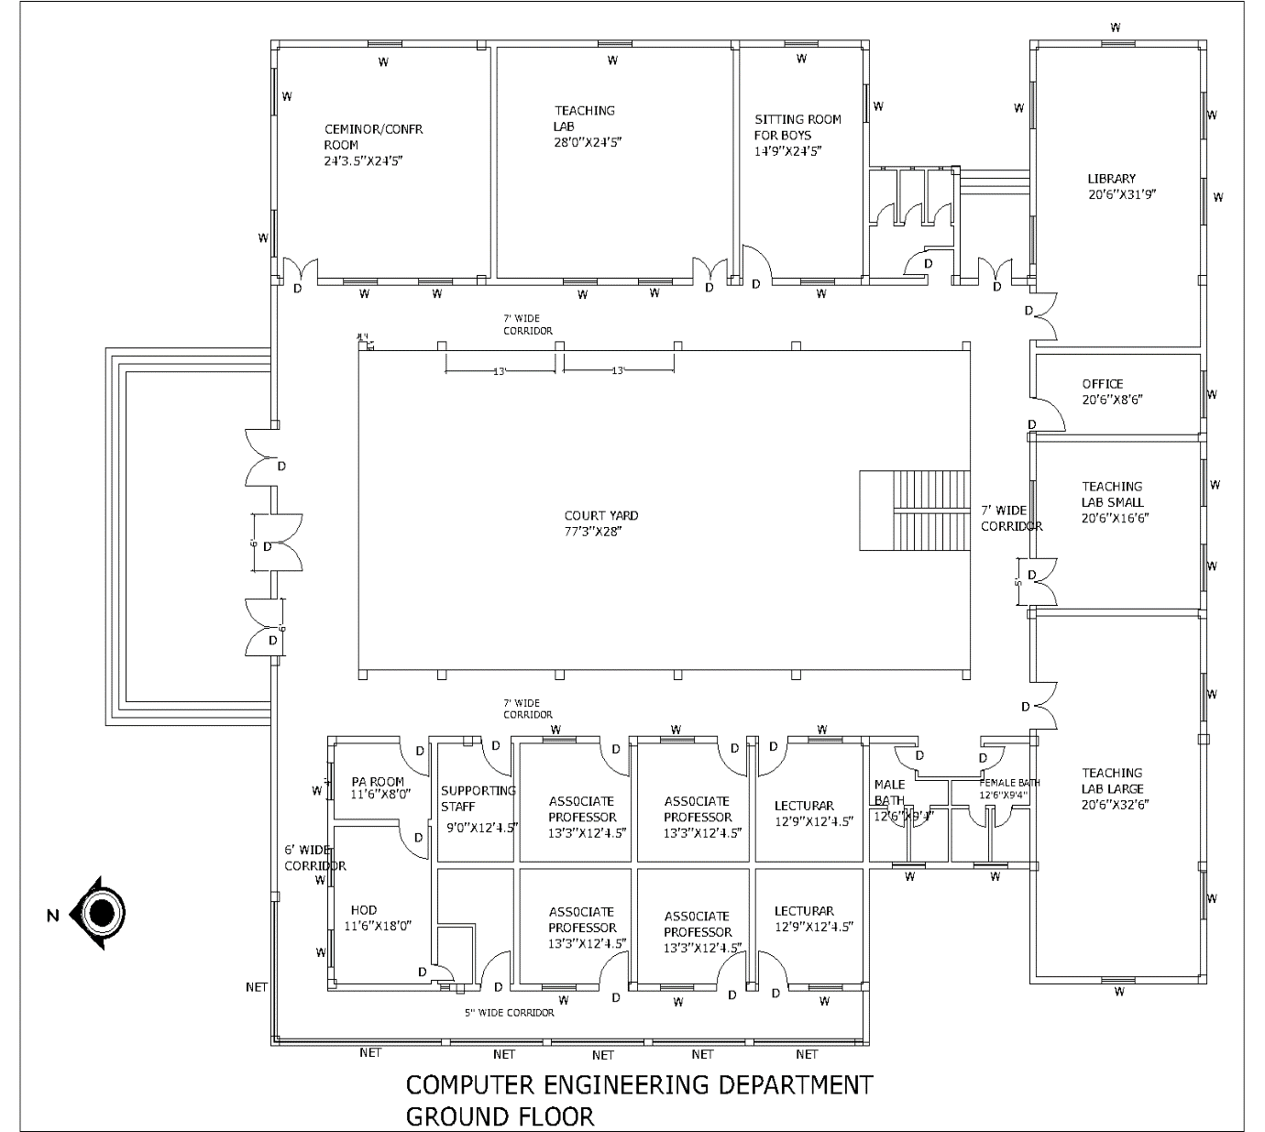

Selected Case Study Building
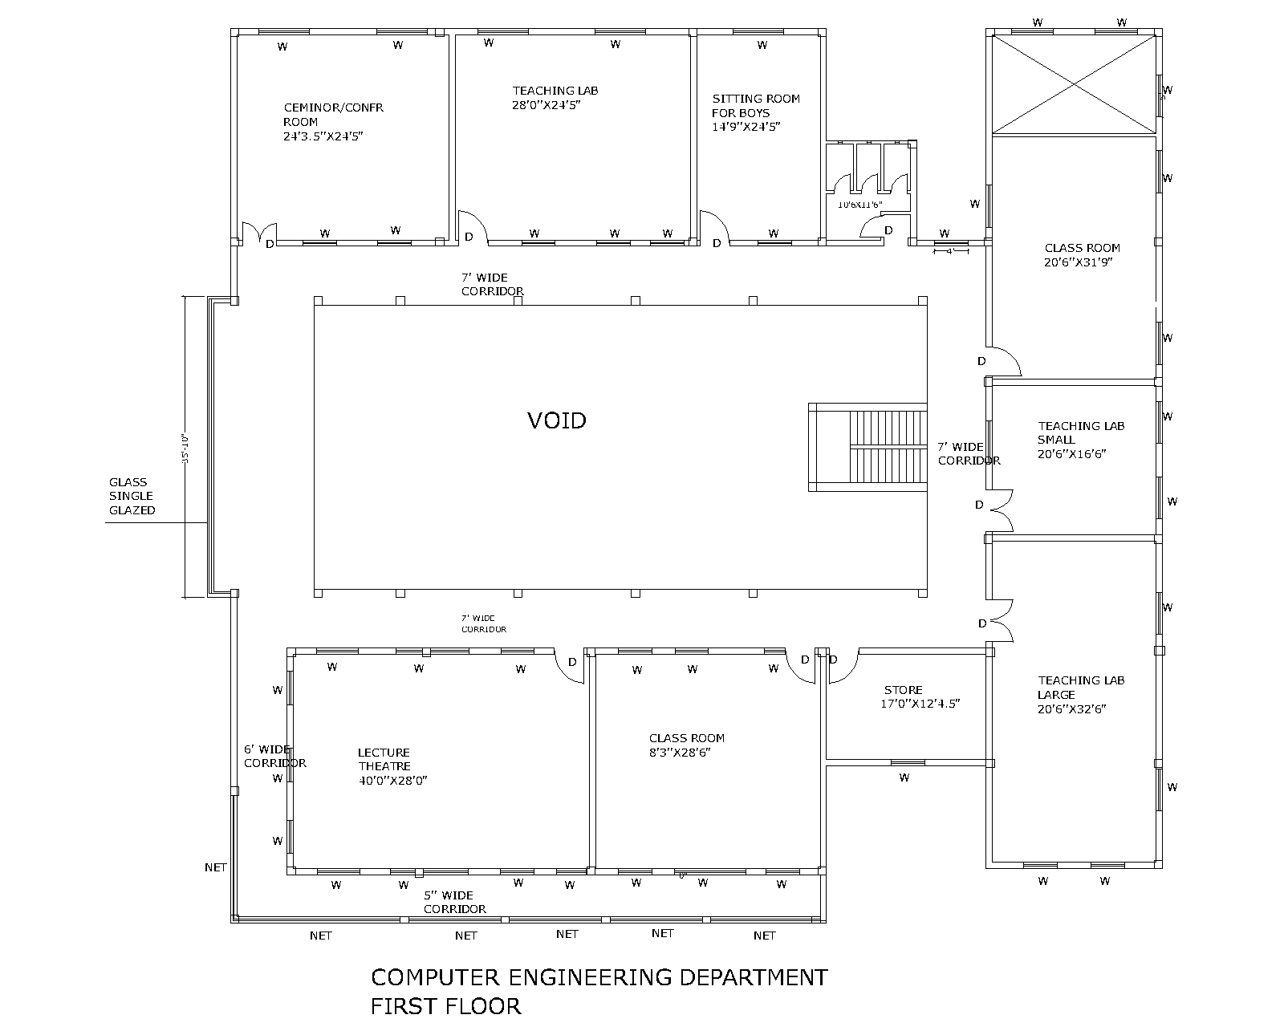

5. THERMAL PERFORMANCE OF BUILDING WITH DIFFERENT MATERIALS
For this research we made four cases with different materials.
BASE CASE: In base case, the building with present construction material was considered. Single glazed glass windows, 9’’ thick brick masonry walls and concrete roof with mud and bitumen coating were used in this building.

TABLE.1 THERMAL PROPERTIES OF BUILDING MATERIALS (BASE CASE) [Source: Ecotect 2011 and www.kingspan.com]
No. | Building Components and Specifications |  | Thickness | Density | Specific Heat | Conductance
 |  |  | (inch) | (kg/m³) | (J/kg.K) | (W/mK)
 |  | Roof Tiles | 1 1/2" | 1 900 | 800 | 0.84
 |  | Mud | 3" | 1 900 | 8 80 | 0.520
 | Roof U Value 0.872
1. |  | Bitumen | 0 3/8" | 1 700 | 1 000 | 0.50
 | (W/m²k)
 |  | Concrete | 6" | 2300 | 656 | 1.046
 |  | Ceramic Tiles | 3 /8" | 2000 | 8 50 | 1.2
 |  | PCC | 2" | 950 | 656 | 0.209
2. | Intermediate Floor U Value 0.500 | Brick blast | 2" | 1900 | 880 | 0.47
 |  | Concrete | 6" | 2300 | 656 | 1.046
 |  | Ceramic Tiles | 3 /8 " | 1 900 | 656 | 0.309
 |  | P CC | 2" | 2000 | 656 | 0.755
3 . | Ground Floor U Value 1.330 | Brick Masonry | 4" | 2000 | 8 36 | 0.711
 |  | Sand | 4" | 2240 | 8 40 | 1.711
 |  | Soil | 9" | 1 300 | 1 046 | 0.837
 |  | Plaster | 3 /8" | 1 250 | 1 088 | 0.431
4. | Walls U Value0.324 | Brick | 9" | 1 900 | 880 | 0.47
 |  | masonry
 |  | Plaster | 3 /8" | 1 250 | 1 088 | 0.431
5 . | Windows U Value 1.098 | Standard Glass | 1/4" | 2300 | 8 36 | 1.046
 |  | Plywood | 1 /8" | 530 | 1 400 | 0.140
6. | Doors U Value 2.980 | Air Gap | 1 5/6" | 1.3 | 1 004 | 5.560
 |  | Plywood | 1 /8" | 5 30 | 1 400 | 0.140

CASE 1: In base case, mud was used in the roof which has the conductance value 0.52 w/mk. In case 1, wool resin bonded was used as an insulating material for roof which has the conductance value 0.021w/mk. 1’’ thick layer of wool was used which is a very energy efficient material with a low conductance value. Modified properties of materials are given in table 3.
CASE 2: In base case, single glazed glass was used for windows which has the U-value 1.098 w/mk. In case 2, double glazed glass was used which has the U-value 0.4244 w/mk. Modified properties of materials are given in table 4.
CASE 3: Walls are also a critical part of the building. 40% heat passes through walls into the building. In base case, 9’’ thick brick masonry wall was used which has the U-value 0.324 w/mk. In case 3, double layer of 4.5’’ thick brick masonry wall with 1’’ air gap was used which has the U-value 0.236 w/mk. Double glazed windows were used in this case. Modified properties of materials are given in table 5.
CASE 4: This was the final case in which materials of roof, walls and windows were changed. In roof, 1’’ thick layer of wool resin bonded was used which has the conductance value of 0.021 w/mk. Cavity wall was used which has the U-value 0.236 w/mk. Double glazed windows were used which has the U-value 0.4244 w/mk. Modified properties of materials are given in table 6.
TABLE 2. INDOOR DESIGN CONDITIONS AS PER WEATHER FILE OF JAIPUR, INDIA (Same Climate as Multan), AUTODESK ECOTECT, 2011.
Relative Humidity | 67%
Wind Speed | 2.31 m/s
Thermostat Range | 30
HVAC System | Air-Conditioning
Air Change Rate | 0.50/hr

- RESULTS AND DISCUSSIONS
The case study building with present materials in the climate of Multan is considered as a base case in which mud was used in the roof. Single glazed windows and 9’’thick brick masonry walls were also used in this building. Autodesk Ecotect 2011 was used for analysis. In base case, total energy load was 57630097 Btu/hr, including 57462640 Btu/hr as cooling loads and 167457 Btu/hr as heating loads.
CASE 1: In this case wool resin bonded was used as an insulation material in the roof. Results indicated reduction in total energy consumption. Total load of Case-I was 51761560 Btu/hr, including cooling loads of 51634884 Btu/hr and heating loads of 126675 Btu/hr. A reduction was observed in energy saving including 10.14% saving in cooling and 24.35% saving in heating loads.
CASE 2: In this case double glazed windows were used. Results indicated reduction in total energy consumption. The building loads were 55734882 Btu/hr, including cooling loads of 55576248 Btu/hr and heating loads of 158634 Btu/hr. Reduction was observed in energy saving including 5.26% saving in heating loads and 3.28% saving in cooling loads.
CASE 3: In this case cavity walls were used and double glass windows were also used. Results indicated a reduction in total energy consumption which was more than case 2. The energy loads were reduced to 55193375 Btu/hr, including the reduction of 55059948 Btu/hr in cooling loads and of 133427 Btu/hr reduction in heating loads. Reduction was observed in energy saving including 4.18% saving in cooling loads and 20.32% saving in heating loads.
CASE 4: We changed the material of roof, walls, and windows and run analysis by Autodesk Ecotect. Results indicated a reduction in total energy consumption which was more than all other cases. The energy loads were reduced to 50792536 Btu/hr, including 50701424 Btu/hr reduction in cooling loads and 91112 Btu/hr reduction in heating loads. Maximum reduction was observed in energy saving including 11.76% saving in cooling loads and 45.59% saving in heating loads.
TABLE 3. THERMAL PROPERTIES OF BUILDING COMPONENTS AND MATERIAL (CASE 1)

No. | Building Components and Specifications |  | Thickness | Density | Specific Heat | Conductance
 |  |  | (inch) | (kg/m³) | (J/kg.K) | (W/mK)
 |  | Roof Tiles | 1 1/2 " | 1 900 | 800 | 0.84
1. | Roof U Value 0.19373(W/m²k) | Mud | 3 " | 1 900 | 8 80 | 0.520
 |  | Wool, resin bonded | 1’’ | 6.18 | 499 | 0.020
 |  | Bitumen | 0 3/8 " | 1 700 | 1 000 | 0.50
 |  | Concrete | 6" | 2300 | 656 | 1.046

TABLE 4. THERMAL PROPERTIES OF BUILDING COMPONENTS AND MATERIAL (CASE II )

No. | Building Components and Specifications |  | Thickness | Density | Specific Heat | Conductance
 |  |  | (inch) | (kg/m³) | (J/kg.K) | (W/mK)
 |  | Standard Glass | 1 /4 " | 2300 | 8 36 | 1.046
3. | Windows
 |  | Air Gap | 0 3/8 " | 1.3 | 1 004 | 5.560
 | U Value 0.4244
 |  | Standard Glass | 1 /4 " | 2300 | 8 36 | 1.046

TABLE 5. THERMAL PROPERTIES OF BUILDING COMPONENTS AND MATERIAL (CASE-III)

No. | Building Components and Specifications |  | Thickness | Density | Specific Heat | Conductance
 |  |  | (inch) | (kg/m³) | (J/kg.K) | (W/mK)
 |  | Plaster | 3 /8 " | 1 250 | 1 088 | 0.431
1. | Walls U Value 0.236 | Brick | 4.5’" | 1 900 | 880 | 0.47
 |  | Masonry
 |  | Air Gap | 1’’ | 1.3 | 1 004 | 5.560
 |  | Brick
 |  | Masonry | 4.5" | 1 900 | 880 | 0.47
 |  | Brick
 |  | Plaster | 3 /4 " | 1 250 | 1 088 | 0.431
 |  | Standard Glass | 1 /4 " | 2300 | 8 36 | 1.046
3. | Windows
 |  | Air Gap | 1’’ | 1.3 | 1 004 | 5.560
 | U Value 0.4244
 |  | Standard Glass | 1 /4 " | 2300 | 8 36 | 1.046

TABLE 6. THERMAL PROPERTIES OF BUILDING COMPONENTS AND MATERIAL (CASE-IV)

No. | Building Components and Specifications |  |  | Thickness |  | Density |  | Specific Heat |  | Conductance
 |  |  |  | (inch) |  | (kg/m³) |  | (J/kg.K) |  | (W/mK)
 |  | Plaster |  | 3 /8 " |  | 1 250 |  | 1 088 |  | 0.431
 |  | Brick |  | 4.5’" |  | 1 900 |  | 880 |  | 0.47
1. |  | Masonry
 | Walls U Value 0.236 | Air Gap |  | 1’’ |  | 1.3 |  | 1 004 |  | 5.560
 |  | Brick
 |  |  |  | 4.5" |  | 1 900 |  | 880 |  | 0.47
 |  | Plaster |  | 3 /4 " |  | 1 250 |  | 1 088 |  | 0.431
 |  | Standard Glass |  | 1 /4 " |  | 2300 |  | 8 36 |  | 1.046
2. | Windows
 |  | Air Gap |  | 1’’ |  | 1.3 |  | 1 004 |  | 5.560
 | U Value 0.4244
 |  | Standard Glass |  | 1 /4 " |  | 2300 |  | 8 36 |  | 1.046
 |  |  | Roof Tiles |  | 1 1/2 " |  | 1 900 |  | 800 |  | 0.84
3. | Roof U Value 0.19373 |  | Mud |  | 3 " |  | 1 900 |  | 8 80 |  | 0.520
 |  |  | Wool, resin bonded |  | 1’’ |  | 6.18 |  | 499 |  | 0.020
 |  |  | Bitumen |  | 0 3/8 " |  | 1 700 |  | 1 000 |  | 0.50
 | (W/m²k)
 |  |  | Concrete |  | 6" |  | 2300 |  | 656 |  | 1.046
- CONCLUSION
The purpose of this research was to reduce the HVAC loads in buildings in the climatic conditions of Multan. From the base case to Case 4, total reduction in energy consumption was 11.86%, including 11.76% reduction in cooling loads and 45.59% in heating loads. The indoor temperatures were controlled for minimizing the energy use by using energy efficient construction materials. Therefore, it is concluded that thermal comfort and healthier environment in buildings can be achieved by providing proper insulation materials.

- FUTURE RECOMMENDATIONS
This research was limited to studying the effects of construction materials. Future studies may be conducted on design strategies like passive and active techniques for buildings, shading devices, orientation of windows, plantations etc.
- LIMITATIONS OF STUDY
This research deals only with the construction materials and the buildings which are situated in a hot climate area like Multan.

REFRENCES

Energy and Buildings, Volume 40, Issue 3, 2008, Pages 394-398 A review on buildings energy consumption information, Luis Pérez-Lombard. Christine Pout. José Ortiz.
- Arif, S., Khan, A., and Alamgir, K., “Modeling the Temperature Effect of Orientations in Residential Buildings”, Mehran University Research Journal of Engineering & Technology, Volume 31, No. 3, pp. 371-378, Jamshoro, Pakistan, 2012.
- Cheung, C.K., Fuller, R.J. and Luther, M.B., “Energy- Efficient Envelope Design for High-Rise Apartments”, Energy and Buildings, Volume 37, No. 1, pp. 37-48, January, 2005.
- “A Performance of Hollow Clay Tile (HCT) Laid Reinforced Cement Concrete (RCC) Roof for Tropical Summer Climates”, Energy and Building, Volume 39, No. 8, Vijay Kumar, K.C.K., Srinivasan, P.S.S., and Dhandapani, S., pp. 886-892, August, 2007.
- Chan, K.T., and Chow ,W.K., “Energy Impact of Commercial-Building Envelopes in the Sub-Tropical Climate”, Applied Energy, Volume 60, pp. 21-39, Hong Kong, China , 1998,
- Bahrami, S., “Energy Efficient Buildings in Warm Climates of the Middle East,” Masters Thesis, Lund university, Department of Energy Sciences, Lund, Swidon, October,2008.
- Wong, N.H., and Li, S., “A Study of the Effectiveness of Passive Climate Control in Naturally Ventilated Residential Buildings in Singapore,” Building Environment, Volume 42, No. 3, pp. 1395-1405, March, 2007.

- Effect of wall thermal properties on the energy consumption of buildings in the gaza strip , Dr. Ahmed Muhaise, Islamic University of Gaza, Faculty of Engineering, Department of Architecture, Gaza, Palestine, 2nd International Sustainable Buildings Symposium (ISBS 2015)
- Sharaf, F.M., and Al-Salaymeh, A., “A Comparative Study of the Use of Energy Conservation Techniques in Office Building: Passive and Solar Energy Applications: The Case of Jordan”, Sustainable Cities Society, Volume 5, pp. 16-22, December, 2012.
- Impact of Window Films on the Overall Energy Consumption of Existing UK Hotel Buildings, Ali Bahadori-Jahromi 1,*, Abdulazeez Rotimi 1, Anastasia Mylona 2, Paulina Godfrey 3, 2 May 2017, Sustainability 2017, 9, 731; doi:10.3390/su9050731, www.mdpi.com/journal/sustainability
- Performance of Typical Residential Building in Karachi with Different Materials for Construction by NAFEESA SHAHEEN*, SABAHAT ARIF**, AND ARIF KHAN** Volume 35 , Issue No 2, April 2016

