A STUDY OF DISINTEGRATION OF LAHORE
FROM A CITY OF GARDENS TO A CITY OF CONGESTION

A.M.Malik*, M.Y.Awan**, M. Rashid*
* Assistant Professor, School of Architecture and Planning
** Professor, School of Architecture and Planning
University of Management and Technology, Lahore, Pakistan
Corresponding e-mail: ayesha.malik@umt.edu.pk

Abstract
Historically, Lahore has been known as the city of gardens. The Mughal emperors, Sikh Raj and the British colonial rulers developed several parks in and around the city of Lahore which still continue to provide the much needed public space for the city's growing population. However, the present government has been enacting massive road development projects which include mass-transit, signal free corridors and overpasses. This has led to an increased urban sprawl and property destruction as more and more space is required for the widening of roads and construction work.
Historical sites, including parks, tombs and graveyards, mosques, churches and government offices etc are under severe threat due to these expansionist policies. Apart from the encroachments, Lahore's air quality has been deteriorating at a steep pace due to vehicular traffic and industrial emissions. This paper will discuss the extent and nature of damages to several historical building facades and their structures. These buildings include Jahangir's tomb, Shalimar Gardens and the Chauburji monument. Moreover, the impact of Badami Bagh Bus Terminal's location and haphazard industrial development around the heritage sites will also be discussed. The studies of various environmental regulatory bodies indicate the ambiguity in the emergence of law as the sole savior, including the judicial activism for the protection of the environment. The paper concludes that due to short-sightedness behind the urban policies of the government, serious threats are posed to cultural heritage sites and there is a strong need for their re-alignment.
Keywords: Lahore, gardens, pollutions, heritage damage, encroachments.

Introduction

Lahore is known as the city of gardens. Both Mughals emperors and British colonial rulers built several gardens in and around the city. Shalimar Gardens, built by the Mughal Emperor Shah Jehan to emulate the Islamic paradise promised for the afterlife as mentioned in the Holy Quran, is a UNESCO World Heritage Site. Lawrence Garden (now Bagh-e-Jinnah) was built during the British rule and named after an Indian Viceroy Sir John Lawrence. This park has a botanical garden, a public library and a cricket ground. Other famous parks include Hazuri Bagh, Mochi Gate Garden, Iqbal Park, Nasir Bagh, Race Course Park, Gulshan-e-Iqbal Park, Model Town Park, Jallo Park and the recently built Lahore Safari Park. Apart from the green spaces, Lahore has several historical buildings with immense architectural and cultural significance which attract many international tourists.
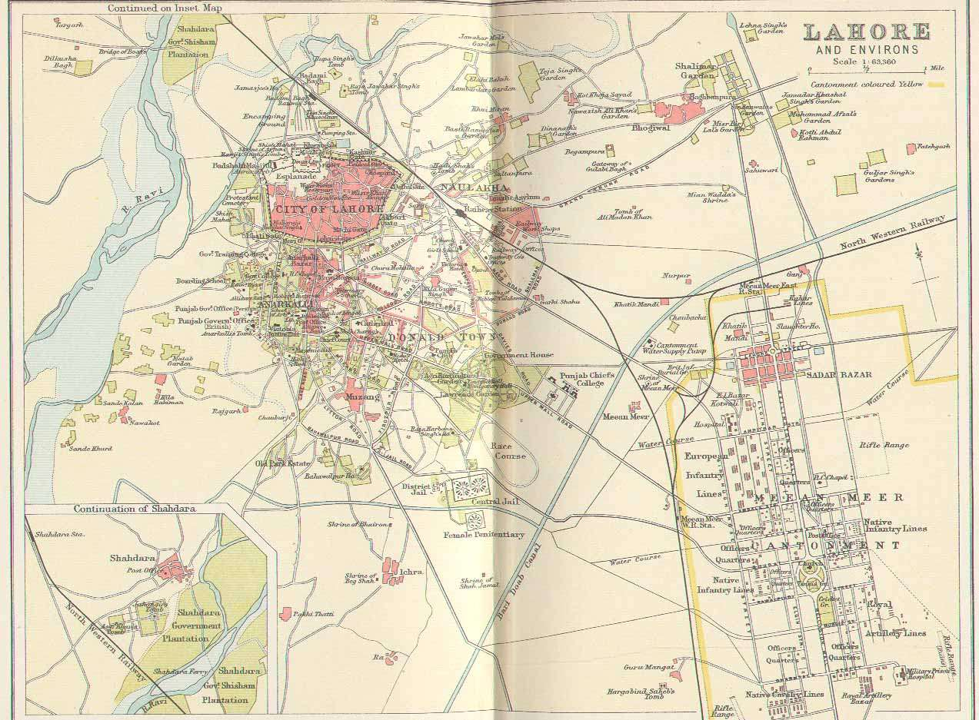
Fig-1; Lahore 1893
Faisal Town has 1.28 sq. meter of green space per person. It has been noticed that the Government of Punjab's priority has been large-scale urban road development projects like Lahore Metro-Bus (2013) stretching all the way from Gajumata to Shahadra, the Orange Line Train (recently inaugurated and trial run test) and other mass-transit projects, signal-free corridors, ring-roads, overpasses and underpasses. Housing, retail and industrial development has largely remained haphazard with a majority of the work performed by the private sector without any cohesive planning. This type of development results in greater automobile dependency mainly due to the urban sprawl. Growing number of automobiles trap urban policy-makers into a vicious cycle of road widening and construction work, instead of developing public spaces such as parks, libraries, auditoriums etc. According to Alamand Shirazi (2014), per person green space available is highest in Gulberg, i.e., 9.74 sq. meter green space per person while Garden Town has only 1. 02 sq. meter space per person. The least amount of per person green space availability is in the Railway Colony, Daras Barey Mianand Bibi Pak Daman, which is 0.01 sq. meters. According to United Nation’s health standard, the minimum standard for the availability of green space per person that is essential for people’s health is 9 sq. meter per person. In Gulberg town, only the union council named Gulberg (UC97) is a locality that meets this standard, while the rest of the union councils fall way short of the UN standard.

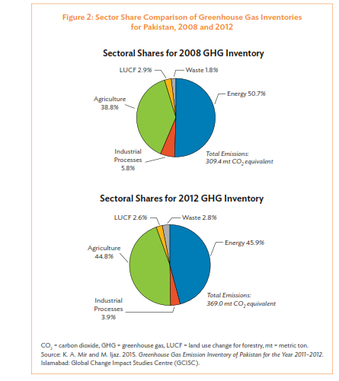
Other identified problems are the lack of green spaces and continued prioritization of short-sighted road projects which have resulted in several negative externalities, the greatest of them is the severe degradation of the city's air quality. The increasing air pollution has caused severe damage to historical buildings, especially their facade and structure have been damaged the most. The aim of this paper is to discuss the nature and extent of these damages along with the factors which are reducing the air quality. The role of different government agencies for environmental protection and development of green spaces will also be discussed.

METHODolody

This paper is divided into various sections. The first section reflects the glorious past of Lahore. The second section highlights the problems that have been identified in the city transformation as per existing conditions. It gives an overview of the various causes of damages to the bits of the city. The third section explores various historical milestones as case studies affected by these problems followed by recommendations regarding how to avoid these threats.

The study employed primary data through the use of case study method. Several heritage milestones Lahore which are remants of different historical periods of the citywere se various parts of Lahore. Some of these amazing built heritage structures are partially damaged, yet they are still on the verge of being victimized directly by these recent large-scale urban road development projects. The paper specifies the various hazardous threats affected the environment of the city adversely and one of the parametersmethods ata analysis was keen observation. As the majority of the buildings weare undergoing athe process of decay due to aging and certain other environmental factors, we specifically targeted the built heritage that is being victimised due to the current manmade issues like metro bus project etc. Other materials and data collected for this study were gathered from the variousdifferent primary ry sources of such as historical literat, books, relevant academic research papers, newspaper clippings, interviews, questionnaires from the user groups and authoritiike the EIA (Environmental Impact Assessment). Its report was thoroughly studied and the conclusive data were aligned with the ground realities checked on site. Thus, the collected data was analyzed with reference to the urban configuration of the city. In a detailed studdiscussed and categorizd into three parameters with the subcategories, highlightinhei side effcts due to them.

study and findings

There can be several natural and environmental phenomena which have destructive effects on cultural heritage sites. These phenomena include severe temperature fluctuations, moisture, rainfall and earthquakes. Since the beginning of the 20th century, such destructive phenomena have occurred at an accelerated pace causing severe damage and in some cases complete collapse of cultural heritage sites. These factorsna are studied meticulously by researchers of working in ferent scientific fields to ascertain their effects on historical monuments. In this regard, the location of historical monuments is one of the most important factors which can increase or decrease the detrimental effects of environmental pollution. Not only environment can cause damage but so can various other causesfactors s missing namelyill maintenance.

Damages due to vehicular emissions

A bulk of Lahore's cultural heritage is located in and around the walled city. Lahore Fort, Badshahi Mosque, Minar-e-Pakistan are all located in close proximity of each other. However, a big source of air pollution in the form of Badami Bagh Bus Terminal (Lorry Adda) is also located nearby. Many national and international agencies including the provincial Environment Protection Department (EPD) and the World Bank have expressed their grave concerns regarding the location of this bus terminal (Hasnain, 2015) fig-2. Hundreds of buses consuming diesel fuel with high sulphur contents pass through the terminal daily ba. The Government of Punjab is planning to relocate all bus terminals to the outskirts of Lahore city including this terminal with the help of the WoBank but has been facing severe resistance from transporters in the form of legal proceedings and protests. There are several hotspots of air pollution throughout Lahore city. Sherwani, Shahid and Asim (2016) Fig-3 found by employing GIS technology (graphical information technology) that Chauburji monument is located at the busiest junction of Lahore's vehicular traffic. It has to bear the highest concentration of harmful gasses like sulphur dioxide, nitric oxide and particle matter.
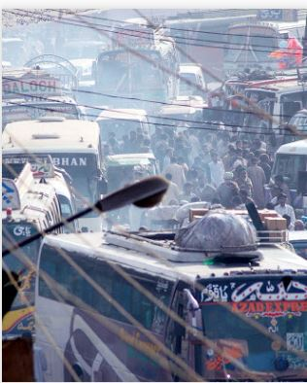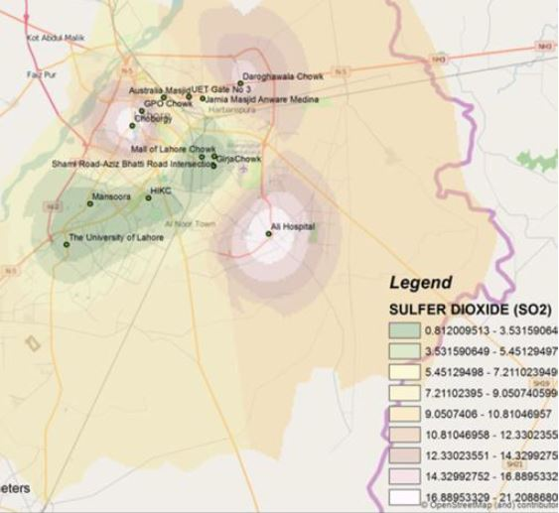
Fig-2 Badami Bagh Bus Station Fig-3 Lahore Pollution Intensity
Jahangir's tomb is located very close to a largely industrial area of Shahdara on the Grand Trunk Road. Air in the whole vicinity is polluted due to the high influx of automobile traffic and industrial emissions. The surface of stone used on the façade has become rough and pitted due to pollutants in the air (Awan and Kazmi, 2008) Fig-4, 5. Stones like the "Sang-e-Badal" and marble have been greatly affected as they are calcareous stones. Lime mortar and lime plaster are also suffering the same degradation with the transformation of calcium carbonate into calcium sulphate, which is water soluble. The disfiguring of the stone surface, especially the fresco work of the surrounding rooms of the main chamber is augmented by the presence of suspended particulates such as dust, fumes, soot, etc. Overall, air pollution has severely weakened the structure of this historic monument. Moreover, mechanical vibration caused by rail and vehicular traffic has also weakened the subsoil foundations of this historic building. Railway line is situated only 400 meters away while the highway is only one kilometer away in Fig-4-5 (Awan and Kazmi, 2008).

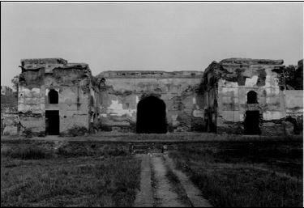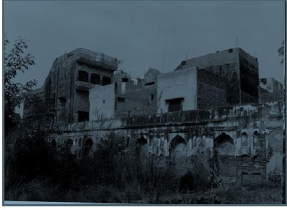
Fig-4 Jahangir's tomb destruction and encroachmentsFig-5 Encroachments along Jahangir tomb's boundary wall
Another historical artifact, the Nawankot monument, which houses the tomb garden of Princess Zeb-un-Nisa, is facing severe structural degradations due to air pollution, natural effects and government's neglect. The monument structure is located near the busy Multan road and has a waste-water drain nearby. The façade surface of stonework kashikari has become coarsened and eroded due to pollutants in the air Fig-5-6 (Malik, Awanand Rashid, 2016).
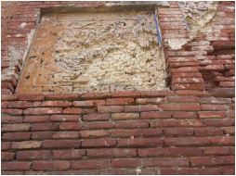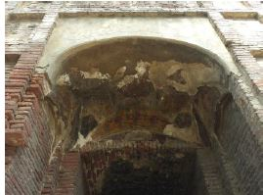
Fig-6 Nawankot Monument's decay Fig-7 Nawankot Monument ornamentation decay
Such detrimental effects due to environmental pollution are not limited to underdeveloped countries. Doytchinov, Screpanti and Leggeri (2016) found that in central Paris historical structures are facing a hard time due to air pollution. Facades of 525 buildings around the banks of Seine experienced the soiling of facades due to the deposition of black carbonaceous particles. Similar results were found for the Parthenon, Greece and high rates of structural corrosion were also observed in these historic buildings. A similar study by US and Indian researchers found air pollutants to be the primary cause for the discoloring of India's greatest historical monument Taj Mahal (Bhattacharaya, 2015). It was found that the deposition of dust and carbon-containing particles is emitted during the burning of fossil fuels, biomass and garbage. Black carbon is emitted by all fossil fuel burning machines including vehicles, while brown carbon is released during combustion of biomass and garbage. One of the researchers claimed that "We found that black carbon gives a grayish color to the surface while the presence of brown carbon and dust results in yellowish-brown hues."
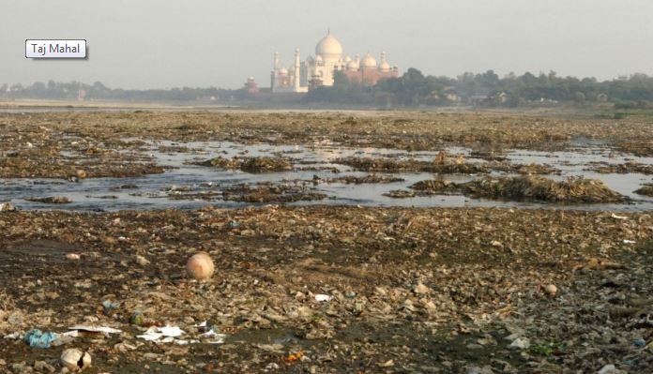
Fig-8Taj Mahal, Agra surrounded by garbage

Industrial emissions: A major source of air pollution

Industrial emissions also cause a significant portion of air pollution in Lahore. According to a rough estimate, more than 700 industrial units are located in Northern Lahore which are causing serious environmental damage to the whole city ("Industrialization mounting", 2009). Historical buildings like the Shalimar Gardens and the set of buildings in/around the walled city are highly prone to these damages due to close proximity with these industrial units/clusters. Most of these units are associated with steel-related industries and are operating from residential localities instead of proper industrial zones. The most alarming fact is that many of these industrial units are using worn-out tires and substandard rubber products as fuels to power their machines. Combustion of used tires and rubber releases highly toxic gasses like carbon monoxide, sulphur oxides and several other toxic metals. There is an informal wheel rim market located in the east of Lahore Fort which also causes air and noise pollution. EPD anticipates that nearly 70 percent of these units are operating without obtaining No-Objection Certificates (NOCs), even when it is obligatory under the Pakistan Environmental Protection Act 1997 (PEPA Act). Some of these industries have installed scrubbers to control harmful emissions due to EPD's intervention but their number is still very small ("Industrialization mounting", 2009).

Mayo and Aziz (2011) have argued that there is no proper industrial location policy throughout the Punjab province and industrial development mostly takes place on firm-specific econometric conditions, often neglecting the principles of social justice and environmental protection. Cities around Lahore have attracted the bulk of industrial development due to their close proximity to Lahore. These cities include Kasur, Gujranwala, and Sheikhupura etc. There is a strong tendency of industrial clustering without any proper planning leading to increased environmental damages.

Heritage destruction due to encroachments

Illegal constructions and road expansion projects also encroach open spaces. Catchment areas must be clearly demarcated and protected to save these monuments from external pressures. The local and provincial government isn’t ready to protect the premises of historical heritage sites while constantly eyeing their lands as an easy catch for road expansion projects. For example, the lack of government's protection for Shalimar Gardens is evident from the fact that the space immediately outside its outer wall has been allowed to become a Sunday bazaar causing consistent damage to the wall (Warraich, 2016). Vandalism can be easily noticed inside the Nawankot monument with signs of illegal activities and witchcraft (Malik, Awan and Rashid, 2016). According to Federal Antiques Act 1975, there ought to be a buffer zone of 200 meters around the major sites of historical and cultural significance, but a wheel rim market right next to the Lahore Fort clearly violates this law and the government has not made any efforts to relocate this market.

Orange Line project causing destruction of Lahore's heritage

Orange Line Metro train project has emerged as the biggest threat to Lahore's heritage sites. Its route passes by several buildings of historical significance. Major sites included in this list are Shalimar Gardens, Lakshmi Building, Lahore General Post Office, Lahore High Court Building and Chouburji. There are two types of hazards posed by this project; the first one is due to government's intention of encroaching the boundaries of these sites and the second one is due to air pollution caused by the construction work. The first hazard is more alarming as it poses serious threats to historical structures on a short-term basis and will be discussed in detail below.

Shalimar Gardens
Historic hydraulic water tank system is situated on the opposite side of GT Road. It used to water the Shalimar Garden's 410 fountains but is currently in a dilapidated condition. This system was housed within two structures, one of them was demolished during the widening of GT Road in the year 1999 and the other one is on the list of sites to be demolished for the Orange Line Metro train (Warraich, 2016) fig-10. Moreover, the outer wall of Shalimar Gardens is also threatened by the vibrations caused by high-speed metro trains as the distance between the two structures is a mere 40-50 feet. Civil society has remained active in pursuing this case at various forums. Apart from the litigation process in courts, the issue has been reported to UNESCO which has expressed deep concerns over this project. Even if the court orders to take the train underground in this section of the route, it will pass directly beneath the fragile Mughal era water pipe system and there is a greater possibility of it being destroyed permanently (Zahid, 2015).
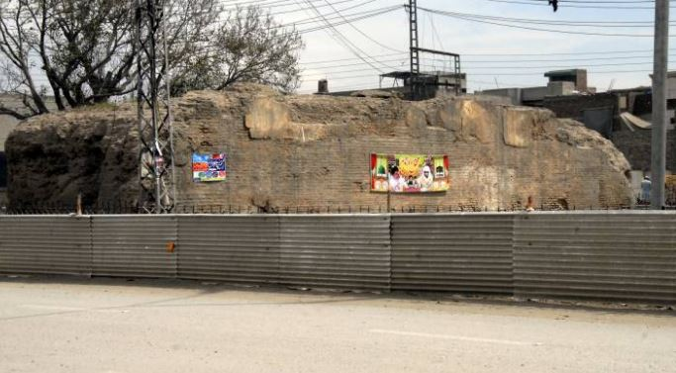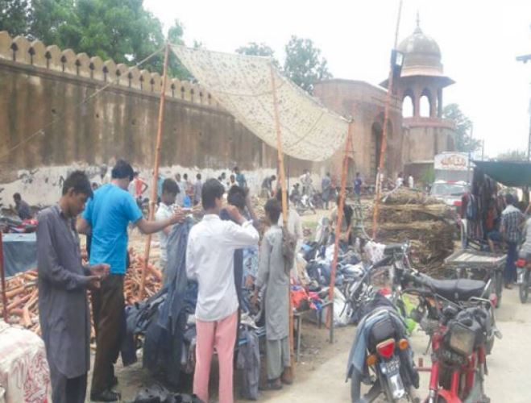
Fig-9Dilapidated hydraulic water tank system of Shalimar Gardens Fig-10 Sunday bazaar along the Shalimar Garden

Chauburji

Chauburji has been suffering the most due to the Orange Line project, the reason being the fact that it has no boundary walls like the Shalimar Gardens and is already situated at the busiest traffic junction of Lahore. It is surrounded by commercial buildings and has remained neglected for years. However, due to protests by civil society and local traders, Lahore Development Authority was forced to change the alignment of the track. Civil society demanded that the train track should be underground in this section as well as the Jain Mandir-Lakshmi Chowk section but LDA refused to cater their demands citing financial and technical reasons. Currently, two pillars of the elevated track have been constructed within the Chauburji square premises.

GPO and the Church

General Post Office building along the Mall Road and Presbyterian Church behind it is also threatened by the Orange Line project. Even though the train will run underground in this section but government officials have placed demolition markings on the outer boundaries of these buildings. GPO building is in public possession while the church is owned by a private organization and is protected by the Antiques Act 1975 (Zahid, 2015). The church management has declined to take any compensation for damages and is unwilling to shift the property as well.

Punjab University Ground (near Chauburji)

Punjab University ground is situated near the PIA planetarium Chauburji. The plight of this ground has remained obscured from media headlines. Once a venue for international cricket test matches, it has now been turned into a construction yard with most of the metal work for Orange Line done here (Hasnain, 2016) fig-11. The place is full of iron girders and other construction materials while lush green grass and jogging tracks are all gone. This ground is at the apex of sports heritage of Pakistan where players like Asif Iqbal, Mushtaq Muhammad and Sarfraz Nawaz used to play Quaid-e-Azam trophy matches and crowds from all parts of the city gathered to watch them play.

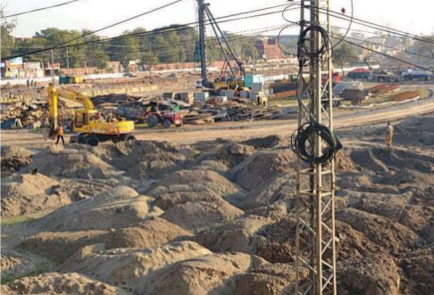
Fig-11 Punjab University

Legislative and legal framework for Air Quality Management at various tiers of the government

In the year 1993, for the first time National Environmental Quality Standards (NEQS) were developed which were later revised in the years 2000 and 2009. However, it was in the year 1997 that Pakistan's national assembly adopted a comprehensive scheme for environmental protection in the form of Pakistan Environmental Protection Act (PEPA) 1997. A federal level council by the name of Pakistan Environmental Protection Council (PEPC) was established under this act of parliament and a full-fledged Federal Minister for Environment was appointed as well. PEPA still remains at the apex of all environmental legislation in the country. The act allowed the establishment of enforcement mechanisms, conditions and penalties for environmental protection and provided legal foundations for the promotion of sustainable development. The act also delineates responsibilities for federal and provincial Environmental Protection Agencies (EPAs). It also provides the mechanism for the application of polluters-pay-principle (PPP). PEPA section 11(2) clearly states that federal government can impose a tax on any person who discharges, emits or allows the discharge of emission of any effluent or waste of air pollutants or noise in an amount or concentration level above the one recommended by NEQS (Sanchez et.al, 2014).

After the 18th Constitutional Amendment, the responsibilities regarding the protection of environment were devolved to provincial governments. Since a majority of the environmental problems are felt at the local municipality level, therefore addressing them at lower tiers of government is always considered a healthy step in achieving superior outcomes. In Punjab, District Environmental Officers have been appointed for this purpose and provincial Environmental Protection Agency (EPA) has been assigned a key role inside the EPD to enforce environmental regulations. With the process of devolution, federal environmental tribunals have also been devolved to the provinces, allowing provinces to further strengthen their mandate and increase their numbers (Sanchez et.al, 2014).

Pakistan's judiciary has been playing an increasingly important role in the enforcement of environmental laws, especially when regulatory avenues fail to do so. The judicial system is often the sole institution which is able to resolve environmental conflicts. Supreme Court of Pakistan has taken up several cases regarding environment protection and has numerous times concluded that under the Articles 9 and 14 of the constitution, clean environment is a fundamental right of all citizens of Pakistan. High Courts in the provinces have also made several policy interventions for this purpose, one such intervention led to the establishment of Lahore Clean Air Commission. This commission was tasked with the submission of a report on measures required to measure and control the levels of air pollution in Lahore city (Sanchez et.al, 2014). Lahore High Court had to halt signal-free Gulberg Main-Boulevard project as due process was not followed in the approval of Environmental Impact Assessment (EIA) report. For a few months, the honorable court stopped Orange Line's construction work within 200 meters perimeter of historical sites including Shalimar Gardens and Lakshmi building.

However, the performance of Punjab EPD has remained subpar in controlling environmental pollution. The overall result was that EPA couldn't measure the levels of toxic elements in the notorious smog which formed last year in the month of November. A NAB inquiry has been launched against EPA (Randhawa, 2016).

Conclusions

As a result of the research investigations carried out it was found that all public places including the new and the old built heritage in Lahore is under threat. These places include parks, playgrounds, historical heritage sites, religious buildings and even old government buildings. It was also elaborated that a transit-oriented urban policy which Punjab government is following is based on political short-sightedness instead of urban tranquility. Projects based on such policies are leading to the encroachment of public spaces and continued growth in the number of vehicles instead of its reduction. The final outcome is that it has led to an abrupt rise in air pollution that is one of the prime reasons behind the chaos created and has led to other hazards as found in the study.

Moreover, air pollution caused by the vehicular exhaust and industrial emissions has led to severe degradation of Lahore's cultural monuments. The building facades and structures show clear signs of damage and deterioration caused by them. This was earlier observed due to the vehicular traffic emissions. The Orange Line Metro Train is also contributing in the disintegration of the city. The situation is further aggravated by the continuous encroachment of these heritage sites by the government and private actors that goes unrestricted and unchecked. After studying a lot of relevant literature and discussion with the local bodies, it was concluded that the judiciary has been playing the most influential role in encroachment control and pollution abatement and numerous regulatory bodies have often failed in performing their duties. The process of environmental legislation in Pakistan has remained positively steady but its enforcement at various tiers of government has failed miserably. It was found that large-scale construction projects have badly affected the lives of people such as the current Orange Line Metro Train project that comprises a long construction period that’s directly going to affect our economy as well. It will also divide this beautiful city into two parts rather than uniting it which is a threat to the uniqueness of the history of Lahore. Similarly, environmental concerns are not addressed during governmental projects and other infrastructure projects. Such large scale projects need to be dealt with and planned according to the needs of the people since planning is supposedly done for the people in order to fulfill their needs and desires. It is also highly recommended that the governments, industry and other bodies must consider environmental sustainability, including examining innovative ways that will reduce the negative impact on any city’s environment.

References

Alam, R., Shirazi, S.A (2014), “Spatial Distribution of Urban Green Spaces in Lahore, Pakistan: A case study of Gulberg Town”Pakistan Journal of Science, 66 (3), 277-281.

Awan, M.Y. Kazmi, N.S. (2008) “Present Condition and Causes of Decay of Tomb of Jahangir at Shahdara Lahore”,Pakistan Journal of Engineering and Applied Sciences, 2, 51-58.

Bhattacharaya, A., (2015)” Pollution turning Taj Mahal yellow: Study”,The Times of India. Retrieved,http://timesofindia.indiatimes.com/india/Pollution-turning-Taj-Mahal-yellow-Study/articleshow/45723593.cms.

Doytchinov, S., Screpanti, A., Leggeri, G. (2012) “Effects of Air Pollution on Materials, Including Historic and Cultural Heritage Monuments Knowledge”, Diagnostics and Preservation of Cultural Heritage, 2, 95-100.

Hasnain, K. (2015, November 30). Plan to build intercity bus terminals on Lahore outskirts. Dawn. Retrieved from https://www.dawn.com/news/1223266.

Hasnain, K. (2016, Feb 23). `That used to be my playground`Dawn. Retrieved from http://epaper.dawn.com/DetailImage.php?StoryImage=23_02_2016_002_008

The News, “Industrialization, mounting pollution threaten Lahore” (2009) Retrieved from https://www.thenews.com.pk/archive/print/198003-industrialisation-mounting-pollution-threaten-lahore.

Kanani, S.,Zandi, H. A.(2011),”Study of the Damages to historical monuments due to Climatic Factors and air pollution and Offering Solutions”,International Journal of Social, Behavioral, Educational, Economic, Business and Industrial Engineering, 5(3), 1018-1021.

Malik, A.M, Awan, M.Y. Rashid. M. (2016)”A Study of the Present Condition and Causes Decay of Nawankot Monument, Lahore”Int'l Journal of Research in Chemical, Metallurgical and Civil Engg, 3(2), 264-269.

Mayo, S.M, Aziz, A. (2011)“An Overview of Industry, Urbanization and Disaster Risk Nexus in Punjab”,Pakistan Journal of Science, 63(1).

Randhawa, S. (2016)”Environment department failed to perform its duties” Pakistan Today. Retrieved from https://www.pakistantoday.com.pk/2016/12/30/environment-department-failed-to-perform-its-duties-in-2016/

Sánchez, E., Enriquez, E., Afzal,Nakagawa, A., Kahn, A.S., (2014) “Cleaning Pakistan’s Air Policy Options to Address the Cost of Outdoor Air Pollution”. The World Bank.

Sherwani, R.K, Shahid. Z. Asim. M. (2016)“Impact of Traffic Pollution on Historic Buildings in Lahore” Int'l Journal of Research in Chemical, Metallurgical and Civil Engg,3(2), 270-273.

Warraich, F.A. (2016) “The plight of Shalimar Garden’s historic hydraulic tank system”The Nation. Retrieved from http://nation.com.pk/featured/06-Apr-2016/plight-of-shalimar-garden-s-historic-hydraulic-tank-system.
Warraich, F.A. (2016) “Sunday Bazaar damaging Shalimar Gardens “The Nation. Retrieved fromhttp://nation.com.pk/lahore/19-Jul-2016/sunday-bazaar-damaging-shalimar-gardens.

Zahid, L., (2015) “Orange Line – Lahore’s heritage under attack”,Pakistan Today. Retrieved from https://www.pakistantoday.com.pk/2015/11/01/orange-line-lahores-heritage-under-attack/

NESPAK (2015) “Environmental impact assessment (EIA),Lahore Orange line Metro Train Project, Ali Town, Environmental ImpactAssessment,Lahore

PEEPA ACT 1997, https://www.elaw.org/system/files/Law-PEPA-1997.pdf

