**Department of Architecture**

**School of Architecture and planning**

**University of Management and technology**

**Course Outline (on OBE)**

## UMT’s Vision

## ***Our Vision is... Learning***

It defines our existence, inspires all stakeholders associated with us, creates a powerful momentum inside, and responds to the challenges outside. It continues to evolve as present captures new realities and foresight to unfold new possibilities. All in an incessant attempt to help individuals and organizations discover their God-given potentials to achieve Ultimate Success actualizing the highest standards of efficiency, effectiveness, excellence, equity, trusteeship and sustainable development of global human society.

## UMT Mission

Our Mission is.... Leading

We aspire to become a learning institution and evolve as the LEADING COMMUNITY for the purpose of integrated development of the society by actualizing strategic partnership with stakeholders, harnessing leadership, generating useful knowledge, fostering enduring values, and projecting sustainable technologies and practices.

### Mission of the School

The mission of the School is to provide the best leadership in the fields of the built environment; particularly in the development, management and innovation in the fields of architecture, urban planning and related specializations and sub-specializations

### Mission of the Department

At the Department of Architecture our mission is to challenge the participants to develop their abilities in solving complex problems by thinking creatively & informed decision making as a core of their professional schooling. Offering them a diverse interdisciplinary and meticulous program of studies led by an adroit faculty in a comprehensive studios or class environment and preparing them for leadership roles in the field of Architecture, Construction, Landscape, Built Environment and community development.

### course outline

Course code: AR-321 Course title: Architecture Design Studio- IV

|  |  |  |
| --- | --- | --- |
| Program | B-Architecture | |
| Credit Hours | 0+8 | |
| Duration | Spring-2023 (16 weeks) | |
| Prerequisites |  | |
| Resource Person | Sec A: Ar. Ilyas Malik, Ayesha Malik  Ar. Farah Jamil, ALLAH Ditta | |
| Counseling Timing | As per Time Table |  |
| Contact |  | Email:  [ilyas.malik@umt.edu.pk](mailto:ilyas.malik@umt.edu.pk)  [ayesha.malik@umt.edu.pk](mailto:ayesha.malik@umt.edu.pk) |

**Chairman/Director signature………………………………….**

**Dean’s signature…………………………… Date…………………………………………**

**Program educational objectives (PEO’s)**

**PEO-1:**

Able to interpret and elaborate architectural knowledge, communication, graphical and computer skills

**PEO- 2:**

Able to develop building and architectural plans through design coordination selecting suitable materials and construction techniques.

**PEO-3:**

Able to propose appropriate solution to complex building issues and adapt recent developments in architecture focusing on research, creativity and innovation.

**PEO-4:**

Able to maximize ethics by keeping spirit of discipline and respecting the professional codes and society.

**Program Learning outcomes PLO’s)**

Graduates of the B-Architecture at UMT are expected to have acquired and developed the following set of knowledge, skills and personality traits (these are also referred to as graduate attributes).

Graduates of the B-Architecture at UMT are expected to have acquired and developed the following set of knowledge, skills and personality traits (these are also referred to as graduate attributes).

**PLO 1Architectural Knowledge:** An ability to illustrate, architectural fundamentals through verbal and graphical Techniques

**PLO 2Design Analysis and development:** An ability to identify literature and analyze architectural problems reaching substantiated conclusions to meet specified needs with appropriate societal and environmental consideration.

**PLO 3 Case study analysis:** An ability to analyze architectural issues in a methodical way including design, field surveys, interpretation of field data, and synthesis of information to derive valid conclusions.

**PLO 4 Digital Tool Usage:** An ability to create, select and apply appropriate techniques, resources, and modern architectural computer simulations, including prediction and modeling, to complex activities, with an understanding of the limitations.

**PLO 5 Environment and Sustainability:** An ability to propose sustainable solutions to environmental problems through architectural design thinking.

**PLO 6 Project Management:** An ability to demonstrate management skills and leadership qualities in individual and teamwork capacity.

**PLO 7 Design Coordination:** An ability to coordinate effectively across different sectors of construction industry. (Material suppliers, Electrical plumbing, HVAC and Civil works).

**PLO 8 Ethics and the society:** An ability to apply ethical principles and professional codes of the profession following the social norms to the best interest of the mankind.

**Course Learning outcomes (CLO’s)**

|  |  |  |  |
| --- | --- | --- | --- |
| **CLO CODE** | **CLO NAME** | **CLO** | **Domain** |
| **321.1** | **321.C1** | Show an understanding and awareness of architectural elements and compositions. | **Cognitive2** |
| **321.2** | **321.C2** | Examine the work of significant architects and use it as a basis for design exploration. | **Cognitive4** |
| **321.3** | **321.C3** | Attempts to make use of the various phases of the building delivery and design process, and of different approaches to ordering that process in a systematic manner. | **Psychomotor 2** |
| **321.4** | **321.C4** | Organizes built form ordering principles, mass/void relationships, scale and proportion, color, texture, contextual relationships, meaning/imagery, and building technology (awareness of structural). | **Psychomotor 4** |
| **321.5** | **321.C5** | Formulate the design solutions for the project of moderate scale and complexity. | **Psychomotor 6** |

**Mapping of CLO’s to Program’s Learning outcomes (PLO’S)**

|  |  |  |  |  |  |  |  |  |  |  |  |
| --- | --- | --- | --- | --- | --- | --- | --- | --- | --- | --- | --- |
| **Semester** | **Course Code** | **Title** | **Course Learning outcomes** | **PLO 1Architectural Knowledge:** | **PLO 2Design Analysis and development:** | **PLO 3 Case study analysis:** | **PLO 4 Digital Tool Usage:** | **PLO 5 Environment and Sustainability:** | **PLO 6 Project Management:** | **PLO 7 Design Coordination:** | **PLO 8 Ethics and the society:** |
| **6TH SEMESTER** | **AR-321** | **Architecture design studio-I** | Show an understanding and awareness of architectural elements and compositions. | √ |  |  |  |  |  |  |  |
| Examine the work of significant architects and use it as a basis for design exploration. |  |  | √ |  |  |  |  |  |
| Attempts to make use of the various phases of the building delivery and design process, and of different approaches to ordering that process in a systematic manner. |  | √ |  |  |  |  |  |  |
| Organizes built form ordering principles, mass/void relationships, scale and proportion, color, texture, contextual relationships, meaning/imagery, and building technology (awareness of structural organization, services networks, construction processes and materials) as his/her own design determinants. |  |  |  |  |  |  | √ |  |
| Formulate the design solutions for the project of moderate scale and complexity. |  | √ |  |  |  |  |  |  |



**ARCHITECTURE DEPARTMENT**

**School of Architecture & Planning**

**University of Management & Technology Lahore**

**title:** Architecture Design Studio- VI

**Course code:** AR- 321

**CLASS:** Batch-11

**RESOURSE PERSONS:**

**_____________________________________________________________________________**

**PROJECT 2:**

**ENTERTAINMENT COMPLEX**

**Duration: 8 Weeks**

**INTRODUCTION:**

*“Recognizing the need is the primary condition for design.” – Charles Eames*

In this busy world people ordinarily misjudge the idea of entertainment. It’s an arrangement of the happenings which attracts the spectators & provide them with joy. Though aristocratic attention is thought to be achieved by different preferences in entertainment and most of them are decipherable like theaters, watching a movie, listening to music may be engaging themselves in a healthy activity like swimming, archery or any other healthy sports.

Entertainment can be public or private, involving formal, arranged and organized performances as in the case of concerts or theaters and spontaneous and impulsive as in the case of juvenile game. Most forms of entertainment have persisted over many centuries, evolving due to changes in culture, technology, and fashion. Over the time, the idea of celebration has changed, one example of primitive entertainment were Mela’s, which undoubtedly lost somewhere in history.

The entertainment complex will play an important role in our society to transform the mental and physical frustration, apart from this it will help the community to transform the current culture of isolation and encourage people to meet and greet in their own way.

Our task is to design a complex comprising of different programs like cinemas, indoor games, open air theater/Amphitheater, meeting rooms, gaming zones, restaurants and cafes. Besides these, students are free to add a program according to their theme.

**FEASIBILITY OF PROJECT:**

SITE: (134 KANALS – 16 ACRES- 603534 SQFT)

The selected site is located on Abdul Haque Road, Johar Town, Lahore. Site is located near residential area and is easily accessible from different locations; Johar Town, Canal Bank side and Thokar Naiz Baig Side.

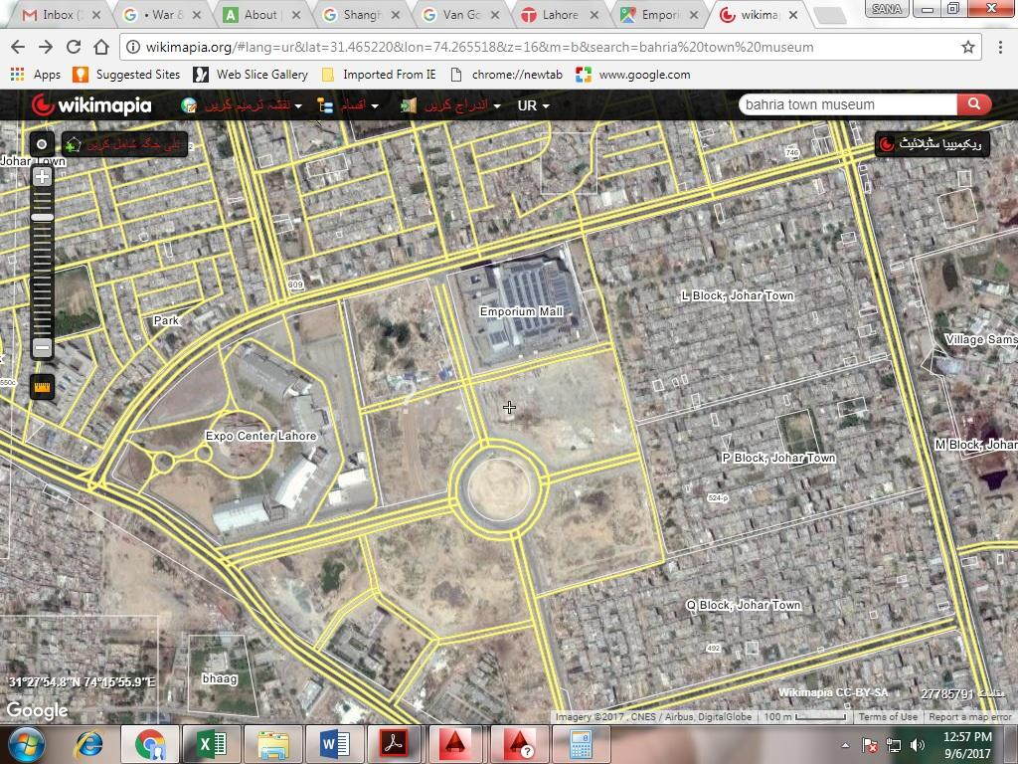

**RECOMMENDED LOCAL CASE STUDIES:**

1. Alhamra Art Center Lahore, Pakistan.
2. Convention center at expo center Lahore.
3. Battlefield new airport road Lahore.
4. Oasis Main Multan Road Lahore.
5. EMAC - Extreme Maneuvers Adventure ClubJohar Town Lahore.
6. X PARK Bedian Road Lahore.
7. CINEGOLD Bahria Town Lahore, Pakistan.
8. Islamabad club (<https://www.facebook.com/pg/islamabadclubislamabad/about/?ref=page_internal> )

**RECOMMENDED INTERNATIONAL CASE STUDIES**

1. Adelaide Entertainment Centre (<https://www.archdaily.com/395028/adelaide-entertainment-centre-designinc>)
2. Roof Prototype for Sports and Public Space (<https://www.archdaily.com/885679/prototipo-de-cubierta-para-espacios-deportivos-y-espacio-publico-el-equipo-mazzanti> )
3. Indoor Swimming Pool in Toro (<https://www.archdaily.com/124418/indoor-swimming-pool-in-toro-vier-arquitectos> )
4. Inter-Company Restaurant / Atelier Didier Dalmas (<https://www.archdaily.com/875640/inter-company-restaurant-atelier-didier-dalmas> )
5. STANDARD 69 / CAPÓ studio (<https://www.archdaily.com/884955/standard-69-cap-estudio> )
6. TREC (training, recreation, education center) Newark Housing Authority / ikon.5 architects (<https://www.archdaily.com/870345/trec-newark-housing-authority-iko-architects> )
7. Auditorium Theatre of Llinars del Valles / Álvaro Siza Vieira + Aresta + G.O.P. (<https://www.archdaily.com/781571/auditorium-theatre-of-llinars-del-valles-alvaro-siza-vieira-plus-aresta-plus-gop> )

**RECOMMENDED READINGS:**

1. **Architecture for sports**

Author:Sturzebecher, Peter

Year of publication: 2002

Call no. 725.8 STU-A,

Available at U.M.T Library

1. **Cultural centers**

Author: Bione, Cecilia.

Year of publication: 2009

Call no. 725.2 BIO-C

Available at U.M.T Library

1. [**New space spa & entertainment**](http://lrc.umt.edu.pk:8000/cgi-bin/koha/opac-detail.pl?biblionumber=52747&query_desc=kw%2Cwrdl%3A%20ENTERTAINMENT)

Publisher: New Delhi,India: CBS, 2009

Call no. 747 NEW

Available at U.M.T Library

1. **Restaurant & bar design**

Editor: Rebora, Marco; Wiedemann, Julius.

Publisher: Koln : Taschen GmbH, 2014

Call no. 725.72 RES

Available at U.M.T Library

1. [**Entertainment complex**](http://lrc.umt.edu.pk:8000/cgi-bin/koha/opac-detail.pl?biblionumber=94967&query_desc=kw%2Cwrdl%3A%20ENTERTAINMENT)

Author: Awais Ashraf, Muhammad.

Publisher: Lahore : UMT, Department of Architecture, 2017

Call no. TP 725.8042 AWA-E

Available at U.M.T Library

1. [**Recreational places of Lahore [CD]**](http://lrc.umt.edu.pk:8000/cgi-bin/koha/opac-detail.pl?biblionumber=60177&query_desc=kw%2Cwrdl%3A%20RECREATION)

by Mubashir Sadiq.

Material type: computer file Computer File;

Format: electronic Publisher: Lahore,Pakistan

Call no. AV 070.1 MUB-R

Available at U.M.T Library

1. **Sports parks : directions in design for recreational zones**

Edited by Jim Barnum

Publisher: Victoria : The Images Publishing Group, 2016

Call no. 725.827 SPO

Available at U.M.T Library

1. **Architecture for sports new concepts and international projects for sport and leisure**

Author Sturzebecher, Peter; Ulrich, Sigrid.

Publisher: West Sussex,USA: John Wiley & Sons, 2002

Call no. 725.8 STU-A

Available at U.M.T Library

1. [**New space health & sports**](http://lrc.umt.edu.pk:8000/cgi-bin/koha/opac-detail.pl?biblionumber=52749&query_desc=kw%2Cwrdl%3A%20SPORTS)

Publisher: New Delhi,India: CBS, 2009

Call no. 747 NEW

Available at U.M.T Library

1. [**Design** for leisure **entertainment**](http://library.uet.edu.pk/cgi-bin/koha/opac-detail.pl?biblionumber=5722)

Author: [Wylson, A.](http://library.uet.edu.pk/cgi-bin/koha/opac-search.pl?q=au:Wylson%2C%20A.)

Publication: London Butterworths 1980

Call no. 725.8 W 97 D

Available at National Library of U.E.T, Lahore

1. [**Sports** **halls and swimming pools design and briefing guide**](http://library.uet.edu.pk/cgi-bin/koha/opac-detail.pl?biblionumber=23424)

Author: [Perrin, G.A.](http://library.uet.edu.pk/cgi-bin/koha/opac-search.pl?q=au:Perrin%2C%20G.A.)

Publication: London EF.N. Spon

Year:1980

Call no. [725.840941 P 43 S](http://library.uet.edu.pk/cgi-bin/koha/opac-search.pl?q=callnum:725.840941%20P%2043%20S)

Available at National Library of U.E.T, Lahore

1. [**Handbook of sports and recreational building design**](http://library.uet.edu.pk/cgi-bin/koha/opac-detail.pl?biblionumber=11251)

Author: [Sports Council](http://library.uet.edu.pk/cgi-bin/koha/opac-search.pl?q=au:Sports%20Council)

Publication: London Architectural press

Year:1981

Call no. [725.8 S 6 H](http://library.uet.edu.pk/cgi-bin/koha/opac-search.pl?q=callnum:725.8%20S%206%20H)

Available at National Library of U.E.T, Lahore

1. [**Sports Architecture**](http://library.uet.edu.pk/cgi-bin/koha/opac-detail.pl?biblionumber=23422)

Author: [Sheard, Rod.](http://library.uet.edu.pk/cgi-bin/koha/opac-search.pl?q=au:Sheard%2C%20Rod.)

Publication: New York, Spon Press, 2001

Call no. 725.85 S 3 S

Available at National Library of U.E.T, Lahore

|  |  |
| --- | --- |
|  |  |

1. [**Theatres and Auditoriums**](http://library.uet.edu.pk/cgi-bin/koha/opac-detail.pl?biblionumber=25947)

Author: [Burris-Meyer, harlod Edward C. Cole](http://library.uet.edu.pk/cgi-bin/koha/opac-search.pl?q=au:Burris-Meyer%2C%20harlodEdward%20C.%20Cole)

Publication: New York Reinholld Publishing Corporation

Year:1964

Call no. [725.8 B 94 T](http://library.uet.edu.pk/cgi-bin/koha/opac-search.pl?q=callnum:725.8%20B%2094%20T)  
Available at National Library of U.E.T, Lahore

**SPATIAL REQUIREMENT:**

* Site Plan
* Cinema
* Open air theatre/Amphitheatre
* Auditorium
* Meeting Rooms
* Lounge areas
* Gaming Zone
* Restaurants
* Administration offices

**SUBMISSION REQUIREMENTS**

* Literature Review + Case Studies
* Site Analysis
* Concept
* Detailed Master Plan (Details including entrance exit design, road network including drop over, car parking, pedestrian paths, zoning and landscaping)
* Detailed Plans
* 2 Elevations
* 2 Sections
* 3D views
* Detailed Model

**WORK SCHEDULE**

|  |  |  |
| --- | --- | --- |
| **Weeks** | **DATES** | **MILESTONE** |
| 7 |  | Introduction of the project and discussions on the outcome of the project and other details |
| 7 |  | Case studies ( Local & International) - 5% |
| 8 |  | 1. Areas 2. Site Analysis + Zoning - 10% |
|  |  |  |
| 9 |  | Detailed Site/Master Planning |
| 10 |  | Initial JURY on master plan – 10% |
| 10 |  | Working on Detailed Plans |
| 11 |  | Working on Detailed Plans |
| 12 |  | Mid JURY on master plan and Plans-20% |
| 13 |  | Discussions on Elevations& Sections |
| 14 |  | Discussion on 3d’s, study model |
|  |  | Final Jury – 50% (External 20 % & Internal 30%) |