Department of Architecture
School of Architecture and planning
University of Management and technology
Course Outline (on OBE)

UMT’s Vision

Our Vision is... Learning
It defines our existence, inspires all stakeholders associated with us, creates a powerful momentum inside, and responds to the challenges outside. It continues to evolve as present captures new realities and foresight to unfold new possibilities. All in an incessant attempt to help individuals and organizations discover their God-given potentials to achieve Ultimate Success actualizing the highest standards of efficiency, effectiveness, excellence, equity, trusteeship and sustainable development of global human society.

UMT Mission
Our Mission is.... Leading
We aspire to become a learning institution and evolve as the LEADING COMMUNITY for the purpose of integrated development of the society by actualizing strategic partnership with stakeholders, harnessing leadership, generating useful knowledge, fostering enduring values, and projecting sustainable technologies and practices.

Mission of the School

The mission of the School is to provide the best leadership in the fields of the built environment; particularly in the development, management and innovation in the fields of architecture, urban planning and related specializations and sub-specializations

Mission of the Department

At the Department of Architecture our mission is to challenge the participants to develop their abilities in solving complex problems by thinking creatively & informed decision making as a core of their professional schooling. Offering them a diverse interdisciplinary and meticulous program of studies led by an adroit faculty in a comprehensive studios or class environment and preparing them for leadership roles in the field of Architecture, Construction, Landscape, Built Environment and community development.

Course code AR-311 Course title: Arch. Design Studio-III
Program | Bachelors in Architecture(B. Arch)
Credit Hours | 0+7 (Practical)
Duration | Program: FIVE YEARS  Course: Fall Semester 2022
Prerequisites | AR-211
Resource Person | Section-B: Dr. Yusuf Awan, A D Asim | Section-B: Ilyas Malik,  Madiha Ghafoor
Counseling Timing | -
Contact | yusuf.awan@umt.edu.pk  ilyas.malik@umt.edu.pk madiha_ghafoor@umt.edu.pk

Chairman/Director signature………………………………….
Dean’s signature…………………………… Date…………………

Program educational objectives (PEO’s)
PEO 1: Ability to think creatively and identify new trends in Architectural design
PEO 2: Critical learning for a broad function in various areas of Architectural sciences including structural, mechanical, electrical, environmental, earthquake, and construction management
PEO 3: Ability to keep themselves abreast with recent developments in the relevant Architecture.
PEO 4: Spirit of discipline and respect for the code of ethics of the profession.

Program Learning outcomes PLO’s)
Graduates of the B-Architecture at UMT are expected to have acquired and developed the following set of knowledge, skills and personality traits (these are also referred to as graduate attributes).

PLO 1 Architectural Knowledge: An ability to apply knowledge of mathematics, science, architectural fundamentals and an architectural specialization to the solution of complex architectural problems.
PLO 2 Design Analysis: An ability to identify, formulate, search literature, and analyze complex architectural problems reaching substantiated conclusions using principles of natural sciences and architecture.
PLO 3 Design/Development of Solutions: An ability to design solutions for complex architecture problems and design systems, components or processes that meet specified needs with appropriate consideration for public health and safety, cultural, societal, and environmental considerations.
PLO 4 Case study analysis: An ability to investigate complex architecture problems in a methodical way including literature survey, design and conduct of experiments, analysis and interpretation of experimental data, and synthesis of information to derive valid conclusions.
PLO 5 Modern Tool Usage: An ability to create, select and apply appropriate techniques, resources, and modern architectural computer simulations, including prediction and modeling, to complex activities, with an understanding of the limitations.
PLO 6 The Architect and Society: An ability to apply reasoning informed by contextual knowledge to assess societal, health, safety, legal and cultural issues and the consequent responsibilities relevant to professional architectural practice and solution to complex problems.
PLO 7 Environment and Sustainability: Ability to understand the impact of professional architectural solutions in societal and environmental contexts and demonstrate knowledge of and need for sustainable development.
PLO 8 Ethics: Apply ethical principles and commit to professional ethics and responsibilities and norms of architectural practice.
PLO 9 Individual and Team Work: An ability to work effectively, as an individual or in a team, on multifaceted and/or multidisciplinary settings.
PLO 10 Communication: An ability to communicate effectively, orally and written, on complex architectural activities with the architectural community and with society at large, such as being able to comprehend and write effective reports, design documentation and make effective presentations. To develop an understanding of architectural language through manual and digital ways, in order to make working drawings and presentable sheets using different rendering modes.
PLO 11 Project Management: An ability to demonstrate management skills and apply architectural principles to one's own work as a member and/or leader in a team and to manage projects in a multidisciplinary environment.
PLO 12 Lifelong Learning: Ability to recognize the importance of, and pursue lifelong learning in the broader context of innovation and technological developments.

Course Learning Outcomes (CLO’s)
After studying this course, the students will be able to better understand the following:
- Outline the projects with multiple functions. (C2)
- Compare the structural systems in different building types (C2)
- Develop the understanding of issues related to project program, site users, materials and technology, services and engineering systems. (C3)
- Distinguish between client brief and architect brief. (C4)

Mapping of CLO’s to Program’s Learning outcomes(PLO’S)
Semester | Course Code | Title | Course Learning outcomes | PLO 1: Architectural Knowledge | PLO 2: Design Analysis: | PLO3: Design/Development of Solutions Design/Development of Solutions Design/Development of Solutions Design/Development of Solutions | PLO 4: Case study analysis | PLO 5: Modern Tool Usage | PLO 6: The Architect and Society | PLO 7: Environment and Sustainability | PLO 8: Ethics | PLO 9: Individual and Team Work | PLO 10: Communication | PLO 11: Project Management | PLO 12: Lifelong Learning
5th- SEMESTER | AR-311 | Architectural Design Studio-III | Outline the projects with multiple functions. (C2) | √ |  |  |  |  |  |  |  |  |  |  | √
5th- SEMESTER | AR-311 | Architectural Design Studio-III | Compare the structural systems in different building types (C2) |  | √ |  |  |  |  |  |  |  |  |  | √
5th- SEMESTER | AR-311 | Architectural Design Studio-III | Develop the understanding of issues related to project program, site users, materials and technology, services and engineering systems. (C3 | √ |  | √
5th- SEMESTER | AR-311 | Architectural Design Studio-III | Distinguish between client brief and architect brief. (C4) | √ |  |  |  |  |  |  |  |  | √

Project I
Mix Use Mid Rise Building
(Retails + Offices + Apartments + Parking)
8 Weeks
PROJECT-1

Project Introduction

The term “mixed use” is largely based on the place making of the built form which is an approach in urban design and planning concerned with creating social life in cities. The concept is commonly referred to the development of a street, an urban block or a building which physically and functionally integrates different functions on the same location. Mixed-use development is characterized as pedestrian-friendly development that blends two or more residential, commercial, cultural, institutional, and/or industrial uses. Mixed use is one of the ten principles of Smart Growth, a planning strategy that seeks to foster community design and development that serves the economy, community, public health, and the environment.

Mixed Use developments are of 2 types described as follows.

1. Vertical. As a single, multi-story building, a typical mix places apartments on the upper levels and retail or offices at street level. A basement level provides parking and/or access to underground public transportation.

2. Horizontal. Spread over several buildings, such as a city block or around an open space or courtyard, these individual buildings serve one or two specific uses while creating a microcosm within a neighborhood.

Mixed Use Building

A mixed-use building aims to combine three or more uses into one structure such as residential, hotel, retail, parking, transportation, cultural, and entertainment. Rapid growth in urban centers continues to spur planners to create new solutions. Some old ideas, however, are being dusted off and given a modern update. Mixed-use buildings and developments go back to ancient times. Today, no planner can get away with simply designing a stand-alone office or residential building. The mixed-use building not only sustainably utilizes resources and precious space, but also provides city inhabitants with neighborhoods that integrate work, home, shopping, transportation, and even green spaces. The concept also allows planners to flexibly adapt building uses as times change.

Benefits of Mixed Use Building
When a mixed-use building or development seamlessly adapts to its context, the combined effect is greater than the sum of its parts. Some benefits include:

- Greater housing variety and density
- Better energy efficiency and sustainability
- Stronger neighborhood character
- Better integration with city services, like public transportation
- More flexibility to adapt to changing needs, thus increasing the building’s long-term life cycle

Project Objectives
- To gain knowledge about concepts of mixed use development through case study of local and international mixed use buildings.
- Become aware of the basic principles of mix of uses psychology, circulation areas, and allied facilities, building services and various facilities for users.
- Learn structural grid requirements for parking and other uses of mixed use building as well as use of mechanical gadgets for vertical movement.
- Detailed case studies, formulating major requirements by analyzing byelaws of the particular society. Development of preliminary design including site plan with proper vehicular access for site, basement and loading/unloading areas.
- Functional planning w.r.t the grid pattern and structural system acquired in you design with overall form development as well.

Client’s brief
Participants are required to design a mixed use building comprising following;
Mixed Use Building with 6-8 floors
- Shopping arcade
  - 100-200 shops
  - 4 anchor shops
- 1 Department store
- food court
- offices
  - 25-50 (studio + suite offices)
- Admin offices
  - 6 offices ( 1 executive)
- Apartments
  - 20-30 , 1 and 2 bed apartments in combination
- Allied facilities
  - Any facility approved by resource person
- PARKING
  - As per the byelaws of building regulatory authorities in basement and at ground level.

CASE STUDIES

- Mall of lahore
- Amana Mall
- model town link road plazas
- Xinhua Mall
- gulberg Galeeria
SITE LOCATION
Option-1
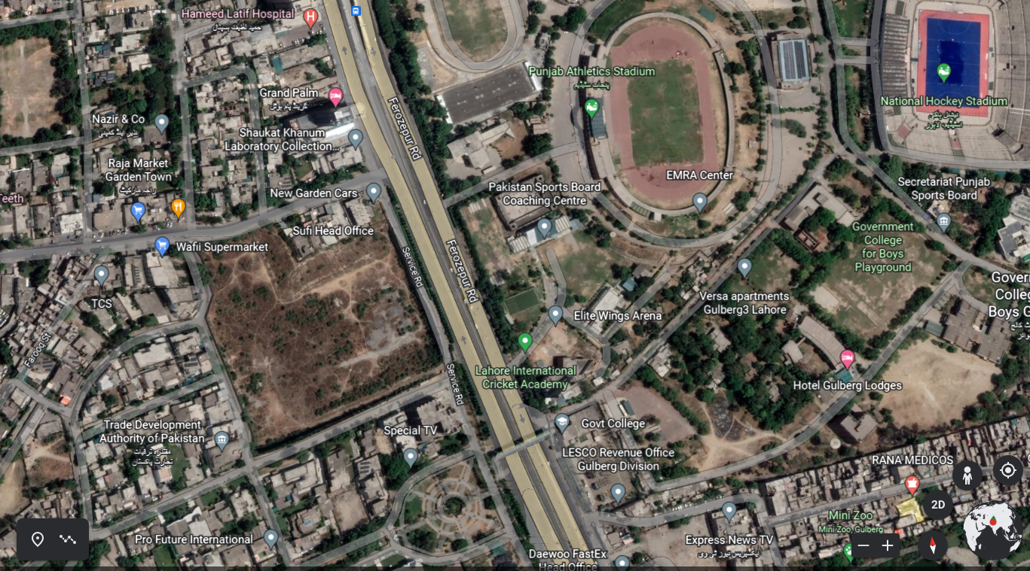
Location: Ferouzpure road, Opposite Qaddafi Stadium

Option-2

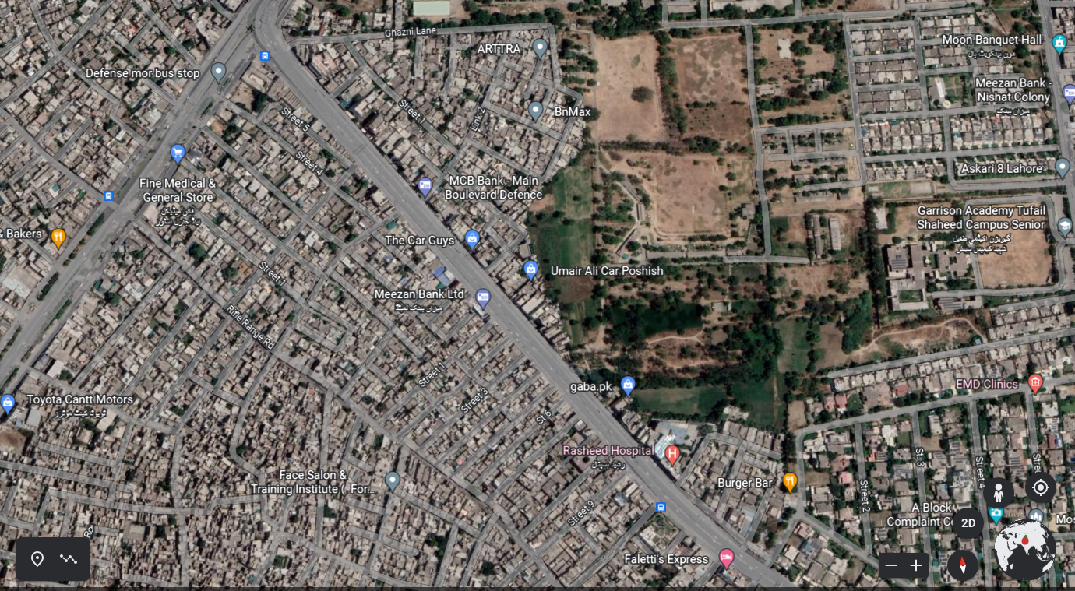
Location: DHA Main Boulevard

Option-3
PACE Gulberg

PROJECT SCHEDULE
The following schedule for the project should be strictly followed as per the dates mentioned below:
S/No | Milestone | CLO | Date
1. | Introduction to Project  (Discussion on nature of project & case studies and final drawing of site)  Data Collection regarding local case studies | 1,2,3
2. | Presentation on Case studies  Site Analysis  (Macro, miso & micro level) | 1,2,3
3 | Presentation on Site Analysis  Discussion on data gathered from TSS  (Initiation of Design Process + formulation of Requirements + design standards) | 1,2,3
4 | Planning of Building  (Working on Grid and site plan) | 3,4
5 | Working on Plans  (Working on Plans  And services) | 3,4
6. | Working on Sections & Elevations | 1,3,4
7. | Discussion on Sections & Elevations  Preparation of 3D & Model | 1,3,4
8. | Final Submission  Final Jury  (Final product to be shown with all previous stages)

SUBMISSION REQUIREMENTS  - Site Analysis (Conclusion Based)  - Case studies (2 local and one international) Analysis and conclusion  - Site Plan  - Plans  - Section  - Elevations  - 3D Views | RECOMMENDED READING  Site Analysis  By: Edward T White  Time Saver Standards; Buildings Types  By: Joseph De Chiara  Design Principles of Atrium Buildings for the Tropics  By: Mohammad Hamdan Ahmad  Shopping Environments; Evolution, Planning and Design  By: Peter Coleman  Building Type Basics for Retail and Mixed-Use Facilities  By: Jerde Partnership

PROJECT- 2
PROJECT INTRODUCTION
Community centers play an important role in our communities. They provide places where people from a range of backgrounds and interests can interact, learn, recreate, be supported and grow. In many areas, they are the focus of socially sustainable communities. It is important that we think creatively about these centers to ensure we develop innovative facilities that reflect our changing lifestyles and community needs. We need to explore new ideas and ways of delivering programs, services and activities which are essential to our daily lives

Community spaces cover a wide range of facilities, forming part of the ‘hard’ social infrastructure that supports community wellbeing in the city. Services and activities developed and delivered from these assets help bring people together, and improve and strengthen neighborhoods, community resilience and community safety. A city’s community spaces, buildings, and amenities provide a platform to deliver activities and services contributing to community wellbeing.

Community centers range from small community halls and meeting rooms available for use by the community to large multipurpose centers / complexes that incorporate a wide range of services and facilities.

PROJECT OBJECTIVES
- Considers how to best integrate, manage and organize services (on a single site).
- To provide particular services, programs and activities for specific target groups, such as young people or older people.
- To design space for hire for private functions.
- To give general community use space for meetings, activities or events.

CLIENTS BRIEF

Participants are required to design a community club comprising following facilities;
- SPORTS COMPLEX
Badminton Court
Snooker Room
Gymnasium
Table Tennis
Squash Court
Sitting Lounge ( Indoor & Outdoor)
Café
Dispensary

- BANQUET HALL
Lobby
Main Hall
Kitchen
Storage
Bride Room
Booking Office

- ADMINISTRATION
Account Office
PA Office
Meeting room
Storage
Offices
Record Room

- PARKING
Maximum Cars 25-30 cars
For banquet Hall, 125 cars approximately

CASE STUDIES

Research of similar Projects in DHA Lahore
SITE LOCATION
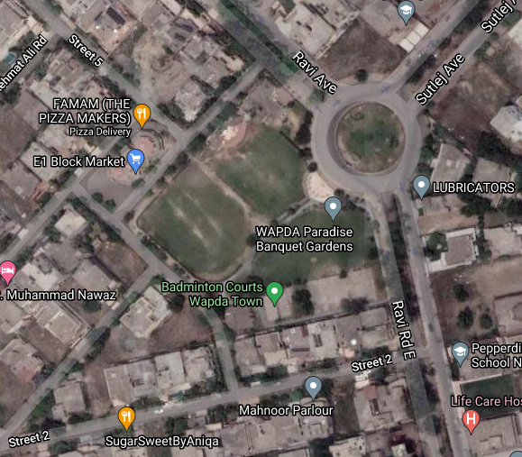

Location: Sutlej Avenue, Block E-1, Wapda Town Lahore
Area of site: 18 kanals approximately

PROJECT SCHEDULE

The following schedule for the project should be strictly followed as per the dates mentioned below:

S/No | Milestone | CLO
1. | Introduction to Project  (Discussion on nature of project & case studies and final drawing of site)  Data Collection regarding local case studies
2. | Presentation on Case studies  Site Analysis  (Macro, meso & micro level)
3 | Discussion on data gathered from TSS  (Initiation of Design Process + formulation of Requirements + design standards)  Master Plan & 3D view  (Discussion)
4 | Master Plan, 3D & Plan of main building  (Discussion)  Plan , section, elevation & Structure of main building  (Discussion)
5 | Plan, Structure, section & elevation of main building with 3D  (Discussion)  Mid Jury
6. | Working on Sections & Elevations
7. | Final Submission  Final Jury  (Final product to be shown with all previous stages)

SUBMISSION REQUIREMENTS
Master Plan
Ariel Views of Site
Detailed Plans of Banquet Hall (For 1000 People)
Section of Banquet hall (min 2)
Elevations (min 2)
Detailed 3D Views of Banquet Hall

