Resource Person: Talha Zubair Ahmad Khan
E-mail:
Mobile:
Semester: Fall, 2015
Course Title: Logistics Systems
Course Code: SC-480
Course Type: Applied course
Pre-Requisite: Nil
Counseling Hours: Monday – Friday @ 4.00 P.M to 6.00 P.M
Program:
Program Head:

 | Name | Signature | Date
Prepared By  (Resource Person) | Talha Zubair Ahmad Khan |  | 5th of October, 2015
Checked By  (Program Head) | Mr. Zakee Sadaat |  | 5th of October, 2015
Approved By  (Director SPA) | Dr. Naveed Yazdani |  | 5th of October, 2015

Course Description

In today’s highly competitive, global marketplace the pressure on organizations to find new ways to create and deliver value the customers grows ever stronger. Gradually, in emerging economies as well as mature markets, the power of buyer has become relatively stronger. In this regard, the discipline and logistics of supply chain management has moved on the center stage over the last two decades. The concept of integration of within the business and between the businesses is not new, but the acceptance of its validity by managers is. There has been a growing recognition that it is through logistics and supply chain management that the twin goals of cost reduction and service enhancement can be achieved.

Keeping all this in view, this course seeks to advance the knowledge of students within the field of logistics systems which supplement the supply chain operations of organizations. Students will able to comprehend the role of variety of different logistics systems in both organizational strategy and organizational environment. In addition, students will be able to understand the commonly used logistics terminologies and obtain the latest information and knowledge on advancement in the subject of logistic management. The efficiency and effectiveness of inventory movement across the supply chain through the capability of logistics management will be highlighted. Furthermore, the role of logistics systems in customer service strategy of the organization will be made explicit.
Format of the Course:
The course pack developed for this course serves as the outline of the important topics which will be covered throughout the study sessions. It contains majority of the important concepts required to improve the basic understanding of the course and contain variety of applied examples from business arena. In addition, new material covering the basics of different logistics systems commonly used in warehousing, transportation, automation and airline industry will be introduced as the course advances in later stages of study sessions. Furthermore, students will also be introduced to basic search engine ‘Google Scholar’ which will aid them in finding most relevant scholarly work for the completion of their assignments. Students are highly encouraged to participate in class discussion, raise relevant questions and share their useful insights.

Students Outcomes
- Ability to manage logistics systems to align customer demands.
- Ability to plan and control different value-added logistics systems through systems thinking
- Ability to take efficient warehousing logistics decisions to achieve the goals related to higher customer satisfaction and lower costs of operations
- Ability to design efficient material handling and storage systems compatible for warehouse layout plans
- Ability to design logistics information systems for achieving supply chain competency
- Ability to control logistics management functions
- Ability to manage logistics in distribution channel
- Ability to understand different logistics costing methods such as traditional costing and activity-based costing methods

Course Content

Session 1: Introduction session
One-to-one orientation
Course Introduction, Teaching Methodology & Assessment Criteria
Distribution of course packs and course outlines
Highlighting significance of the course

Session 2: Logistics: At the centre of the World Trade
Reading: Chapter No.1 in the course pack
Key Concepts:
- A paradigm shift
- Logistics defined
- Logistics and system thinking
- Customer value chain and logistics functions
Learning outcomes:
This introductory session on logistics management will highlight the basic concepts, scope and objectives of logistics systems within organizations. Students will be able to understand the important functions of an effective logistics system. In addition, role of logistics in customer value chain will be highlighted.
Activity No.1: (Graded) Based on the discussed logistics functions in class, identify key logistics operations under each function for Pakistan Army. Perform this activity in a form of groups and write your answers on a piece of paper. Submit the papers after the class.

Session 3: Customer service: Key element in logistics strategy
Reading: Chapter No.2 of the course pack
Key concepts:
- Business level strategies
- Customer service for competitiveness
- Customer satisfaction
- Value added logistical services
Learning Outcomes
The focus of this session is to highlight the role of customers’ service as a measure of effectiveness of a logistics system in creating time and place utilities of the product. Students will be able to understand the role of value-added logistics services for the attainment of higher customer satisfaction.
Activity No.2: (Graded) you heard about the major cable and internet provider that made “headline” news last year when a customer recorded a call to the company’s customer service center. The customer had simply called to terminate his service, but first, the representative he spoke to insisted upon asking him some questions. The agent asked why the customer wanted to disconnect since the company offered the best services and the best price.
The agent basically refused to accept the fact that the customer simply wanted to disconnect his service. After the customer listened for several minutes, he got the idea to record the call with his iPhone. The agent went on and on, for more than 15 minutes in total. The customer ultimately posted the disastrous call on social media and the incident went viral. Think of three main problems that can lead to this type of poor customer service. Perform this activity individually.
Session 4: Supply chain management as source of competitive advantage
Reading: Chapter No.3 of the course pack
Key Concepts:
- Competitive advantage
- Market orientation and competitive advantage
- Role of logistics in supply chain
- Leveraging logistics for competitiveness
Leaning outcomes:
The concept of gaining and sustaining competitive advantage is not new to business management. This session will focus on developing the basic understanding of the term competitive advantage. The source of competitive advantage will be discussed from the perspective of supply chain management, particularly through logistics systems. Students will be able to understand the role of supply chain management in gaining and sustaining competitive advantage through cost efficient, quality maximizing and productive logistics systems.

Session 5: Role of warehousing in logistics mix
Reading: Chapter No.4 of the course pack
Skills outcomes and core concepts:
- Warehousing: A logistical challenge
- Warehousing skills related to warehouse site selections, layout designs, costing and strategies
Learning Outcomes
Students will be able to understand the role of warehousing in logistics, its functions, costing mechanisms and operations. The concept of warehousing will be highlighted as a source of achieving logistical competency which departs from the traditional view of considering as added cost to the distribution process
Activity no.3: (Graded): To be performed individually (15 mins).
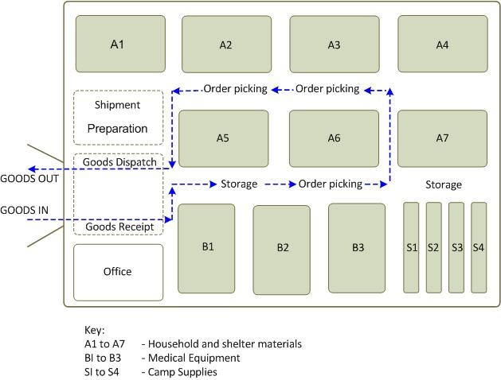
What are the main warehousing operations being performed in the warehouse layout design shown above? If we want to convert it into fully automated warehouse, what should be the ratio of utilized space and open space? Do we need to change the warehouse layout design?

Session 6: Material handling systems in logistics systems: Exploiting productivity potential in logistics
Reading: Chapter No.5 of the course pack
Key concepts:
- Role of material handling in logistics
- Types of material handling systems and their features
Learning Outcomes
Material handling is an important component for efficient logistics system. Improving material handling system fuels a stunning return on investments. Students will be able to understand the important components of an efficient material handling system decisions such as hygiene and human safety, dead weight to pay load ratio, compatible storage system and cost implications.
Activity no.4: (Graded): To be performed individually (15 mins).

Review the picture above related to the materials handling at airport (name confidential). Based on the different material handlings equipment and systems discussed in the session, provide a solution to the airport to properly manage their material handling system.

Session 7: Material storage systems: Space efficiency and storage density
Reading: Chapter No.6 of the course pack
Key concepts:
- Material storage principles
- ‘Unit load’ storage
- Material storage method
- Design of storage system
Learning Outcomes
Similar to material handling, material storage systems can provide increased efficiency, and cost savings benefits. Students will be able to understand the important components of an efficient material storage decisions such as product characteristics and class of goods, dead regulations and standards, distribution needs, hygiene and human safety and, cost implications.
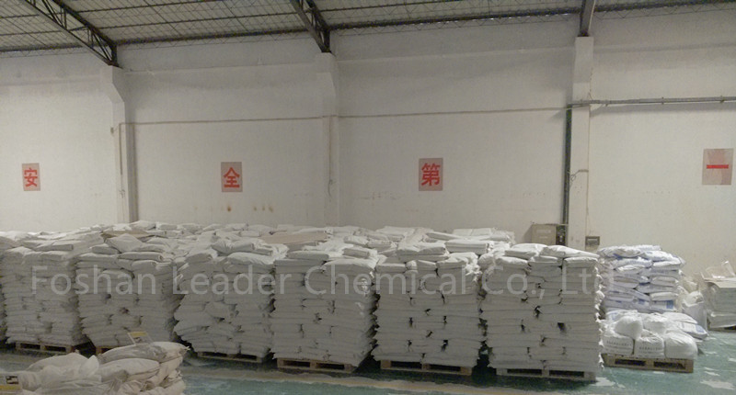
Activity no.3: (Graded): To be performed individually (15 mins).

Review the material storage of raw materials as shown the picture above. Do you think that it reflects an efficient storage of materials? If not, what are the problems associated with the storage system and how can it is improved?

Session 8: Managing inventory systems for efficient distribution logistics chain
Reading: Chapter No.7 of the course pack
Key Concepts:
- Bullwhip effect
- Inventory classifications and functions
- Role of inventory in distribution logistics chain
- Inventory planning models and control techniques
  - Just-in-Time Systems (JIT)
Skills related Outcomes:
- To determine annual usage cost of particular item
- Perform Vital, Essential and Desirable (VED) analysis of the inventory
- Performing material requirement planning
- Performing distribution requirement planning
Learning Outcomes
Although, inventory management systems are widely discussed as an important and separate component of an efficient supply chain management but it is imperative to highlight the role of inventory management in managing efficient logistics systems particularly to meet fluctuated customers demands and avoiding increased costs due to inventory pileups. Students will be able to understand the key role of logistics systems towards increasing coordination between organization departments and managing the flow of information to avoid inventory pileups as well as inventory shortages.
Session 9: Logistics information systems: Towards achieving supply chain competency
Reading: Chapter No.10 of the course pack
Skills related Outcomes:
- Designing logistics information systems
- Understanding important components of logistics information system (LIS)
Learning Outcomes
As discussed earlier, logistics information systems plays an important role towards exploration and exploitation of knowledge and keeping the information database up to date. Its role becomes significant while managing logistics systems within dynamic environments. Students will be able to understand and design logistics systems as an information-based process of material movement across the supply chain.

Session 10: Logistics Costing
Reading: Chapter No.20 of the course pack
Key concepts and skills related outcomes:
- Logistics costs
- Performing traditional costing methods
- Performing activity-based costing methods
- Understanding performance measurements
Learning Outcomes
Control for logistics costs has become increasingly important to firms seeking competitive advantage. This session is specifically design for students to understand the accounting and control of logistics costs. Students will be able to understand different logistics costing methods in relation to the components of logistics costs such as order processing, warehousing and inventory controls.

Session 11: Quantitative Techniques: For Optimization in Logistics
Reading: Chapter No.21 of the course pack
Skills related Outcomes:
- Perform correlation analysis, time series analysis for demand forecasting
- Developing transportation models
- Perform route planning
Learning Outcomes
This session focuses on developing students to use various quantitative techniques for forecasting customers demand, allocation of resources to specific tasks for improving efficiency, and designing logistical route planning for costs control and achieving higher customer satisfaction.

Session 12: Organizing for logistic systems
Reading: Chapter No.22 of the course pack
Key concepts:
- Logistics and organization structure
- Factors influencing organization structure
- Organizational designs
- Logistics as teamwork

Learning Outcomes
With the growing nature, scope and importance of logistics in overall performance of an enterprise, it is essential to have a well-defined organizational structure that supports the corporate mission and improves logistics systems performance. Keeping this in view, this session particularly designed to make students familiar with different organizational structures. Students will be able to create a link between business model and supply chain model of the organization and understand the need for organization of logistics systems

Session 13: Leading-edge logistics: Fundamental business transformations for managing supply chain for the future
Handout No.1 of the course pack
Key concepts:
- Managing supply chain for the future
- The new organizational paradigm
- Role of information in supply chain
- Dynamism
- Organizational inertia
Leaning Outcomes
Turbulent environmental conditions, rapid phase of technological change, introduction of new innovative products are few examples of a dynamic business environment. In order to meet ever changing demands from the customers, leading-edge logistics systems and responsive organizations are being designed subject to high levels of adaptability and flexibility. The aim of this session is to highlight the importance of dynamic environmental conditions and role of making adaptive supply chain and logistics management systems.

Session 14 and 15: Presentations from students in group format discussing different case studies assigned related to the areas of logistics management
Reading: Assigned reading no.13 of the course pack
List of cases added in the course pack
- Case study No.1: Tushar Enterprises: Consolidating Distribution Systems
- Case study No.2: Dora Ceramic Tiles: Preparing to Meet Supply Chain Challenges of Tomorrow
- Case study No.3: Aditya Digital T.V: Deciding on Warehousing Locations
- Case study No.4: Bharatcraft.com: Business Logistics Systems for an Online Selling Store

ASSESSMENT METHODOLOGY
Class Participation | 20
Class Activities | 15
Presentation | 10
Final Term Exam | 35
Assignments | 10
Quizzes | 10
Total | 100

Calendar of Activities

Session | Topic | Readings | Activities
1 | Orientation Session | - | Groups formation
2 | Logistics: At the Centre of World Trade | Chapter no.1 of the course pack | Activity no.1  Assignment No.1
3 | Customer service: Key element in logistics strategy | Chapter no.2 of the course pack | Activity no.2  Assignment no.1 distribution to students
4 | Session 4: Supply chain management as source of competitive advantage | Chapter no.3 of the course pack | Assignment no.2  Quiz no.1
5 | Role of warehousing in logistics mix | Chapter no.4 of the course pack | Activity no.3  Assignment no.2 distribution to students
6 | Material handling systems in logistics systems: Exploiting productivity potential | Chapter no.5 of the course pack | Activity no.4  Assignment no.3
7 | Session 7: Material storage systems: Space efficiency and storage density | Chapter no.6 of the course pack | Activity no.5  Assignment no.3 distribution to students
8 | Managing inventory systems for efficient distribution logistics chain | Chapter no.7 of the course pack | Quiz no.2
9 | Logistics information systems: Towards achieving supply chain competency | Chapter no.10 of the course pack | Quiz no.3
10 | Logistics Costing | Chapter no.20 of the course pack | Case Study
11 | Quantitative Techniques: For Optimization in Logistics | Chapter no.21 of the course pack | Quiz 4
12 | Organizing for logistic systems | Chapter no.22 of the course pack | Case Study
13 | Leading-edge logistics: Fundamental business transformations for managing supply chain for the future | Class Handouts | Quiz 5
14 | Class Presentations | Case no.1 and 2 | Revisions
15 | Class Presentations | Case no. 3 and 4 | Revisions

