COMPLIANCE CERTIFICATE FOR UNDERGRADUATE 2.0 POLICY
Program Name: BSSE
Program Scheme of Studies
Structure of the Scheme
Courses Credit Hours | 1-4
Core Courses: (Credit Hours) | 14  47
Foundation Courses : (Credit Hours)
Major Courses: (Credit Hours) | 6 18
Technical Electives: (Credit Hours) | 7 21
General Electives: (Credit Hours) | 12  35
Supporting Science: (Credit Hours) | 4 12
University Electives: (Credit Hours) | 1  3
Undergraduate 2.0 courses (Credit hours) | Distributed above
Total Credit Hours: | 136

Program Road Map
Applicable to Batch No. _________ Session Fall 2023

1st Year

1st Semester | 2nd Semester
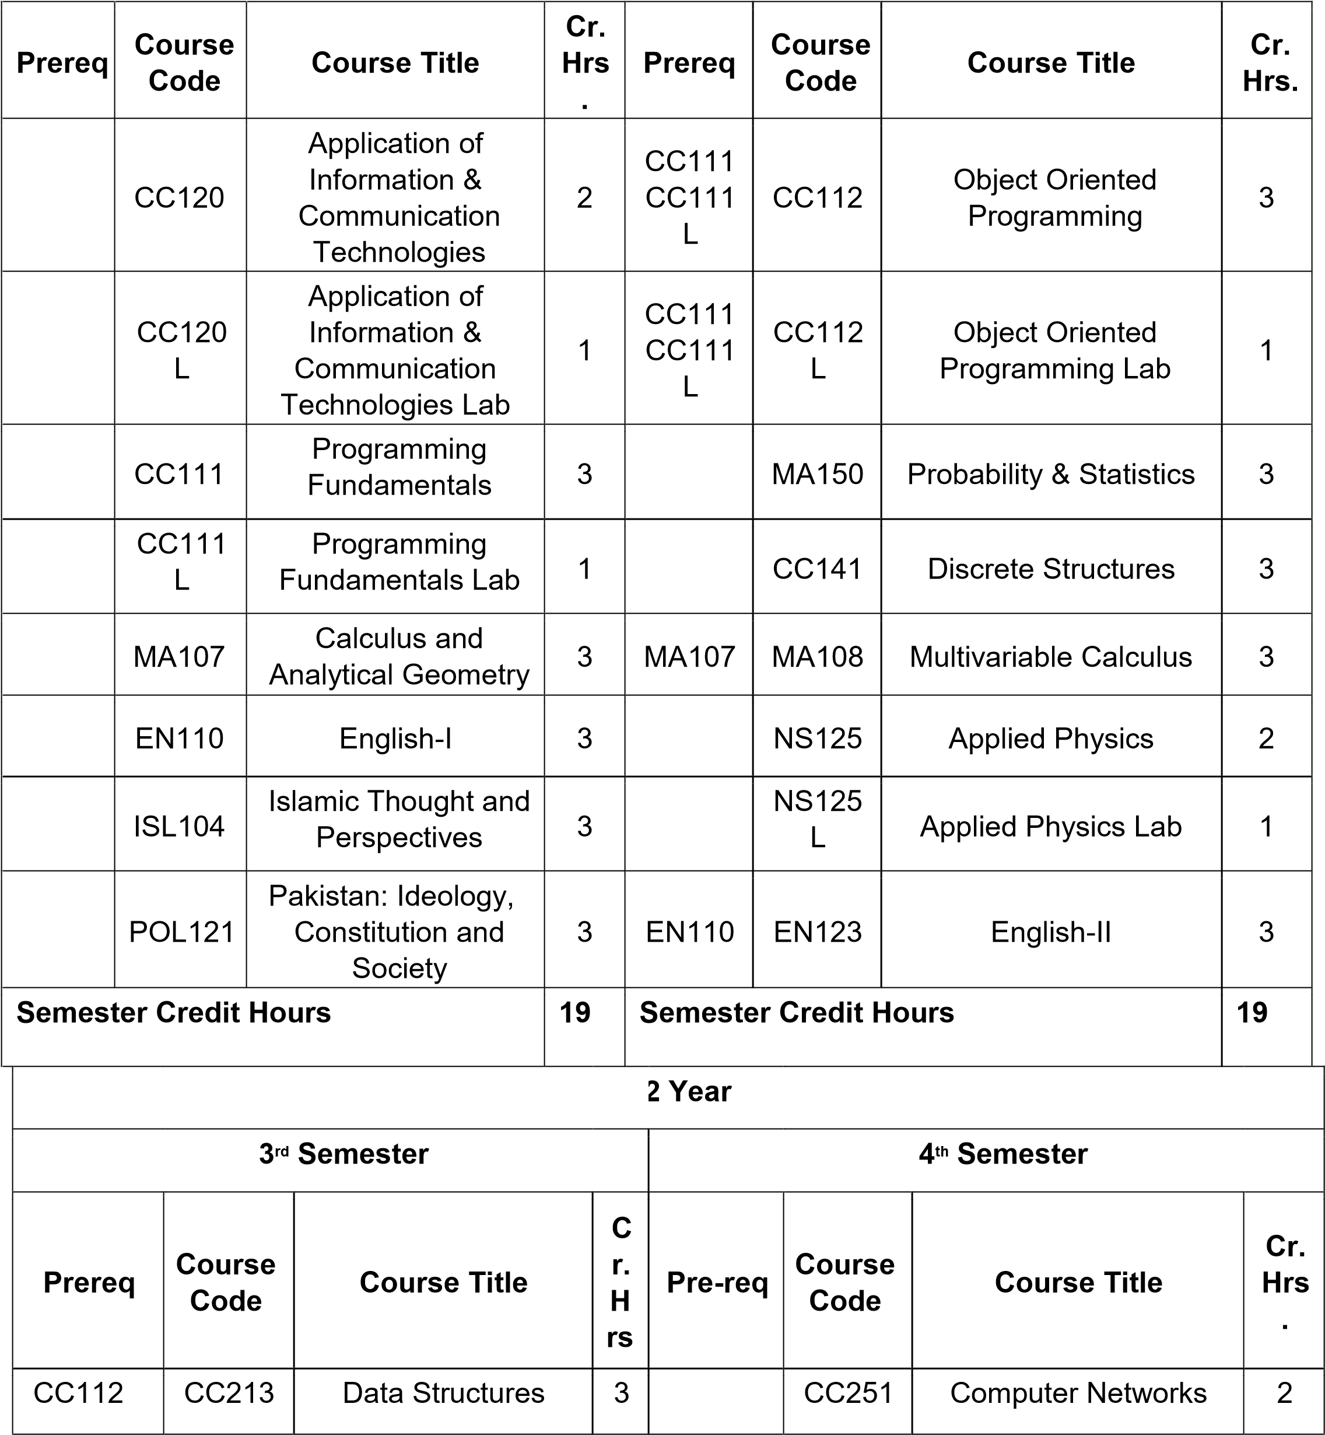

CC112
L
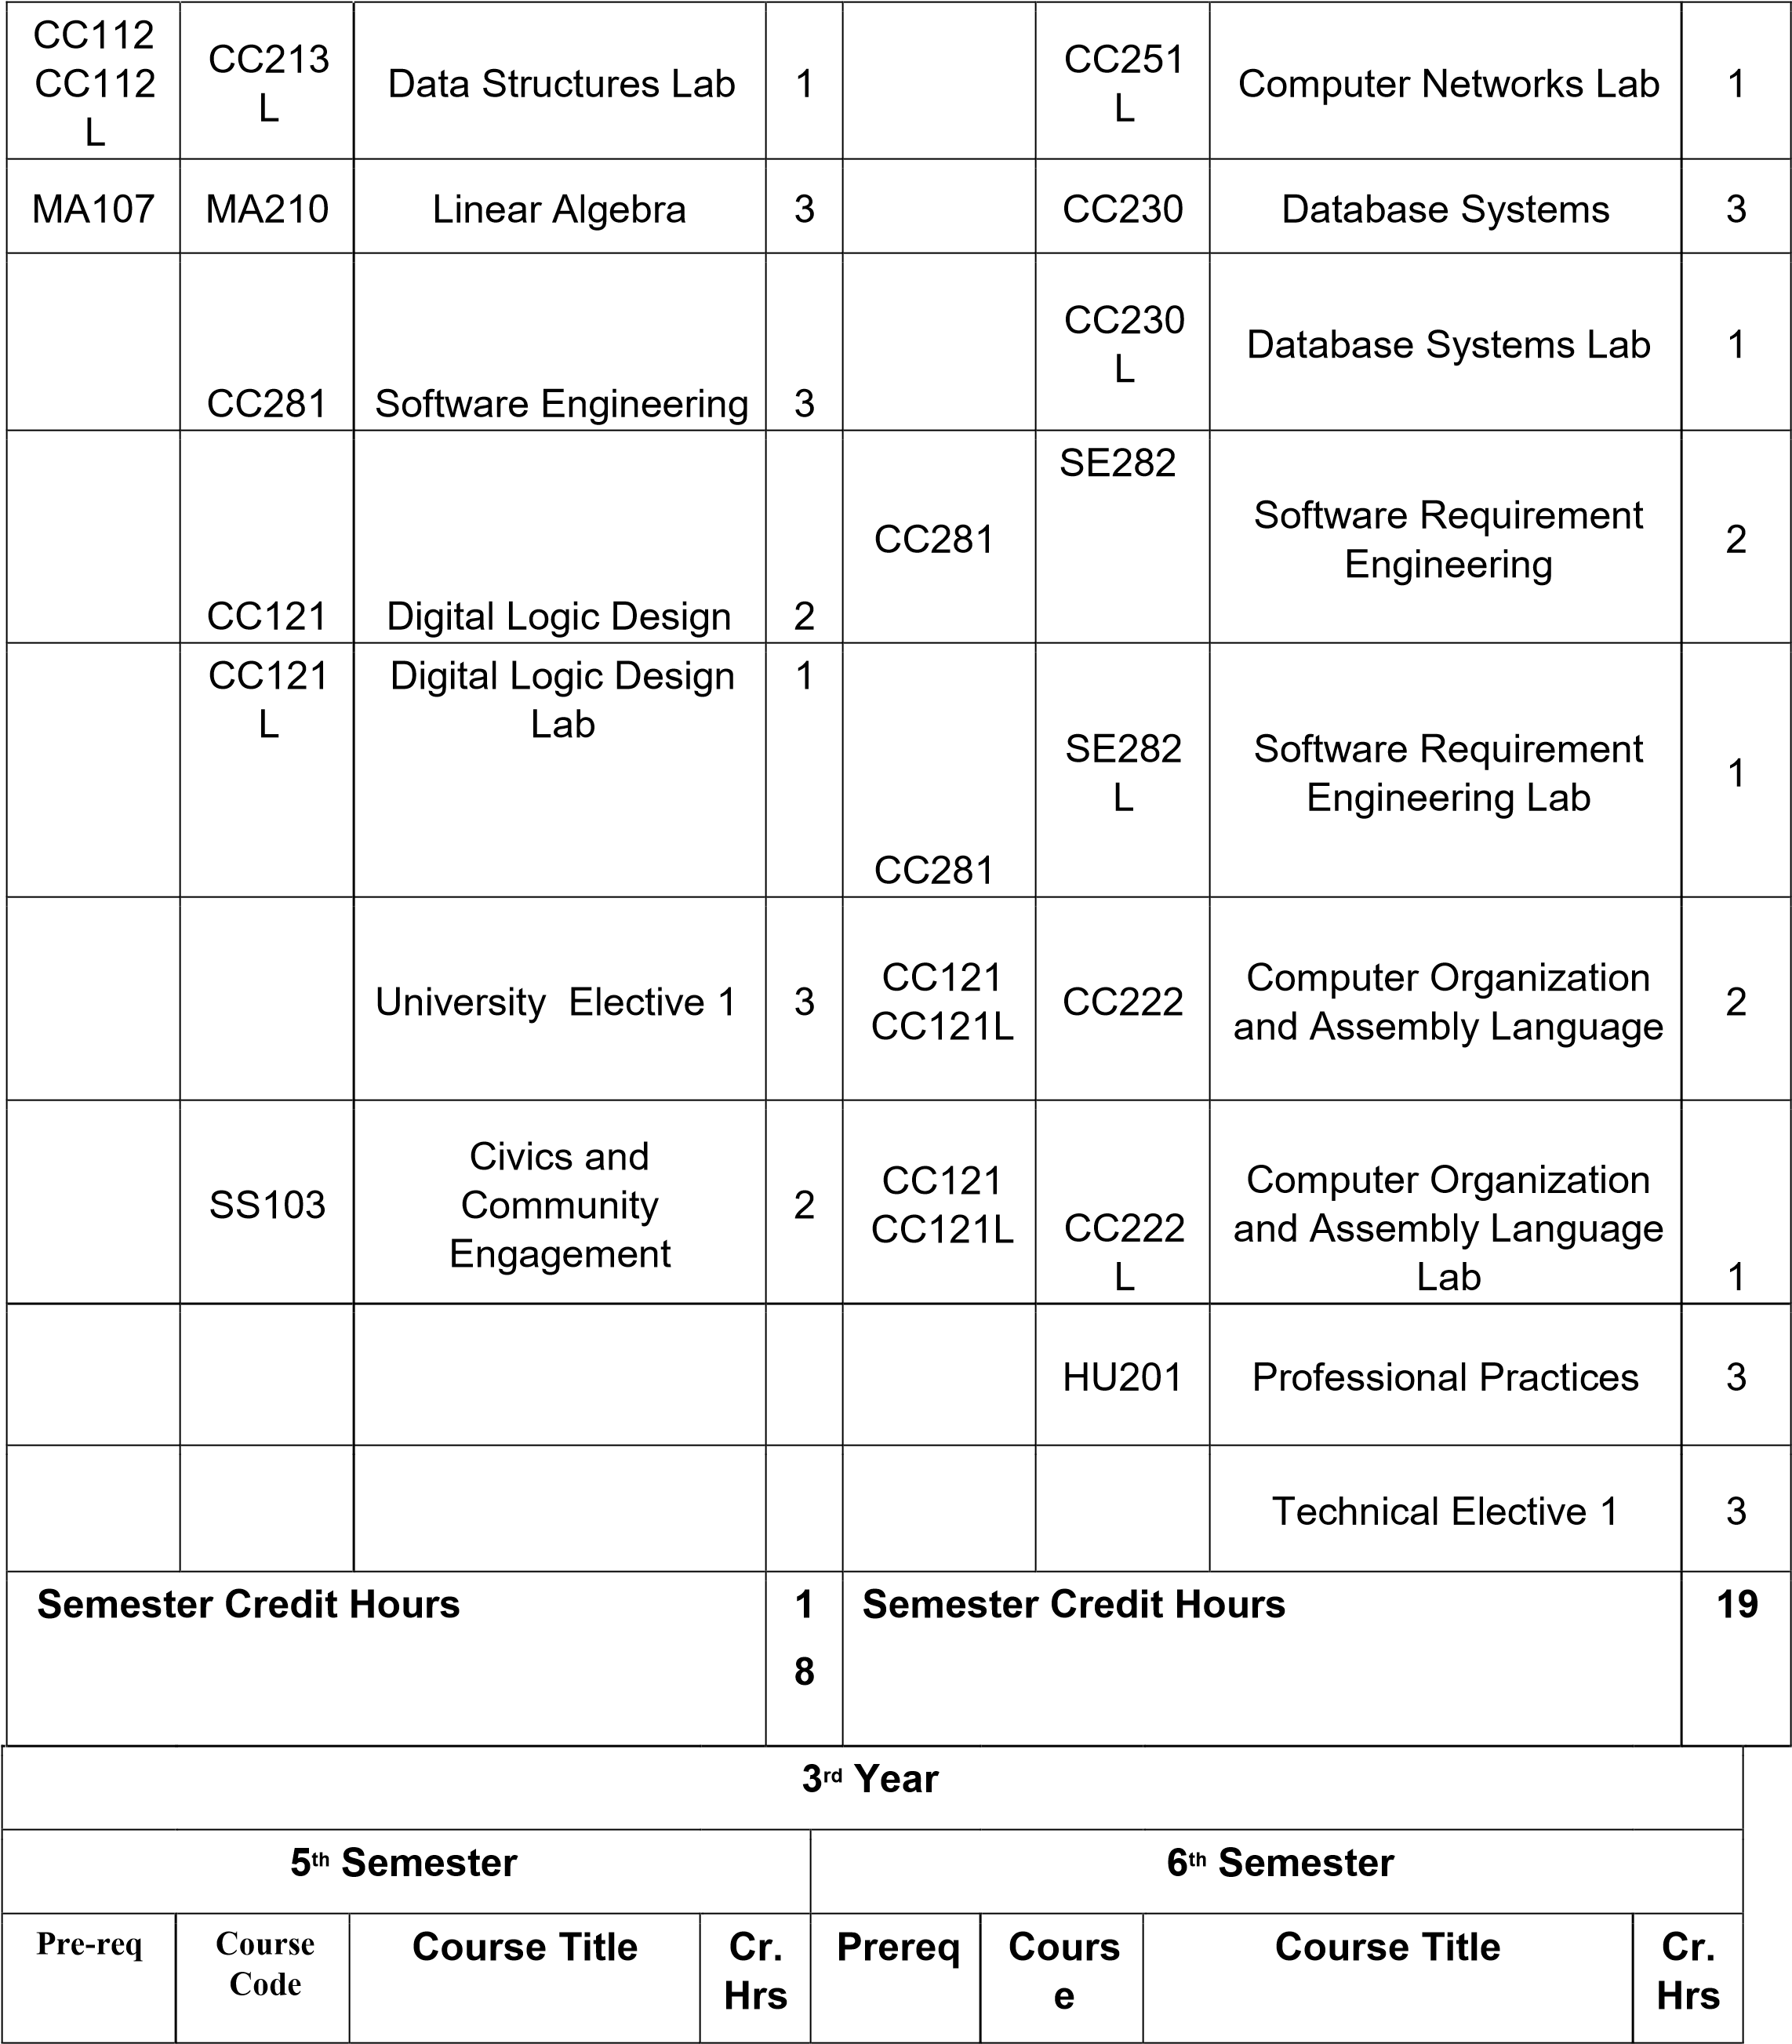

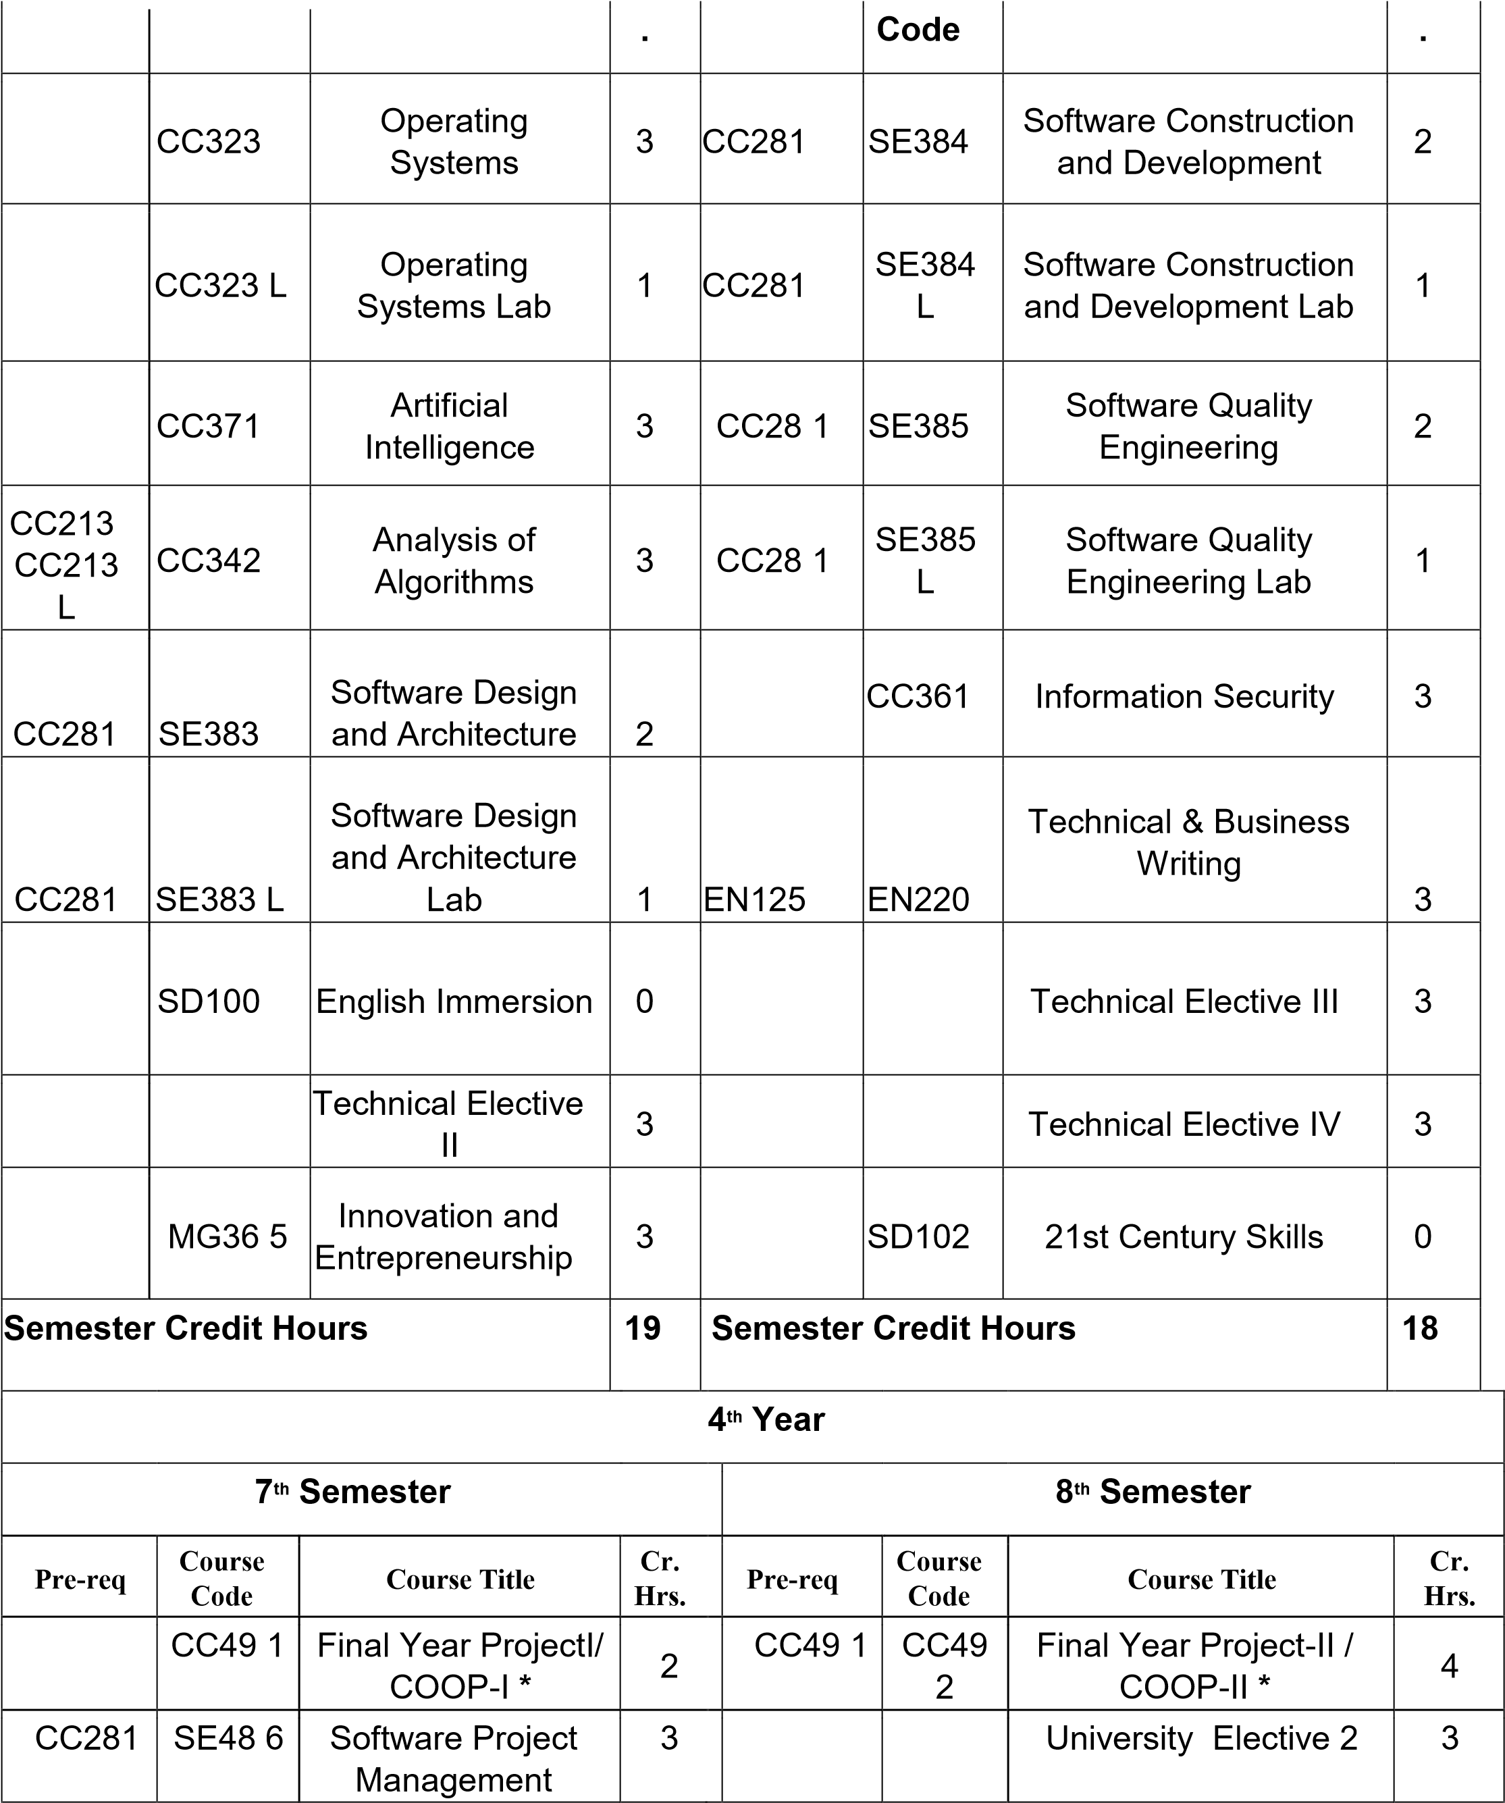

CC323 CC323L | CC42 5 | Parallel and  Distributed  Computing | 3 |  |  | Technical Elective VII | 3
 |  | Technical Elective V | 3
 |  | Technical Elective VI | 3
Semester Credit Hours |  |  | 14 | Semester Credit Hours |  |  | 10
Total Credit Hours |  |  |  | 136
*COOP means FYP undertaken by the industry.
Non-Exhaustive List of Electives
Course  Code | Course Title | Cr. Hrs.
SE489 | Software Verification and Validation (Testing &  QA) | 3
SE394 | Object Oriented Analysis & Design | 3
CS245 | Computer Architecture | 3
CS341 | Theory of Automata | 3
CS324 | HCI & Computer Graphics | 3
IT291 | Web Technologies | 2 + 1
CS431 | Advanced Database Management | 2 + 1
SE393 | Web Engineering | 2 + 1
DS291 | Introduction to Data Science | 2 + 1
SE488 | Software Re-Engineering | 3
SE491 | Mobile Application Development 1 | 2 + 1
SE492 | Open Source Software Development | 3
SE496 | Operation Research | 3
SE387 | Formal Method in Software Engineering | 3
SE495 | Game Design and Development | 2 + 1
University Elective 1 (3 Chrs.) (From Arts and Humanities)
Arts and Humanities (3-Credit Hours) Min One Course
SD221: Life and Learning | 3
SD222: Foreign Language | 3
SD223: Logical Reasoning | 3
University Elective 2 (3 Chrs.) (From Social Sciences)
Social Sciences (3-Credit Hours) Min One C | ourse
HWB101: Health and Wellbeing |  | 3
SOC102: Understanding Society and Sociocultural Dynamics |  | 3
PSY110: Psychology of Mind and Behaviour |  | 3
ECO202: Economics |  | 3
MK210: Principles of Marketing |  | 3
MG120: Principles of Management |  | 3
Note:
The program BS(SE) is accredited by NCEAC. The roadmap must contain the courses provided by the NCEAC. Some of the courses we offer differ from those prescribed by UMT UG 2.0 but they are those that are mandated by NCEAC and do fulfill the requirement of the respective areas of UG 2.0. The roadmap is compliant with all the other courses proposed in UG 2.0.
It is hereby certified that curriculum of BSSE program, Session Fall 2023 is compliant to Undergraduate 2.0 Policy. All the courses of UG 2.0 are incorporated in the roadmap accordingly.

Chairperson of Department Dean concerned

Director AAQIC Registrar

